Full Stack Development with MERN
Project Documentation format
1. Introduction
• Project Title: Import Data using Transform Maps (Spreadsheet)
• Team Members:
o Dhanalakshmi Pl – Team Leader (TL)
o Dhalapathi C – Team Member
o Dhanalakshmi S – Team Member
o Dhanusri S B – Team Member
2. Project Overview
• Purpose: The objective is to import data from a spreadsheet into ServiceNow using Import Sets and Transform Maps. The spreadsheet records are loaded into a staging (Import Set) table and a Transform Map maps the spreadsheet columns to the corresponding fields of a target ServiceNow table, transforms the data if required, and inserts or updates the records accurately. This automates data migration and ensures the imported data is correctly structured and stored in ServiceNow.
• Features:
o Upload of a spreadsheet (.xlsx / .csv) through a Data Source
o Loading of spreadsheet rows into an Import Set (staging) table
o Transform Map to map spreadsheet columns to target table fields, including Auto Map Matching Fields
o Transform scripts to clean or convert data before it is saved
o Coalesce field to update existing records and avoid duplicates
o Transform History and error log to review and correct failed rows
3. Architecture
• Frontend: The solution uses the standard ServiceNow web interface in a browser instead of a custom React application. The administrator works through the System Import Sets screens (Load Data, Data Sources, Transform Maps and Import Sets) built on ServiceNow’s Next Experience / platform UI.
• Backend: The ServiceNow platform server runs the Import Set and Transform engines instead of a Node.js / Express.js server. It loads the file into the staging table, applies the Transform Map (field maps, coalesce and server-side JavaScript transform scripts using the Glide API) and writes the results to the target table.
• Database: ServiceNow’s relational database is used instead of MongoDB.
o Staging (Import Set) table: one column per spreadsheet column; each spreadsheet row becomes one staged record.
o Target table: the table that receives the final records, with fields mapped from the staging columns.
o Supporting tables: Data Source (sys_data_source), Transform Map (sys_transform_map), Field Maps (sys_transform_entry), Transform Scripts (sys_transform_script) and Attachments (sys_attachment).
o Interaction: Data Source → Import Set table → Transform Map → Target table, with results recorded in Transform History.
4. Setup Instructions
• Prerequisites:
o A ServiceNow instance (for example a Personal Developer Instance) and a web browser
o A user with the admin or import_admin role
o A spreadsheet (.xlsx / .csv) with a header row and clean, consistent data
o A target table that already exists (standard or custom)
• Installation: No cloning, dependency installation or environment variables are needed because the solution is configured on the instance.
o Step 1: Log in to the ServiceNow instance with an authorized user.
o Step 2: Prepare the spreadsheet so that the column headers match the data to be imported.
o Step 3: Confirm that the target table and its fields exist (create them if needed).
o Step 4: Create a Data Source of type File and attach the spreadsheet.
o Step 5: Create the Transform Map and field maps, then save the configuration (it can be moved to other instances with an Update Set).
5. Folder Structure
• Client: ServiceNow has no client folders; the user-interface structure is the navigation under System Import Sets.
o Load Data – upload the file and create the staging table
o Administration > Data Sources – manage the file source
o Administration > Transform Maps – manage mapping and field maps
o Import Sets / Import Set Rows – view staged data
• Server: The server-side configuration records are organized as follows.
o Data Source record with the attached spreadsheet
o Import Set (staging) table
o Transform Map with Field Maps, coalesce settings and Transform Scripts (onBefore / onAfter)
o Target table
6. Running the Application
• Steps to run the import in the instance (instead of starting servers locally):
o Frontend: Open System Import Sets > Load Data, select the Data Source / spreadsheet and load the data into the Import Set table.
o Backend: Open the Import Set, use the Transform Map related link and click Run Transform to insert or update records in the target table.
7. API Documentation
• Endpoints exposed by the platform for this project (REST, optional for automated loading and verification):
o POST /api/now/import/{stagingTableName} – inserts a record into the staging table and runs the Transform Map.
o GET /api/now/import/{stagingTableName}/{sys_id} – retrieves a staged record.
o GET /api/now/table/{targetTable} – lists records of the target table (parameters: sysparm_query, sysparm_fields, sysparm_limit).
• Example request and response (field names are illustrative):
Request – POST /api/now/import/u_spreadsheet_import
{ "u_name": "Sample Name", "u_email": "sample@example.com" }
Response – 201 Created
{ "import_set": "ISET0010001", "staging_table": "u_spreadsheet_import",
"result": [ { "transform_map": "Spreadsheet Import Map",
"table": "<target table>", "status": "inserted",
"sys_id": "<record sys_id>" } ] }
8. Authentication
• Authentication: Users sign in to the ServiceNow instance with a username and password (single sign-on can be added). The web interface keeps the user logged in with a session; REST calls use Basic Authentication or an OAuth 2.0 access token.
• Authorization: Role-based access control decides who can create Data Sources, run Transform Maps and write to the target table (roles such as admin, import_admin and import_transformer). ACLs on the Import Set and target tables protect the data.
9. User Interface
• Screenshots to be captured from the team’s instance and inserted here:
o Load Data screen with the spreadsheet selected
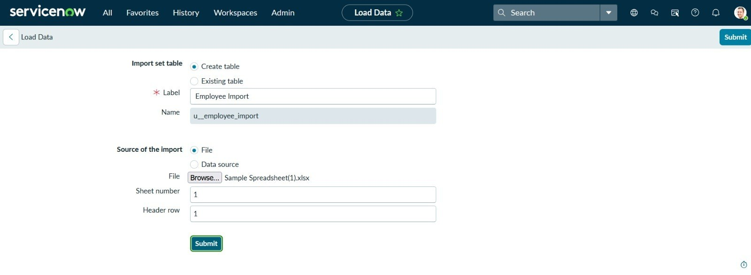
o [Insert screenshot: Import Set table showing the staged rows]
o Transform Map and Field Map mapping screen
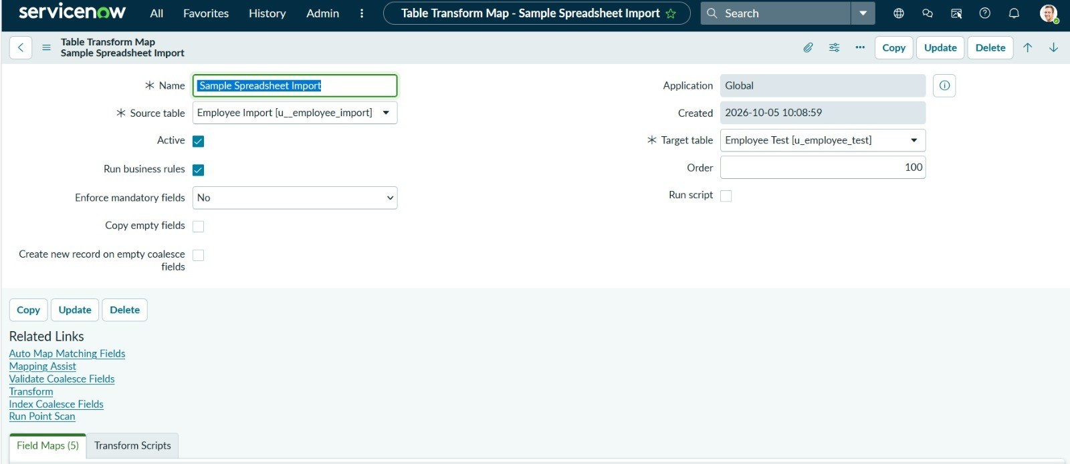
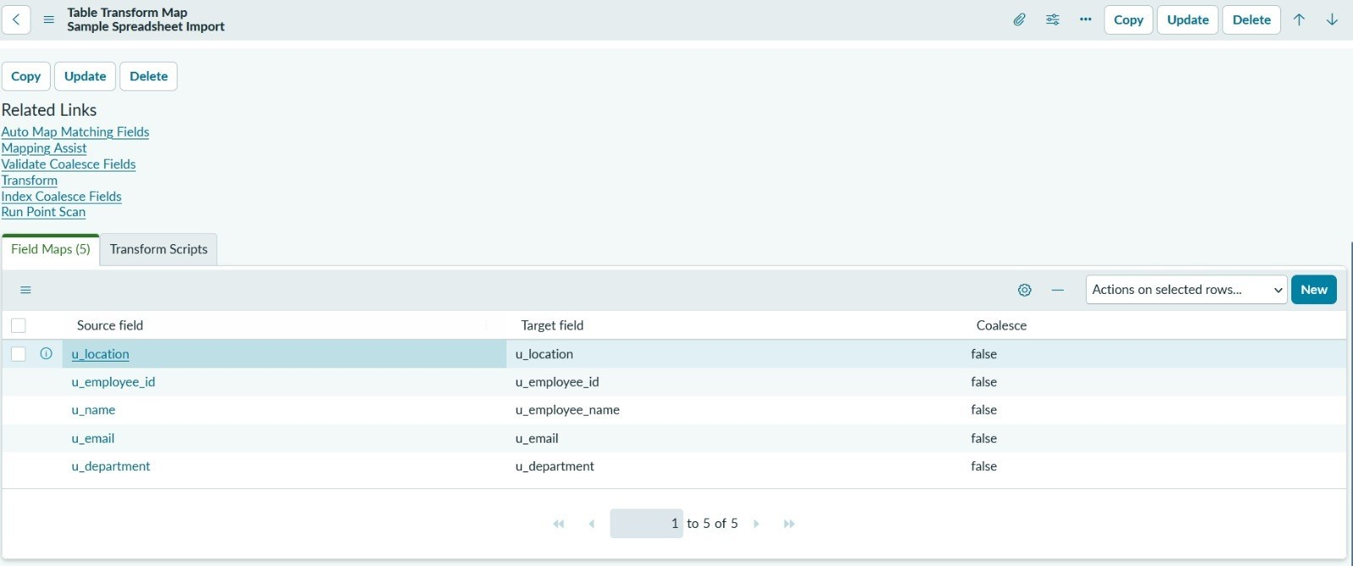
o Run Transform confirmation and Transform History
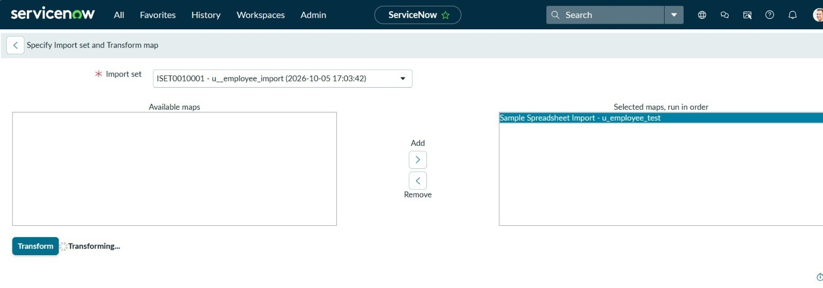
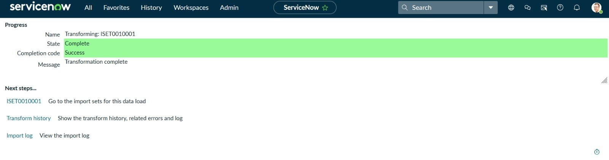
10. Testing
• Strategy: The import is tested with a sample spreadsheet and the results are compared with the source file.
o Valid rows are inserted into the target table with the correct field values.
o Row counts in the Import Set table and the target table are compared with the spreadsheet.
o Duplicate rows are tested to confirm the Coalesce field updates records instead of duplicating them.
o Rows with missing or invalid values (for example wrong date formats) are tested to confirm they are reported in the error log and can be corrected and re-imported.
o Access is tested with an authorized and an unauthorized user.
• Tools: Import Set Rows preview, Transform History, System Logs / Script Debugger for transform scripts, target table list view, and REST API Explorer for the optional API.
11. Screenshots or Demo
• Screenshots or a demo link to be added by the team:
o Data Source with the attached spreadsheet
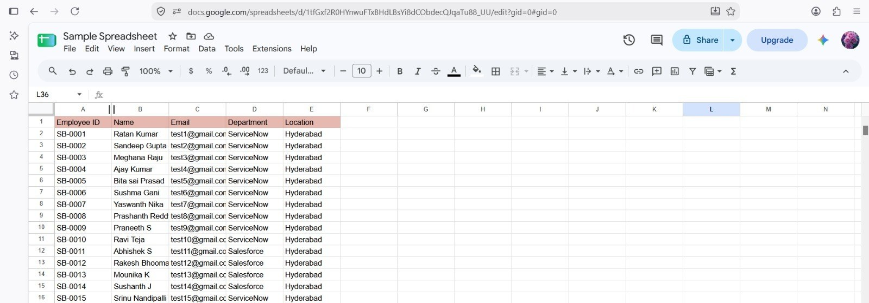
o Records imported into the target table
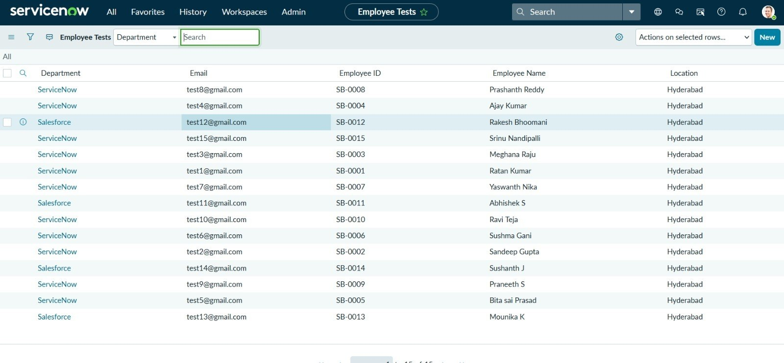
12. Known Issues
• Limitations that users and developers should be aware of:
o If the spreadsheet column headers change, the field maps must be updated.
o Date, choice and reference values may need a transform script to be saved correctly.
o Choosing a Coalesce field that is not unique can update the wrong record.
o Very large files may load slowly and are better split into smaller files.
o A Personal Developer Instance can hibernate when it is inactive.
13. Future Enhancements
• Possible improvements:
o Scheduled imports of spreadsheets from a shared location
o Validation checks on the spreadsheet before the transform is run
o Email or notification on import success or failure
o Dashboard showing import counts and failed rows
o Support for multiple sheets and reusable import templates

