Project Development Phase
Model Performance Test

Date | 03 October 2026
Team ID | Team 5
Project Name | Import Data using Transform Maps (Spreadsheet)
Maximum Marks | 10 Marks

Model Performance Testing:
Project team shall fill the following information in model performance testing template.
S.No. | Parameter | Values | Screenshot
 | Metrics | Regression Model:  Not applicable - no regression model is used in this project  Classification Model:  Not applicable - no classification model is used in this project  Equivalent import metrics:  Total rows in spreadsheet - 15, Inserted - 15, Updated - 0, Ignored/Error - 0 (from Import Set Rows and Transform History) | 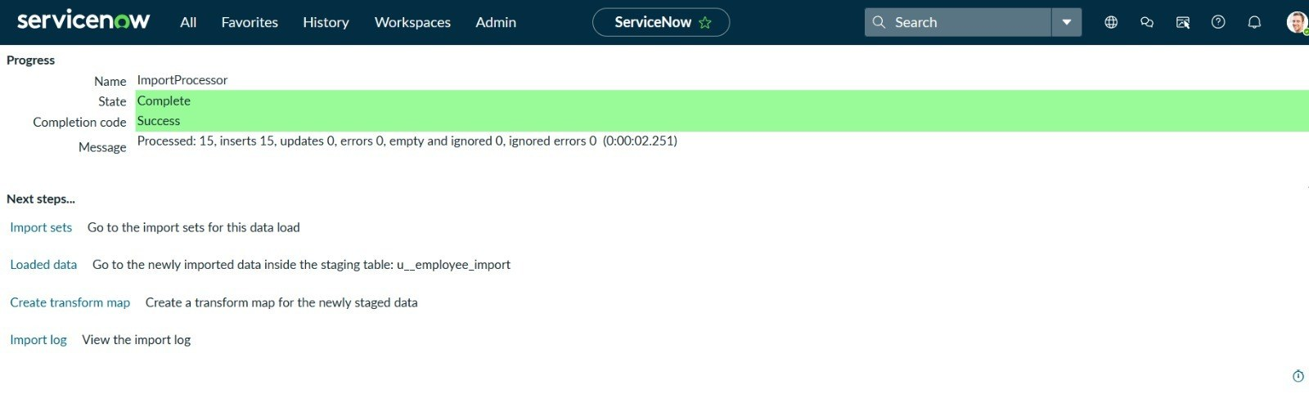  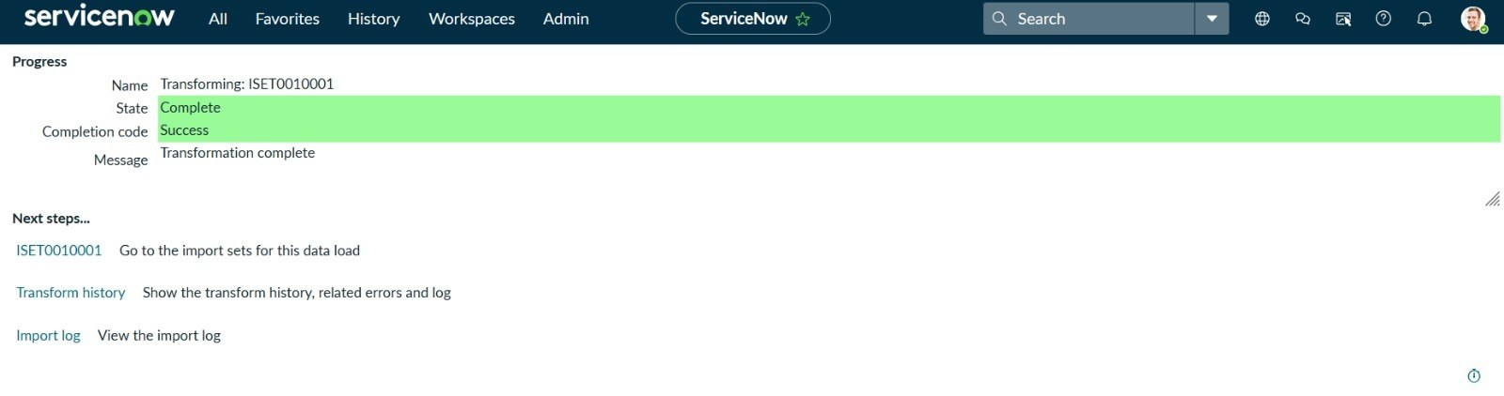
 | Tune the Model | Hyperparameter Tuning - Not applicable (no ML model); Transform Map settings (field mapping, coalesce, transform scripts) are tuned instead  Validation Method - Compare the spreadsheet row count with Import Set Row states and the records in the target table (Transform History) | 