Project Development Phase
Model Performance Test

Date | 03 October 2026
Team ID | Team 5
Project Name | Import Data using Transform Maps (Spreadsheet)
Maximum Marks

Model Performance Testing:
Project team shall fill the following information in model performance testing template.
S.No. | Parameter | Screenshot / Values
 | Data Rendered | Spreadsheet (.xlsx) loaded into an Import Set staging table using System Import Sets > Load Data; all rows and columns display correctly.  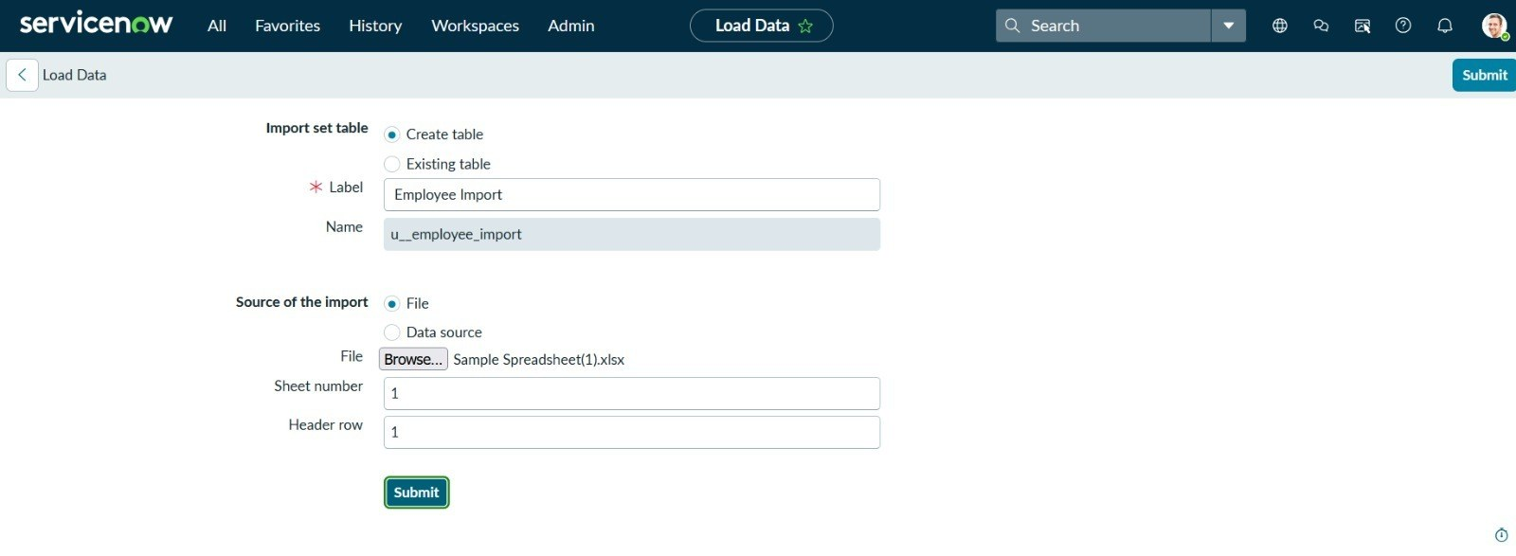  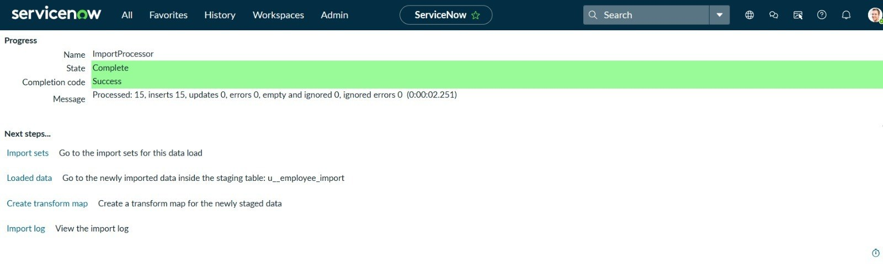
 | Data Preprocessing | Missing values handled, inconsistent formats (dates, choice values) standardised and duplicates removed in the spreadsheet; required fields created in the target table before import.  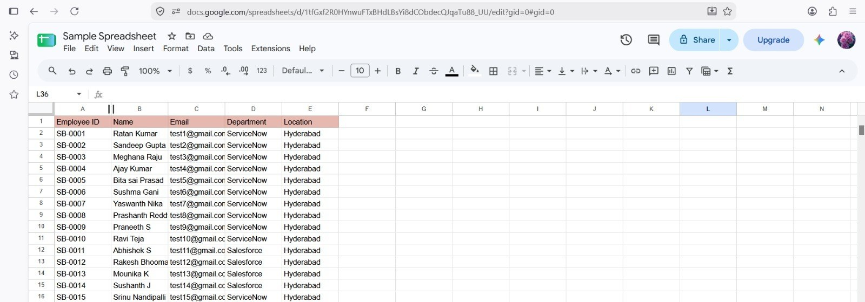  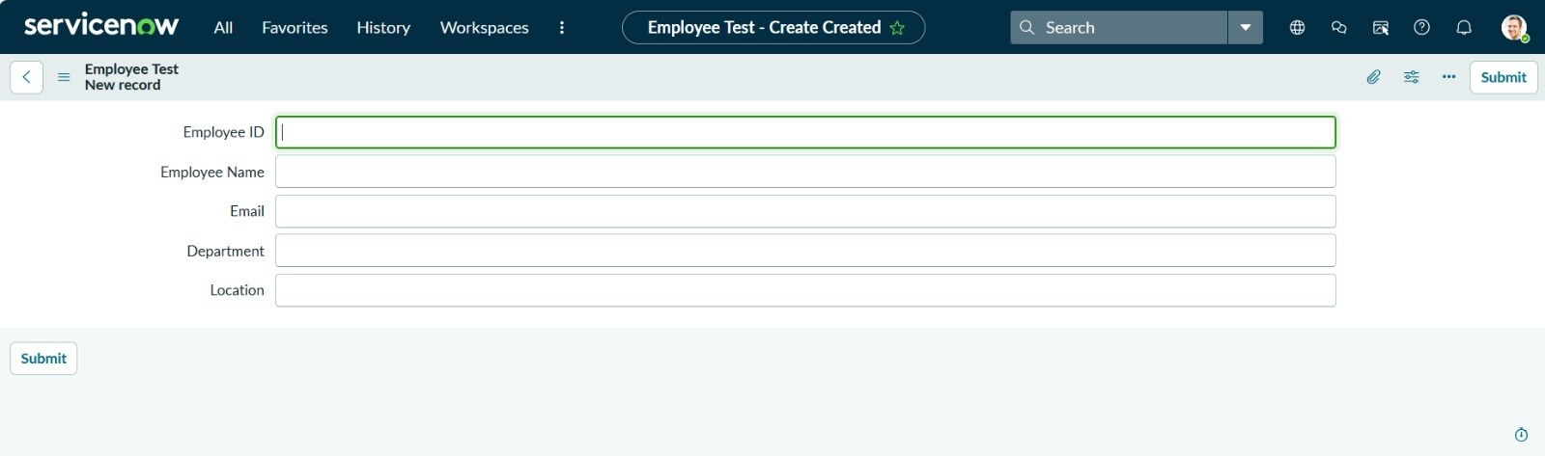
3. | Utilization of Data Filters | List filters on Import Set Rows and Transform History (e.g., State = Inserted / Updated / Ignored / Error) used to verify the results.
4. | DAX Queries Used | Not applicable (no DAX is used); field transform scripts and coalesce on a key field are used instead.  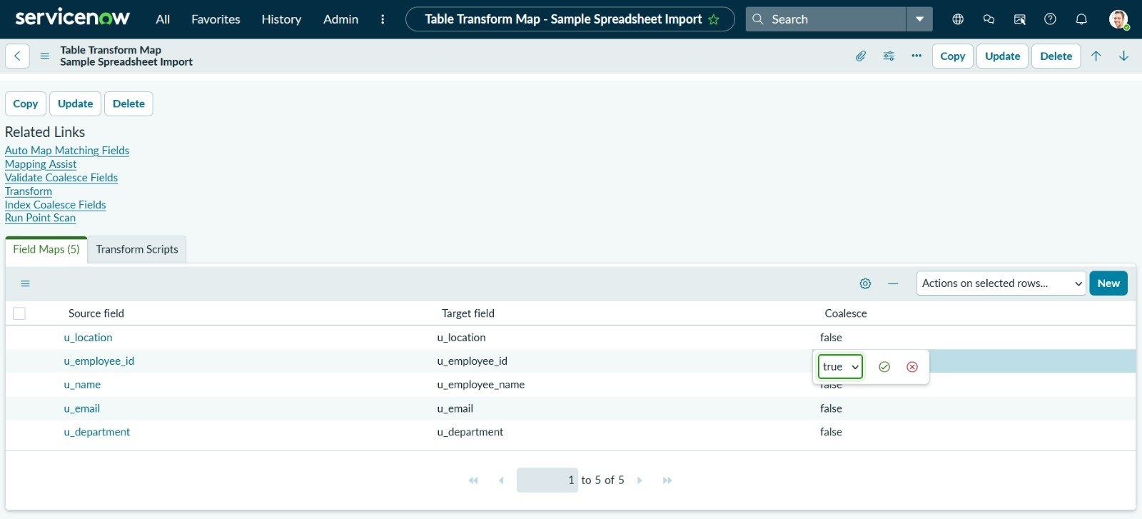
5. | Dashboard design | No of Visualizations / Graphs - 3 (Employee List Report, Employees by Location bar chart and Employees by Department pie chart) on the Employee Analytics Dashboards dashboard in Platform Analytics  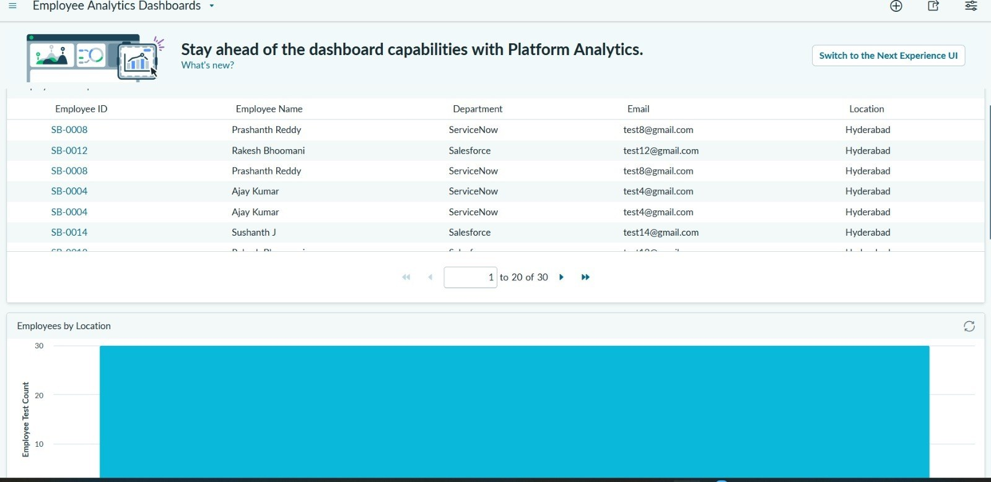  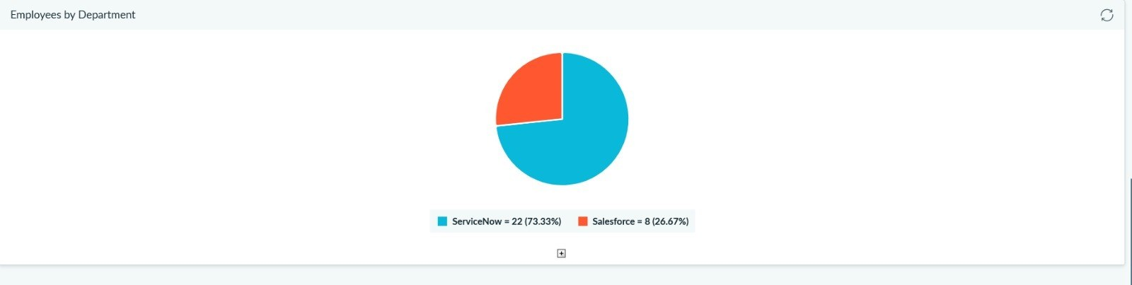
6 | Report Design | No of Visualizations / Graphs - 3 reports on the Employee Test table: Employee List Report (list), Employees by Department (pie chart) and Employees by Location (bar chart)  