Project Development Phase
Model Performance Test

Date | 03 October 2026
Team ID | Team 5
Project Name | Import Data using Transform Maps (Spreadsheet)
Maximum Marks

Model Performance Testing:
Project team shall fill the following information in model performance testing template.
S.No. | Parameter | Values | Screenshot
 | Model Summary | ServiceNow automation setup for data management using Import Sets, Transform Maps and target table fields.  Note: Import records - if the data matches correctly then records will be created or updated, else the row will show an error/ignored state. | 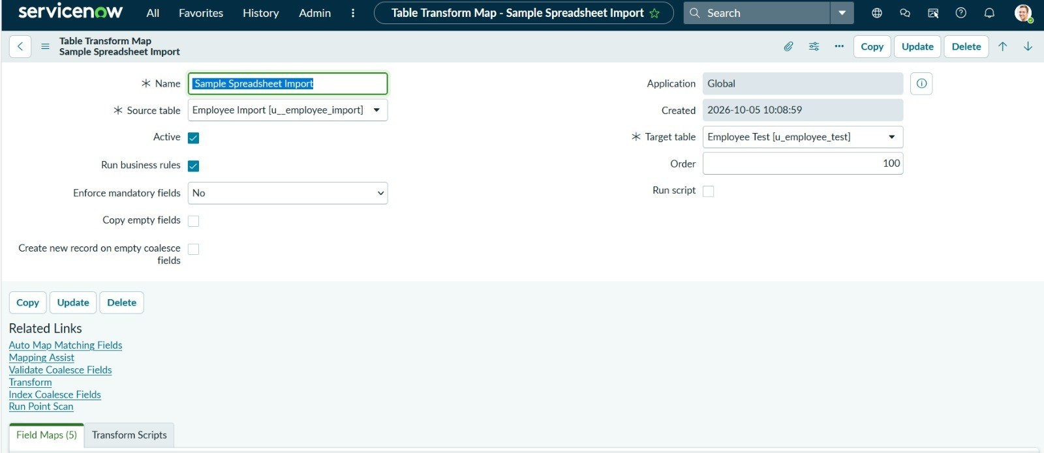
 | Accuracy | Training Accuracy - Not applicable (rule-based Transform Map; no ML model is trained)  Validation Accuracy - Import accuracy: target is 100% of valid rows inserted/updated correctly in the target table (actual: 100% - 15 of 15 rows inserted, 0 errors) | 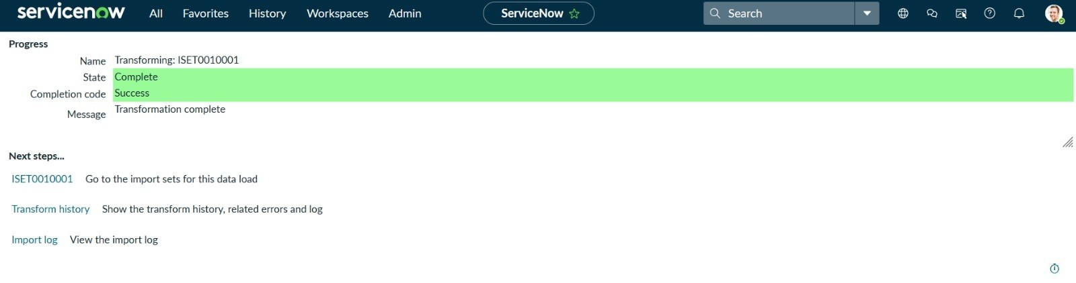  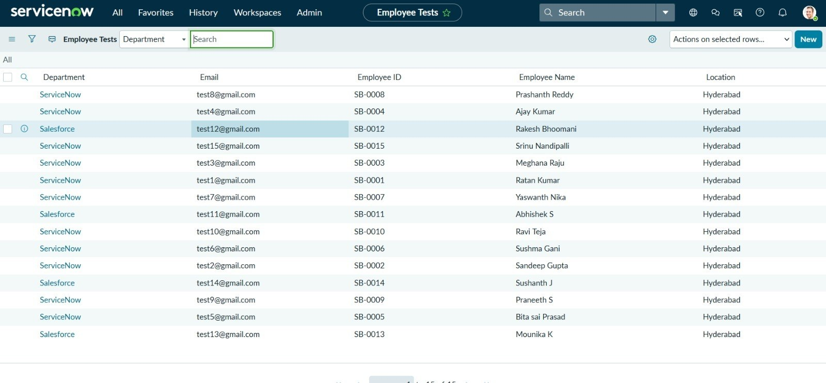
3. | Confidence Score (Only Yolo Projects) | Class Detected - Not applicable (no YOLO / object detection is used in this project)  Confidence Score - Not applicable

