**ExNo:8**

**Date: ALARM APPLICATION**

**Aim:**

To implement an alarm application using android.

**Algorithm:**

**Step 1:**Open eclipse and select new Android project.

**Step 2:**Give project name and click next.

**Step 3:**Choose the Android version and choose lowest android version(Android2.2) and select next.

**Step 4:**Enter package name and click next.

**Step 5:**Go to package explorer in the left hand side select our project.

**Step 6:**Go to res folder and select layout .Double click the main.xml file.Add the code below.

**Step7:**Now go to main.xml and right click select run as android application.

**Step8:**Android output shown in android emulator.

**Step 9:**Stop the program.

**Main_Activity**

package com.example.alarm;

import android.app.Activity;

import android.app.AlarmManager;

import android.app.PendingIntent;

import android.content.BroadcastReceiver;

import android.content.Context;

import android.content.Intent;

import android.content.IntentFilter;

import android.os.Bundle;

import android.util.Log;

import android.view.Menu;

import android.view.View;

import android.widget.Toast;

public class MainActivity extends Activity {

PendingIntent pendingIntent;

AlarmManager alarmManager;

BroadcastReceiver mReceiver;

@Override

protected void onCreate(Bundle savedInstanceState) {

super.onCreate(savedInstanceState);

setContentView(R.layout.*activity_main*);

RegisterAlarmBroadcast();

}

public void onClickSetAlarm(View v){

alarmManager.set(AlarmManager.*RTC_WAKEUP*,System.*currentTimeMillis*()+10000,pendingIntent);

}

private void RegisterAlarmBroadcast()

{

Log.*i*("Alarm Example:RegisterAlarmBroadcast()", "Going to register Intent.RegisterAlramBroadcast");

mReceiver = new BroadcastReceiver()

{

private static final String *TAG* = "Alarm Example Receiver";

@Override

public void onReceive(Context context, Intent intent)

{

Log.*i*(*TAG*,"BroadcastReceiver::OnReceive() >>>>>>>>>>");

Toast.*makeText*(context, "Congrats!. Your Alarm time has been reached", Toast.*LENGTH_LONG*).show();

}

};

registerReceiver(mReceiver, new IntentFilter("com.example.alarm") );

pendingIntent = PendingIntent.*getBroadcast*( this, 0, new Intent("com.example.alarm"),0 );

alarmManager = (AlarmManager)(this.getSystemService( Context.*ALARM_SERVICE* ));

}

private void UnregisterAlarmBroadcast()

{

alarmManager.cancel(pendingIntent);

getBaseContext().unregisterReceiver(mReceiver);

}

@Override

public boolean onCreateOptionsMenu(Menu menu) {

getMenuInflater().inflate(R.menu.*main*, menu);

return true;

}

protected void onDestroy(){

unregisterReceiver(mReceiver);

super.onDestroy();

}

}

**Activity_main.xml**

<RelativeLayout xmlns:android=*"http://schemas.android.com/apk/res/android"*

xmlns:tools=*"http://schemas.android.com/tools"*

android:layout_width=*"match_parent"*

android:layout_height=*"match_parent"*

android:paddingBottom=*"@dimen/activity_vertical_margin"*

android:paddingLeft=*"@dimen/activity_horizontal_margin"*

android:paddingRight=*"@dimen/activity_horizontal_margin"*

android:paddingTop=*"@dimen/activity_vertical_margin"*

tools:context=*".MainActivity"* >

<AnalogClock

android:id=*"@+id/analogClock1"*

android:layout_width=*"wrap_content"*

android:layout_height=*"wrap_content"*

android:layout_alignParentTop=*"true"*

android:layout_centerHorizontal=*"true"*

android:layout_marginTop=*"20dp"* />

<Button

android:id=*"@+id/button1"*

android:layout_width=*"wrap_content"*

android:layout_height=*"wrap_content"*

android:layout_alignParentBottom=*"true"*

android:layout_centerHorizontal=*"true"*

android:layout_marginBottom=*"81dp"*

android:onClick=*"onClickSetAlarm"*

android:text=*"SET TIME"* />

<TextView

android:id=*"@+id/textView1"*

android:layout_width=*"wrap_content"*

android:layout_height=*"wrap_content"*

android:layout_below=*"@+id/analogClock1"*

android:layout_centerHorizontal=*"true"*

android:layout_marginTop=*"44dp"*

android:text=*"WAKE UP!!!"*

android:textAppearance=*"?android:attr/textAppearanceLarge"* />

</RelativeLayout>

**OUTPUT:**

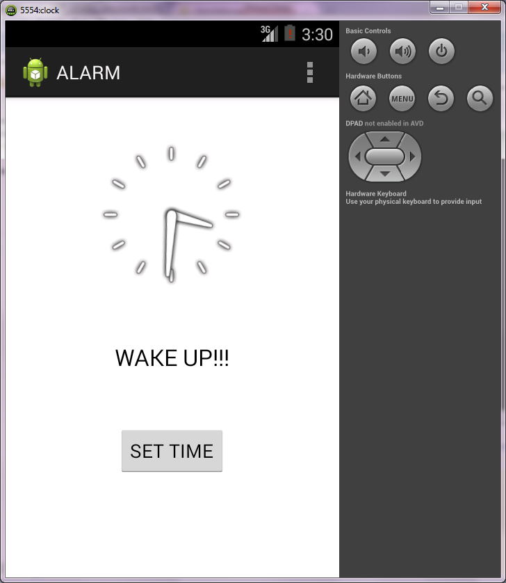

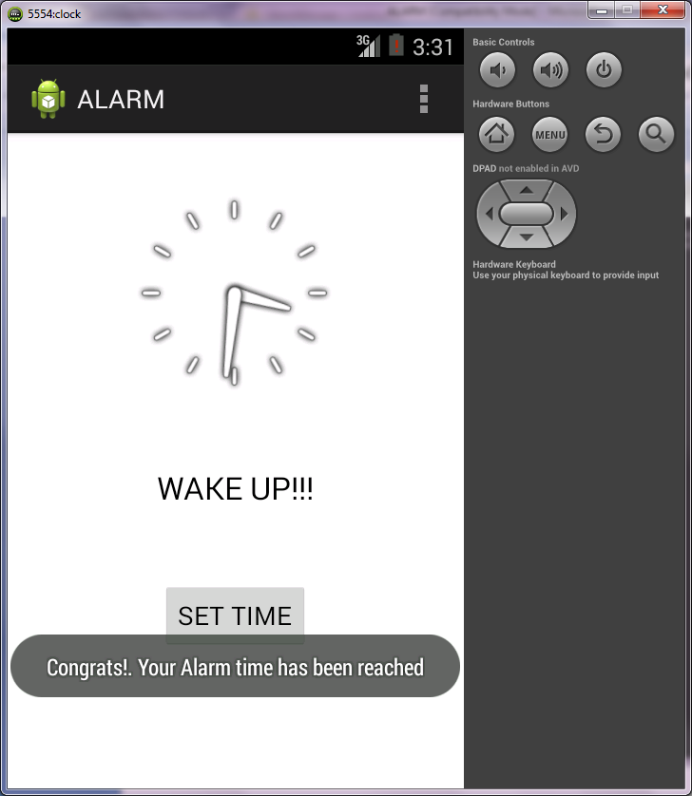

**RESULT:**

Thus the program to implement alarm application using android is executed successfully.