Week 2 — Supervised Learning
Regression and classification with scikit-learn
COMPLETED PROJECT REPORT • Yuva Internship
Project repository: https://github.com/Dhanam33/Yuva_intern/tree/arena/01a1004b-yuva-intern

Executive summary
Four classification algorithms are compared on a stratified held-out test split. Linear Regression is also trained for a continuous target, monthly charges, so both classification and regression workflows and metrics are demonstrated.
Experiment | Configuration
Classification rows | 1,440 train / 360 test
Split | 80/20 stratified test split; random_state=42
Positive class | Yes (1)
Preprocessing | Median/mode imputation, numeric scaling, one-hot categories inside each pipeline
Regression target | monthly_charges; total_charges excluded to avoid target leakage

Classification model comparison
Scores use the same held-out test records. Precision, recall, F1, and ROC-AUC are especially useful alongside accuracy because churn is the minority class in this sample.
Model | Accuracy | Balanced acc. | Precision | Recall | F1 | ROC-AUC
Logistic Regression | 67.8% | 67.4% | 43.2% | 66.7% | 52.5% | 76.7%
Random Forest | 69.7% | 66.8% | 45.0% | 60.4% | 51.6% | 74.6%
Decision Tree | 67.2% | 65.1% | 42.0% | 60.4% | 49.6% | 71.3%
K-Nearest Neighbors | 73.1% | 59.4% | 49.2% | 30.2% | 37.4% | 69.6%

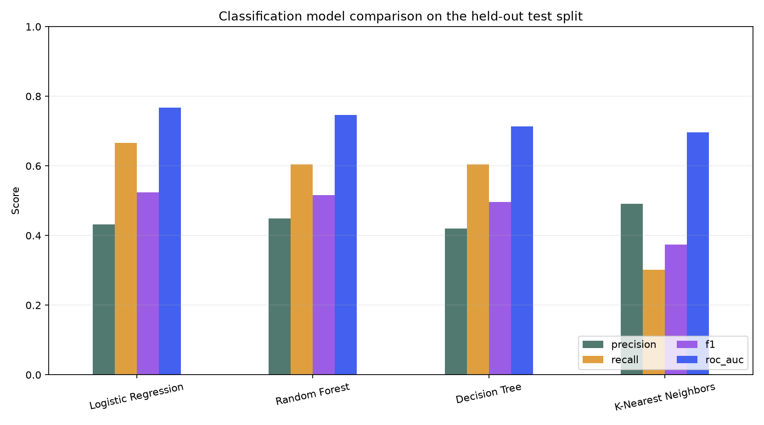
Figure 1. Precision, recall, F1, and ROC-AUC on the held-out classification test split.
In this run, Logistic Regression has the largest ROC-AUC (0.767) and recall (0.667) among the four classifiers. KNN has the largest accuracy (0.731) but lower recall (0.302), illustrating that predicting the majority class more often can improve accuracy while missing churners. Threshold and error costs should guide a business decision; the table alone does not establish a winner.

Regression: predict monthly charges
Model | Training rows | Test rows | MAE | RMSE | R-squared
Linear Regression | 1,377 | 345 | 7.61 | 9.68 | 0.817

The regression target has charge units, so MAE and RMSE are interpreted in those units. The held-out R-squared is 0.817. Total charges are omitted from predictors because this field is calculated from monthly charges and tenure; using it would make the exercise unrealistically easy through target leakage.

Method and interpretation
- The classification test split is stratified and uses a fixed seed (42), preserving approximate class balance.
- All four classifier pipelines independently fit imputers, one-hot encoding, and scaling on the training split only.
- The reported test metrics are for a fixed comparison. Week 3 performs hyperparameter selection with cross-validation on training data and evaluates the test set only after tuning.
- The dataset is synthetic and moderately imbalanced; results are educational and are not expected production performance.

Reproducibility
Run `python -m yuva_ml.week2_supervised`. Results are saved to outputs/supervised_classification_metrics.csv and outputs/supervised_regression_metrics.json, with the plotted comparison in outputs/plots/.

Submission description (207 words)
This Week 2 report presents a reproducible supervised-learning exercise that covers both regression and classification. The raw customer-churn sample is split into stratified training and held-out test portions for the classification task, and every model receives the same raw inputs through a scikit-learn preprocessing pipeline. Logistic Regression, a Decision Tree, a Random Forest, and K-Nearest Neighbors predict whether a customer will churn. Accuracy and balanced accuracy are reported alongside precision, recall, F1, and ROC-AUC so the comparison reflects both thresholded decisions and probability ranking. The report explains the observed trade-off: KNN has the largest accuracy in this run, while Logistic Regression has the strongest ROC-AUC and a higher recall than KNN; no single score alone establishes the best operational model. Linear Regression is used for a separate numeric target, monthly charges, rather than being incorrectly applied to class labels. It is evaluated with MAE, RMSE, and R-squared, and `total_charges` is excluded because it is derived from the regression target and could leak information. Tables, a model-comparison chart, code, and saved metric files make the results auditable. The report also notes the synthetic nature of the data, the fixed random seed, the held-out test protocol, and the need to use training-only cross-validation for selection before any real-world deployment.

