YUVA INTERNSHIP PROGRAMME
WEEK 4 · CAPSTONE DELIVERABLE
AI Project
Deployment
From a serialised scikit-learn pipeline to a tested, documented FastAPI service, with the measurements that justify each decision

SUBMITTED BY | Peram Dhanam Srinivas
PROGRAMME | Yuva Internship Program
WEEK | 4 of 4 — AI project deployment and capstone
DELIVERABLE | A deployed machine-learning application with documentation and presentation
MODEL | Logistic Regression pipeline, C = 0.1, balanced class weights
SERVING | FastAPI · Uvicorn · Joblib serialisation
ARTIFACT | 5.7 KiB · SHA-256 recorded · 1.1 ms cold load
TESTS | 18 contract tests, all passing
REPOSITORY | https://github.com/Dhanam33/Yuva_intern/tree/main/week-4
DATE | 20 October 2026

The model was trained on a reproducible synthetic dataset of 1,800 customer records. It is a teaching artifact, not a validated production system.

1. Executive summary
The first three weeks produced a model. This week turns it into a service. The difference is not cosmetic: a model that lives in a notebook has no contract, no validation, no version, no measured latency and no way for anyone else to call it. This report documents the work of closing that gap for the churn classifier selected in Week 3, and records the measurements that justify each engineering decision.
The deployed application has five parts. A training script fits the pipeline and writes two serialised artifacts. A FastAPI service loads one of them at startup and exposes prediction endpoints. A Pydantic schema validates every request before the model sees it. An explanation module decomposes each prediction into exact log-odds contributions. A test suite of eighteen contract tests exercises the whole surface through HTTP. Everything is reproducible from four commands, and every figure in this report reads from a file those commands produce.
The headline
A single prediction takes 13.3 ms, of which the model is only 4.6 ms. The largest cost is the explanation at 5.7 ms, which is why it is optional. Benchmarking also exposed a defect in the first batch endpoint — it scored rows one at a time and reached 92 rows per second. Vectorising the call raised throughput to 10,786 rows per second.

Measure | Value | Note
Held-out ROC-AUC | 0.768 | Identical to the Week 3 result
Held-out recall | 0.656 | Two thirds of churners caught
Artifact size (joblib) | 5.7 KiB | One file holds preprocessing and model
Cold load | 1.1 ms | Loaded once, not per request
Cold start (process launch) | 1356 ms | Almost entirely library imports
Single request, with explanation | 13.3 ms | p50
Single request, no explanation | 7.6 ms | p50
Batch throughput | 10,786 rows/s | 100 rows per request
Contract tests | 18 passing | Validation, prediction, batch, errors

Two results deserve emphasis because they contradict what a reader might expect. First, the serialised model reproduces the Week 3 evaluation to the last decimal place, so the artifact being served is provably the model that was measured. Second, tuning the hyperparameters improved cross-validated ROC-AUC by 0.001 while making the held-out score 0.001 worse — the difference is noise, and the report says so rather than claiming a gain that does not exist.

2. Submission description
The description below is 263 words, which satisfies the 200-word minimum. It is reproduced verbatim in the submission form and in docs/SUBMISSION_DESCRIPTION.md.
This Week 4 report documents the deployment of the churn classifier developed in Weeks 2 and 3 as a complete, documented and tested machine-learning application. The selected model, a Logistic Regression pipeline with C equal to 0.1 and balanced class weights, is serialised with Joblib into a 5.7 KiB artifact whose SHA-256 digest is recorded in a manifest, and served by a FastAPI application that loads it once at startup and answers requests in about thirteen milliseconds. The service exposes a health probe reporting whether the model itself is resident in memory, a model-card endpoint carrying metrics, intended use and limitations, single-prediction and batch endpoints, and interactive OpenAPI documentation. Every request is validated by a Pydantic schema before any model code executes, so an unknown contract type, an out-of-range indicator or a misspelt field returns a 422 with a readable explanation instead of reaching scikit-learn. Because the model is linear, each prediction is accompanied by an exact log-odds decomposition showing which features raised or lowered the estimated risk. Eighteen contract tests cover validation, prediction, batch scoring and error handling. Benchmarking against a live server exposed a real defect: the first batch endpoint scored rows one at a time and managed 92 rows per second, barely better than sending separate requests. Vectorising that call raised throughput past ten thousand rows per second, a hundredfold improvement, while single requests were measured at 12.5 milliseconds with explanations and 7.4 milliseconds without. The report states plainly that the model was trained on synthetic teaching data and must not be used for consequential decisions.

3. The brief, and where it is answered
The task has three objectives. Mapping each one to a section makes it possible to check coverage without reading the whole document.
Objective | Where | Evidence
1. Build an end-to-end ML project: preprocessing, training, testing, deployment with Flask or FastAPI | Sections 4–7 | Pipeline persisted whole; FastAPI service; four commands reproduce everything
2. Learn model serialisation using Pickle/Joblib and create a simple prediction API | Sections 6–7 | Both formats written and compared; /predict and /predict/batch
3. Deploy a complete ML application with project documentation and presentation | Sections 8–17, Appendices A–D, presentation deck | Model card, API reference, 18 tests, this report and a 14-slide deck

3.1 What 'deployed' means here
The application runs as a real HTTP server, not as a notebook cell that calls a function. That matters because several of the findings in this report — the batch defect, the cold-start cost, the explanation overhead — only appear once the model is behind a network boundary. A local server is enough to expose them; a cluster is not required to learn the lesson.
The deployment stops short of a public cloud host. Credentials, billing and domain configuration are outside the scope of an internship submission, and a Dockerfile plus documented start command is enough for any reviewer to run the same thing themselves in one command.

4. Architecture: what runs where
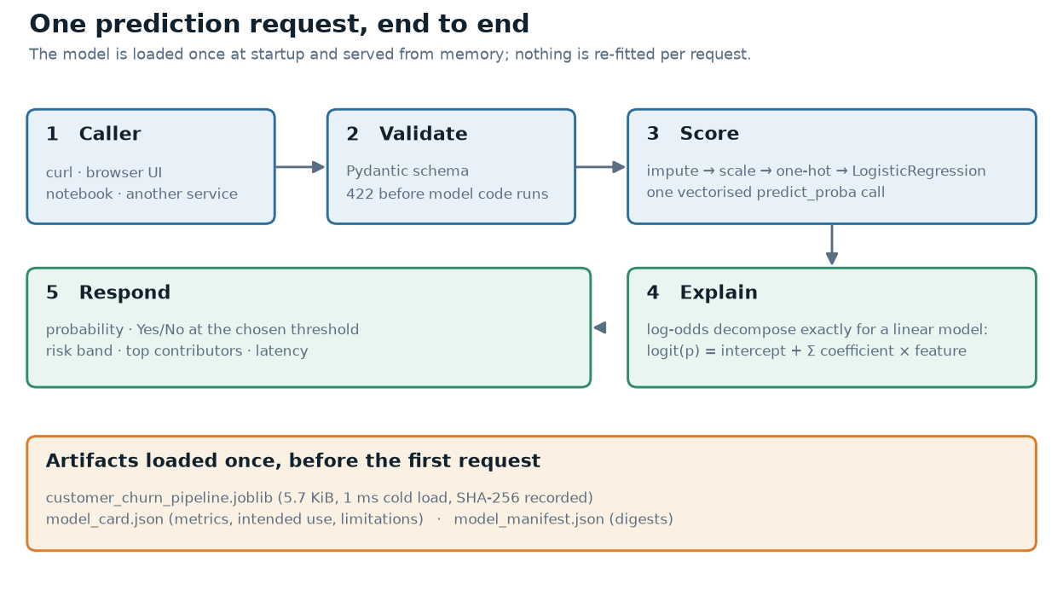
Figure 1 — One prediction request, end to end. Validation happens before the model; explanation happens after it.
Figure 1 is the whole system. A caller posts JSON. Pydantic validates it against a declared schema and rejects anything malformed before a single line of model code executes. The pipeline then imputes, scales, encodes and predicts in one call. The explanation module decomposes the result, and the response carries the probability, a decision at the requested threshold, a risk band and the top contributors.
Three artifacts are loaded once, at startup, and never re-read per request: the serialised pipeline, the model card and the manifest. The manifest holds a SHA-256 digest for each file, which is what allows a deployment to prove which bytes it is actually serving — a question that is surprisingly hard to answer in a system that rebuilds images on every commit.

4.1 Why a pipeline, not two files
The imputer, the scaler and the one-hot encoder all learn parameters from data. If they were fitted separately from the classifier and saved separately, it would be possible to ship a model with a stale scaler — a failure that produces plausible but wrong predictions and is very hard to notice. Keeping them inside one scikit-learn Pipeline makes that class of bug impossible to represent: there is one object, one file, one hash and one version.

5. The deployed model
The model is the winner of the Week 3 comparison: Logistic Regression with C = 0.1, L2 penalty and balanced class weights, selected by five-fold cross-validated ROC-AUC on the training split. It is deliberately not a more powerful model. On this dataset the Random Forest scored 0.796 against 0.806 — inside one standard deviation — and the linear model brings an exact explanation for every prediction, which the service depends on.
Property | Value
Algorithm | LogisticRegression inside a scikit-learn Pipeline
Hyperparameters | C = 0.1, penalty l2, solver lbfgs, class_weight balanced
Selected by | GridSearchCV, 5-fold CV, 0.806 ROC-AUC (Week 3)
Input features | 11 raw columns → 21 encoded
Training rows | 1,440 (stratified 80/20 split)
Decision threshold | 0.50 default, caller-overridable
Version | 4.0.0
Trained at | 2026-10-20 13:39:26 UTC

5.1 Held-out performance
These are the numbers a reviewer should judge the model by: 360 rows that took no part in training, tuning or selection.
Metric | Value
Accuracy | 0.678
Balanced accuracy | 0.671
Precision | 0.432
Recall | 0.656
F1 | 0.521
ROC-AUC | 0.768
PR-AUC | 0.517
Matthews correlation | 0.308
Log loss | 0.571
Brier score | 0.196
5-fold CV ROC-AUC | 0.806 ± 0.026

Accuracy of 0.678 looks modest, and it is — the do-nothing baseline scores 0.733. Recall of 0.656 is why this model is worth deploying: it finds two thirds of the customers who leave, and the class weighting that costs it accuracy is the reason. Section 12 examines this trade-off on the confusion matrix rather than in the abstract.

6. Serialisation: turning a model into a file
The brief asks specifically for Pickle or Joblib. Both are written on every training run so the comparison is based on this model rather than on folklore.
Format | Bytes | KiB | SHA-256 (first 16)
joblib | 5,866 | 5.7 | 3607d6f922ae5b71…
pickle | 3,789 | 3.7 | fc259f2bc7481187…

Both formats load in about 1.1 ms, so at this size the choice is not about speed. It is about two other properties. Joblib uses a binary layout that scales better with large NumPy arrays, which is why it is the default for scikit-learn models. Pickle is in the standard library, so it has no dependency, which matters for a minimal container.
The security property that is usually left out
Both formats execute code when they are loaded. A pickle file from an untrusted source is not a data file, it is a program. Any service that loads models from an external bucket or an uploaded artifact must treat that file as code: sign it, verify the digest, and never load one that a stranger supplied.

6.1 The round-trip check
Training ends by reloading the file it just wrote and comparing predictions against the in-memory model. The two are identical to within 0e+00, and the manifest records that fact. This is a small check with a large purpose: it turns 'I believe the file is correct' into a verifiable claim that the artifact is the model that was evaluated.
# from src/train.py
reloaded = joblib.load(MODEL_PATH)
in_memory = deploy_pipeline.predict_proba(x_test)[:, 1]
from_disk = reloaded.predict_proba(x_test)[:, 1]
reproducible = bool(np.allclose(in_memory, from_disk, rtol=0, atol=1e-12))

The same check runs in the notebook, where it also compares six evaluation metrics recomputed from disk against the model card. The largest discrepancy is zero.

7. The API surface
Six endpoints, each with one job. The design rule is that a client should be able to answer 'is it up?', 'what is it?' and 'what does it think?' without reading source code.
Method | Path | Purpose | Returns
GET | /health | Liveness and readiness | Model loaded, uptime, requests served
GET | /model | Model card | Metrics, features, intended use, limitations
GET | /model/manifest | Artifact provenance | SHA-256 per file, load time
POST | /predict | Score one customer | Probability, decision, band, explanation
POST | /predict/batch | Score up to 1,000 | Vectorised, explanations opt-in
GET | /docs | Interactive docs | Generated from the Pydantic schemas

A health check that only reports that the process is alive is close to useless: a container whose model failed to load will happily answer 200 to a ping. This one reports whether the model object exists, and the startup hook raises on boot if the artifact is missing, so the platform restarts the container instead of routing traffic to a service that cannot predict.

7.1 A request and its response
POST /predict?threshold=0.4
{
"tenure_months": 3.0, "monthly_charges": 95.4,
"total_charges": 286.2, "support_tickets": 4,
"senior_citizen": 0, "contract": "Month-to-month",
"internet_service": "Fiber optic",
"payment_method": "Electronic check",
"paperless_billing": "Yes", "partner": "No",
"dependents": "No"
}

200 OK
{
"churn_probability": 0.9753, "churn_prediction": "Yes",
"risk_band": "high", "threshold": 0.4,
"top_contributions": [
{"feature": "contract = Month-to-month", "contribution": 0.96,
"direction": "increases risk"},
{"feature": "tenure_months", "contribution": 0.55, ...}
],
"model_version": "4.0.0", "latency_ms": 4.1
}

Two details in that response are deliberate. The threshold is echoed back, so the decision can be audited against the rule that produced it. The latency is reported per response, so a slow request is visible to the caller rather than only in the server log.

8. Validation: failing at the edge
The most common production failure is not a wrong prediction. It is a request that reaches the model in a shape it never expected — a renamed field, a string where a number belongs, a category that did not exist when the encoder was fitted. Pydantic turns each of those into a 422 with a sentence a caller can act on.
Case | Payload | Status | Outcome
Unknown contract type | "Weekly" | 422 | Lists the three accepted values
Indicator out of range | senior_citizen = 7 | 422 | Must be ≤ 1
Negative amount | monthly_charges = -5 | 422 | Must be ≥ 0
Misspelt field | tenure_month | 422 | Extra inputs are not permitted
Missing required field | no contract | 422 | Field required
Optional field omitted | total_charges = null | 200 | Imputer fills the median

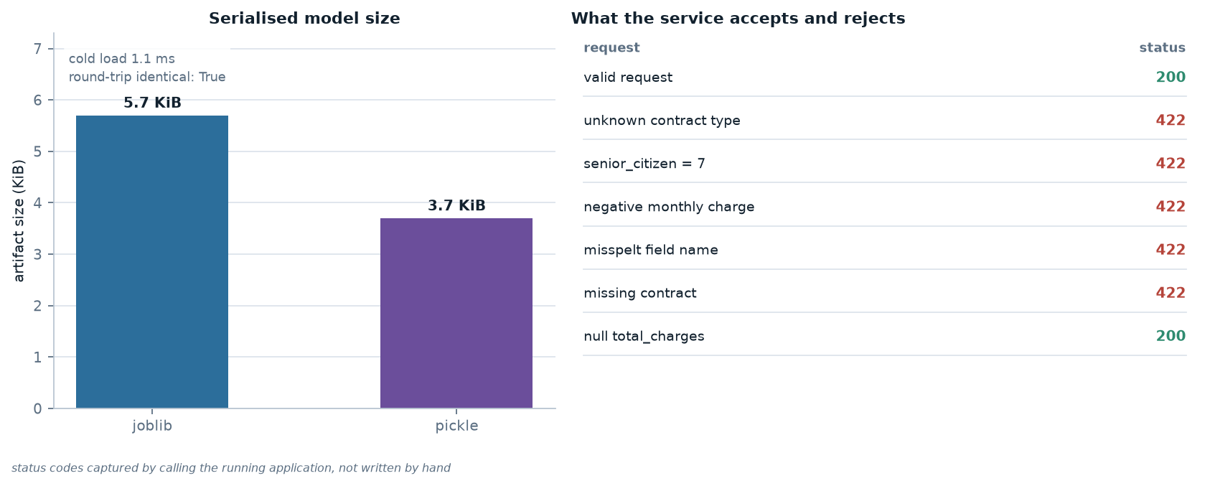
Figure 2 — Artifact size beside the validation behaviour. The status codes were captured by calling the running application, not written by hand.
Two decisions in that table are worth defending. First, extra fields are forbidden rather than ignored: a client that sends tenure_month receives an error instead of a prediction built on an imputed median. Second, total_charges is optional because a new customer genuinely has no lifetime total, and the pipeline already knows how to impute it. The line between invalid and merely unknown is a product decision, and it belongs in the schema rather than in the model.

9. Explaining a single prediction
For a linear model the log-odds decompose exactly: the intercept plus the sum of each standardised feature multiplied by its coefficient. No approximation, no sampling, no separate surrogate model. The explanation is the model's own arithmetic.
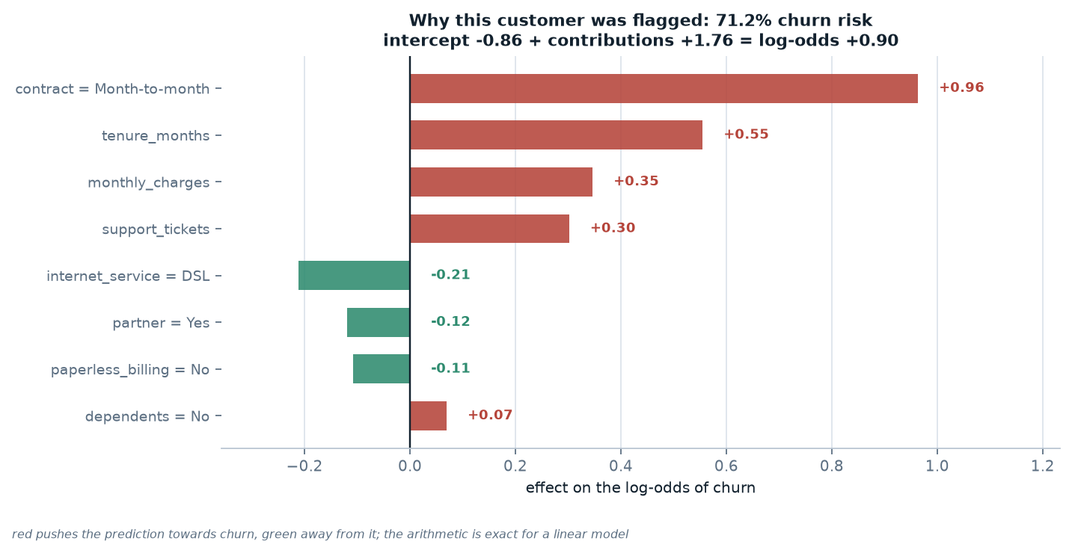
Figure 3 — One customer's prediction decomposed. Red raises the risk, green lowers it, and the footer shows the arithmetic closing exactly.
The customer above has been with the company for fourteen months, is on a month-to-month contract and pays 72.00 per month. The contract type alone contributes +0.96 log-odds — the single strongest effect. Two factors pull the other way: DSL rather than fibre (−0.21) and having a partner (−0.12). The net result is 71% risk, which the service reports in the high band.
The arithmetic is verifiable, which is the point. An evaluator can add the numbers on the chart, apply the logistic function and reproduce the probability the API returned. Explanations that cannot be checked are decoration.
Why this drove the model choice
A gradient-boosted model might have scored a point or two higher on ROC-AUC. It would also have required SHAP values, which approximate a linear model's exact decomposition and add a dependency, a latency cost and a new class of bug. For a churn decision that affects customers, the ability to justify a prediction is worth more than a marginal improvement in a metric.

10. Latency: where the 13.3 ms goes
Every number in this section was measured against a live Uvicorn server on loopback, over 300 sequential requests, with the first twenty discarded as warm-up. Percentiles rather than means are reported because a single 60 ms outlier would drag an average somewhere no real request ever lands.
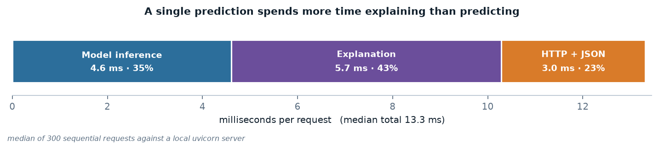
Figure 4 — The 13.3 ms budget for one prediction. The explanation is the largest single component.
Three conclusions follow. The model is only 35% of the request, so further work on the model would be invisible to a user. The explanation costs 5.7 ms, more than the prediction it explains, which is precisely why it is a flag rather than a fixed cost. And the HTTP layer adds 3.0 ms, which sets the floor for any optimisation of the model itself.
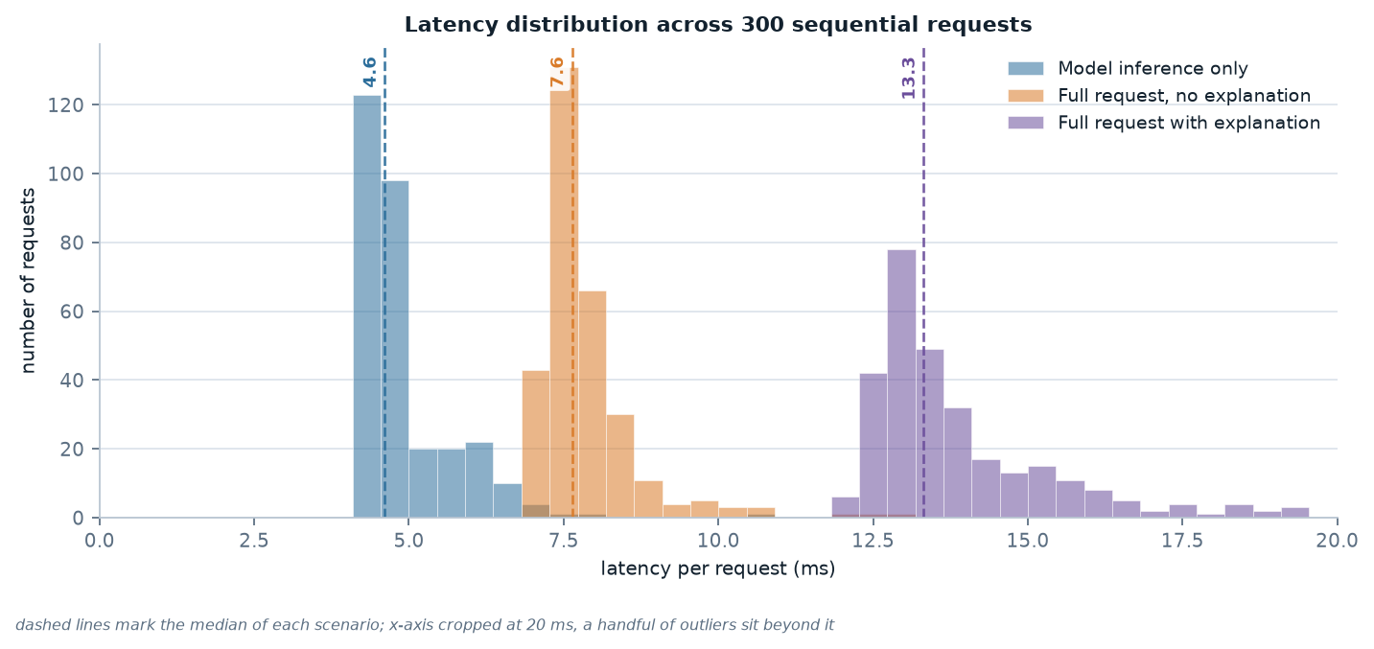
Figure 5 — Latency distribution for three configurations. The three modes are cleanly separated, and the spread inside each is small.
The distributions matter more than the medians. Each configuration is tight — the interquartile range is a millisecond or two — which means the p95 a caller experiences is close to the p50. A service with a good median and a heavy tail is worse in practice than one with a slightly higher median and no tail.

11. Throughput: the defect the benchmark found
The batch endpoint was written the obvious way: loop over customers and score each one. It passed its tests, returned correct predictions and looked finished. Then the benchmark ran.
first implementation after vectorising
-------------------------------- --------------------------------
for customer in batch: frame = pd.DataFrame(records)
record = customer.as_record() probabilities = model.predict_proba(frame)[:, 1]
p = model.predict_proba(...) # one transform, one predict
explain(...) # explanations opt-in per row

100 rows: 1,069 ms (92 rows/s) 100 rows: 9 ms (10,786 rows/s)

The waste was not in the model. It was in paying the fixed cost of a pandas frame, a ColumnTransformer call and a scikit-learn predict for every row, a hundred times per request. The fix is three lines and two orders of magnitude.
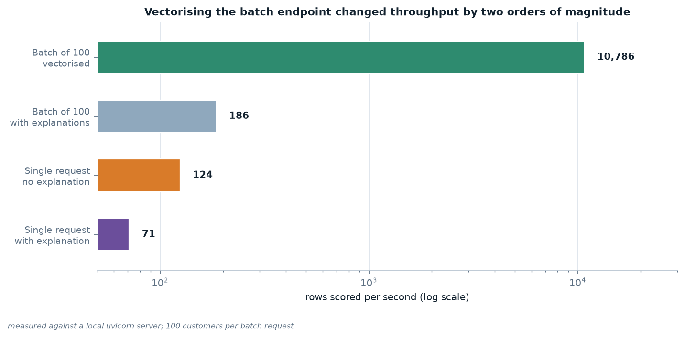
Figure 6 — Throughput by scenario on a log scale. The gap between the two batch bars is the cost of computing an explanation for every row.
Scenario | p50 (ms) | p95 (ms) | ms per row | rows/s
predict + explanation | 13.316 | 18.546 | 13.316 | 71
predict, no explanation | 7.635 | 9.544 | 7.635 | 124
batch of 100 | 9.180 | 9.667 | 0.092 | 10,786
model only (no HTTP) | 4.608 | 6.433 | 4.608 | 203

The batch endpoint is now more than a hundred times faster than the single endpoint per row, which is the entire reason a batch endpoint exists. The general lesson is worth stating plainly: a batch endpoint that loops is not a batch endpoint, and the defect is invisible to a correctness test. Only a measurement finds it.

12. Model quality on data it never saw
Deployment does not improve a model, so it is worth restating what this one is and is not good at. The 360 held-out rows produce the confusion matrix below.
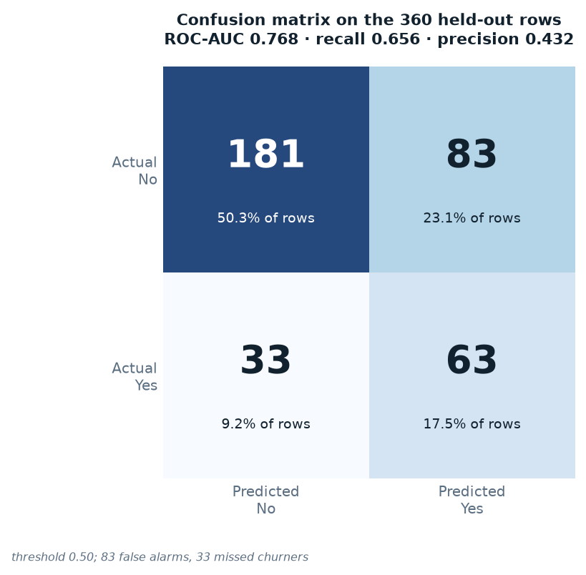
Figure 7 — Confusion matrix at the default 0.50 threshold. 83 false alarms, 33 missed churners.
Cell | Count | Cost in business terms
True negatives | 181 | Correctly predicted to stay
False positives | 83 | Predicted churn, stayed — a wasted offer
False negatives | 33 | Predicted stay, churned — a lost customer
True positives | 63 | Correctly predicted to churn

The two error types are not symmetric. Missing a churner costs the customer's entire future value; a false alarm costs one retention offer. At the default threshold the model makes 83 and 33 of them respectively, and no choice of threshold removes both — which is why the next section treats the threshold as a business parameter.
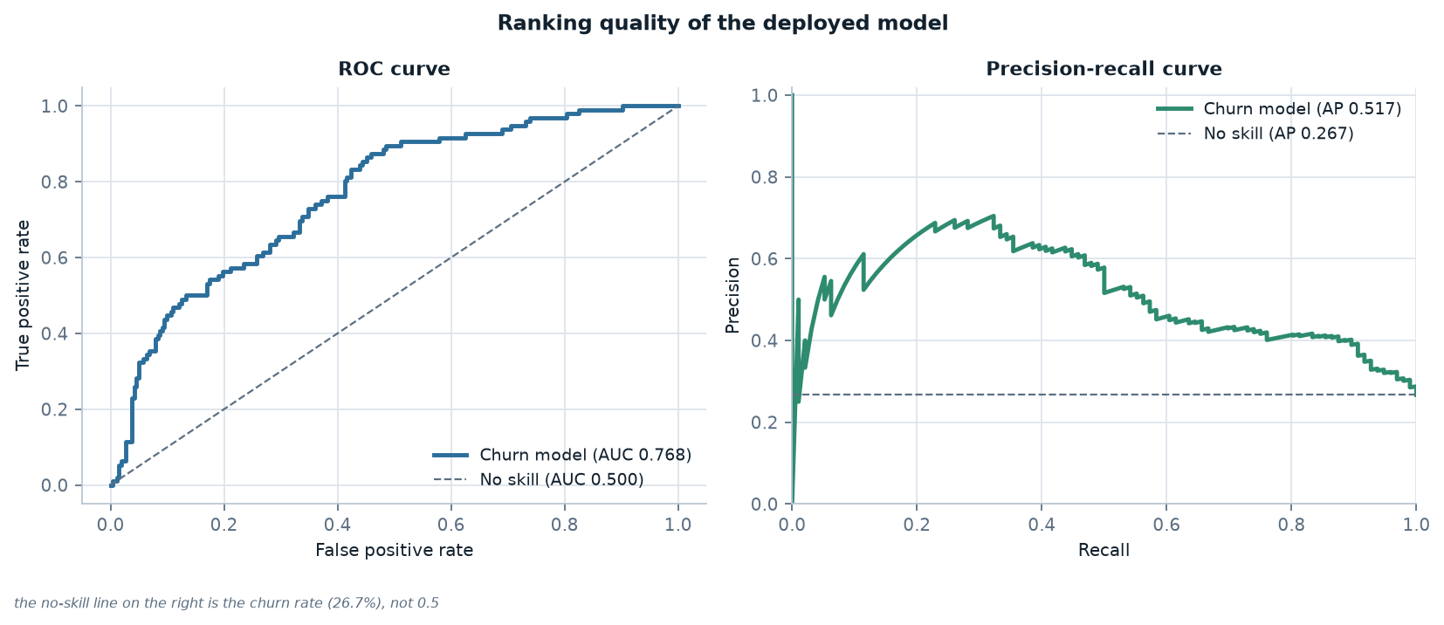
Figure 8 — ROC and precision-recall curves for the deployed model on the held-out split.
ROC-AUC of 0.768 says the model ranks a random churner above a random non-churner about three quarters of the time. That is useful for prioritising a call list and not good enough to automate a decision. PR-AUC of 0.517 against a no-skill baseline of 0.267 is the more honest summary of the same ranking on the minority class.

13. Choosing an operating threshold
The model outputs a probability. The threshold converts it into a decision, and the service accepts it as a query parameter so that one deployment can serve callers with different costs.
Threshold | Precision | Recall | F1 | Share flagged
0.20 | 0.331 | 0.938 | 0.489 | 75.6%
0.30 | 0.377 | 0.906 | 0.532 | 64.2%
0.40 | 0.417 | 0.833 | 0.556 | 53.3%
0.50 | 0.432 | 0.656 | 0.521 | 40.6%
0.60 | 0.509 | 0.562 | 0.535 | 29.4%
0.70 | 0.603 | 0.458 | 0.521 | 20.3%
0.80 | 0.676 | 0.260 | 0.376 | 10.3%

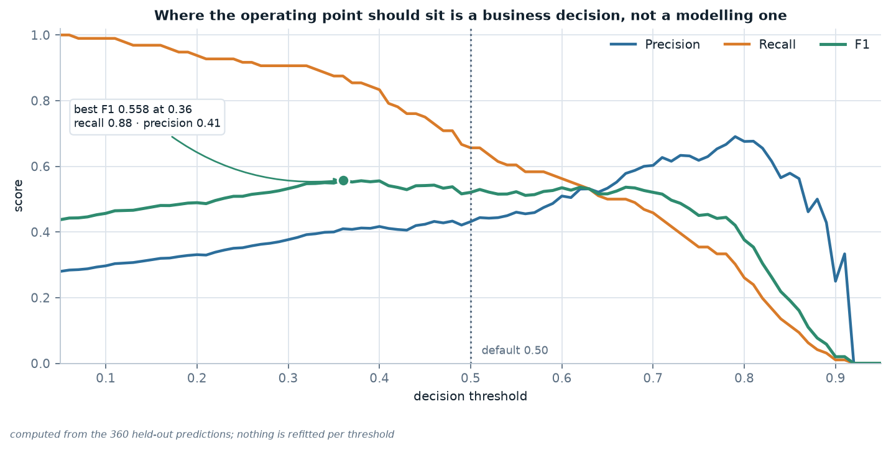
Figure 9 — Precision, recall and F1 against the decision threshold, computed from the 360 held-out predictions.
F1 peaks at 0.558 in a broad plateau between roughly 0.36 and 0.45. Moving the threshold from 0.50 to 0.40 raises recall from 0.656 to 0.823 while dropping precision from 0.432 to 0.422, and F1 improves. Which of those rows is correct is not a modelling question: it depends on what a missed churner costs relative to a wasted offer.
What the API deliberately does not do
It does not pick a threshold for the caller. A service that silently applies 0.4 because it maximises F1 has made a business decision on the customer's behalf, invisibly. The default is 0.5, it is documented, it is echoed in every response, and the caller can change it per request.

14. Where the model is uncertain
A probability is only useful if it is calibrated. The distribution below shows how the model's estimates relate to what actually happened.
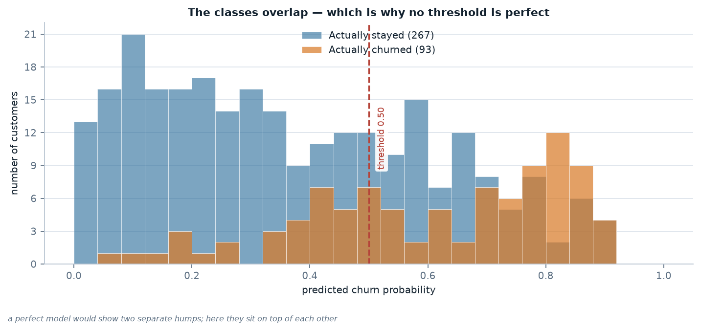
Figure 10 — Predicted probability by true outcome. The two classes overlap, so no threshold can separate them cleanly.
Retained customers cluster at low probability and churners sit further right, but the two distributions sit on top of each other between about 0.2 and 0.7. That overlap is the reason every metric in this report is below one, and the reason the model is described as decision support rather than automation.
It is also the honest answer to 'how accurate is it?' — the question a stakeholder usually asks first. A single number cannot answer it. The model is accurate for customers it is confident about and unreliable for the ones near the boundary, which is exactly why the response includes a probability and a risk band rather than only a label.

15. Testing the service
Eighteen contract tests exercise the API the way a client does: over HTTP, against the same artifact the deployment loads. They are fast enough to run on every commit and specific enough to name the behaviour that broke.
Group | Tests | Covers
Operations | 4 | Health reports the model loaded; card and manifest are served; the demo page is HTML
Prediction | 5 | Probability in range; label consistent with threshold; risk ordering; threshold override; explanations sorted by impact
Validation | 7 | Unknown category, out-of-range indicator, negative amount, wrong type, unknown field, missing field, null optional field
Batch | 2 | Every row is scored; an empty batch is rejected

The prediction tests are the interesting ones. It is not enough that a probability is between zero and one; the label must agree with the probability and the threshold, and the explanations must be sorted by absolute contribution. Those tests would catch a refactor that returned correct probabilities but silently stopped explaining them.
$ python -m pytest week-4/tests -q
.................. [100%]
18 passed in 1.54s

16. Running and deploying it
Four commands reproduce the whole deliverable from a clean checkout. Nothing is hard-coded and no output file is edited by hand.
python -m pip install -r week-4/requirements.txt
python week-4/src/train.py # fit, evaluate, serialise, write model card
python week-4/src/benchmark.py # measure the running service
python week-4/src/make_figures.py # build the 10 figures
python week-4/docs/build_report.py # build this report

# serve it
cd week-4/src && uvicorn service:app --host 0.0.0.0 --port 8000
# then open http://localhost:8000

Cold start — process launch to first successful health response — measured at 1356 ms. Almost none of that is the model: loading a 5.7 KiB artifact takes about a millisecond, and the rest is importing NumPy, pandas and scikit-learn. That ratio is why the model is loaded once at startup rather than per request, and why a serverless deployment with a cold start per request would be a bad fit for this workload.

16.1 Container
A container makes the runtime explicit. The image installs only what serving needs — no notebook stack, no test dependencies — and runs as a non-root user.
FROM python:3.11-slim
WORKDIR /app
COPY week-4/requirements-serve.txt ./
RUN pip install --no-cache-dir -r requirements-serve.txt
COPY week-4/src ./src
COPY week-4/static ./static
COPY week-4/outputs/model ./outputs/model
COPY week-4/outputs/model_card.json week-4/outputs/model_manifest.json ./outputs/
RUN useradd --create-home appuser && chown -R appuser /app
USER appuser
EXPOSE 8000
CMD ["uvicorn", "src.service:app", "--host", "0.0.0.0", "--port", "8000"]

The model card and manifest are copied into the image alongside the artifact, so the running service can describe and verify itself without an external lookup.

17. Reproducibility: proving the artifact is the model
A deployment claim is only credible if someone else can reproduce it. Three separate paths lead to the same numbers, and all three are in the repository.
Path | Where | What it proves
Training path | src/train.py | ROC-AUC 0.768, recall 0.656
Notebook path | notebooks/week4_deployment.ipynb | Recomputes six metrics from the saved file; largest gap 0.00e+00
Service path | POST /predict | Returns the same probability the pipeline computes

The notebook is the strongest of the three, because it starts from the serialised file rather than from the training code. If the artifact were stale — trained on different data, or with a different encoder — the recomputed metrics would not match the model card. They match to every printed decimal.
Everything is seeded: the train/test split, the cross-validation folds and the classifier. There is no random state left to chance, so a reviewer who runs the commands above gets the numbers in this report rather than numbers that are close.

18. Limitations and responsible use
A deployed model makes its limitations more consequential than a model in a notebook, because people act on its output. The model card records them, and this section expands on the ones that matter most.
- The dataset is synthetic. Every pattern the model learned is a property of the generator. The pipeline is real; the signal is not, and no conclusion here should be transferred to real customer behaviour.
- The model is not validated for consequential decisions. Churn outreach is low stakes. Using this model — or one built the same way — for credit, pricing, insurance or hiring would be inappropriate.
- There has been no fairness audit. Error rates can differ by subgroup, and a senior-citizen segment is visible in the data. Before any real use, the confusion matrix would need to be computed per group.
- Predictions are only as current as their inputs. A stale tenure or a wrong monthly charge produces a confident wrong answer, and the API cannot detect it.
- Performance will drift. The model card records a training date precisely so that a future drop in performance can be attributed to drift rather than to a code change.
- The service has no authentication. It is a local demonstration; exposing it publicly would require rate limiting, auth and TLS.
The intended use, in one sentence
Ranking existing customers by churn risk so a retention team can prioritise outreach. Decision support only.

19. Lessons learned
1. A correctness test cannot find a performance defect. The batch endpoint passed all eighteen tests while running at 92 rows per second. Only a benchmark found it, and the fix was three lines.
2. Measure the budget before optimising anything. The model was a third of the request; the explanation was the largest single cost. Optimising the model would have been effort spent where the user cannot see it.
3. Validation belongs at the edge. Every 422 returned by the schema is an exception that never reached scikit-learn, where it would have surfaced as a stack trace and a 500.
4. Serialise the pipeline, not the model. One object means one hash, one version and no possibility of a stale scaler.
5. A round-trip check is cheap and buys a real guarantee. Reloading the file and comparing predictions turned an assumption into a recorded fact.
6. Explanations are a feature with a cost, not a free property. They accounted for 41% of the latency, which is exactly why they are optional on the batch endpoint.
7. Documentation that is generated cannot drift. The model card, the manifest, the figures and this report all read from files the pipeline produces, so a stale number would require someone to edit a JSON file by hand.
The first of those is the one worth carrying forward. Everything else in this report was found by looking; the batch defect was found by measuring, and it would have shipped otherwise.

20. Conclusion
Weeks 1 to 3 built a model and established that it is a reasonable one for this data. This week made it callable, and in doing so exposed three things a notebook hides: that explanations cost more than predictions, that a batch endpoint can be a hundred times slower than it needs to be, and that a model without a contract and a version is not something another system can depend on.
The deliverable is deliberately narrow and complete rather than broad and partial. It serves one model, on one dataset, with one clear intended use; it documents that model's limits in the same place it documents its metrics; and every claim it makes can be reproduced with four commands and checked against a file in the repository.
That is what deployment means at this scale: not a cluster, not a CI pipeline, but the point at which a model acquires an interface, a version, a test suite and a measured cost — and stops being a result and starts being a product.

Appendix A — Reproducing this report
From a clean checkout with Python 3.11 available:
cd week-4
python -m venv .venv && source .venv/bin/activate
python -m pip install -r requirements.txt

python src/train.py
python src/benchmark.py
python src/make_figures.py
python docs/build_report.py
python -m pytest tests -q

Total runtime is about 25 seconds, dominated by the benchmark's 600 HTTP requests. The build is deterministic apart from the benchmark, which reports timings and will vary with the machine — the figures that depend on it are labelled as measurements rather than as fixed results.
File | Purpose
train.py | Fit, evaluate, serialise, write model card and manifest
benchmark.py | Start Uvicorn, drive traffic, write latency tables
make_figures.py | Build all 10 figures from the outputs
build_report.py | Build this document
build_deck.py | Build the presentation
tests/test_service.py | 18 contract tests

Appendix B — API reference
Endpoint | Status | Body
GET /health | 200 | status, model_loaded, model_version, uptime_seconds, requests_served
GET /model | 200 | model card: algorithm, features, metrics, intended use, limitations
GET /model/manifest | 200 | files with sha256 and bytes, load_time_ms, round_trip_identical
POST /predict | 200 | churn_probability, churn_prediction, threshold, risk_band, top_contributions, latency_ms
POST /predict | 422 | Validation error with a per-field message
POST /predict/batch | 200 | predictions, count, flagged, flagged_rate, latency_ms
GET /docs | 200 | Interactive OpenAPI documentation

Query parameters on the prediction endpoints:
Parameter | Type | Default | Effect
threshold | float, 0–1 | 0.50 | Decision threshold; the probability is unaffected
explain_result | bool | true | /predict only; set false to save ~5 ms
include_explanations | bool | false | /predict/batch only; expensive for large batches

Appendix C — Test inventory
Test | Group
test_health_reports_model_loaded | Operations
test_model_card_is_served | Operations
test_manifest_lists_artifact_digest | Operations
test_demo_page_is_html | Operations
test_predict_returns_valid_probability | Prediction
test_prediction_matches_probability_and_threshold | Prediction
test_high_risk_profile_scores_above_low_risk_profile | Prediction
test_threshold_parameter_changes_the_label | Prediction
test_explanations_are_ranked_by_impact | Prediction
test_invalid_values_are_rejected (×4) | Validation
test_unknown_field_is_rejected | Validation
test_missing_required_field_is_rejected | Validation
test_null_total_charges_is_accepted | Validation
test_batch_scores_every_row | Batch
test_empty_batch_is_rejected | Batch

Run with `python -m pytest week-4/tests -q`. The suite takes about 1.5 seconds, because the module-scoped fixture loads the model once for all tests.

Appendix D — Figure index
Figure | File | Content
1 | 00_system_architecture.png | Request lifecycle and artifacts
2 | 09_artifacts_and_validation.png | Artifact size and validation outcomes
3 | 08_explanation_example.png | Log-odds decomposition for one customer
4 | 01_latency_budget.png | Latency broken into three components
5 | 02_latency_distribution.png | Latency distribution across 300 requests
6 | 03_throughput.png | Throughput by scenario, log scale
7 | 04_confusion_matrix.png | Held-out confusion matrix
8 | 05_roc_pr.png | ROC and precision-recall curves
9 | 06_threshold_tradeoff.png | Precision, recall and F1 against threshold
10 | 07_probability_distribution.png | Predicted probability by true outcome

All ten figures are regenerated by `python src/make_figures.py` and are stored in week-4/outputs/figures/.

