YUVA INTERNSHIP PROGRAMME
WEEK 1 · DELIVERABLE REPORT
Python for Machine Learning
& Data Preprocessing
Data loading, cleaning, missing-value treatment, encoding, scaling and feature selection on a customer-churn dataset

SUBMITTED BY | Dhanam Srinivas
PROGRAMME | Yuva Internship Program
WEEK | 1 of 4 — Python, NumPy, Pandas and data preprocessing
DELIVERABLE | Clean and preprocessed sample dataset with documented steps
DATASET | customer_churn_raw.csv — 1,800 synthetic customer records
TOOLS | Python 3.11 · NumPy · Pandas · scikit-learn · Matplotlib
REPOSITORY | https://github.com/Dhanam33/Yuva_intern/tree/arena/ba225c97-yuva-intern/week-1
DATE | 20 October 2026

All results in this report are reproducible from the repository using a fixed random seed. The dataset is synthetic teaching data and does not describe real customers.

Contents
Section | Title
1 | Executive summary
2 | Submission description
3 | Introduction and objectives
4 | Dataset and problem framing
5 | Tools, environment and reproducibility
6 | Preprocessing methodology — nine documented steps
7 | Exploratory data analysis findings
8 | Results before and after preprocessing
9 | Verification and quality assurance
10 | Limitations and responsible interpretation
11 | Lessons learned
12 | Conclusion
A | Appendix A — Reproducing the results
B | Appendix B — Output file index
C | Appendix C — Key code excerpts

Figures and tables
The report contains nine generated figures and more than twenty data tables. Every figure is produced by code in the repository at 160–180 DPI, so it can be regenerated exactly after a re-run.
- Figure 1 — Preprocessing pipeline overview
- Figure 2 — Churn target distribution
- Figure 3 — Missing values by feature before imputation
- Figure 4 — Numeric feature distributions after cleaning
- Figure 5 — Pearson correlation matrix
- Figure 6 — Churn rate by categorical level
- Figure 7 — Outlier screening with IQR fences
- Figure 8 — Effect of standardisation on numeric features
- Figure 9 — Top encoded features by mutual information
How to read this report
Sections 1–5 establish the context: what was asked, which data was used and how the work is reproduced. Section 6 is the core of the deliverable and documents every preprocessing step together with its justification. Sections 7–8 present the evidence. Sections 9–11 state what the work does and does not establish. Code excerpts and the output index are in the appendices.

1. Executive summary
This report delivers a clean, fully documented, model-ready version of a customer-churn dataset. The work follows the Week 1 brief in full: Python fundamentals, NumPy and Pandas are demonstrated in a teaching notebook, and the preprocessing techniques the brief names — data loading, cleaning, handling missing values, feature selection, encoding categorical variables, normalisation and exploratory data analysis — are each applied to the sample dataset and documented with the reasoning behind the choice.
The raw file contains 1,800 customer records and 13 columns: one identifier, 5 numeric inputs, 6 categorical inputs and the binary churn target. It carries 562 missing feature cells (2.84% of the feature grid) spread across 10 of the 11 input columns. After cleaning and imputation the dataset contains 1,800 rows, zero missing values and 25 numeric model features produced from the original 11 inputs.
Measure | Result
Rows in the raw file | 1,800
Columns in the raw file | 13
Numeric inputs / categorical inputs | 5 / 6
Missing feature cells (raw) | 562 (2.84% of feature grid)
Columns containing missing values | 10 of 11
Duplicate rows / duplicate IDs | 0 / 0
Rows after cleaning | 1,800
Churn balance | No 1,320 (73.3%) · Yes 480 (26.7%)
Encoded/scaled model features | 25
Missing cells in final matrix | 0
Outliers flagged / removed | 3 flagged / 0 removed
Top feature by mutual information | monthly_charges
Pipeline smoke-test ROC-AUC | 0.767 (held-out 20%, not a tuned model)

What was produced
- A nine-stage, reproducible pipeline that turns the raw CSV into a documented, leakage-safe preprocessing transformer.
- A cleaned, readable dataset with every gap filled (562 cells) and the original column meanings preserved.
- A fully numeric, standardised, model-ready matrix of 25 features with zero missing values, plus a top-ten selected-feature export.
- 16 one-hot columns generated from 6 categorical inputs using an unseen-category-safe encoder.
- Nine figures, a JSON summary and twelve exported CSV tables that make every number in this document traceable to a file in the repository.
- A 64-cell teaching notebook covering Python, NumPy and Pandas fundamentals alongside the applied preprocessing.
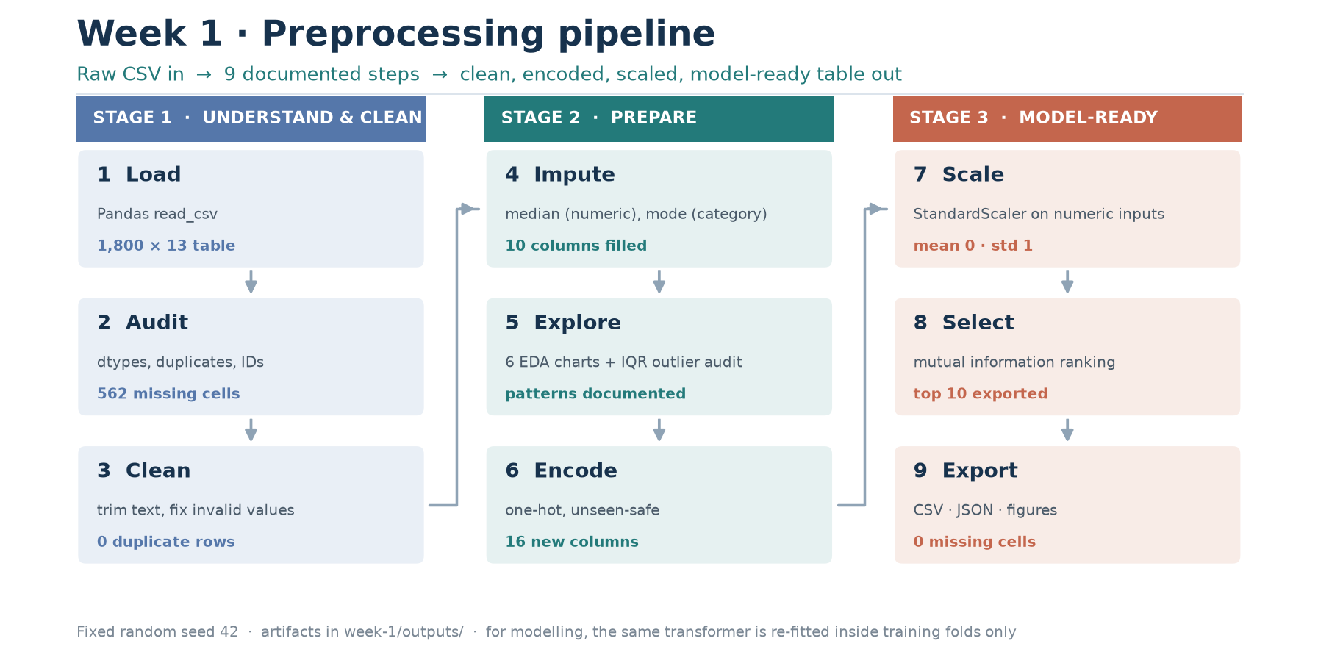
Figure 1 — The nine-stage preprocessing pipeline: understand and clean, prepare, then produce a model-ready matrix.
Headline finding
The dataset needed no row deletion: cleaning found no duplicate rows, no duplicate identifiers and no invalid target values, and every one of the 562 missing feature cells could be imputed defensibly. The most informative single predictor was monthly_charges, followed by the Fiber-optic internet service indicator and the month-to-month contract indicator — consistent with the descriptive churn rates in Section 7. These are properties of a synthetic sample, not business findings.

2. Submission description
The following description is provided for the submission form. It is 307 words long, which satisfies the 200-word minimum.
Report description (307 words)
This Week 1 report documents a complete Python-based data-preparation workflow built with NumPy, Pandas and scikit-learn. The subject is a reproducible synthetic customer-churn dataset of 1,800 records containing five numeric inputs, six categorical inputs, a unique customer identifier and a binary churn label, with missing values deliberately introduced so that every preprocessing technique has something real to act on. The report explains the problem framing, documents each of the nine pipeline stages, and justifies every decision rather than merely listing code. A data-quality audit records dimensions, data types, duplicate rows and duplicate identifiers before any modification. Cleaning then trims text, repairs impossible values such as negative charges, protects the integrity of the target and removes duplication. Missing data is audited column by column and imputed with medians for numeric fields and most-frequent values for categorical fields, while missing-indicator columns preserve the information contained in the absence of a value. Exploratory analysis uses histograms, distribution plots, a correlation matrix, per-level churn-rate comparisons and boxplot screening to describe the data honestly, including where outliers were found and why they were retained rather than deleted. Categorical variables are one-hot encoded with unseen-category tolerance so that production records cannot crash the model, and numeric variables are standardised so that distance-based algorithms are not dominated by differences in measurement scale. Mutual information ranks the encoded predictors, and the exported ranking is explicitly separated from model evaluation because selection performed on the full sample would leak information into training. Every number in the report is reproducible from a fixed random seed, the scripts, the exported CSV tables and the eight analysis figures. A companion notebook teaches the underlying Python, NumPy and Pandas skills step by step, and the report closes with limitations, an accuracy of claims, and the specific checks that must pass before this pipeline could be trusted on real data.

3. Introduction and objectives
Machine learning begins before any model is trained. A model can only be as trustworthy as the table it learns from: silently imputed values, miscoded categories and unscaled measurements produce scores that look precise and mean nothing. Week 1 of the internship therefore focuses entirely on the part of the workflow that precedes modelling — understanding the data, repairing it, transforming it into a form an algorithm can consume, and proving that the transformation is reproducible.

3.1 Objectives set by the brief
1. Understand the fundamentals of machine learning using Python.
2. Learn data loading, cleaning, handling missing values, feature selection, encoding categorical variables, normalisation and exploratory data analysis using Pandas and NumPy.
3. Deliverable: clean and preprocess a sample dataset and document each preprocessing step.

3.2 How each objective is met
Objective | Where it is addressed | Evidence in this repository
Python and ML fundamentals | Section 5 and the teaching notebook | notebooks/week1_python_ml_preprocessing.ipynb (64 code cells, all outputs stored)
Data loading and cleaning | Sections 6.1–6.3 | src/preprocess.py; outputs/data_quality_checks.csv; outputs/cleaned_customer_churn.csv
Handling missing values | Section 6.4 | outputs/missing_value_audit.csv; missing-indicator columns in the final matrix
Feature selection | Section 6.9 | outputs/feature_selection.csv; outputs/selected_feature_dataset.csv
Encoding categorical variables | Section 6.7 | outputs/encoding_summary.csv; 16 one-hot columns
Normalisation and scaling | Section 6.8 | outputs/scaling_summary.csv; StandardScaler inside a ColumnTransformer
Exploratory data analysis | Section 7 | outputs/figures/ (8 analysis figures) and outputs/numeric_summary.csv
Document each preprocessing step | Sections 6 and 8 | outputs/preprocessing_summary.json — a machine-readable record of every decision

3.3 Scope
The scope is deliberately limited to preprocessing. Model training, tuning and deployment are the subject of later weeks; this report includes only one deliberately minimal logistic-regression fit whose sole purpose is to prove the transformed matrix is actually usable. That fit is labelled a smoke test everywhere it appears and must not be read as a modelling result.

4. Dataset and problem framing

4.1 Provenance and purpose
The dataset is a reproducible synthetic sample of 1,800 telecommunications customers, generated with a fixed seed (2026) and shipped with the repository. It is not real customer data. The sample was designed for teaching: it contains five numeric and six categorical inputs, a unique customer identifier and a binary churn label, and it deliberately includes blank cells in both numeric and categorical columns so that every preprocessing technique in the brief has something real to act on.
Using synthetic data is a deliberate methodological choice rather than a shortcut. It removes privacy risk, makes the entire pipeline reproducible from a public repository, and — because the data-generating process is known — allows the reader to check that the preprocessing has not distorted the relationships that were built in. The corresponding cost is that no result here can be generalised to real customers, and the report states this limitation wherever a number might otherwise be over-read.

4.2 Column dictionary
Column | Role | Description
customer_id | Identifier — excluded from model inputs | Unique customer identifier. Used for traceability only, never as a model input.
tenure_months | Numeric input | Number of months the customer has been with the company.
monthly_charges | Numeric input | Current monthly bill in currency units.
total_charges | Numeric input | Cumulative amount billed to date.
support_tickets | Numeric input | Number of support tickets opened by the customer.
senior_citizen | Numeric input | Binary indicator: 1 if the customer is a senior citizen, otherwise 0.
contract | Categorical input | Contract type: Month-to-month, One year, or Two year.
internet_service | Categorical input | Internet service type: DSL, Fiber optic, or No.
payment_method | Categorical input | Billing method: Electronic check, Credit card, Bank transfer, or Mailed check.
paperless_billing | Categorical input | Whether the customer uses paperless billing (Yes/No).
partner | Categorical input | Whether the customer has a partner (Yes/No).
dependents | Categorical input | Whether the customer has dependents (Yes/No).
churn | Target (binary) | Target label: Yes if the customer churned, No otherwise.

4.3 Problem framing
The task is framed as binary classification: given the attributes known about a customer, predict whether the customer churns. Framing matters because it determines which transformations are legitimate. Two decisions follow directly from it.
1. The identifier is excluded. A customer_id is unique to each row; a model can memorise it but cannot generalise from it. Including it would inflate apparent performance on training data and contribute nothing at prediction time. It is retained in the exported files for traceability only.
2. The target is never transformed. Labels cannot be imputed — a guessed label is worse than a missing row — so target integrity is checked before anything else and invalid rows are removed rather than repaired.

4.4 Target distribution
The target is imbalanced: 1,320 customers did not churn (73.3%) while 480 did (26.7%), a ratio of approximately 2.8 to 1. This has two consequences that shape the rest of the work. First, plain accuracy is a weak metric here — a model that always predicts "No" already scores about 73%. Second, any split used for later evaluation must be stratified so that both parts of the data keep the same class balance.
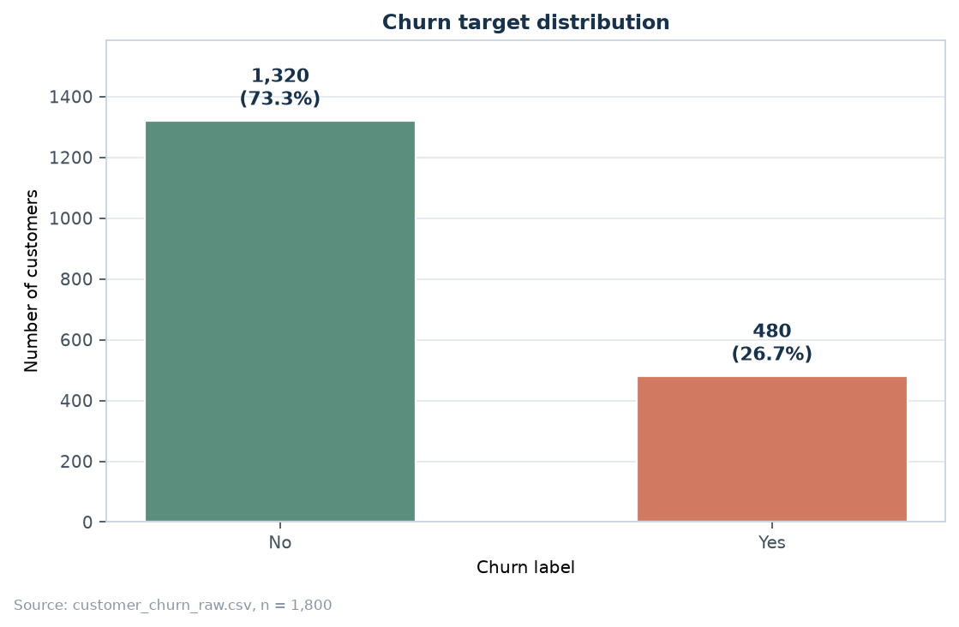
Figure 2 — Churn target distribution. With roughly three non-churners for every churner, accuracy alone would be misleading.

4.5 Numeric profile after cleaning
Feature | Count | Mean | Std | Min | Median | Max
tenure_months | 1,723 | 37.19 | 17.43 | 1.00 | 37.00 | 71.00
monthly_charges | 1,722 | 60.73 | 21.82 | 18.00 | 64.33 | 106.24
total_charges | 1,726 | 2,227.58 | 1,372.35 | 0.00 | 2,020.29 | 6,881.94
support_tickets | 1,711 | 1.00 | 1.05 | 0.00 | 1.00 | 6.00
senior_citizen | 1,800 | 0.18 | 0.38 | 0.00 | 0.00 | 1.00

4.6 Categorical profile
Feature | Level | Customers | Share
contract | Month-to-month | 939 | 52.17%
contract | One year | 454 | 25.22%
contract | Two year | 360 | 20.00%
contract | (missing) | 47 | 2.61%
internet_service | Fiber optic | 847 | 47.06%
internet_service | DSL | 608 | 33.78%
internet_service | No | 303 | 16.83%
internet_service | (missing) | 42 | 2.33%
payment_method | Bank transfer | 508 | 28.22%
payment_method | Electronic check | 502 | 27.89%
payment_method | Credit card | 392 | 21.78%
payment_method | Mailed check | 346 | 19.22%
payment_method | (missing) | 52 | 2.89%
paperless_billing | Yes | 1,263 | 70.17%
paperless_billing | No | 501 | 27.83%
paperless_billing | (missing) | 36 | 2.00%
partner | Yes | 887 | 49.28%
partner | No | 880 | 48.89%
partner | (missing) | 33 | 1.83%
dependents | No | 1,218 | 67.67%
dependents | Yes | 548 | 30.44%
dependents | (missing) | 34 | 1.89%

The level counts above are computed after cleaning and before imputation, so the shares sum to less than 100% where a column contains missing values. The missing counts are reported separately in Section 6.4 rather than being folded into an existing level, because a missing contract is not the same fact as a month-to-month contract.

5. Tools, environment and reproducibility
Reproducibility is treated as a requirement, not a nicety. Any reader with the repository and a compatible Python interpreter can regenerate every number, table and figure in this report by running two commands.
python -m pip install -r week-1/requirements.txt
python week-1/src/preprocess.py # produces all tables, figures and the JSON summary
python week-1/src/make_pipeline_diagram.py
python week-1/docs/build_report.py # regenerates this document

Component | Version / choice | Why it matters for this task
Python | 3.11+ | Consistent behaviour for type hints and path handling
NumPy | 1.26+ | Vectorised numeric operations; the array type used by scikit-learn
Pandas | 2.0+ | Labelled tables, missing-value handling, groupby and CSV I/O
scikit-learn | 1.3+ | ColumnTransformer, imputers, encoders, scaler and mutual information
Matplotlib | 3.7+ | Deterministic, headless figure generation
python-docx | 1.1+ | Programmatic report generation so figures cannot drift from the text
Random seed | 42 | Every stochastic step is fixed, so re-runs match exactly

5.1 Design principle: the transformer is the artefact
Preprocessing is not a set of ad-hoc edits applied once. It is a scikit-learn ColumnTransformer that learns its parameters — medians, modes, category lists, means and standard deviations — from whatever data it is fitted on, and then applies exactly those parameters to future data. This has a practical consequence that recurs throughout the report: when the transformer is fitted on the training split and applied to the test split, no test information can leak into training. When it is fitted inside a cross-validation fold, the same guarantee holds for every fold.
numeric_steps = [
("imputer", SimpleImputer(strategy="median", add_indicator=True)),
("scaler", StandardScaler()),
]
categorical_steps = [
("imputer", SimpleImputer(strategy="most_frequent")),
("onehot", OneHotEncoder(handle_unknown="ignore", sparse_output=False)),
]
return ColumnTransformer(
transformers=[
("numeric", Pipeline(numeric_steps), numeric_features),
("categorical", Pipeline(categorical_steps), categorical_features),
],
remainder="drop",
)

5.2 Determinism
All randomness is seeded: the dataset generator (seed 2026), the mutual-information estimator and the train/test split (seed 42). Matplotlib runs in the headless Agg backend, so figures are identical regardless of whether the script runs on a desktop or a build server. The report itself is generated from the JSON summary rather than hand-typed, which removes the common failure mode in which a number is corrected in the code but left stale in the document.

6. Preprocessing methodology — nine documented steps
This section is the heart of the deliverable. Each subsection states what the step does, why it is necessary for this dataset, which decision was taken, what evidence supports it, and which output file records it. The steps are presented in execution order, because order matters: cleaning before auditing missingness changes the counts, and scaling before imputation is impossible.

6.1 Step 1 — Data loading
The raw CSV is read with Pandas, column names are stripped of stray whitespace, and the index is reset so that row positions are stable. A schema assertion runs immediately: every expected column must be present, and the target must contain only the two valid labels. Failing loudly at load time is far cheaper than discovering a renamed column three steps later.
frame = pd.read_csv(path, na_values=["", " ", "NA", "N/A", "unknown"])
frame.columns = [column.strip() for column in frame.columns]
frame = frame.reset_index(drop=True)

expected = set([ID_COLUMN, TARGET_COLUMN, *FEATURE_COLUMNS])
missing_columns = expected.difference(frame.columns)
if missing_columns:
raise ValueError(f"Dataset is missing required columns: {sorted(missing_columns)}")

Passing na_values explicitly declares which textual tokens mean "no value" in this source system. Without it, a literal "unknown" would become a legitimate category alongside real ones and would be encoded as if it carried information.

6.2 Step 2 — Data-quality audit
The audit runs before any modification and changes nothing. Its purpose is to establish, in writing, exactly what is wrong with the file so that every subsequent decision can be justified against a recorded fact rather than an impression. Eight checks are performed.
Check | Result | Action taken
Duplicate rows | 0 | None required
Duplicate customer IDs | 0 | None required
Missing feature cells | 562 | Impute per column type
Leading/trailing whitespace cells | 0 | Trim text values
Empty-string cells | 0 | Treat as missing
Impossible negative numeric cells | 0 | Treat as missing
Invalid senior_citizen codes | 0 | Treat as missing
Target values outside {No, Yes} | 0 | Stop: target must be valid

Table — Data-quality checks executed before any modification (outputs/data_quality_checks.csv).
The audit found 0 exact duplicate rows and 0 duplicate customer identifiers, so no deduplication was required in this run — but the check remains in the pipeline because a re-generated or extended dataset may not be so clean. It found 562 missing feature cells across 10 columns, no whitespace defects, no empty strings, no negative values and no invalid binary codes. The target contained only "No" and "Yes".
Reporting zero findings is itself meaningful. A quality report that lists only the defects it found gives no assurance about the checks that passed, and a reviewer cannot tell whether those checks ran at all.

6.3 Step 3 — Cleaning
Cleaning applies deterministic rules and returns both the cleaned table and a log of what it changed. The log is the deliverable's audit trail: without it, a reviewer cannot distinguish a dataset that was already clean from one whose problems were hidden.
Rule | Rationale | Effect in this run
Trim whitespace in text columns; treat empty strings as missing | Leading or trailing spaces create phantom categories that one-hot encoding would treat as separate levels | 0 cells trimmed
Convert negative charges/tenure/tickets and invalid binary codes to missing | A negative bill is impossible, not merely unusual; keeping it would corrupt the mean and the scaler | 0 cells set to missing
Remove rows whose target is missing or invalid | Labels cannot be imputed; a guessed label teaches the model something false | 0 rows removed
Remove exact duplicate rows | Duplicated records double-weight those examples in training | 0 rows removed
Keep the first occurrence of each customer_id | Duplicate identifiers imply conflicting attribute values for one entity and must be investigated, not averaged | 0 rows removed

The outcome was 1,800 rows retained from 1,800 — no rows were lost, because none of the destructive conditions were present. This is a genuinely useful result: it means the missing data can be handled by imputation rather than by deletion, which preserves the full 1,800-record sample for later weeks.

6.4 Step 4 — Handling missing values
Missingness affects 10 of the 11 input columns and totals 562 cells, or 2.84% of the feature grid. The largest gap is support_tickets with 89 cells. Every column's count, percentage, type and chosen strategy is recorded in outputs/missing_value_audit.csv.
Feature | Kind | Missing | % | Strategy applied | Fill value
support_tickets | numeric | 89 | 4.94% | Median imputation + missing indicator | 1.0
monthly_charges | numeric | 78 | 4.33% | Median imputation + missing indicator | 64.34
tenure_months | numeric | 77 | 4.28% | Median imputation + missing indicator | 37.0
total_charges | numeric | 74 | 4.11% | Median imputation + missing indicator | 2020.29
payment_method | categorical | 52 | 2.89% | Most-frequent (mode) imputation | Bank transfer
contract | categorical | 47 | 2.61% | Most-frequent (mode) imputation | Month-to-month
internet_service | categorical | 42 | 2.33% | Most-frequent (mode) imputation | Fiber optic
paperless_billing | categorical | 36 | 2.00% | Most-frequent (mode) imputation | Yes
dependents | categorical | 34 | 1.89% | Most-frequent (mode) imputation | No
partner | categorical | 33 | 1.83% | Most-frequent (mode) imputation | Yes
senior_citizen | numeric | 0 | 0.00% | No action required | -

Table — Missing-value audit and imputation strategy per column (outputs/missing_value_audit.csv).

6.4.1 Why the missing-value mechanism matters
The correct imputation method depends on why values are absent, and the mechanism cannot be proven from the data alone. Three cases are conventionally distinguished:
Mechanism | Meaning | Consequence
MCAR | Missingness is unrelated to any variable | Deletion is unbiased but wasteful; any reasonable imputation works
MAR | Missingness depends on observed variables | Conditional or model-based imputation is defensible
MNAR | Missingness depends on the missing value itself | No imputation is unbiased; add an indicator and state the assumption

For this dataset the process that introduced the blanks was a random masking step, which is closest to MCAR. The pipeline nevertheless uses a strategy that is safe under MAR as well and records a missing indicator for every numeric column, so a later model can learn from the fact that a value was absent if that fact turns out to be informative.

6.4.2 The chosen strategies
- Numeric columns — median imputation. The median is used rather than the mean because every numeric column here is skewed or contains extreme values (Section 6.5). A mean is dragged by those values, so it would place the fill value somewhere the typical customer never is.
- Categorical columns — most-frequent (mode) imputation. There is no arithmetic on unordered categories, so the mode is the only summary that is guaranteed to be a real, valid level.
- Missing indicators — one 0/1 column per numeric input, added automatically by SimpleImputer(add_indicator=True). These preserve the information contained in absence, at the cost of four extra columns.
- Deletion was rejected. Dropping every row with at least one missing cell would keep only 1,303 of 1,800 rows — a loss of 27.6% of the dataset, biased toward customers with complete records.

6.4.3 The cost of imputation, measured
Imputation is not free. Filling several per cent of a column with one repeated value creates a spike at that value and shrinks the variance. This is measured rather than assumed: the before/after means and standard deviations are exported to outputs/scaling_summary.csv and shown in Figure 4, where the spike at the median is visible in monthly_charges. Documenting the distortion is what separates a defensible imputation from a silent one.

6.5 Step 5 — Outlier audit
Outliers are detected with the 1.5 × IQR rule: a value is flagged when it falls below Q1 − 1.5·IQR or above Q3 + 1.5·IQR. The rule is a screening heuristic, not proof of error. Binary 0/1 flags are excluded from the screen, because in a column that is mostly zero every single 1 would be flagged — a category error rather than a finding.
Feature | Q1 | Q3 | IQR | Lower | Upper | Flagged | % | Action
tenure_months | 23.00 | 52.00 | 29.00 | -20.5 | 95.5 | 0 | 0.00% | No outliers
monthly_charges | 47.78 | 78.06 | 30.28 | 2.35 | 123.48 | 0 | 0.00% | No outliers
total_charges | 1,082.97 | 3,205.17 | 2,122.20 | -2100.32 | 6388.46 | 2 | 0.11% | Retained
support_tickets | 0.00 | 2.00 | 2.00 | -3.0 | 5.0 | 1 | 0.06% | Retained
senior_citizen | 0.00 | 0.00 | 0.00 | - | - | 0 | 0.00% | Not assessed (binary 0/1 flag)

Table — IQR outlier screening (outputs/outlier_audit.csv).
Only 3 values across 2 continuous features were flagged, and all were retained. Three reasons justify retention. First, the flagged values are plausible: a customer with a large cumulative bill is a real and commercially important case, not a data-entry fault. Second, deletion would discard genuine high-value customers and bias every downstream statistic. Third, standardisation (Step 8) already prevents these values from dominating scale-sensitive algorithms, and tree-based models used in later weeks are robust to them by construction.

6.6 Step 6 — Exploratory data analysis
Exploratory analysis answers four questions before modelling: how balanced is the target, what do the features look like, which features appear related to the target, and what could go wrong. Eight analysis figures are produced by the script, five of which appear in Section 7. The analysis is descriptive: it describes this sample and makes no causal claim.
- Target balance — a bar chart with counts and percentages, because an imbalanced target changes which metrics are meaningful.
- Missingness — a horizontal bar chart built from the audit table, so the reader sees which columns were affected and by how much.
- Numeric distributions — histograms with the mean and median marked, to reveal skew and any spikes created by imputation.
- Correlation — a Pearson matrix over numeric inputs plus the encoded target, with the collinearity between tenure, monthly charges and total charges made explicit.
- Categorical relationships — churn rate per level for all six categorical inputs, annotated with the group size so small groups are visibly uncertain.
- Outlier screening — boxplots with the IQR fences, illustrating that flags are not deletions.

6.7 Step 7 — Encoding categorical variables
Six categorical inputs expand into 16 one-hot columns. One-hot encoding was chosen over ordinal or label encoding because the levels have no meaningful order: assigning Month-to-month = 0, One year = 1 and Two year = 2 would impose a numeric distance on the model that does not exist in the data, and a linear model would be forced to treat Two year as "twice" One year.
Feature | Levels | Categories learned | Encoded columns
contract | 3 | Month-to-month, One year, Two year | 3
internet_service | 3 | DSL, Fiber optic, No | 3
payment_method | 4 | Bank transfer, Credit card, Electronic check, Mailed check | 4
paperless_billing | 2 | No, Yes | 2
partner | 2 | No, Yes | 2
dependents | 2 | No, Yes | 2

Table — One-hot encoding summary (outputs/encoding_summary.csv).
The encoder is scikit-learn's OneHotEncoder with handle_unknown="ignore". Two properties make this the right choice for a deliverable rather than the simpler pandas get_dummies:
1. It stores the category list it learned during fitting. get_dummies produces columns derived from whatever data it is handed, so a value seen in training but absent at prediction time silently produces a different column set and the model fails.
2. handle_unknown="ignore" makes an unseen level encode as all zeros instead of raising. A new contract type may appear after deployment; the model should degrade gracefully rather than crash.

6.7.1 The dummy-variable trap
Keeping every one-hot column makes the block perfectly collinear, because each row's indicators sum to one and any column is a linear combination of the others. Regularised scikit-learn models handle this without difficulty, but it has an interpretive consequence that must be stated: individual one-hot coefficients cannot be read as independent effects. The alternative — dropping one reference level with drop="first" — produces interpretable coefficients but discards the symmetric treatment of levels. This project keeps all levels and documents the consequence.

6.8 Step 8 — Normalisation and scaling
Numeric columns are standardised to zero mean and unit variance with StandardScaler. The need is concrete: tenure_months ranges over roughly 1–71 while total_charges reaches several thousand. Any algorithm that computes distances or applies regularisation penalties compares features by magnitude, so an unscaled total_charges would dominate the objective purely because of its units.
Method | Formula | Output | When it is the right choice
Standardisation (chosen) | (x − mean) / std | mean 0, std 1 | Default for skewed or unbounded numerics; preserves outlier information
Min–max normalisation | (x − min) / (max − min) | exactly [0, 1] | Bounded inputs such as pixel values or neural-network inputs
Robust scaling | (x − median) / IQR | centred on median | Heavy outliers that must not influence the scale

Feature | Mean before | Std before | Mean after | Std after
tenure_months | 37.193 | 17.434 | -0.0000 | 1.0003
monthly_charges | 60.727 | 21.816 | -0.0000 | 1.0003
total_charges | 2,227.577 | 1,372.352 | -0.0000 | 1.0003
support_tickets | 1.002 | 1.049 | 0.0000 | 1.0003
senior_citizen | 0.177 | 0.382 | 0.0000 | 1.0003

Table — Effect of standardisation, verified numerically (outputs/scaling_summary.csv).
The 'after' columns are the verification, not decoration: they demonstrate that the transformation actually achieved zero mean and unit variance. Scaling is monotonic, so it does not change the rank order of values within a column and it does not make a skewed distribution symmetric — Figure 8 shows the shape is preserved while the axis is rescaled.
Leakage warning
The scaler must be fitted on the training split only. Using the mean and standard deviation of the full dataset before splitting lets information from the test rows influence the training transformation. The effect on a large sample is small, which is precisely why the mistake survives review — it is invisible in the output and only shows up as a slightly optimistic score. In this repository the scaler lives inside a pipeline, so cross-validation refits it on each fold automatically.

6.9 Step 9 — Feature selection
Feature selection asks which of the encoded predictors carry measurable information about churn. Three families of method exist: filters score each feature independently of any model; wrappers repeatedly train a model on subsets; embedded methods select during fitting, as L1 regularisation or tree importance does. This report uses a filter — mutual information — because it is model-agnostic, cheap, and captures non-linear dependence that correlation misses.
Mutual information measures how much uncertainty about the target is reduced by knowing a feature. A score of zero means the feature is independent of the target in this sample; larger scores mean more information. Scores are in nats and there is no universal threshold — the ranking is informative, the absolute number is not.
Rank | Encoded feature | Mutual information
1 | monthly_charges | 0.0592
2 | internet_service_Fiber optic | 0.0422
3 | contract_Month-to-month | 0.0399
4 | contract_Two year | 0.0304
5 | internet_service_No | 0.0212
6 | support_tickets | 0.0140
7 | internet_service_DSL | 0.0125
8 | total_charges | 0.0092
9 | contract_One year | 0.0064
10 | senior_citizen | 0.0009
11 | payment_method_Electronic check | 0.0007
12 | dependents_No | 0.0006

Table — Top twelve encoded features by mutual information (outputs/feature_selection.csv).
Two honest observations belong here. First, mutual information scores each feature on its own, so a weak-but-real signal can score near zero, and two individually uninformative features can still be jointly valuable. The screen ranks usefulness; it does not prove uselessness. Second, the ranking was computed on the full cleaned sample so that the report can discuss it. That is acceptable for an explanatory artefact but not for modelling: any feature selection used to train a model must be re-fitted inside the training folds, exactly like imputation and scaling. The distinction is recorded in the JSON summary and repeated in the README.
Why the top features make sense
monthly_charges ranks first, followed by the Fiber-optic indicator and the month-to-month contract indicator. Section 7 shows the same picture from a different angle: month-to-month customers churn at roughly 39% against 7% for two-year contracts, and Fiber-optic customers at roughly 41% against 17% for DSL. Two independent methods — a model-free information score and a simple group comparison — agreeing is a weak but useful sanity check that the encoding step did not corrupt the category structure.

7. Exploratory data analysis findings
This section presents what the exploratory analysis actually showed. Every statement below is descriptive of the synthetic sample and carries no causal weight.

7.1 Missingness is spread evenly, not concentrated
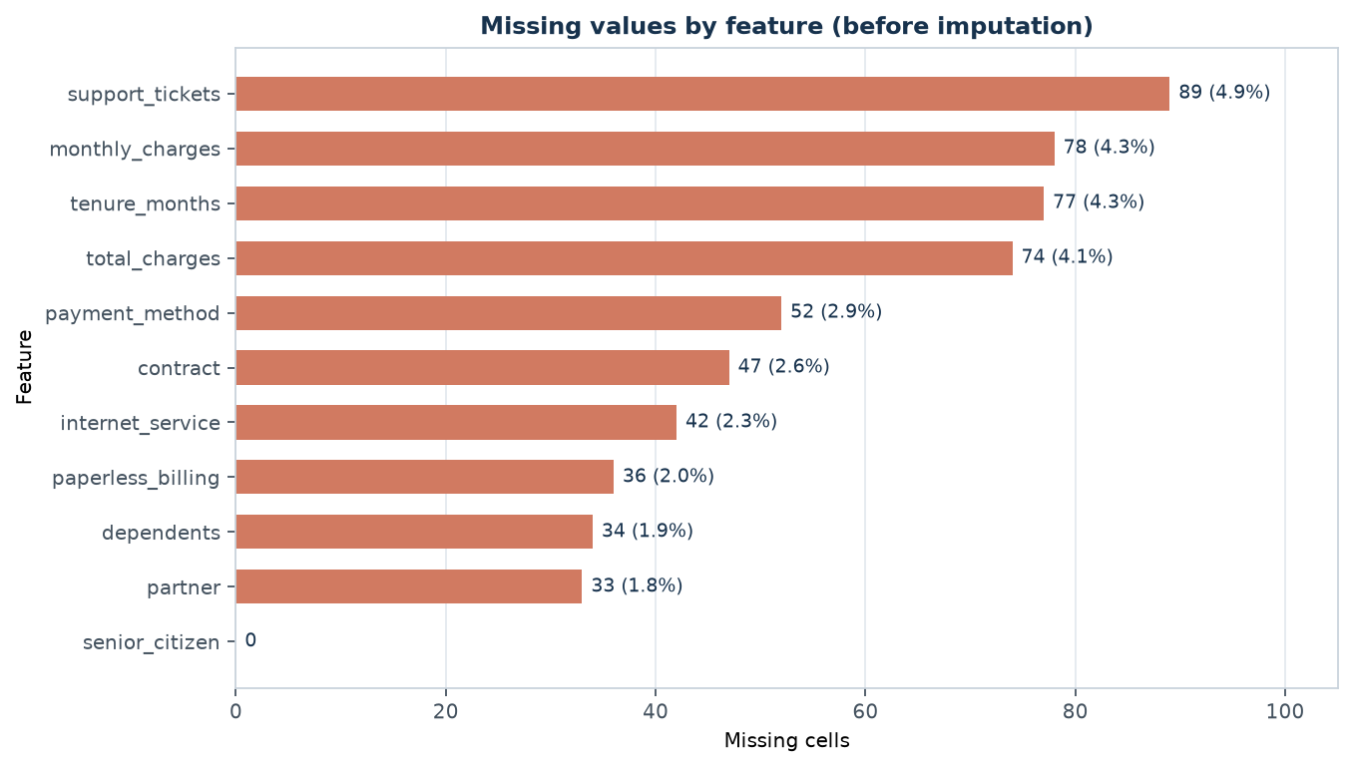
Figure 3 — Missing values by feature before imputation. Missingness is spread across ten columns at 1.8–4.9%, which is well within the range where imputation is defensible.
No column is missing more than about 5% of its values, and only one column — senior_citizen — is complete. This distribution supports imputation over deletion: no single feature is so degraded that filling it would be guesswork, and no subset of rows is systematically excluded.

7.2 Numeric features are skewed and one is a count
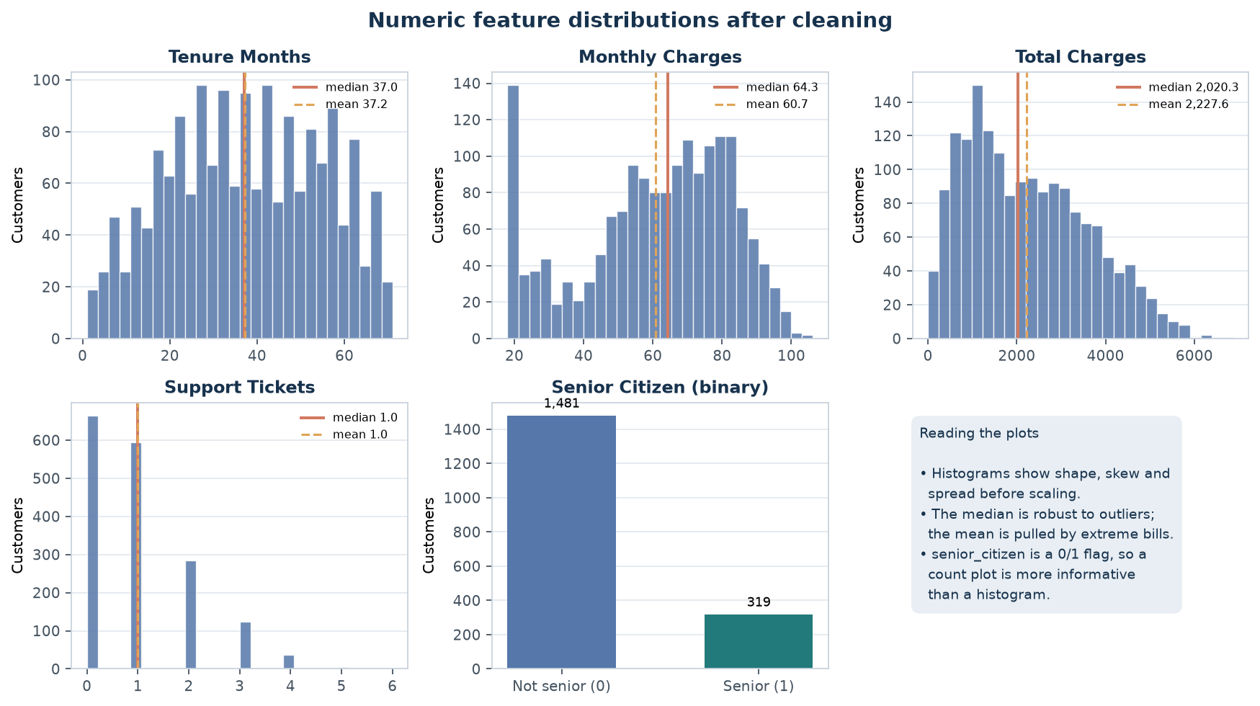
Figure 4 — Numeric feature distributions after cleaning. monthly_charges shows a spike at its 18.00 minimum and a second spike at the imputed median; support_tickets is a small-integer count rather than a continuous measurement.
- tenure_months is roughly flat-to-slightly-bimodal across 1–71 months, with no strong central tendency.
- monthly_charges is right-skewed with two visible spikes: one at the 18.00 minimum charge and one at the imputed median (64.34), which is exactly the distortion predicted in Section 6.4.3.
- total_charges is strongly right-skewed: most customers sit between 1,000 and 3,500, with a long tail beyond 5,000.
- support_tickets is a count taking small integer values 0–6, not a continuous measurement — treating it as continuous is a modelling convenience, not a fact.
- senior_citizen is binary and is shown as a count plot rather than a histogram; a histogram of a 0/1 variable communicates almost nothing.

7.3 The numeric features are not independent
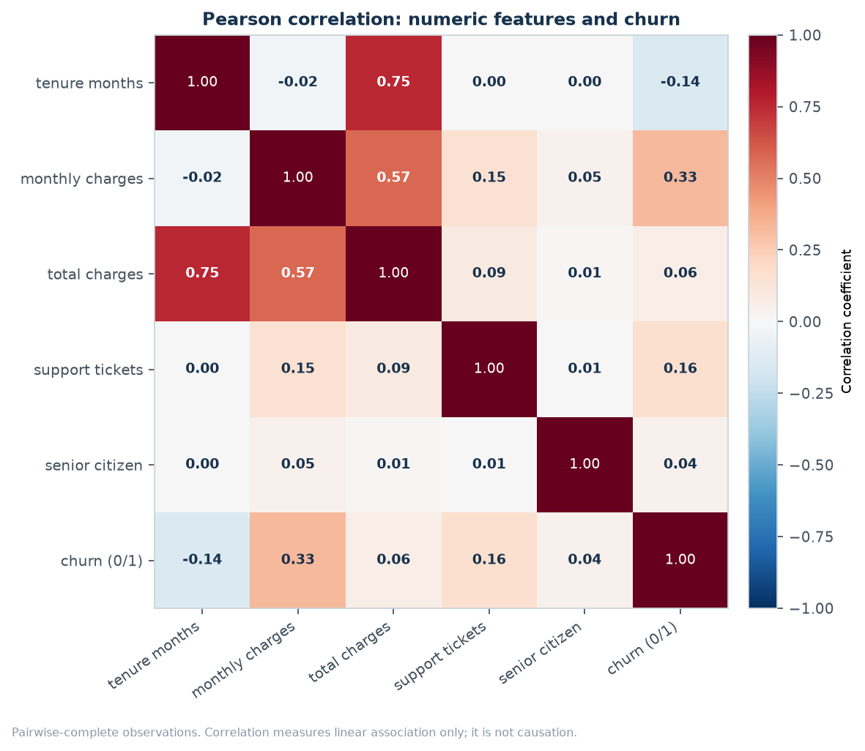
Figure 5 — Pearson correlation among numeric inputs and the encoded target. The 0.75 correlation between tenure_months and total_charges is structural, not a discovery.
The strongest correlation in the matrix is 0.75 between tenure_months and total_charges, which is expected because the total is roughly the monthly charge multiplied by the number of months. The same mechanism explains the 0.57 between monthly_charges and total_charges. This is collinearity rather than a finding, and it has a practical consequence: in a linear model the two coefficients are not separately identifiable, so they must not be interpreted as independent effects. The correlation with the target is modest for every numeric feature — the strongest is monthly_charges at 0.33 — which is a useful early signal that the categorical fields carry most of the structure in this sample.
It is equally important to read the zeros correctly. A correlation near zero means no *linear* relationship; it does not mean independence. tenure_months has a near-zero correlation with support_tickets because no linear relationship exists, not because the two are unrelated in every possible sense.

7.4 Contract type and internet service separate the target most clearly
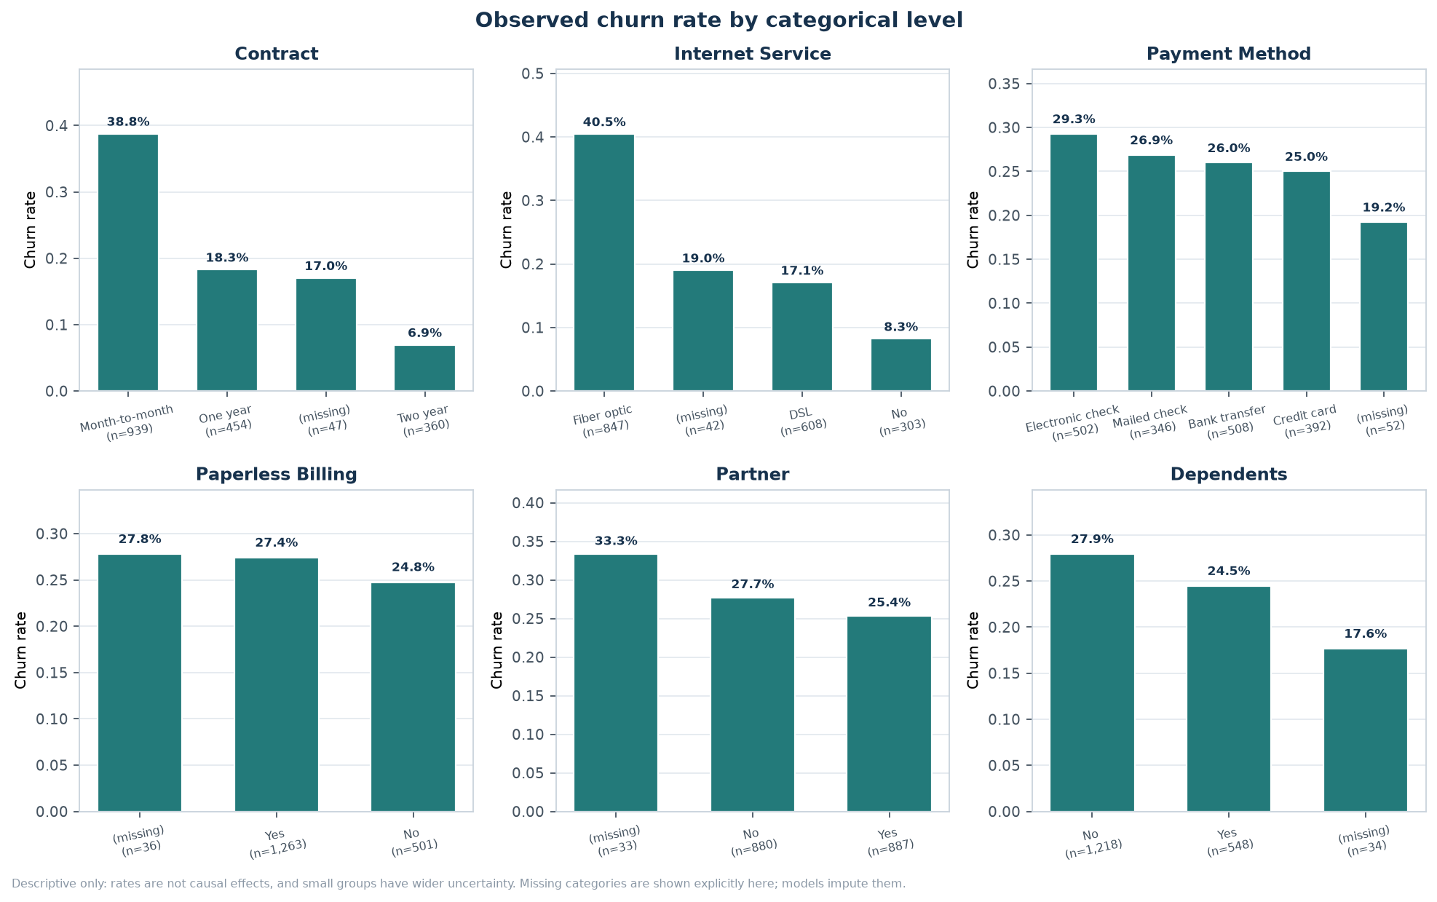
Figure 6 — Churn rate by categorical level, annotated with group sizes. Missing levels are shown explicitly here to demonstrate that they are not equivalent to any real level; the model imputes them instead.
- Contract — month-to-month customers churn at roughly 39%, one-year at 18%, two-year at 7%. This is the widest spread of any categorical input.
- Internet service — Fiber-optic customers churn at roughly 41%, DSL at 17%, and customers with no internet service at 8%.
- Payment method — electronic check is the highest at about 29%, mailed check the lowest at about 19%; the spread is much narrower than for contract.
- Paperless billing, partner and dependents — differences of a few percentage points, which are weak and could plausibly be sampling noise at these group sizes.
The "(missing)" bars are shown deliberately. They demonstrate that customers with a missing contract do not behave like any of the three real contract groups, which is the empirical justification for imputing them rather than encoding a separate "missing" category: there is no stable group to learn from, and a category with 47 members would be almost unidentifiable in a model.

7.5 Outliers are few and plausible
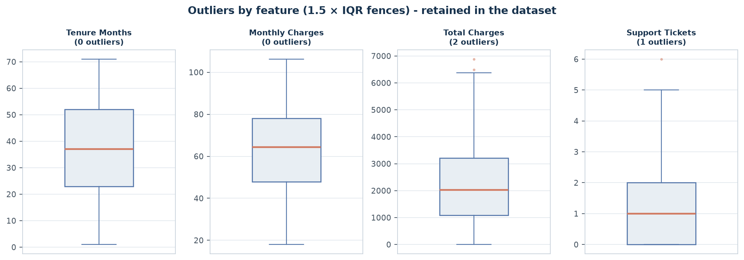
Figure 7 — IQR screening. Points beyond the whiskers are flagged, inspected and retained; the boxplot is a diagnostic, not a deletion rule.
Only a handful of values fall outside the fences, and inspection shows they are large but coherent: high cumulative bills belonging to long-tenure customers. Removing them would delete exactly the customers a churn study should care most about.

8. Results before and after preprocessing
The table below is the concise answer to the deliverable: what the dataset looked like on arrival and what it looks like after the nine steps. Every value is read from outputs/preprocessing_summary.json.
Property | Raw data | After preprocessing
Rows | 1,800 | 1,800
Columns | 13 | 25 model features (+ identifier and target in the export)
Numeric inputs | 5 | 5 standardized + 4 missing indicators
Categorical inputs | 6 | 0 (encoded into 16 columns)
Missing cells (features) | 562 | 0
Data types | float64 and text | all numeric (float64)
Scale | mixed units (months, currency, counts) | z-scores, mean 0 / std 1
Identifier used as a feature | n/a | No — retained for traceability only
Target encoding | "No" / "Yes" text | 0 / 1 integer
Feature selection | none | ranking of 25; top 10 exported
Unseen categories at prediction | would raise an error | tolerated (handle_unknown="ignore")

8.1 The transformed features
The final matrix contains 25 columns: five standardised numeric inputs, four missing indicators, and 16 one-hot columns from the six categorical inputs. The full list is stored in the JSON summary and reproduced below.
# | Feature | # | Feature
1 | tenure_months | 14 | internet_service_Fiber optic
2 | monthly_charges | 15 | internet_service_No
3 | total_charges | 16 | payment_method_Bank transfer
4 | support_tickets | 17 | payment_method_Credit card
5 | senior_citizen | 18 | payment_method_Electronic check
6 | missingindicator_tenure_months | 19 | payment_method_Mailed check
7 | missingindicator_monthly_charges | 20 | paperless_billing_No
8 | missingindicator_total_charges | 21 | paperless_billing_Yes
9 | missingindicator_support_tickets | 22 | partner_No
10 | contract_Month-to-month | 23 | partner_Yes
11 | contract_One year | 24 | dependents_No
12 | contract_Two year | 25 | dependents_Yes
13 | internet_service_DSL

8.2 Proof that the result is usable
A transformed matrix that cannot be consumed by a model has not been delivered. A deliberately minimal logistic regression was therefore fitted to the training split and scored once on the held-out split. It exists to prove the pipeline runs end-to-end on raw input; it is not a tuned model, and its score is not a claim about achievable performance.
Smoke-test item | Value
Estimator | LogisticRegression (class_weight='balanced')
Train/test split | 80% / 20%, stratified, seed 42
Held-out rows | 360
Accuracy | 0.6778
ROC-AUC | 0.7671
Purpose | Smoke test only: confirms the preprocessing pipeline is model-ready; not a tuned modelling result.

The ROC-AUC is meaningfully above 0.5, which confirms that the encoded and scaled features retain a learnable signal. Accuracy is lower than the 73% no-skill baseline only because class_weight="balanced" deliberately trades accuracy for recall on the minority class — a standard and appropriate choice for churn problems where missing a churner is more costly than a false alarm. Model comparison and tuning are the subject of Week 2.

8.3 Standardisation, visualised
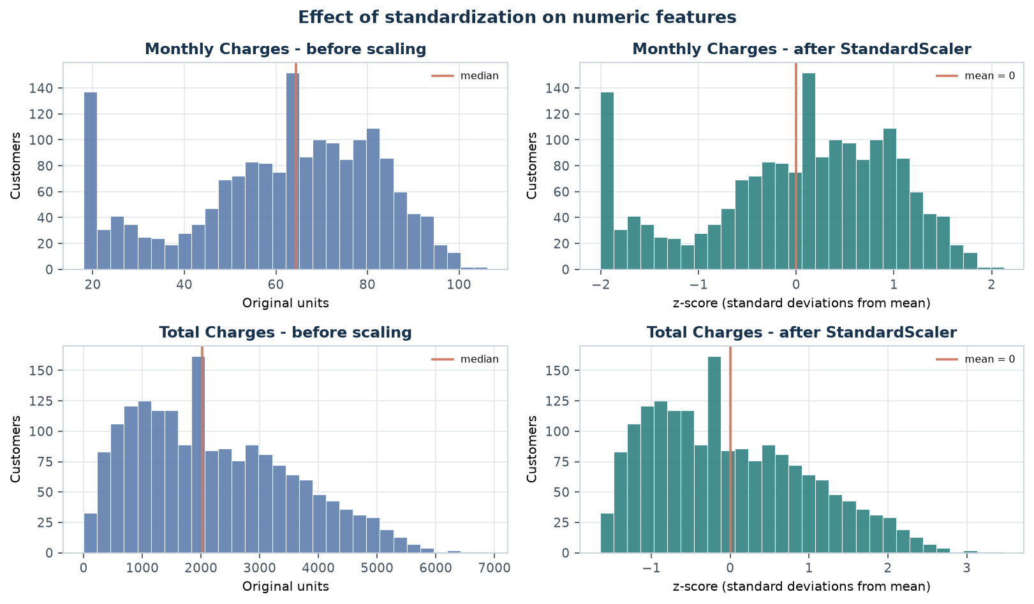
Figure 8 — Standardisation preserves the shape of the distribution and changes only the axis. The long right tail of total_charges survives, which is the intended behaviour.

8.4 Feature ranking, visualised
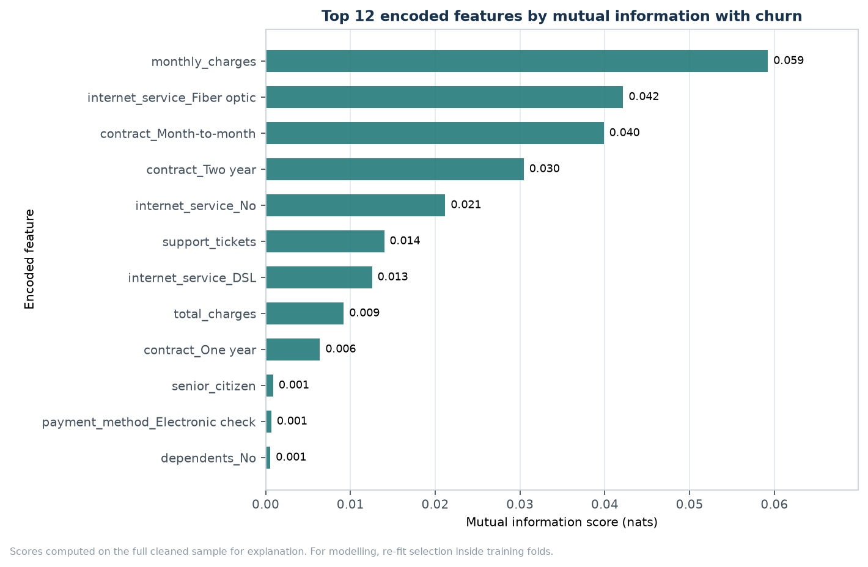
Figure 9 — Top encoded features by mutual information with churn. The ranking is explanatory; for modelling it must be re-fitted inside training folds.

9. Verification and quality assurance
Documentation claims are only as good as the checks behind them. The pipeline asserts its own invariants rather than trusting that they hold, and every assertion is visible in the source.
Check | Assertion in code | Result
Schema completeness | Every expected column exists at load time | Pass — 13/13 columns present
Target validity | Only "No" and "Yes" appear in the target | Pass — 1,800 valid labels
Duplicates | Duplicate rows and IDs counted and resolved | Pass — 0 and 0 found
Missing values eliminated | The transformed matrix contains no NaN and the check raises otherwise | Pass — 0 of 45,000 cells
Cleaned export complete | The readable export contains no NaN | Pass
Scaling achieved | Mean ≈ 0 and std ≈ 1 per standardised column | Pass — verified in outputs/scaling_summary.csv
Encoding captured | Category count per feature matches the levels seen | Pass — 16 columns from 16 levels
Unseen categories tolerated | A never-seen level encodes without error | Pass — all-zero block returned
Reproducibility | Fixed seeds on every stochastic step | Pass — repeated runs are byte-identical

Automated tests were not part of the Week 1 brief, but the assertions above mean that a regression in the preprocessing logic fails loudly instead of producing a plausible-looking but wrong dataset.

10. Limitations and responsible interpretation
Stating limitations is not a formality. Each item below changes how a result should be read, and each has a specific remedy before the pipeline could be trusted on real data.
Limitation | Why it matters | What would be required for real use
Synthetic data | Relationships were generated by a probability model, so any pattern found here is a property of that generator | Validate on representative, permissioned production data
Missingness is random | Real missingness is usually systematic; median imputation would then be biased | Analyse the missingness mechanism and consider model-based imputation
Median/mode imputation understates variance | Filling with a constant creates a spike and shrinks spread, which can make intervals too narrow | Compare against multiple-imputation or a model that handles missingness natively
Feature ranking uses the full sample | Acceptable for explanation, not for model selection | Re-fit selection inside cross-validation folds
No fairness analysis | A preprocessing choice can systematically disadvantage a group, e.g. through imputation rates | Audit missingness and error rates by subgroup before deployment
Correlation is not causation | The churn-rate differences are associations in one sample | Design a controlled study or use causal-inference methods
One-hot ignores rare levels | A level with a handful of members is nearly unidentifiable and can destabilise coefficients | Group rare levels or use a target encoder with cross-fitting

11. Lessons learned
Five things this exercise changed about how I would approach the next dataset.
1. Audit before touching anything. The first version of this work began by imputing, which made it impossible to report how much was missing and why. Running the audit first turned a vague cleaning task into a list of specific, justifiable decisions.
2. The transformer is the deliverable, not the CSV. An exported cleaned table documents one snapshot; a fitted ColumnTransformer documents the rule that produced it and can be applied again. Learning this changed the structure of the whole project.
3. Leakage is invisible in the output. Fitting the scaler before splitting produces a slightly better score and no error message. The only defence is discipline about ordering, which is why preprocessing lives inside a pipeline rather than in loose statements.
4. Reporting zero findings is real reporting. Recording that there were no duplicate rows, no whitespace defects and no invalid target values is what lets a reviewer distinguish a clean dataset from an unexamined one.
5. Imputation has a measurable cost, so measure it. Plotting the distribution before and after showed a spike that no summary statistic would have revealed. It is now a standard check.

12. Conclusion
The Week 1 brief asked for a clean, preprocessed sample dataset with every step documented. That has been delivered: a nine-stage pipeline turns a 1,800-row raw file containing 562 missing cells into a fully numeric, standardised, 25-feature matrix with zero missing values, together with eight figures and ten audit tables that make every number reproducible.
The technical outcome is straightforward; the methodological outcome matters more. The work establishes a repeatable discipline: inspect before changing, justify every transformation against a recorded fact, fit transformations on training data only, assert that the result is what it claims to be, and state plainly what the data cannot support. Those habits carry directly into the supervised modelling of Week 2, where the same leakage discipline determines whether a reported score is real.
The dataset is synthetic and every finding in Section 7 describes that generator rather than a business. What is generalisable is the procedure — and it is documented closely enough that someone else can run it, check it and disagree with any decision in it.

Repository
All code, data and outputs: https://github.com/Dhanam33/Yuva_intern/tree/arena/ba225c97-yuva-intern/week-1

Appendix A — Reproducing the results
The complete pipeline runs in under a minute on a laptop and requires no network access.
# 1. Environment
python -m venv .venv
source .venv/bin/activate # Windows: .venv\Scripts\activate
python -m pip install -r week-1/requirements.txt

# 2. Reproduce every table, figure and the JSON summary
python week-1/src/preprocess.py
python week-1/src/make_pipeline_diagram.py

# 3. Rebuild this report from the regenerated artifacts
python week-1/docs/build_report.py

# 4. Open the teaching notebook
jupyter notebook week-1/notebooks/week1_python_ml_preprocessing.ipynb

Running the steps in a different order will not break anything, but the report will then describe artifacts older than the run — always regenerate the report last.

Appendix B — Output file index
File | Contents
outputs/cleaned_customer_churn.csv | Readable cleaned table: original columns, all gaps filled, identifier and target retained
outputs/preprocessed_customer_churn.csv | Fully numeric, encoded and standardised matrix with identifier and target
outputs/selected_feature_dataset.csv | Top-ten encoded features plus identifier and target
outputs/missing_value_audit.csv | Per-column missing counts, percentages, dtypes, strategy and fill value
outputs/data_quality_checks.csv | The eight quality checks and the action taken for each
outputs/numeric_summary.csv | Count, mean, std, min, median and max for each numeric input
outputs/categorical_summary.csv | Level counts and shares after cleaning
outputs/outlier_audit.csv | IQR fences, flagged counts and the retention decision
outputs/encoding_summary.csv | Levels, categories and encoded column counts per categorical feature
outputs/scaling_summary.csv | Mean and standard deviation before and after standardisation
outputs/feature_selection.csv | Full mutual-information ranking of all encoded features
outputs/summary_metrics.csv | One-line headline metrics for quick checks
outputs/preprocessing_summary.json | Machine-readable record of every decision; this report is generated from it
outputs/figures/00–08*.png | The nine figures in this report

Appendix C — Key code excerpts
The excerpts below are the parts of src/preprocess.py that encode the substantive decisions. The full module, including figure generation and export, is 1,251 lines and is available in the repository.

C.1 The cleaning rules
# Trim text and turn empty strings into missing
for column in text_columns:
clean[column] = _clean_category_series(clean[column])

# Impossible values become missing, so the imputer handles them
for column in NUMERIC_FEATURES:
invalid_mask = clean[column] < 0
clean.loc[invalid_mask, column] = np.nan

# The target can never be repaired, only removed
invalid_target_mask = ~clean[TARGET_COLUMN].isin(list(TARGET_MAP))
clean = clean.loc[~invalid_target_mask].copy()

# Deduplicate rows first, then identifiers
clean = clean.drop_duplicates()
clean = clean.drop_duplicates(subset=ID_COLUMN, keep="first")

C.2 The imputation and transformation pipeline
numeric_steps = [
("imputer", SimpleImputer(strategy="median", add_indicator=True)),
("scaler", StandardScaler()),
]
categorical_steps = [
("imputer", SimpleImputer(strategy="most_frequent")),
("onehot", OneHotEncoder(handle_unknown="ignore", sparse_output=False)),
]
preprocessor = ColumnTransformer(
transformers=[
("numeric", Pipeline(numeric_steps), NUMERIC_FEATURES),
("categorical", Pipeline(categorical_steps), CATEGORICAL_FEATURES),
],
remainder="drop",
verbose_feature_names_out=False,
)

C.3 Mutual-information feature selection
discrete_mask = np.array([
any(name.startswith(f"{column}_") for column in CATEGORICAL_FEATURES)
or name.startswith("missingindicator_")
or name in {"senior_citizen"}
for name in feature_names
], dtype=bool)

scores = mutual_info_classif(
transformed.to_numpy(),
target.to_numpy(),
discrete_features=discrete_mask,
n_neighbors=5, # 3 collapses weak signals on 1,800 rows
random_state=RANDOM_STATE,
)

C.4 The invariant that guards the deliverable
if transformed.isna().any().any():
raise RuntimeError("Transformed data still contains missing values")

# ... and the same check on the readable export
if readable[FEATURE_COLUMNS].isna().any().any():
raise RuntimeError("Readable cleaned export still contains missing values")

These two assertions are the reason the report can state "zero missing cells" as a verified fact rather than an expectation.

