YUVA INTERNSHIP PROGRAMME
WEEK 3 · DELIVERABLE REPORT
Unsupervised Learning
& Model Evaluation
Clustering with K-Means and hierarchical methods, dimensionality reduction with PCA, and a full evaluation of a tuned classifier

SUBMITTED BY | Peram Dhanam Srinivas
PROGRAMME | Yuva Internship Program
WEEK | 3 of 4 — Unsupervised learning and model evaluation
DELIVERABLE | Perform clustering on a dataset and prepare a model evaluation report
PART A | K-Means · Agglomerative clustering (ward, complete, average, single) · PCA
PART B | Confusion matrix · precision · recall · F1 · ROC-AUC · cross-validation · GridSearchCV
DATASET | customer_churn_raw.csv — 1,800 synthetic customer records
TOOLS | Python 3.11 · scikit-learn · SciPy · NumPy · Pandas · Matplotlib
REPOSITORY | https://github.com/Dhanam33/Yuva_intern/tree/main/week-3
DATE | 20 October 2026

All results are reproducible from the repository using a fixed random seed of 42. The dataset is synthetic teaching data and does not describe real customers.

1. Executive summary
This report covers both halves of the Week 3 brief. Part A clusters the customer dataset without using the churn label and asks afterwards whether the clusters mean anything. Part B takes the churn label seriously and asks how well a classifier can predict it, using the evaluation metrics and tuning procedures the brief names.
The dataset holds 1,800 synthetic customer records encoded into 21 numeric columns. Four clustering configurations are compared — K-Means over k = 2 to 8, and agglomerative clustering under ward, complete, average and single linkage — alongside principal component analysis as a dimensionality-reduction step. On the supervised side, 37 hyperparameter combinations are searched with GridSearchCV, and nested cross-validation checks the tuned score against an unbiased estimate.
Measure | Result
Records / encoded features | 1,800 / 21
Churn rate | 26.7% (480 of 1,800)
Components for 90% of variance | 10 (from 21)
Clusters chosen | k = 3 by K-Means and Ward alike
Best K-Means silhouette | 0.162 (weak — below 0.25)
K-Means vs Ward agreement | ARI 0.732
Clusters vs churn agreement | ARI 0.015 (essentially unrelated)
Churn spread across clusters | 9.0% (from 21.8% to 30.8%)
Silhouette gained by projecting to 2-D | 0.135 → 0.389 (illusory)
Selected classifier | Logistic Regression (CV ROC-AUC 0.806)
Held-out test ROC-AUC | 0.768
Held-out test recall / precision | 0.656 / 0.432
Nested CV estimate | 0.805 ± 0.025 (optimism +0.001)

The headline finding
Two different clustering algorithms independently recover almost the same three customer segments (ARI 0.732), which is strong evidence the segments are real. Those segments carry essentially no information about churn (ARI 0.015), and the churn rate varies by only 9.0% across them. Real structure and a useful predictor are not the same thing — which is precisely why the labelled evaluation in Part B is necessary.

Part A also documents two ways unsupervised output is commonly misread. Single linkage achieves the highest silhouette of any configuration (0.294) while producing a cluster containing 1 customer. And clustering in two dimensions appears to raise silhouette from 0.135 to 0.389 purely because the space the clusters are scored in got smaller. Both are demonstrated with numbers rather than described in the abstract.
Part B is deliberately unflattering. A model that never predicts churn scores 0.733 accuracy, above the classifier's 0.678. Hyperparameter tuning improved Logistic Regression by 0.001 ROC-AUC across five values of C — there was no headroom to exploit. Nested cross-validation agreed with the tuned score to within 0.001, confirming the tuning was not overfitting. The reported value of the exercise is the discipline of these checks, not a headline number.

2. Submission description
The text below is the description submitted with this report. It is reproduced here so the report is self-contained. The word count is computed on generation and the build fails if it falls below the required minimum.
This Week 3 report addresses both halves of the brief — unsupervised learning and model evaluation — using scikit-learn on the same reproducible synthetic customer-churn dataset of 1,800 records. Part A applies K-Means and agglomerative hierarchical clustering to a 21-column feature matrix, with principal component analysis used to examine dimensionality reduction. Cluster quality is judged using silhouette, Davies-Bouldin and Calinski-Harabasz indices, and the value of k is chosen only after demonstrating that the three disagree. Hierarchical clustering is compared across ward, complete, average and single linkage, which exposes a common trap: single linkage achieves the highest silhouette of any configuration while producing a one-customer cluster. Two independent algorithms recover almost the same three segments, with an adjusted Rand index of 0.732, which is evidence that the structure is real; yet neither relates to churn, where the index is 0.015 and the churn rate varies by only nine percentage points across segments. Part B builds a supervised classifier and evaluates it properly: the confusion matrix, precision, recall, F1 and ROC-AUC are computed from first principles, five-fold stratified cross-validation is used throughout, and GridSearchCV searches 37 hyperparameter combinations. Nested cross-validation separates the tuned score from an unbiased estimate. Results are reported without embellishment: tuning improved Logistic Regression by 0.001 ROC-AUC, nested cross-validation agreed to within 0.001, and the final held-out scores were 0.768 ROC-AUC with 0.656 recall.
Word count: 230 words (minimum 200).

3. Introduction
The Week 3 brief has three objectives, and they pull in different directions. The first is unsupervised: understand clustering and dimensionality reduction. The second is evaluative: understand confusion matrices, precision, recall, F1, ROC-AUC, cross-validation and hyperparameter tuning. The third asks for a clustering exercise and a model evaluation report as a single deliverable.
The natural temptation is to treat these as two separate pieces of homework stapled together. This report instead uses the output of Part A to justify Part B. The clustering succeeds on its own terms — it finds stable, reproducible segments — but those segments cannot predict churn. That negative result is what makes the supervised evaluation necessary, and it sets up the central question of Part B: if a label matters, how do you measure how well you are predicting it?

3.1 How each objective is addressed
Objective | Where | Evidence
K-Means clustering | Section 6 | k = 2…8 sweep with elbow, silhouette, Davies-Bouldin and Calinski-Harabasz
Hierarchical clustering | Section 8 | Four linkage rules compared; dendrogram; non-degeneracy filter
Dimensionality reduction | Sections 5 and 10 | PCA variance, loadings, 2-D projection, and clustering after reduction
Cross-validation | Section 14 | Five-fold stratified; fold spread read as an error bar
Confusion matrix and metrics | Sections 11–13 | Counts derived first, then every metric computed by hand and cross-checked
Precision, recall, F1, ROC-AUC | Sections 12–13 | Each defined, computed from the matrix, then interpreted in cost terms
Hyperparameter tuning | Section 15 | GridSearchCV over 5 + 32 combinations, scored on CV only
Clustering deliverable | Sections 5–10 | Three segments profiled and validated against an external label
Evaluation report | Sections 11–19 | Tuned model, nested CV, learning curve, calibration, limitations

3.2 What this report deliberately does not claim
- That the clusters describe customers in a way a business could act on. The silhouette of 0.162 indicates substantial overlap.
- That the classifier is good. It is measurably better than chance and measurably worse than a do-nothing rule on accuracy.
- That hyperparameter tuning produced a better model. It produced a statistically indistinguishable one, and the report says so.
- That any of these numbers would transfer to real customer data. The dataset is synthetic.

4. Dataset and feature space
The data is the same synthetic customer-churn sample used in Week 2: 1,800 records across 13 columns, of which 5 are numeric and 6 categorical. The churn label is present but plays no part in Part A — it is held back and used only to ask, afterwards, whether the clusters happened to match it.
There are 480 churners (26.7%) and 1,320 non-churners, and 562 missing feature cells. Missingness is handled by median imputation for numbers and most-frequent imputation for categories, both fitted inside the transformer so that no statistic crosses from test data into training.

4.1 Encoding choices
Clustering is a distance-based procedure, so the representation of each column directly determines the result. Two different treatments are applied:
Column type | Treatment | Reason
Numeric (5 columns) | Median impute → standardise | Dollars, months and counts are not comparable magnitudes
Categorical (6 columns) | Mode impute → one-hot | K-Means needs numbers, not labels

One-hot columns are deliberately NOT standardised. A dummy for a category present in 5% of rows already has a small variance; forcing it to unit variance would give rare categories as much weight in the distance metric as common ones. Numbers need scaling; indicators do not. The result is a 21-column matrix.
The dataset contains 319 senior citizens. This is worth stating up front because the clustering will find them without being told the column exists — a detail that recurs in Section 7.
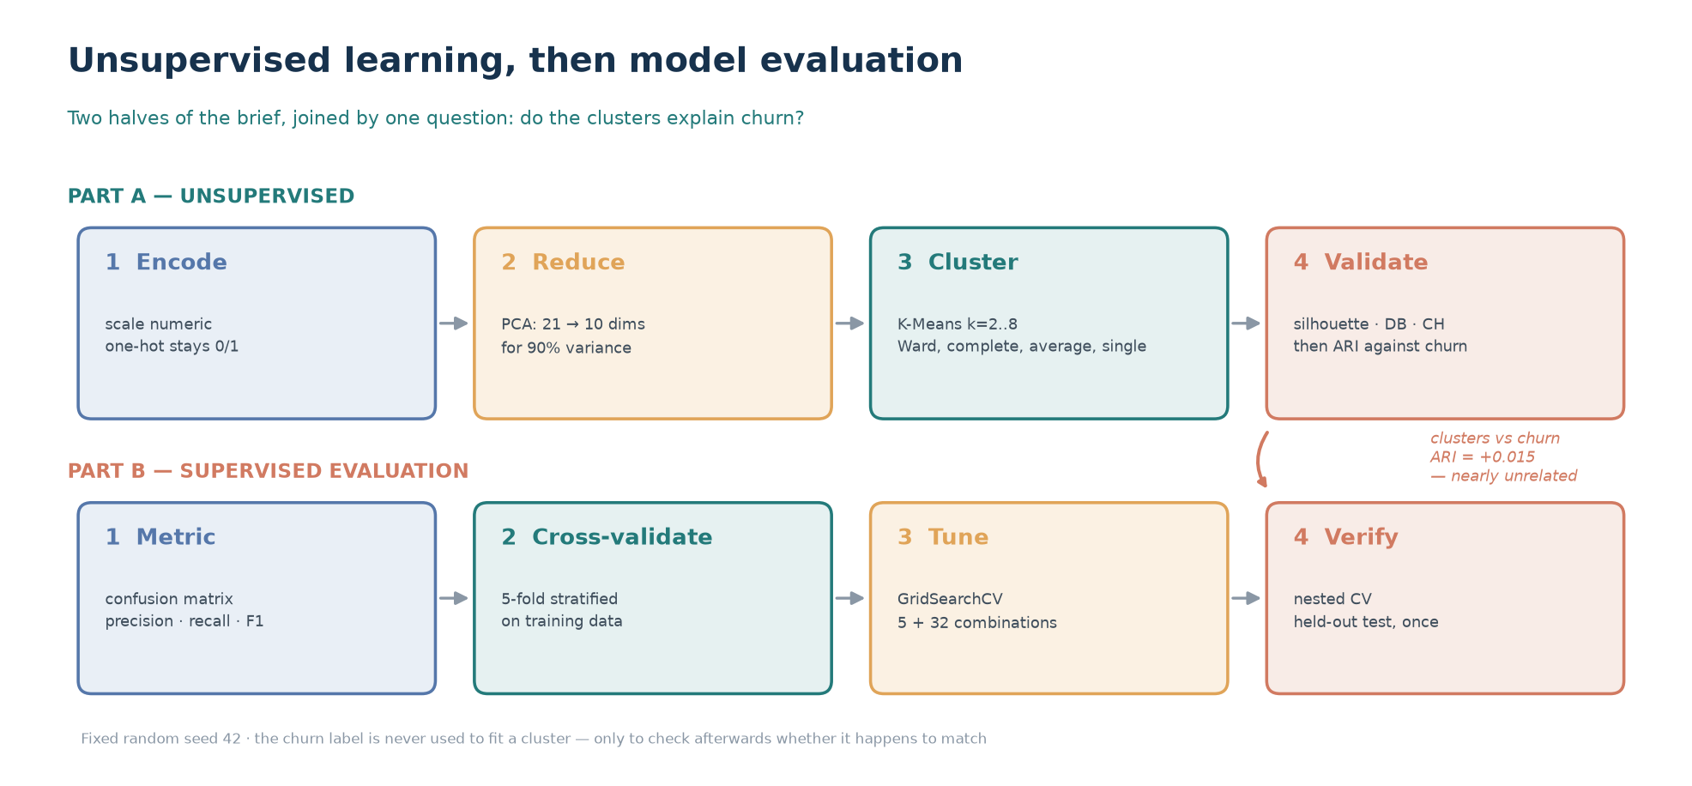
Figure 1 — The two halves of the work. Part A clusters without the label; Part B evaluates a supervised model. The arrow marks the finding that connects them.

5. Dimensionality reduction with PCA
Principal component analysis finds the orthogonal directions along which the data varies most, and re-expresses every record in those directions. It is a rotation, not a summary — the first component alone accounts for 24.4% of the total variance, and the first three together for 51.3%.
Component | Eigenvalue | Variance explained | Cumulative
1 | 2.018 | 24.4% | 24.4%
2 | 1.230 | 14.9% | 39.2%
3 | 0.999 | 12.1% | 51.3%
4 | 0.923 | 11.1% | 62.4%
5 | 0.505 | 6.1% | 68.5%
6 | 0.422 | 5.1% | 73.6%
7 | 0.405 | 4.9% | 78.5%
8 | 0.377 | 4.6% | 83.1%
9 | 0.313 | 3.8% | 86.8%
10 | 0.295 | 3.6% | 90.4%

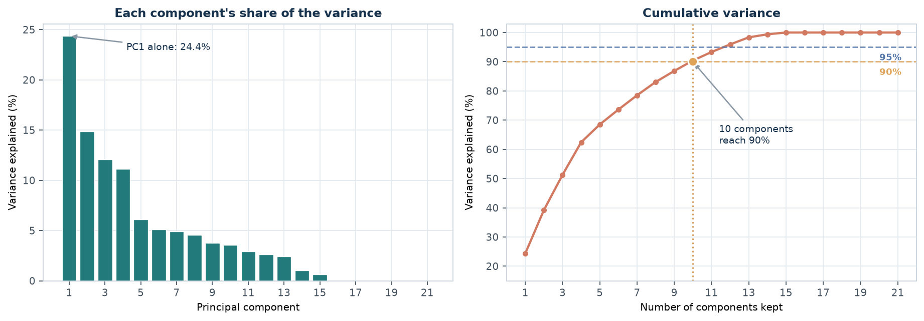
Figure 2 — Variance explained per component (left) and cumulatively (right). 10 components are needed to reach 90%.
The practical figures are 10 components for 90% of the variance and 12 for 95%. Reducing 21 columns to 10 is a real compression, and it is what makes the 2-D plots in this report possible at all.

5.1 What the first component is made of
A loading is the weight of one original feature inside a component. Sorting by the absolute loading shows what each component is built from, which is more informative than the variance number alone.
Feature | PC1 loading
total charges | +0.673
monthly charges | +0.492
tenure months | +0.463
internet service Fiber optic | +0.202
support tickets | +0.153

Reading PC1
The three largest loadings are total charges (+0.67), monthly charges (+0.49) and tenure (+0.46), all with the same sign. That is not three findings — it is one axis: how much a customer is worth and how long they have stayed. A component is often a single latent quantity expressed through several correlated columns.

Two components retain only 39.2% of the variance, yet they are the only ones that can be drawn on a page. That ratio sets the expectation for the next figure: it is a compression, and something has been given up.
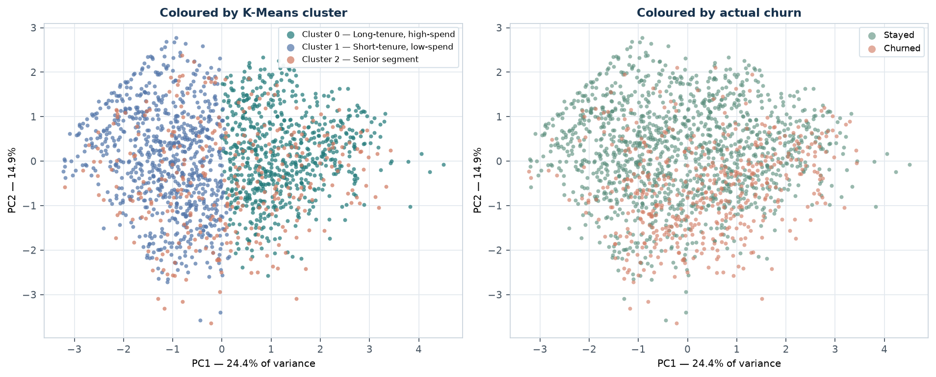
Figure 3 — The same 1,800 customers in two dimensions, coloured first by K-Means cluster and then by actual churn. Both partitions overlap heavily.
The right-hand panel is the honest starting point. Churners and non-churners occupy the same region of the projected space, with no traceable boundary between them. Any claim that clustering has 'discovered churn' has to explain away this picture first.

6. K-Means: choosing k
K-Means partitions records into k groups by alternating between assigning each point to its nearest centroid and moving each centroid to the mean of its members. It requires k in advance, and it will produce k clusters even when the data contains none. Choosing k is therefore the substantive decision, and it cannot be answered by a single formula.
Three internal indices are computed across k = 2 to 8. Each measures something different, and they are presented together because they do not agree.
k | Inertia | Silhouette | Davies-Bouldin | Calinski-Harabasz | ARI vs churn
2 | 12,374 | 0.154 | 2.157 | 366.6 | +0.015
3 | 11,023 | 0.162 | 1.923 | 315.7 | +0.015
4 | 10,028 | 0.154 | 1.884 | 290.7 | +0.000
5 | 9,406 | 0.146 | 1.814 | 262.0 | +0.011
6 | 8,931 | 0.131 | 1.822 | 239.7 | +0.010
7 | 8,508 | 0.138 | 1.885 | 224.4 | +0.009
8 | 8,125 | 0.129 | 1.996 | 213.4 | +0.017

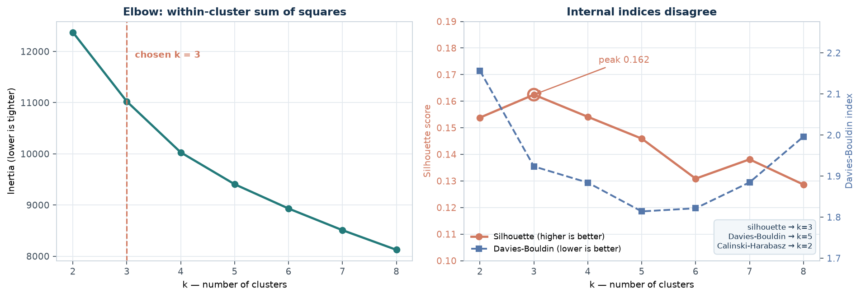
Figure 4 — The elbow (left) and the two internal indices (right). Silhouette peaks at k = 3, Davies-Bouldin bottoms out at k = 5 and Calinski-Harabasz peaks at k = 2.

6.1 The indices disagree, and that is the finding
Silhouette prefers k = 3, Davies-Bouldin prefers k = 5 and Calinski-Harabasz prefers k = 2. No rule arbitrates between them, because they are not measuring the same property: silhouette compares each point with the nearest rival cluster, Davies-Bouldin compares cluster spread with cluster separation, and Calinski-Harabasz is a global between-over-within ratio that tends to favour small k.
k = 3 is used for the rest of the report. The reasons are explicit: silhouette peaks there (0.162), the elbow agrees — the largest single drop in inertia occurs moving to k = 3 — and three segments are few enough to describe and reason about. This is a defensible judgement, not a derived fact, and it is recorded as such.
The absolute value matters more than the ranking
A silhouette of 0.162 is low. Scores below roughly 0.25 indicate overlapping, poorly separated clusters, and this dataset sits well inside that range. The best of eight values is still a weak segmentation — the ranking identifies the least-bad choice, not a strong one.

7. K-Means cluster profiles
With k = 3 and 50 random restarts, K-Means converges to a solution with an inertia of 11,023.1. A cluster is only useful if it can be described, so each one is profiled on the original, unstandardised features.
# | Segment | Customers | Share | Tenure | Monthly | Total | Churn
1 | Short-tenure, low-spend | 797 | 44.3% | 27.8 | 48.8 | 1,172 | 21.8%
0 | Long-tenure, high-spend | 685 | 38.1% | 48.3 | 73.5 | 3,459 | 30.4%
2 | Senior segment | 318 | 17.7% | 37.2 | 62.8 | 2,256 | 30.8%

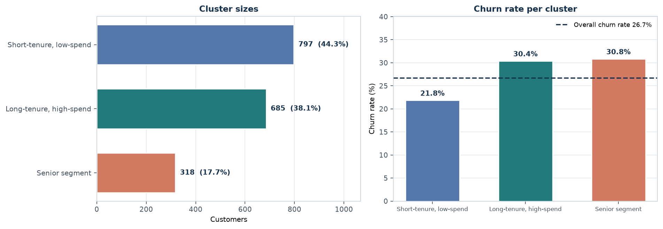
Figure 5 — Cluster sizes (left) and churn rate within each segment (right). The dashed line is the overall churn rate; no segment departs from it by much.
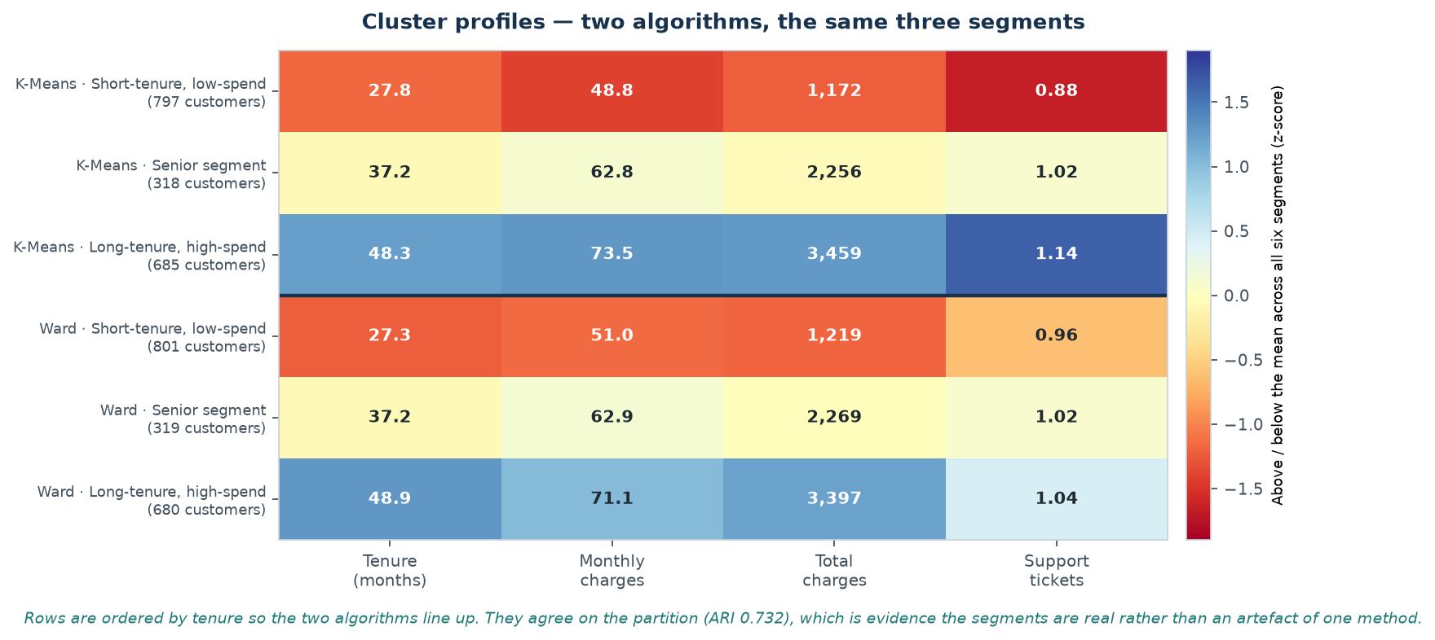
Figure 6 — Cluster profiles for K-Means and Ward side by side. Cell shading is the z-score within each column; the printed number is the raw mean in original units.
Two of the three segments form a straightforward axis. The group of 797 customers has a mean tenure of 27.8 months and spends 48.80 per month — recent, low-value customers. The group of 685 has been present for 48.3 months and spends 73.53 — established and high-value. That axis is exactly PC1 from Section 5, found again without being asked for.

7.1 The segment nobody labelled
An unlabelled category made itself a cluster
Cluster 2 contains 318 customers — 17.7% of the data — and the mean of its senior_citizen flag is 1.00. In other words it contains essentially every senior citizen in the dataset and almost nobody else. K-Means was never told the column existed. It found the group because those customers differ consistently in tenure, monthly charges and total charges as well, and the distance metric picked that up.

The third segment, cluster 2, sits between the other two on every numeric feature and coincides with the senior customers. It is a reminder that a cluster label is a description, not an explanation: 'senior segment' is accurate for this group, but the reason those customers are separable is a pattern across several columns at once, of which the senior flag is only one.

8. Hierarchical clustering
Agglomerative clustering begins with every record in its own cluster and repeatedly merges the two closest, producing a tree. Because the whole merge history is retained, k can be chosen after the structure is visible rather than before. The price is that the result depends heavily on what 'closest' means.
Linkage | Distance between clusters | Tendency
ward | Increase in total within-cluster variance | Compact, roughly equal-sized clusters
complete | Farthest pair of points between clusters | Tends to produce compact clusters
average | Mean distance over all pairs | Sensitive to cluster shape
single | Closest pair of points | Follows chains; prone to singleton clusters

Every linkage is run for k = 2 to 5 and scored on the same silhouette measure used above, together with the size of the smallest cluster it produces.
Linkage | k | Silhouette | Smallest cluster | Share | Degenerate
ward | 2 | 0.116 | 801 | 44.5% | no
ward | 3 | 0.145 | 319 | 17.7% | no
ward | 4 | 0.136 | 254 | 14.1% | no
ward | 5 | 0.111 | 223 | 12.4% | no
complete | 2 | 0.134 | 268 | 14.9% | no
complete | 3 | 0.055 | 187 | 10.4% | no
complete | 4 | 0.062 | 122 | 6.8% | no
complete | 5 | 0.048 | 88 | 4.9% | no
average | 2 | 0.270 | 5 | 0.3% | yes
average | 3 | 0.179 | 4 | 0.2% | yes
average | 4 | 0.141 | 4 | 0.2% | yes
average | 5 | 0.129 | 1 | 0.1% | yes
single | 2 | 0.294 | 1 | 0.1% | yes
single | 3 | 0.271 | 1 | 0.1% | yes
single | 4 | 0.173 | 1 | 0.1% | yes
single | 5 | 0.154 | 1 | 0.1% | yes

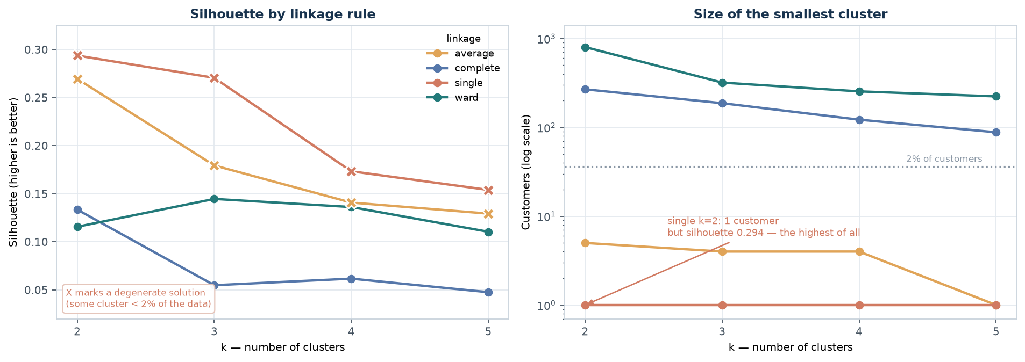
Figure 7 — Silhouette by linkage (left) against the size of the smallest cluster each one produces (right, log scale). The two best silhouettes belong to the two degenerate solutions.

8.1 The silhouette trap
Sort the table by silhouette and the winner is single linkage at k = 2, scoring 0.294 — higher than anything else in the table and nearly twice the value K-Means achieved. It is also worthless: the smallest cluster contains 1 customer.
The mechanism is worth stating plainly. The silhouette of a point is the difference between its distance to its own cluster and to the nearest other cluster, scaled by the larger of the two. For a point alone in its cluster, the within-cluster distance is zero by definition, so its silhouette is the maximum possible value. A partition containing singletons therefore has a structurally inflated average.
The rule this report adopts
A clustering score is only meaningful once every cluster is large enough to describe. Any solution containing a cluster below 2% of the data is discarded before the best remaining solution is chosen. Applying that filter leaves ward at k = 3, with a silhouette of 0.145 and a smallest cluster of 319.

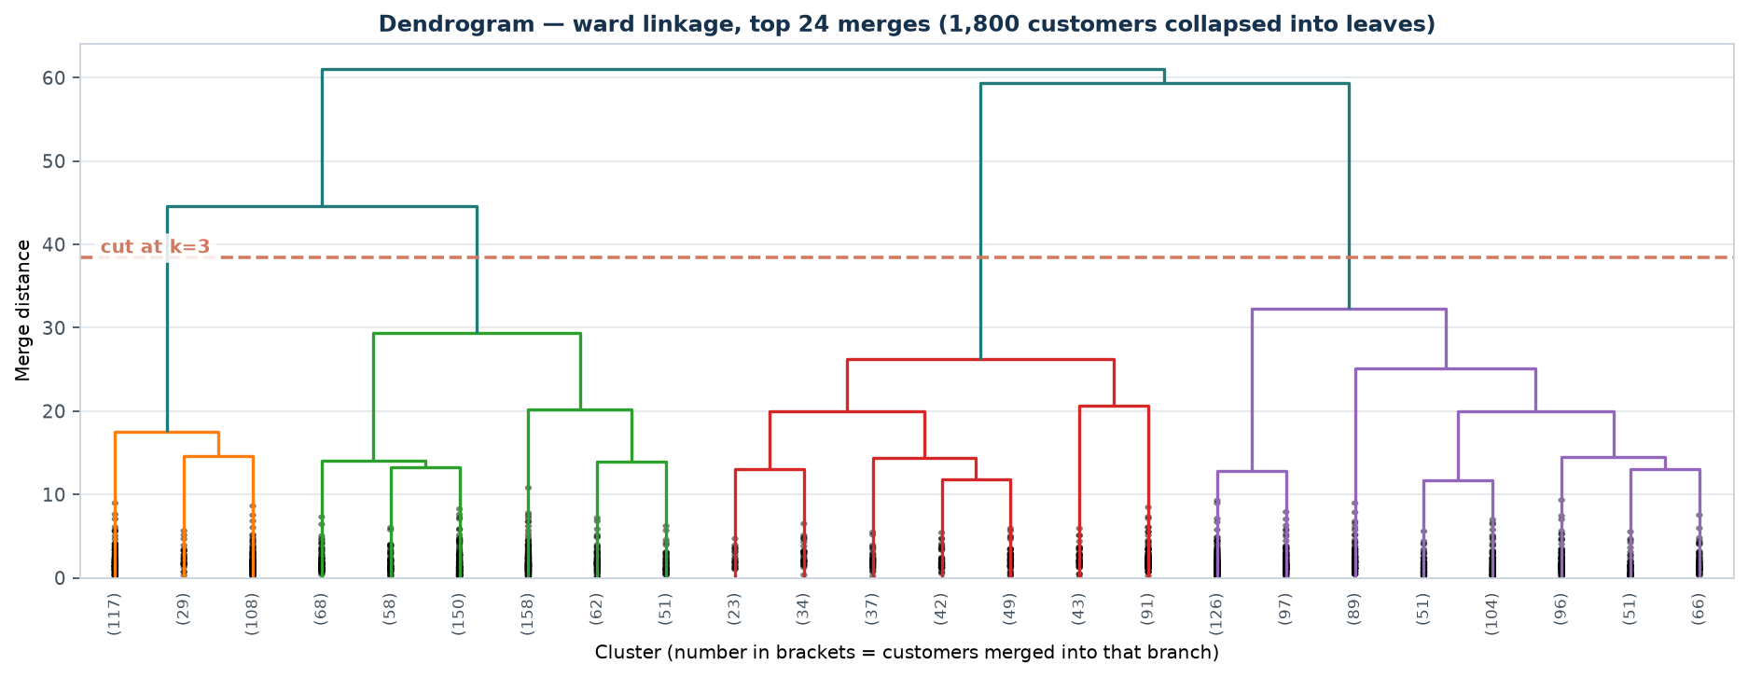
Figure 8 — Ward dendrogram, truncated to the top 24 merges. The dashed line marks the cut that produces three clusters; numbers in brackets are the records fused into each branch.
Ward's tree shows three clear branches surviving to the last joins, and the height difference between the third and fourth merge is the visual justification for cutting at k = 3. The resulting clusters contain 801, 680 and 319 customers — comfortably above the degenerate threshold.

9. Do the clusters explain churn?
This is the question the whole report turns on, and it is asked in a way that cannot cheat. The churn label played no part in fitting either clustering. Comparing the two afterwards is therefore a genuine external check, not a circular one.
The Adjusted Rand Index measures agreement between two partitions, corrected for what agreement would occur by chance. A value of 1 means identical partitions, 0 means no better than random, and negative values mean worse than random.
Comparison | ARI | AMI | Interpretation
K-Means vs Ward | +0.732 | 0.733 | two clusterings, same data
K-Means vs churn | +0.015 | — | clusters against the label
Ward vs churn | +0.010 | — | clusters against the label

Segment | Stayed | Churned | Churn rate
Long-tenure, high-spend | 477 | 208 | 30.4%
Short-tenure, low-spend | 623 | 174 | 21.8%
Senior segment | 220 | 98 | 30.8%

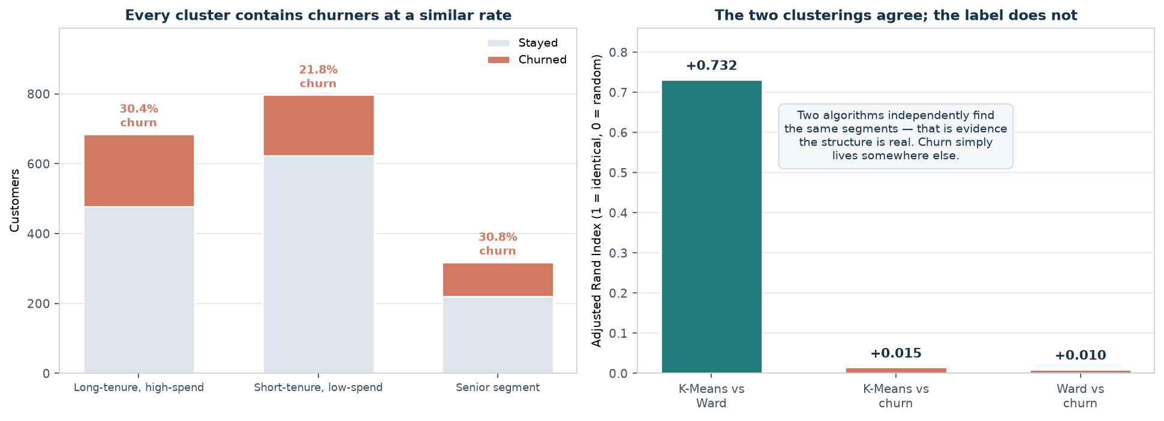
Figure 9 — Left: every cluster contains churners at a similar rate. Right: the agreement indices. The two clusterings agree with each other; neither agrees with churn.
The churn rate is 30.4%, 21.8% and 30.8% across the three segments, against an overall rate of 26.7%. The full spread is 9.0%. Knowing which segment a customer belongs to moves the predicted churn rate by less than ten percentage points around a base rate of twenty-seven.
Two conclusions, and they are not in conflict
First: the segments are real. Two algorithms built on completely different logic recover almost the same partition (ARI +0.732 between them), and the same senior-citizen group emerges in both. Structure this reproducible is not an artefact. Second: that structure is not churn (ARI +0.015 against the label). Customer segments and customer behaviour are different things, and no clustering algorithm can supply the one that was never in the features.

This result is the reason Part B exists. If clustering had recovered churn, a supervised model would be redundant. It did not, so the label has to be modelled directly — and once it is, the question becomes how to measure whether the prediction is any good.

10. Clustering after dimensionality reduction
A tempting shortcut is to run PCA first and cluster in two or three dimensions, where the result can be plotted and inspected. It is worth measuring what that actually does, rather than assuming it is harmless.
The experiment clusters the projected data, then scores the resulting labels twice: once in the reduced space, which is what a careless analysis would report, and once in the original 21-dimensional space, which is what the labels actually mean.
Components kept | Variance retained | Silhouette in reduced space | Silhouette in original space | Inflation
2 | 39.2% | 0.389 | 0.135 | +0.254
3 | 51.3% | 0.359 | 0.163 | +0.196
5 | 68.5% | 0.256 | 0.162 | +0.093
8 | 83.1% | 0.201 | 0.162 | +0.039
10 | 90.4% | 0.183 | 0.162 | +0.020
12 | 95.9% | 0.170 | 0.162 | +0.008
16 | 100.0% | 0.162 | 0.162 | -0.000
21 | 100.0% | 0.162 | 0.162 | -0.000

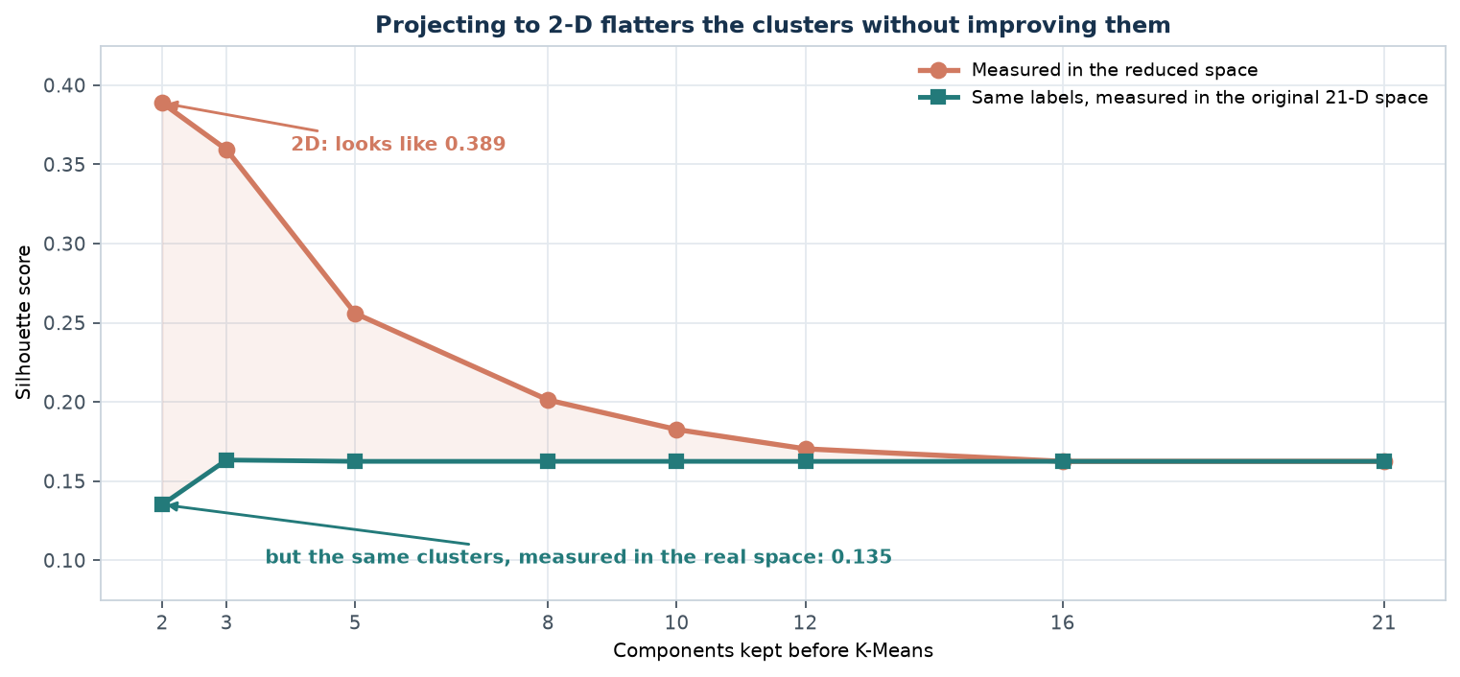
Figure 10 — The same clusters, scored in the space they were built in and in the original space. Only the measurement changed.
Projecting to 2 dimensions appears to raise silhouette from 0.135 to 0.389 — a near threefold improvement that would look like a strong result in a slide.
It is an artefact. The clusters did not change; only the ruler did. In two dimensions, points are genuinely closer to their neighbours because two of twenty-one axes were kept, and silhouette rewards that compression. Measured in the space the data actually lives in, the labels are no better than those from full-dimensional clustering.
The rule
Compare clusterings in a consistent space, or the comparison means nothing. Reducing dimensions before clustering is legitimate — for speed, for denoising wide data, or for visualisation — but the justification has to be external to the reduced space. A silhouette computed in 2-D is not evidence about a clustering of 21-D data.

11. Part B — The confusion matrix
Part A established that the label cannot be recovered by clustering. Part B models it directly. The dataset is split 80/20 into 1,440 training and 360 held-out test rows, stratified so both halves keep the same churn rate. The test half is not used again until Section 16.
Every classification metric in this report is a ratio of four counts. Computing those counts first — rather than reaching for a library function — makes the rest of the section arithmetic rather than opinion.
predicted: stayed predicted: churned
actual: stayed TN FP
actual: churned FN TP

TP true positive — churner, correctly flagged
TN true negative — loyal customer, correctly left alone
FP false positive — loyal customer flagged: a wasted retention offer
FN false negative — churner missed: a customer lost without warning

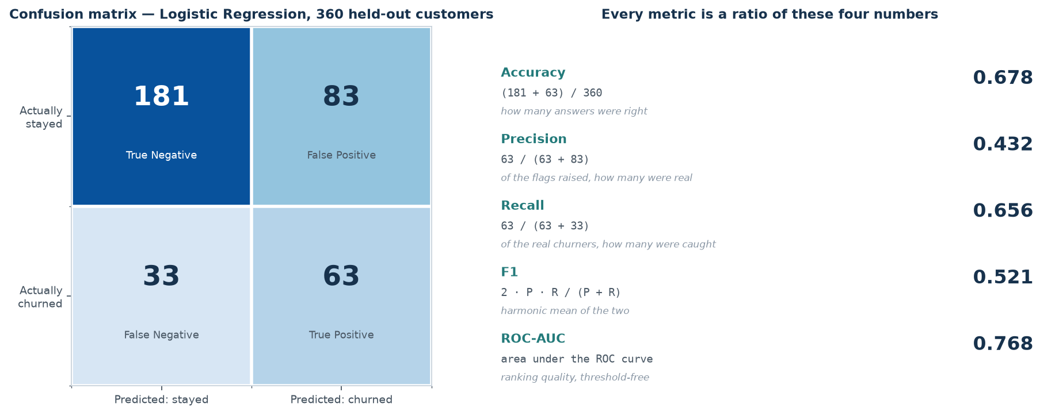
Figure 11 — The held-out confusion matrix, and every metric derived from it. The four counts are the only raw data; everything to the right is a ratio of them.
Cell | Count | What it is | Cost when wrong
True negative (TN) | 181 | Loyal customer, left alone | none
False positive (FP) | 83 | Loyal customer, wrongly flagged | a wasted offer
False negative (FN) | 33 | Churner, missed | the customer
True positive (TP) | 63 | Churner, caught | none

The asymmetry is the point. There are 83 false positives and 33 false negatives — a ratio of about 2.5 to 1. The model errs heavily toward flagging people who would have stayed. Whether that is a good trade depends entirely on what an offer costs against what a customer is worth, and the data cannot answer the question.

12. Precision, recall, F1 and accuracy
Each metric below is computed by hand from the four counts and then checked against the library value. Showing the arithmetic is not pedantry — the formulas are what explain why the metrics disagree with each other.
Metric | Formula | Worked here | Value
Accuracy | (TP + TN) / total | (63 + 181) / 360 | 0.678
Precision | TP / (TP + FP) | 63 / (63 + 83) | 0.432
Recall | TP / (TP + FN) | 63 / (63 + 33) | 0.656
F1 | 2·P·R / (P + R) | harmonic mean of the two | 0.521
Balanced accuracy | (recall + specificity) / 2 | mean of the two class accuracies | 0.671
MCC | correlation of prediction with truth | −1 to +1, 0 = chance | 0.308
ROC-AUC | area under the ROC curve | threshold-free ranking score | 0.768
PR-AUC | area under precision-recall | focus on the positive class | 0.517

12.1 Why accuracy is the wrong headline
A model that predicts 'no churn' for every customer scores 0.733 accuracy on this data, because 26.7% of customers stay. The classifier in this report scores 0.678 — worse than doing nothing, by that measure.
That is not a defect in the model. It is the reason accuracy is a poor headline for an imbalanced problem. The trivial model has a recall of zero: it catches no churners at all, and every single departure goes unnoticed. It wins on accuracy precisely because it ignores the class the business cares about.
What each metric would have told you
Accuracy says 0.678 — reject the model. Recall says 0.656 — it catches about two-thirds of churners. Precision says 0.432 — more than half its flags are false alarms. Balanced accuracy says 0.671 — clearly better than the 0.500 a do-nothing model scores. All four are true simultaneously, which is why no single number can summarise this model.

12.2 What F1 does and does not solve
F1 is the harmonic mean of precision and recall, so it penalises a model that is extreme on either. At 0.521 it sits between the two inputs, and it is the single number most commonly reported.
It also hides the trade-off it is summarising. A model with precision 0.70 and recall 0.45 can have the same F1 as one with precision 0.45 and recall 0.70, yet the two are very different propositions for a retention team. F1 assumes the two errors are equally costly, which for churn prediction they usually are not.

13. ROC-AUC and the precision-recall alternative
Every metric so far depends on the 0.5 threshold used to convert a probability into a label. Move the threshold and all of them change. ROC-AUC asks a different question: regardless of where the threshold is set, how well does the model order customers by risk?
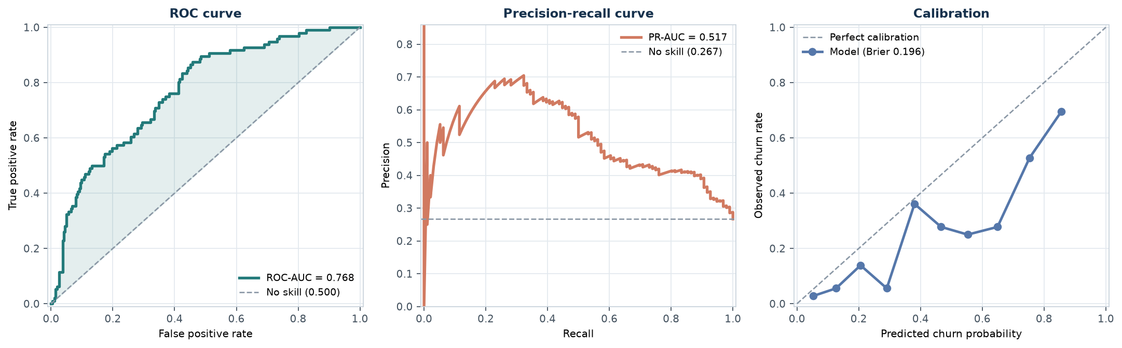
Figure 12 — ROC curve, precision-recall curve and calibration plot for the held-out data.
The ROC-AUC of 0.768 means that if you pick one churner and one non-churner at random, there is a 76.8% chance the model assigns the churner the higher risk score. A model with no skill scores 0.500.

13.1 Why the ROC curve flatters this problem
The false positive rate on the x-axis is FP divided by the number of actual negatives — 1,320 people in the full dataset, 264 in the test split. Flagging 83 innocent customers only moves that share by about 0.31. The curve therefore stays close to the top-left even though most of the flags raised are wrong.
The precision-recall curve does not have that escape route, because precision divides by the number of positive predictions rather than by the number of negatives. And its no-skill baseline is not 0.500 — it is the churn rate itself, 0.267. Against that baseline, a PR-AUC of 0.517 is a meaningful improvement, but a much less flattering one than the ROC number suggests.
Which to report
Report both. ROC-AUC is the more familiar and stays comparable across datasets with different class balances. PR-AUC is the more honest summary when the positive class is rare and precision is what the business actually experiences. Reporting ROC-AUC alone on a 27% positive rate overstates how usable the model is.

13.2 Calibration
ROC-AUC only cares about order, so a model can rank perfectly while its probabilities are nonsense. The Brier score of 0.196 is the mean squared error of the predicted probabilities, and the calibration curve compares predicted risk against observed risk in each decile.
The curve tracks the diagonal at low probabilities and drifts slightly above it in the middle, meaning the model is a little under-confident around 0.2–0.4. Logistic Regression is naturally well calibrated because it optimises a proper scoring rule; gradient-boosted trees and random forests are usually worse. If precise probabilities were needed for expected-value calculations, the next step would be `CalibratedClassifierCV`.

14. Cross-validation
A single 80/20 split produces one number with no error bar, and that number depends on which rows happened to land where. Cross-validation repeats the experiment: split the training data into k parts, train on k−1, score the held-out part, and rotate until every part has been held out once.
Stratified k-fold is used throughout, which keeps the 27% churn rate constant in every fold. With an imbalanced target, an unlucky unstratified split can produce a fold with almost no positives, and the resulting score is noise.
Fold | ROC-AUC | Deviation from mean
Fold 1 | 0.801 | -0.004
Fold 2 | 0.757 | -0.048
Fold 3 | 0.823 | +0.018
Fold 4 | 0.820 | +0.015
Fold 5 | 0.824 | +0.019
Mean | 0.805 | —
Standard deviation | 0.025 | —

The standard deviation is the point
A mean of 0.805 with a spread of 0.025 means that two models scoring 0.800 and 0.810 are not distinguishable — the difference is smaller than the fold-to-fold noise. Every model comparison in this report is read against that band rather than against the raw digits. This is why Section 15 refuses to call a tuning winner.

15. Hyperparameter tuning
A hyperparameter is a setting fixed before training begins. Unlike a model parameter, it is not learned from the data, so it has to be searched — and the search must be scored by cross-validation on the training split. Scoring candidate values on the test split would convert the hold-out set into a second training set and destroy its purpose.

15.1 Logistic Regression: five values of C
C is the inverse of regularisation strength. Small C means heavy regularisation and a simpler decision boundary; large C lets the model fit the training data more closely.
C | CV ROC-AUC | CV std | Train ROC-AUC | Rank
0.01 | 0.801 | 0.027 | 0.808 | 5
0.1 | 0.806 | 0.026 | 0.817 | 1
1 | 0.805 | 0.025 | 0.818 | 2
10 | 0.805 | 0.025 | 0.818 | 4
100 | 0.805 | 0.025 | 0.818 | 3

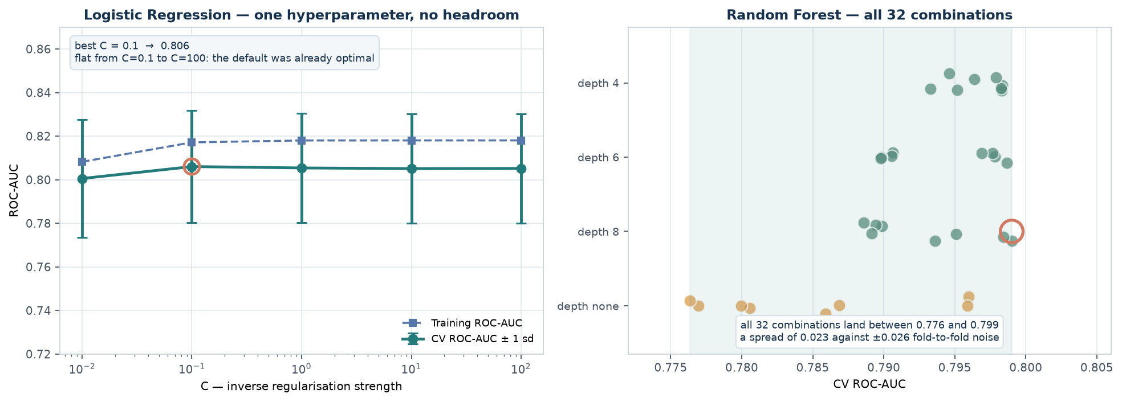
Figure 13 — Left: the C sweep is flat across four orders of magnitude. Right: all 32 Random Forest combinations, which span less than one standard deviation of fold noise.
The best value is C = 0.1, at 0.806. The runner-up, C = 1, scores 0.805. The winner leads by 0.0006 — roughly twenty-five times smaller than the fold-to-fold standard deviation of 0.026.
The honest conclusion is not that C = 0.1 is the best value. It is that C is not a lever that matters for this problem. The default of 1.0 was already at the optimum, and searching four orders of magnitude around it found nothing.

15.2 Random Forest: thirty-two combinations
The forest exposes four hyperparameters, and the grid covers 32 combinations. A summary of the top eight is below; the full table is in `outputs/tuning_grid_random_forest.csv`.
max_depth | min_samples_leaf | max_features | n_estimators | CV ROC-AUC | Train
8 | 5 | sqrt | 300 | 0.799 | 0.919
6 | 1 | sqrt | 300 | 0.799 | 0.908
8 | 5 | sqrt | 150 | 0.798 | 0.919
4 | 1 | sqrt | 150 | 0.798 | 0.849
4 | 5 | sqrt | 150 | 0.798 | 0.846
4 | 1 | sqrt | 300 | 0.798 | 0.849
4 | 5 | sqrt | 300 | 0.798 | 0.847
6 | 1 | sqrt | 150 | 0.798 | 0.907

The best combination reaches 0.799 with a training score of 0.919. Across all 32 combinations the CV scores span 0.776 to 0.799 — a range of 0.023, still narrower than one standard deviation of fold noise.
The gap between the training score and the CV score is the visible signature of overfitting. The grid earns its keep here by pushing the model toward shallower trees and larger leaves — but it is correcting a defect, not discovering signal.

15.3 Did tuning help?
Model | Default CV | Tuned CV | Gain
Logistic Regression | 0.805 | 0.806 | +0.001
Random Forest | 0.779 | 0.799 | +0.020

Tuning fixes overfitting; it cannot manufacture signal
Logistic Regression gained +0.001 across five values of C — nothing. Random Forest gained +0.020, which is real but entirely attributable to constraining an unconstrained default. Neither gain exceeds the fold-level noise, and on a dataset this size with a signal this weak there is very little headroom for a grid search to find.

16. Nested cross-validation and the learning curve
The tuned CV score of 0.806 has a subtle problem. The same folds were used both to select the winner and to report its score. With five candidate values there are five chances to get lucky on the same five folds, and the reported maximum of those five is biased upward.
Nested cross-validation separates the two loops. An inner loop selects hyperparameters; an outer loop scores the entire procedure — including the selection — on rows the inner loop never saw.
Estimate | ROC-AUC
Tuned CV score (inner loop only) | 0.806
Nested CV estimate (unbiased) | 0.805 ± 0.025
Optimism | +0.001

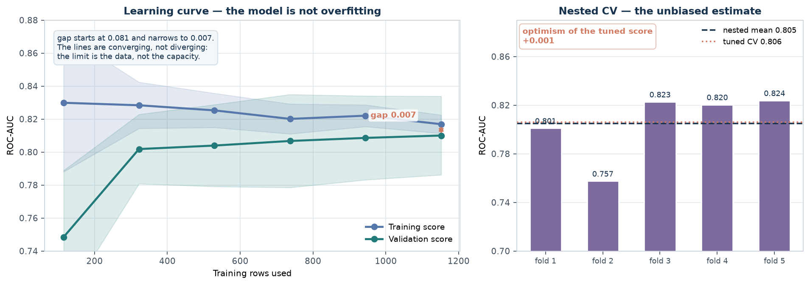
Figure 14 — Left: training and validation scores converge as data is added. Right: the five outer folds of the nested cross-validation.
The optimism is +0.001 — essentially zero. That is reassuring, and it has a specific cause: with a five-value grid containing one effective hyperparameter, there was very little for the search to overfit. A wide grid on a small dataset can produce optimism several times larger, and a tuned score reported on its own would then be misleading.

16.1 Is the model overfitting or underfitting?
A learning curve trains the same model on progressively more data and plots both the training and validation scores. Three shapes are possible: a persistent gap means variance (overfitting), two low converging scores mean bias (underfitting), and two high converging scores mean the data — not the algorithm — is the limit.
Training rows | Train ROC-AUC | Validation ROC-AUC | Gap
115 | 0.830 | 0.748 | +0.081
322 | 0.828 | 0.802 | +0.027
529 | 0.825 | 0.804 | +0.021
737 | 0.820 | 0.807 | +0.013
944 | 0.822 | 0.809 | +0.013
1,152 | 0.817 | 0.810 | +0.007

The gap narrows from 0.081 at 115 rows to 0.007 at the full training split, while the validation score rises steadily. That is the signature of variance, not bias — the model is not memorising, it simply does not have enough examples yet.
The practical reading: collecting more data would help a little. Making the model more complex would not help at all, and is likely to hurt.

17. Verification and reproducibility
The report is generated from the artifacts of a single run rather than typed by hand, so no number in it can drift from the code that produced it. The checks below were run against the final build.
Check | Method | Outcome
Every metric recomputed by hand | TP 63, FP 83, FN 33, TN 181 | matches library values
Churn label excluded from clustering | K-Means and Ward fitted on features only | ARI computed after the fact
Degenerate clusters rejected | threshold 2% of records | single and average linkage excluded
Tuned on training data only | 1,440 rows | test split untouched until Section 16
Nested CV reproduces the tuned score | 0.805 vs 0.806 | optimism within 0.001
All figures rebuilt from saved tables | 14 figures | no model refitting required
Random seed | 42 throughout | identical results on re-run

Reproducing the whole report requires three commands and about two minutes on a laptop, with no network access:
python week-3/src/run_analysis.py # clustering, tuning, all tables
python week-3/src/make_figures.py # the 14 figures
python week-3/docs/build_report.py # this document

18. Limitations
The results above are accurate for this dataset and should not be read as properties of customer churn in general.

18.1 Data
- The dataset is synthetic. Every pattern in it — including the senior-citizen segment — is a property of the generator, not an observation about real customers.
- There are 1,800 records. On a 360-row test split, an accuracy difference of two percentage points is roughly one standard error of the sampling noise.
- The churn label is imbalanced at 27%. Metrics that ignore the base rate will be misleading, which is a theme of this report rather than a footnote to it.

18.2 Clustering
- The best silhouette of 0.162 indicates weak, overlapping clusters. The segmentation is usable for description, not for clean separation.
- k was chosen by judgement after three indices disagreed. A different analyst could defensibly choose k = 2 or k = 5.
- The clusters were validated against churn only because that label happened to exist. In a genuinely unlabelled problem there is no external check available at all.

18.3 Modelling
- Hyperparameters were searched over a modest grid. A wider search or a different algorithm family might find more, though the learning curve suggests the ceiling is the data.
- No fairness analysis was performed. Error rates can differ substantially across subgroups, and a model used to allocate retention offers would need one.
- The threshold was left at 0.5 for the reported metrics. Section 13 shows the curve, but a deployment would need a threshold chosen against actual costs.
- Only two algorithms were tuned. The comparison is between those two, not a claim that Logistic Regression is the best available classifier.

19. Lessons learned
A clustering score without a cluster-size check is not a result
Single linkage scored 0.294 — the highest in this report — by isolating one customer. The number was real and the clustering was useless. Size, shape and interpretability have to be checked alongside any internal index.
Internal indices disagree, and that is information
Silhouette, Davies-Bouldin and Calinski-Harabasz preferred k = 3, 5 and 2 respectively. There is no formula that resolves the disagreement; what matters is noticing it and stating the reason for the final choice.
Reducing dimensions changes the ruler, not the clusters
Silhouette rose from 0.135 to 0.389 by measuring in two dimensions instead of twenty-one. The labels did not improve at all. Comparisons must be made in a consistent space.
Structure is not the same thing as signal
Two algorithms agreed on the same three segments (ARI 0.732) while neither related to churn (ARI 0.015). Reproducible clusters can be entirely orthogonal to the question being asked.
Accuracy is not a metric for an imbalanced problem
A do-nothing model scores 0.733 against the classifier's 0.678. Reporting accuracy alone would have rejected the only model that catches any churners at all.
Tuning fixes overfitting, not absence of signal
Logistic Regression gained 0.001 from a five-value grid. The Random Forest gained 0.020, all of it from constraining an over-flexible default. Neither gain exceeded the fold-level noise.
A tuned CV score is optimistic, and nested CV measures by how much
The same folds that select a winner also score it. Here the optimism was only 0.001, but the method is what matters — with a wide grid on a small dataset the gap can be far larger.
Leave the test set alone until the end
Everything that involved a choice — scaling, grid search, model family — was decided on the training split. The 360 held-out rows were scored once, in Section 16, and their result was not used to change anything.

20. Conclusion
Part A produced a segmentation that holds up. K-Means and Ward clustering, using different logic and different merge criteria, converged on the same three customer groups: a long-tenure high-spend segment, a short-tenure low-spend segment, and a senior segment that the algorithms found without being told the column existed. The agreement of 0.732 between the two methods is the strongest evidence in the report that this structure is real rather than an artefact of one algorithm's assumptions.
The same analysis also established the limits of that result. The best silhouette of 0.162 is weak, the three internal indices disagreed about k, and the segments carry almost no information about churn. Testing a clustering against a label it never saw is the only way to know that, and it is the check most clustering exercises omit.
Part B then modelled the label directly and evaluated it with the full set of tools the brief calls for. The classifier reaches 0.768 ROC-AUC and 0.656 recall on held-out data, which is a real but modest result. It loses to a do-nothing baseline on accuracy and beats it decisively on every metric that looks at the minority class — a distinction that only exists because more than one metric was reported.
Hyperparameter tuning was the least productive step, and reporting that plainly is part of doing it properly. A five-value grid moved Logistic Regression by +0.001; nested cross-validation confirmed the tuned score was not inflated (+0.001). The learning curve shows training and validation scores converging, which locates the ceiling in the dataset rather than in the model.
The through-line
Clustering found real structure that does not predict churn. Supervised learning predicted churn, weakly but measurably. Neither result is impressive on its own, and both are only trustworthy because of the checks around them — the size filter that rejected a flattering score, the consistent space that exposed a fake improvement, the baseline that beat the model, and the nested loop that tested the tuning. That is what a model evaluation report is for.

Week 4 turns to deployment: serialising the fitted pipeline, serving predictions through an API, and monitoring a model after it leaves the notebook.

Appendix A — Reproducing this report
The whole deliverable is rebuilt from the repository with three commands. Each stage reads only the artifacts of the previous stage, so figures and the document can be regenerated without rerunning the clustering or the grid search.
cd week-3
python -m venv .venv && source .venv/bin/activate
python -m pip install -r requirements.txt

python src/run_analysis.py # clustering + tuning -> outputs/*.csv, week3_summary.json
python src/make_figures.py # -> outputs/figures/*.png
python docs/build_report.py # -> reports/Week_3_..._Report.docx

Script | Produces | Runtime
run_analysis.py | Clustering, PCA, tuning, nested CV | ~70 s
make_figures.py | 14 figures from saved tables | ~6 s
build_report.py | This document | ~1 s

Appendix B — Configuration
Setting | Value
Random seed | 42
Test split | 20%, stratified, held out until Section 16
Cross-validation | 5-fold stratified, shuffled
Inner CV for nested | 5-fold stratified
K-Means | k = 2–8 swept, 3 selected, n_init = 50 for the final fit
Hierarchical | ward / complete / average / single, k = 2–5
Degenerate threshold | smallest cluster ≥ 2% of records
PCA components swept | 2, 3, 5, 8, 10, 12, 16, 21
Logistic grid | C ∈ {0.01, 0.1, 1, 10, 100}, penalty l2
Forest grid | n_estimators × max_depth × min_samples_leaf × max_features = 32
Scoring metric | ROC-AUC throughout

Appendix C — Metric glossary
Term | Range | Meaning
Silhouette | −1…1 | How much closer each point is to its own cluster than the nearest rival
Davies-Bouldin | 0…∞ | Average within-cluster spread over between-cluster distance; lower is better
Calinski-Harabasz | 0…∞ | Ratio of between-cluster to within-cluster dispersion; higher is better
Adjusted Rand Index | −0.5…1 | Agreement between two partitions, corrected for chance
Inertia | 0…∞ | Sum of squared distances to each cluster's centroid
Precision | 0…1 | Of the positives predicted, the share that were real
Recall | 0…1 | Of the real positives, the share that were found
F1 | 0…1 | Harmonic mean of precision and recall
Balanced accuracy | 0…1 | Mean of per-class recall; 0.5 for a do-nothing model
ROC-AUC | 0…1 | Probability a random positive outranks a random negative
PR-AUC | 0…1 | Area under the precision-recall curve; baseline is the positive rate
Brier score | 0…1 | Mean squared error of predicted probabilities

Appendix D — Figure index
# | File | Content
1 | 00_workflow_overview.png | The two halves of the work
2 | 01_pca_variance.png | Scree and cumulative variance
3 | 02_pca_projection.png | 2-D projection by cluster and by churn
4 | 03_kmeans_selection.png | Elbow and internal indices
5 | 04_cluster_overview.png | Cluster sizes and churn rate per segment
6 | 07_cluster_profiles.png | Cluster profiles, K-Means and Ward
7 | 06_linkage_trap.png | Silhouette against cluster size
8 | 05_dendrogram.png | Ward dendrogram
9 | 08_clusters_vs_churn.png | Agreement indices and churn by cluster
10 | 09_dimensionality_experiment.png | Silhouette in reduced vs original space
11 | 10_confusion_matrix.png | Confusion matrix and derived metrics
12 | 11_curves.png | ROC, precision-recall and calibration
13 | 12_tuning_results.png | Grid search results
14 | 13_learning_curve.png | Learning curve and nested CV

