Week 1 — Data Preprocessing
Python fundamentals • NumPy • Pandas • Exploratory analysis
COMPLETED PROJECT REPORT • Yuva Internship
Project repository: https://github.com/Dhanam33/Yuva_intern/tree/arena/01a1004b-yuva-intern

Executive summary
This report loads, audits, explores, cleans, and transforms a sample dataset for a machine-learning workflow. It demonstrates numeric and categorical missing-value handling, encoding, scaling, and feature selection, with reproducible outputs in the repo.
Dataset measure | Result
Source | Synthetic customer-churn sample (seed 2026; not real customer data)
Rows | 1,800
Input features before encoding | 11
Raw missing feature cells | 562
Churn labels | No 1,320; Yes 480 (26.7% Yes)
Encoded/scaled feature columns | 25
Missing cells after transformation | 0

Data loading and quality audit
The raw CSV contains a customer identifier, 11 model inputs, and a Yes/No target. The identifier is preserved in the clean export for traceability but excluded from model inputs. Duplicate rows and duplicate IDs are checked before analysis; none were found in the seeded sample. The target remains complete so records can be used consistently.
Feature | Missing cells | Missing %
tenure_months | 77 | 4.28%
monthly_charges | 78 | 4.33%
total_charges | 74 | 4.11%
support_tickets | 89 | 4.94%
senior_citizen | 0 | 0.00%
contract | 47 | 2.61%
internet_service | 42 | 2.33%
payment_method | 52 | 2.89%
paperless_billing | 36 | 2.00%
partner | 33 | 1.83%
dependents | 34 | 1.89%

Exploratory data analysis
The target plot makes the 26.7% positive-class share visible. The contract comparison shows lower observed churn among longer-term contracts in this generated sample. These patterns are descriptive, not causal, and should not be generalized to real customers.
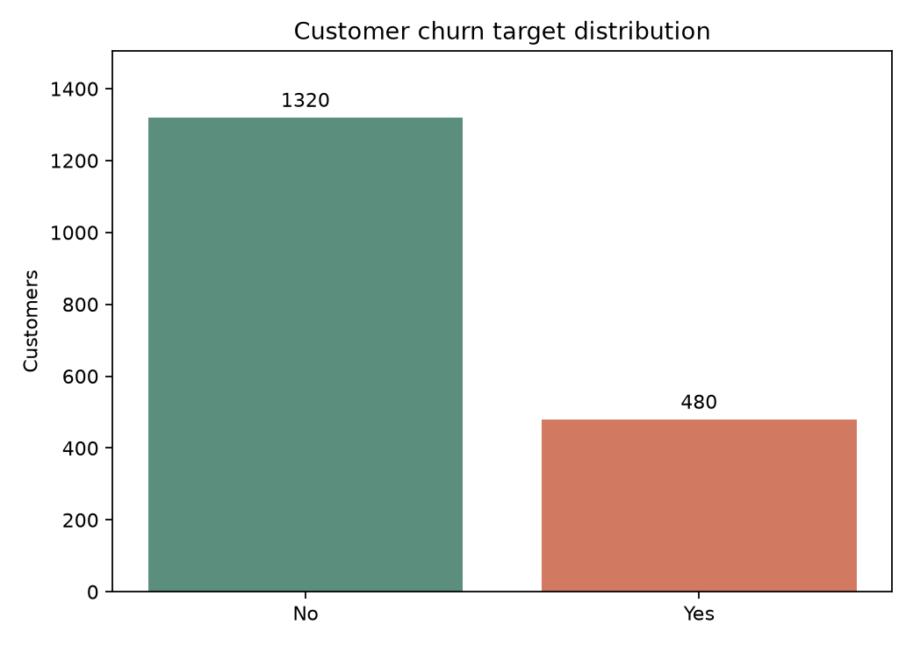
Figure 1. Distribution of the churn target.
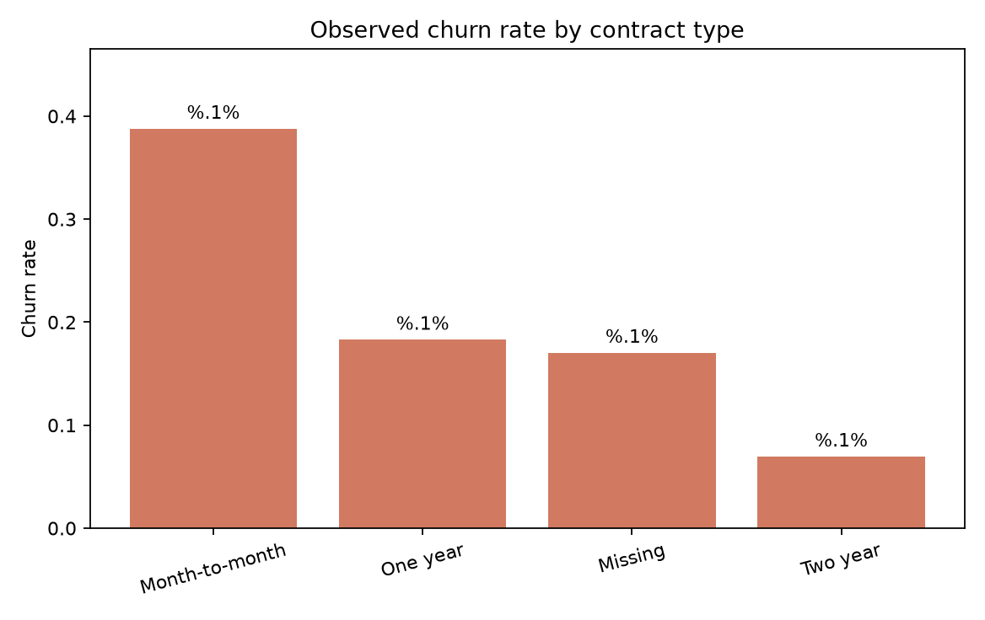
Figure 2. Descriptive churn rate by contract; missing contract values are shown separately.

Preprocessing decisions
- Numeric input columns: fill missing values with the median and add indicators for fields that were missing; standardize with StandardScaler.
- Categorical input columns: fill missing values with the most frequent value, then apply one-hot encoding with handle_unknown='ignore'.
- Target: map No to 0 and Yes to 1. Customer ID is not a predictor; duplicate records/IDs are audited.
- Feature selection: rank transformed predictors by mutual information with the churn label and export the top ten for exploratory inspection; this ranking is not used in the model evaluations.
- Evaluation safety: the all-row transformed CSV is a Week 1 teaching artifact; later model scripts fit preprocessing only within train/CV folds. Any feature selection used for modeling should also be fitted within those folds.
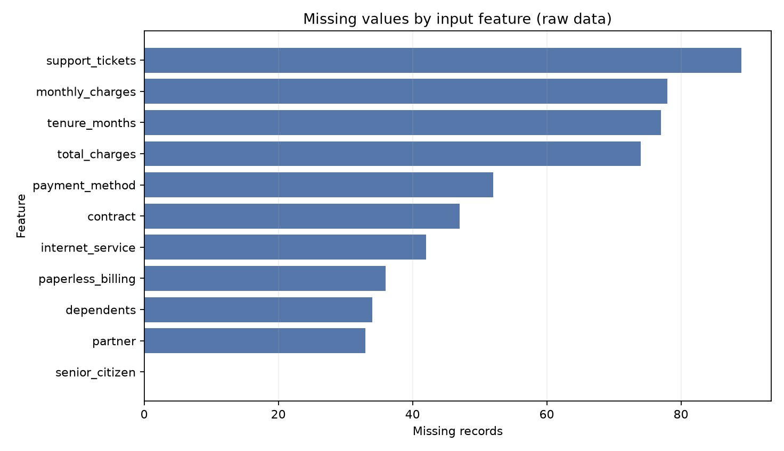
Figure 3. Missingness audit before imputation.

Top ten features by mutual information
Rank | Encoded feature | Mutual information
1 | monthly_charges | 0.0762
2 | internet_service_Fiber optic | 0.0422
3 | contract_Month-to-month | 0.0399
4 | contract_Two year | 0.0304
5 | internet_service_No | 0.0212
6 | internet_service_DSL | 0.0125
7 | support_tickets | 0.0078
8 | contract_One year | 0.0064
9 | senior_citizen | 0.0055
10 | missingindicator_monthly_charges | 0.0039

Files produced
- outputs/missing_value_audit.csv — raw counts, percentages, and dtypes.
- outputs/preprocessed_customer_churn.csv — complete imputed, scaled, encoded demonstration table.
- outputs/selected_feature_dataset.csv and outputs/feature_selection.csv — top-feature export and ranking.
- outputs/plots/ — missingness, target balance, and contract/churn visualizations.

Limitations
The dataset is synthetic by design. Median/mode imputation and mutual-information ranking are baseline teaching choices; a real project would validate assumptions, consider missingness mechanisms and fairness, and select features using training data only.

Submission description (215 words)
This Week 1 report documents a complete Python-based data-preparation workflow using Pandas, NumPy, and scikit-learn. The example is a reproducible synthetic customer-churn dataset containing 1,800 rows, numeric and categorical input fields, a binary churn label, and deliberately introduced missing values. The report begins by describing the dataset structure, data types, label balance, duplicate checks, and missing-value audit. It then presents exploratory plots and explains why the customer identifier is not used as a model feature. Numeric gaps are filled with median estimates and categorical gaps with most-frequent values; missingness indicators are retained for numeric fields. Categorical variables are one-hot encoded with support for unseen categories, while numeric inputs are standardized. The churn target is mapped from No and Yes to zero and one. Mutual information is used to rank the encoded features, and both the complete transformed table and a top-ten-feature export are included as reproducible artifacts. The report distinguishes these all-row teaching exports from model evaluation: later training and cross-validation pipelines learn imputation and scaling only from their training folds to prevent leakage. Finally, it records the limitations of generated data and points to the scripts, audit tables, and visualizations needed to repeat the work. Companion notes introduce Python variables, functions, NumPy arrays, Pandas tables, model metrics, and leakage concepts in beginner-friendly language.

