Week 3 — Unsupervised Learning & Evaluation
Clustering • PCA • cross-validation • model evaluation
COMPLETED PROJECT REPORT • Yuva Internship
Project repository: https://github.com/Dhanam33/Yuva_intern/tree/arena/01a1004b-yuva-intern

Executive summary
This report evaluates K-Means and Agglomerative clustering, uses PCA for visualization, and tunes a supervised Logistic Regression model with stratified cross-validation. Clustering excludes the churn target; evaluation metrics use a separate held-out split.

Clustering experiments
Numeric and categorical features are imputed, scaled, and encoded before clustering. For each algorithm, candidate values k=2 through k=6 are scored with the silhouette coefficient on a seeded sample of 1,000 rows. The best score in this run is Agglomerative Clustering with k=4 (silhouette 0.355).
Algorithm | k | Silhouette | Sampled rows
Agglomerative | 4 | 0.355 | 1000
Agglomerative | 5 | 0.350 | 1000
Agglomerative | 3 | 0.346 | 1000
Agglomerative | 2 | 0.333 | 1000
K-Means | 5 | 0.175 | 1000
K-Means | 6 | 0.168 | 1000
Agglomerative | 6 | 0.157 | 1000
K-Means | 4 | 0.157 | 1000
K-Means | 3 | 0.140 | 1000
K-Means | 2 | 0.120 | 1000

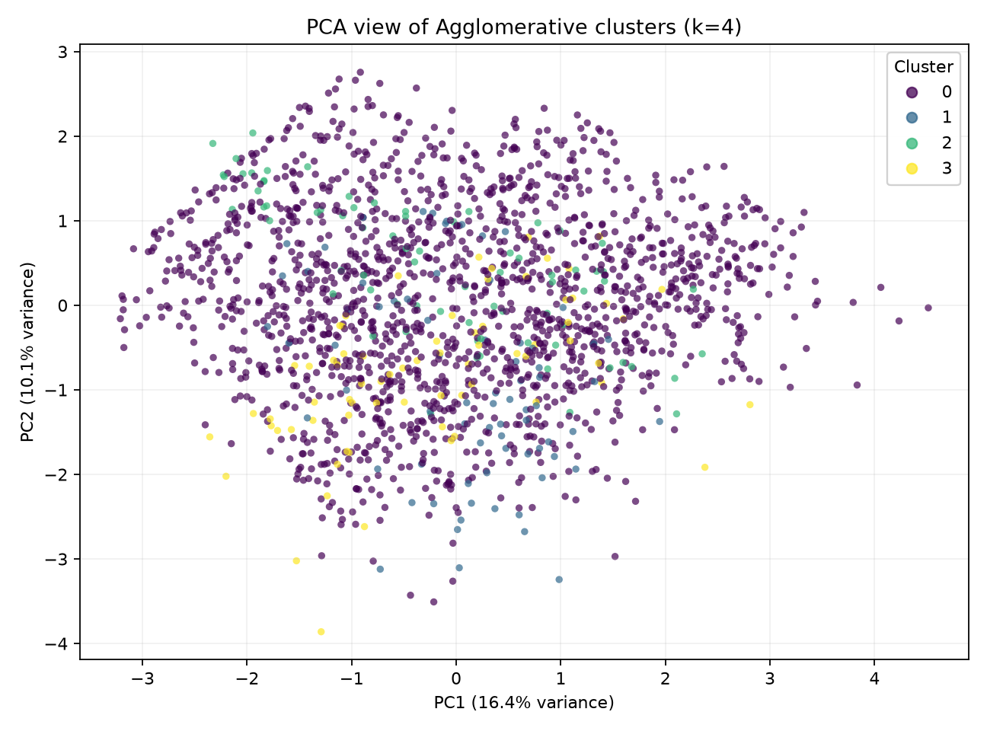
Figure 1. PCA projection colored by the highest-silhouette clustering labels; clustering used the complete encoded feature space.
The first two principal components explain 26.6% of the variance in transformed features. PCA is used only to display a high-dimensional dataset in two dimensions; clustering itself uses all transformed features.

Cluster composition and caution
Cluster | Customers | Churn count | Churn rate
0 | 1579 | 421 | 26.7%
1 | 74 | 22 | 29.7%
2 | 75 | 21 | 28.0%
3 | 72 | 16 | 22.2%

The selected four-cluster solution is strongly imbalanced: most observations are in one cluster while three smaller groups contain only a few dozen records each. The silhouette score is a geometric separation measure, not proof of useful or stable customer segments. Cluster sizes, robustness, domain meaning, and alternative distance/scaling choices should be investigated before acting on any segmentation. Churn rates above are descriptive only.

Cross-validation and hyperparameter tuning
A five-fold StratifiedKFold grid search evaluates Logistic Regression regularization values C = 0.1, 1, and 10 using ROC-AUC. Each fold refits preprocessing on its own training partition. The best parameter is C=0.1, with mean cross-validation ROC-AUC 0.802 ± 0.022.
C | Mean CV ROC-AUC | Std. dev. | Mean training ROC-AUC
0.1 | 0.802 | 0.022 | 0.818
1 | 0.801 | 0.022 | 0.819
10 | 0.801 | 0.022 | 0.819

Held-out test evaluation
Accuracy | Balanced acc. | Precision | Recall | F1 | ROC-AUC
67.5% | 66.9% | 42.9% | 65.6% | 51.9% | 0.766

Actual / Predicted | No | Yes
No | 180 | 84
Yes | 33 | 63

The matrix contains true negatives, false positives, false negatives, and true positives in that order by row. Recall emphasizes finding actual churners; precision reflects how many flagged customers are actual churners. The test set was not used to tune C. The metrics characterize this synthetic sample and one fixed random split, not future customers.

Reproducibility
Run `python -m yuva_ml.week3_unsupervised`. Candidate cluster scores, PCA coordinates, cluster composition, cross-validation results, the tuned confusion matrix, and JSON summaries are stored under outputs/.

Submission description (214 words)
This Week 3 report combines unsupervised learning with a careful evaluation of the supervised churn classifier. K-Means and Ward-linkage Agglomerative Clustering are run on imputed, scaled, and one-hot-encoded customer features for candidate cluster counts from two through six. The churn label is deliberately left out of clustering; it is used only afterward to describe the composition of the selected groups. Silhouette scores are compared on a reproducible sample of up to 1,000 observations, and a two-component PCA plot visualizes the selected clustering solution. The report discusses both the highest-scoring Agglomerative result and its important limitation: the four-cluster solution is highly imbalanced, so its silhouette value should not be mistaken for proof of four stable business segments. For model evaluation, a five-fold stratified grid search tunes Logistic Regression regularization on training data only. The best mean cross-validation ROC-AUC is approximately 0.802 with a standard deviation of 0.022, and the selected model is evaluated once on the untouched test split. The report includes the confusion matrix and accuracy, precision, recall, F1, and ROC-AUC, explaining how false positives and false negatives differ. It also records the PCA variance, tuning table, cluster metrics, and limitations of the synthetic sample. Reproducible scripts and CSV/JSON outputs are supplied so each score and visualization can be regenerated.

