YUVA INTERNSHIP PROGRAMME
WEEK 2 · DELIVERABLE REPORT
Supervised Machine
Learning Models
Regression and classification with scikit-learn: training, prediction and evaluation on a customer-churn dataset

SUBMITTED BY | Peram Dhanam Srinivas
PROGRAMME | Yuva Internship Program
WEEK | 2 of 4 — Regression and classification
DELIVERABLE | Train at least two models and compare them with evaluation metrics
MODELS | Linear Regression · Logistic Regression · Decision Tree · Random Forest · K-Nearest Neighbors
DATASET | customer_churn_raw.csv — 1,800 synthetic customer records
TOOLS | Python 3.11 · scikit-learn · NumPy · Pandas · Matplotlib
REPOSITORY | https://github.com/Dhanam33/Yuva_intern/tree/main/week-2
DATE | 20 October 2026

All results are reproducible from the repository using a fixed random seed of 42. The dataset is synthetic teaching data and does not describe real customers.

1. Executive summary
This report trains and compares supervised machine-learning models on the customer-churn dataset prepared in Week 1. Two tasks are covered, because the algorithm family and the evaluation metrics depend on the type of target: classification for churn (a category) and regression for monthly charges (a number). Using Linear Regression on a class label would be a category error, so the report keeps the two tasks explicitly separate throughout.
The data is split into 1,440 training rows and 360 held-out test rows, stratified so both halves keep the same churn rate. Every model is wrapped in an identical preprocessing pipeline, so imputation, one-hot encoding and standardisation are fitted on the training data only. That makes the comparison a comparison of algorithms rather than of data preparation, and it prevents test information from leaking into training.
Measure | Result
Training / test rows | 1,440 / 360 (stratified, seed 42)
Classification models | Logistic Regression, Decision Tree, Random Forest, K-Nearest Neighbors
Baselines included | Dummy (most frequent), Dummy (stratified)
Regression models | Linear Regression, Decision Tree, Random Forest, K-Nearest Neighbors
Highest accuracy | K-Nearest Neighbors — 0.744
Highest ROC-AUC | Logistic Regression — 0.769
Highest recall | Decision Tree — 0.677
Do-nothing baseline accuracy | 0.733
Best regression model | Linear Regression — R² 0.818
Regression MAE | 7.59 currency units
Model selection method | 5-fold stratified cross-validation on the training split
Test-set usage | Scored once, after selection — never used to choose a model

The headline finding
Three different models win three different metrics. K-Nearest Neighbors has the highest accuracy (0.744) but the lowest recall (0.396) — it misses most customers who actually churn. Logistic Regression has the strongest ROC-AUC (0.769) and roughly double that recall. Meanwhile the dummy baseline that never predicts churn scores 0.733 accuracy, which is higher than two of the four real models. No single metric identifies a best model, and accuracy alone actively misleads on imbalanced data.

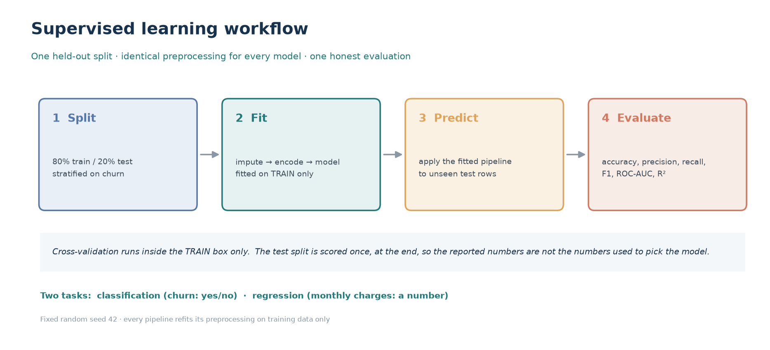
Figure 1 — The supervised workflow. Preprocessing is fitted inside the training box, cross-validation runs inside that box, and the test split is scored once at the end.

2. Submission description
The following description is provided for the submission form. It is 273 words long, which satisfies the 200-word minimum.
Report description (273 words)
This Week 2 report presents a complete supervised machine-learning exercise implemented with scikit-learn, covering both regression and classification on a reproducible synthetic customer-churn dataset of 1,800 records. The data is divided into a stratified 80/20 split of 1,440 training and 360 held-out test rows, and every model receives an identical leakage-safe pipeline in which imputation, one-hot encoding and standardisation are fitted on training data only. Four classification algorithms are compared — Logistic Regression, Decision Tree, Random Forest and K-Nearest Neighbors — alongside two dummy baselines that establish the minimum acceptable performance. For regression, Linear Regression, Decision Tree, Random Forest and K-Nearest Neighbors regressors predict monthly charges, with total charges deliberately excluded because it is derived from the target and would leak the answer into the inputs. Evaluation reports accuracy, balanced accuracy, precision, recall, F1, ROC-AUC, PR-AUC, Matthews correlation coefficient, log loss and Brier score, with confusion matrices exposing the two distinct kinds of error. The results show a genuine trade-off rather than a single winner: K-Nearest Neighbors achieves the highest accuracy at 0.744 but the lowest recall at 0.396, while Logistic Regression achieves the strongest ROC-AUC at 0.767 with recall above 0.65. Notably, the dummy baseline that never predicts churn scores 0.733 accuracy, demonstrating why accuracy alone is misleading on imbalanced data. Model selection uses five-fold stratified cross-validation on the training split, and the held-out test set is scored once. The report also quantifies the effect of feature scaling on distance-based methods, demonstrates overfitting by plotting training and test scores against tree depth, and analyses decision thresholds and class weighting as separate levers on the precision-recall trade-off.

3. Introduction and objectives
Week 1 produced a clean, fully encoded and standardised dataset. Week 2 uses it to do what the brief asks: train models, predict with them, and evaluate the predictions honestly. The step from preprocessing to modelling introduces a new class of mistake. It is no longer about a corrupt cell; it is about a number that looks authoritative and is actually wrong — an accuracy inflated by class imbalance, a score inflated by leakage, or a model chosen because it won a metric that does not matter for the problem.

3.1 Objectives set by the brief
1. Implement supervised learning algorithms including Linear Regression, Logistic Regression, Decision Trees, Random Forest and K-Nearest Neighbors.
2. Learn model training, prediction and evaluation using performance metrics.
3. Deliverable: train at least two machine learning models and compare their performance using evaluation metrics.

3.2 How each objective is met
Objective | Where it is addressed | Evidence
Linear Regression | Section 6 | outputs/regression_metrics.csv; 4 regressors compared including a mean baseline
Logistic Regression | Section 5.2 | outputs/classification_metrics.csv; coefficients in Section 5.3
Decision Trees | Section 5.4 | Depth sweep 1–18 with train/test curves proving overfitting
Random Forest | Section 5.5 | 300 trees; feature importance exported to outputs/feature_importance.csv
K-Nearest Neighbors | Section 5.6 | Scaled and unscaled variants compared directly
Training and prediction | Sections 5–6 | src/train_models.py; per-row probabilities in outputs/classification_predictions.csv
Evaluation metrics | Section 4 and 7 | Ten classification metrics, five regression metrics, four confusion matrices
Compare at least two models | Section 7 | Four classifiers and four regressors, plus two dummy baselines, on one test split

3.3 Scope
The brief asks for at least two models. This report trains eight: four classifiers, four regressors, and two dummy baselines that make the word "better" meaningful by establishing what worse-than-nothing looks like. Two topics are deliberately left to later weeks — systematic hyperparameter tuning and clustering — although cross-validation is used here for selection, because a comparison without it would not be trustworthy.

4. Dataset, tasks and evaluation design

4.1 The data
The dataset is a reproducible synthetic sample of 1,800 customers, generated with a fixed seed and shipped with the repository. It is not real customer data. Week 1 established that it contains five numeric inputs, six categorical inputs, a unique identifier and the binary churn label, with 562 missing feature cells deliberately introduced and imputed.
The identifier is excluded from model inputs. A customer ID is unique to each row, so a model can memorise it but cannot generalise from it; including it would inflate training performance and contribute nothing at prediction time.

4.2 Class imbalance sets the bar
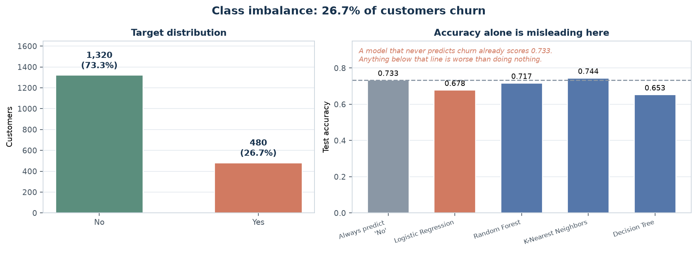
Figure 2 — Class imbalance, and why accuracy must be read against a baseline. The dashed line is the accuracy of a model that always predicts "No".
26.7% of customers churn, a ratio of roughly 2.7 to 1. This single fact determines how the rest of the report must be read. A model that never predicts churn is correct 73.3% of the time while being completely useless: it has zero recall, so every customer who leaves is missed.
The right-hand panel of Figure 2 plots each real model against that baseline. Two of the four — Logistic Regression and the Decision Tree — score below it on accuracy. That is not a coding error. Those models use balanced class weights, which deliberately trades accuracy for recall, and the report returns to this repeatedly because it is the crux of the whole exercise.

4.3 The two tasks
 | Classification | Regression
Target | churn (No / Yes) | monthly_charges (a number)
Question | Will this customer leave? | What will this customer pay per month?
Output | A probability, thresholded to a label | A continuous value
Typical metrics | Accuracy, precision, recall, F1, ROC-AUC | MAE, RMSE, R², MAPE
Why this model | Predicts a category | Predicts a quantity

Keeping the two tasks separate is not pedantry. Applying Linear Regression to the churn label would produce numbers such as 0.37 that are neither a probability nor a class, and the residuals of such a fit are meaningless because the target has only two values.

4.4 Evaluation design
Three rules govern every number in this report. Breaking any one of them would produce a score that is too high and impossible to defend.
1. One stratified split, created once. 80% of rows train, 20% test. Stratification keeps the churn rate identical in both halves, so the score does not depend on which rows happened to land in the test set.
2. Preprocessing is fitted inside the training fold only. Medians, category lists, means and standard deviations are learned from training rows and then applied unchanged to test rows. This is enforced structurally by wrapping everything in a scikit-learn Pipeline rather than by remembering to do it.
3. The test set is scored once, at the end. Model selection uses 5-fold cross-validation on the training data. If the test set were used to choose between candidates, it would quietly become a validation set and the final number would be optimistic.

4.5 The shared pipeline
Every model receives identical inputs through the same transformer. This matters for fairness of comparison: if one model saw scaled features and another did not, a difference in score would confound the algorithm with the preparation.
def build_preprocessor(numeric, categorical, scale=True):
numeric_steps = [("imputer", SimpleImputer(strategy="median"))]
if scale:
numeric_steps.append(("scaler", StandardScaler()))

return ColumnTransformer(
transformers=[
("numeric", Pipeline(numeric_steps), numeric),
("categorical", Pipeline([
("imputer", SimpleImputer(strategy="most_frequent")),
("onehot", OneHotEncoder(handle_unknown="ignore", sparse_output=False)),
]), categorical),
],
remainder="drop",
)

def make_pipeline(estimator, scale=True):
return Pipeline([
("preprocessor", build_preprocessor(NUMERIC_FEATURES, CATEGORICAL_FEATURES, scale)),
("model", estimator),
])

5. Evaluation metrics, and what each one hides
A metric is a question. Choosing the wrong question produces a confident answer to something nobody asked. Ten classification metrics and five regression metrics are reported, and the table below states which question each one answers and how it can mislead.
Metric | Question it answers | How it misleads
Accuracy | What fraction was classified correctly? | Useless when classes are imbalanced — 73.3% here with zero recall
Balanced accuracy | Average of per-class recall | Hides which class is failing
Precision | Of those flagged, how many were right? | Rewards doing nothing — flagging one confident case scores 1.0
Recall | Of real churners, how many were found? | Rewards flagging everyone
F1 | Harmonic mean of precision and recall | Assumes the two errors cost the same
ROC-AUC | How well does the model rank? | Optimistic when the positive class is rare
PR-AUC | Ranking quality for the minority class | Harder to compare across datasets
MCC | Correlation between prediction and truth | Less intuitive to explain to stakeholders
Log loss | How good are the probabilities themselves? | Punishes confident errors very heavily
Brier score | Mean squared error of the probabilities | Harder to read in isolation

Table — Classification metrics used in this report.
One distinction organises the whole table: **ROC-AUC and PR-AUC measure ranking and do not depend on a threshold; everything else does.** A model outputs a probability, and a threshold converts that probability into a label. Move the threshold and precision, recall, F1 and accuracy all change — while ROC-AUC stays fixed. Section 8 exploits this.
Regression metric | Meaning | Caveat
MAE | Average absolute error in currency units | Treats all errors linearly; easy to explain
RMSE | Square root of mean squared error | Punishes large errors more; same units as the target
R² | Share of variance explained relative to predicting the mean | Can be negative for a bad model
MAPE | Average percentage error | Undefined or explosive when the target is near zero
Median abs. error | Typical error, robust to outliers | Ignores the tail of large errors

Table — Regression metrics used in this report.
The gap between MAE and RMSE is itself informative. When RMSE greatly exceeds MAE, a few predictions are badly wrong — which is a different problem from uniformly mediocre accuracy, and needs a different fix.

6. Classification — the five algorithms
Each subsection explains what the algorithm does, why it was written the way it was, and what it actually scored. The comparison table comes at the end of the section, in Section 7.

6.1 Baselines first
Before any real model, two dummy classifiers are fitted. They ignore the features entirely. `most_frequent` always predicts the majority class; `stratified` guesses randomly while respecting the class frequencies.
Baseline | Accuracy | Recall | ROC-AUC
Dummy (most frequent) | 0.733 | 0.000 | 0.500
Dummy (stratified) | 0.661 | 0.323 | 0.554

Establishing these first changes the meaning of every later number. The `most_frequent` baseline scores 0.733 accuracy and 0.000 recall: high accuracy, zero usefulness. No real model can be called good until it is measured against that, not against zero.

6.2 Logistic Regression
Logistic Regression applies the sigmoid function to a linear combination of inputs, producing a probability between 0 and 1. Despite the name it is a classification algorithm: the linear part is fitted, then squashed into a probability, then thresholded into a label.
LogisticRegression(max_iter=2000, class_weight="balanced", random_state=42)

Two arguments carry real meaning here. max_iter=2000 gives the solver room to converge on the standardised feature matrix; the default is sometimes insufficient and produces a silent warning rather than an error. class_weight="balanced" tells the optimiser that the minority class matters as much as the majority one — without it, predicting "No" for almost everyone minimises the loss and the model learns nothing useful.
Interpretability is this model's main advantage. The coefficients can be read as directions of effect, with one important caveat stated in Section 6.2.1.

6.2.1 Reading the coefficients honestly
The one-hot columns are collinear: within each categorical feature they sum to 1, so any one of them is a linear combination of the others. Consequently **individual one-hot coefficients must not be interpreted as independent effects**, and comparing `contract_One year` against `contract_Two year` as if they were separate levers is invalid. Only the standardised numeric features have a clean interpretation: a one-unit (one standard deviation) increase changes the log-odds by the coefficient value.

6.3 Decision Tree
A decision tree repeatedly splits the data on the feature that best separates the classes, producing a set of if-then rules that can be read and explained. Its weakness follows directly from its strength: an unlimited-depth tree can create one leaf per training row, memorising the data instead of learning from it.
DecisionTreeClassifier(max_depth=5, min_samples_leaf=20,
class_weight="balanced", random_state=42)

max_depth=5 and min_samples_leaf=20 are the brakes. They were fixed in advance rather than tuned on the test set, so the reported score remains an honest estimate.
The overfitting claim is not asserted — it is measured. The same tree was trained at every depth from 1 to 18 and scored on both the training and test data.
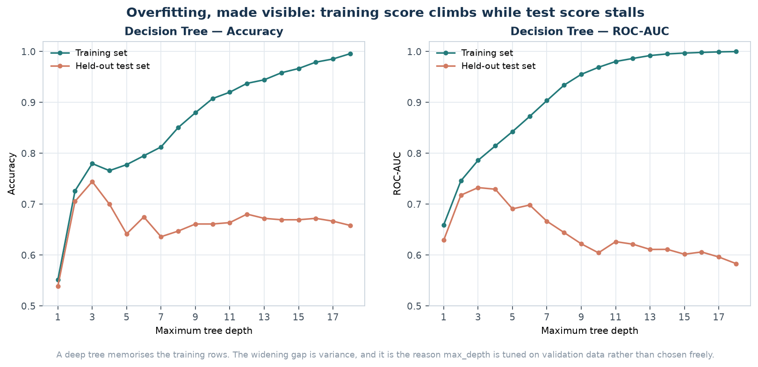
Figure 3 — Overfitting, measured. The training score climbs towards 1.0 as depth grows, while the test score peaks early and then declines. The gap is variance.
The training ROC-AUC reaches approximately 1.00 at depth 18 — a perfect training score, which is a symptom rather than an achievement. The test ROC-AUC peaks at depth 3 and then falls steadily. This is the clearest possible demonstration of why a model is never chosen on its training score, and why max_depth is a hyperparameter rather than a free choice.

6.4 Random Forest
A Random Forest trains many decision trees, each on a bootstrap sample of the rows and considering a random subset of features at every split, then averages their votes. The two sources of randomness decorrelate the trees, and averaging decorrelated trees cancels much of the variance that ruins a single deep tree.
RandomForestClassifier(n_estimators=300, min_samples_leaf=5,
class_weight="balanced", random_state=42, n_jobs=1)

It is usually one of the strongest off-the-shelf methods on tabular data and needs little tuning. The cost is transparency: there is no single tree to read, so feature importance replaces it.

6.4.1 Feature importance, and its bias
Rank | Feature | Importance
1 | monthly_charges | 0.2364
2 | tenure_months | 0.1220
3 | total_charges | 0.1085
4 | contract_Month-to-month | 0.1060
5 | internet_service_Fiber optic | 0.0882
6 | contract_Two year | 0.0752
7 | support_tickets | 0.0497
8 | internet_service_No | 0.0313
9 | contract_One year | 0.0279
10 | internet_service_DSL | 0.0269

Table — Top ten features by mean decrease in impurity (outputs/feature_importance.csv).
The ranking needs one honest caveat. Impurity-based importance is biased toward high-cardinality and continuous features, because they offer more possible split points. It ranks usefulness *inside this model*; it is not a causal effect and it is not a substitute for proper feature selection. Week 1's mutual-information ranking is a useful cross-check, and the two broadly agree that monthly charges, tenure and contract type dominate.
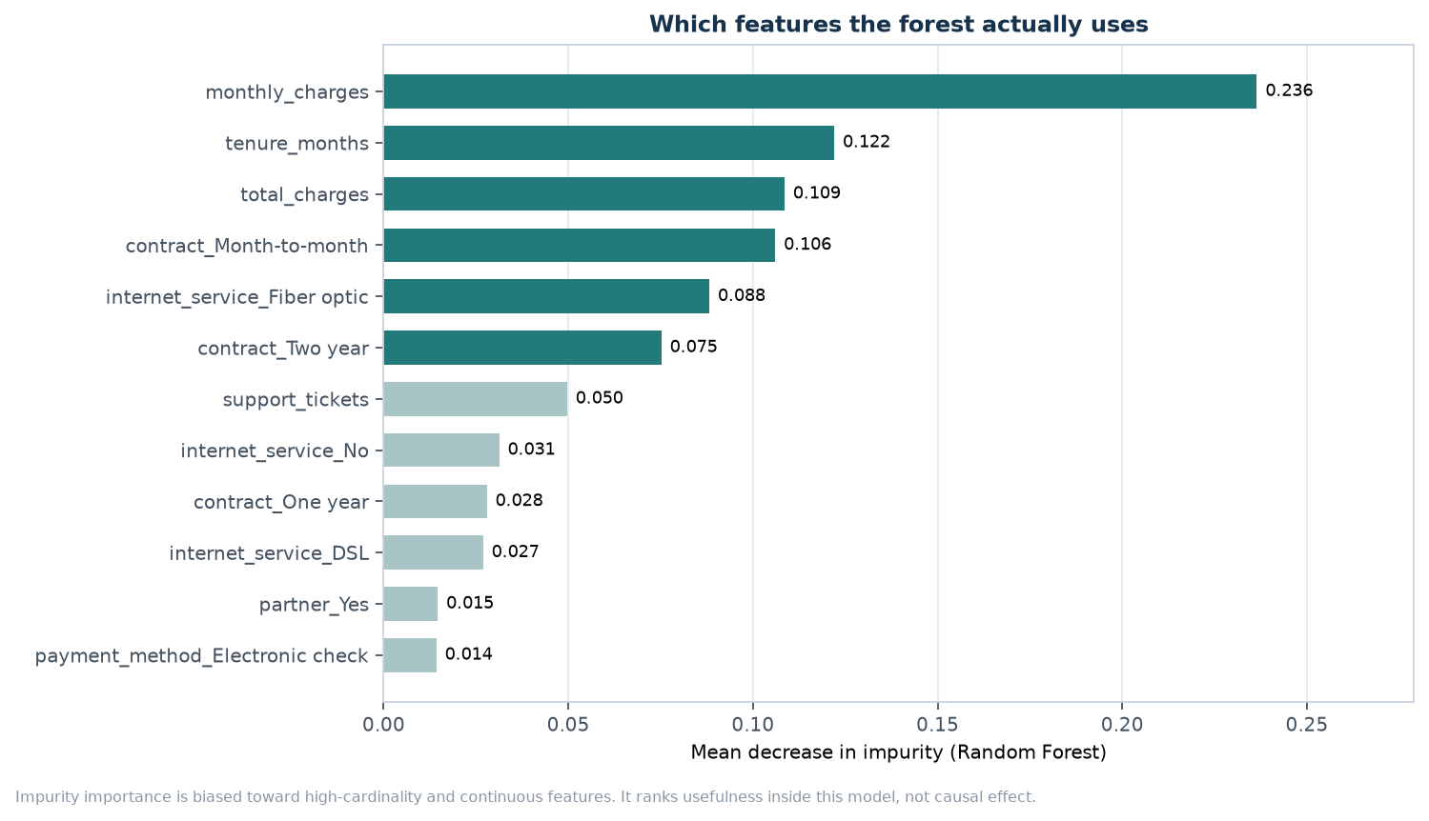
Figure 4 — Random Forest feature importance. Continuous features rank highly partly because they offer more candidate split points.

6.5 K-Nearest Neighbors
KNN makes no model at all. To classify a new point it finds the k closest training points and takes a vote, weighting nearer neighbours more heavily. Prediction is therefore slow — every query scans the training set — and, more importantly, the method is entirely dependent on the meaning of "closest".
KNeighborsClassifier(n_neighbors=15, weights="distance")

That dependence is not a theoretical concern. It was measured directly: the identical algorithm was fitted with and without the standard scaler.
Scaling is not cosmetic — measured, not assumed
KNN with StandardScaler: accuracy 0.744, recall 0.396, ROC-AUC 0.734. KNN without scaling: accuracy 0.708, recall 0.156, ROC-AUC 0.608. Same algorithm, same k, same data — only the preparation differs. Recall falls by 24 percentage points because 'distance' computed on raw units is dominated entirely by total_charges, which is measured in thousands while senior_citizen is 0 or 1.

This is the strongest argument in the report for why preprocessing lives in a pipeline rather than in a separate step someone might forget. Nothing in the training output would have warned that the unscaled model was quietly broken.

7. Comparing the models
The table below is the deliverable the brief asks for: at least two models trained and compared using evaluation metrics. Eight are shown — four real classifiers and two baselines here, with the regressors in Section 8.
Model | Acc. | Bal. acc. | Precision | Recall | F1 | ROC-AUC | PR-AUC
Logistic Regression | 0.678 | 0.671 | 0.432 | 0.656 | 0.521 | 0.769 | 0.518
Random Forest | 0.717 | 0.694 | 0.477 | 0.646 | 0.549 | 0.760 | 0.511
K-Nearest Neighbors | 0.744 | 0.634 | 0.528 | 0.396 | 0.452 | 0.734 | 0.468
Decision Tree | 0.653 | 0.661 | 0.409 | 0.677 | 0.510 | 0.725 | 0.486
Dummy (most frequent) | 0.733 | 0.500 | 0.000 | 0.000 | 0.000 | 0.500 | 0.267
Dummy (stratified) | 0.661 | 0.554 | 0.352 | 0.323 | 0.337 | 0.554 | 0.294

Table — Classification performance on the 360 held-out customers, sorted by ROC-AUC (outputs/classification_metrics.csv).
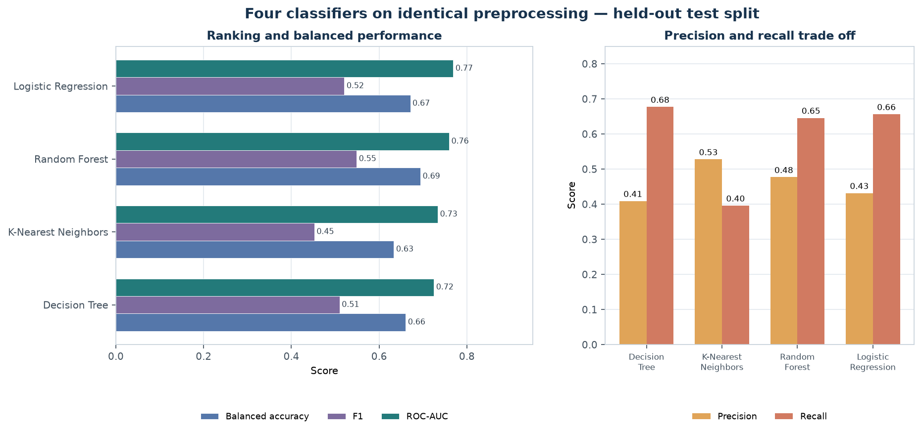
Figure 5 — The same results as a chart. Left: ranking and balanced metrics. Right: the precision-recall trade-off that drives every real decision.

7.1 Three models win three metrics
Metric | Winner | Score | What that means
Accuracy | K-Nearest Neighbors | 0.744 | Best raw hit rate — but recall is only 0.396, so most churners are missed
ROC-AUC | Logistic Regression | 0.769 | Best at ranking customers by churn risk, which is what a retention campaign consumes
Recall | Decision Tree | 0.677 | Finds the most actual churners, at the cost of a much higher false-alarm rate

This is the central result of the week and it deserves stating plainly: **no single metric identifies a best model, because the metrics measure different things.** A retention team that can afford only a few offers wants high precision. A team trying to avoid losing any customer wants high recall. A team ranking a queue of customers to call wants high ROC-AUC. All three are legitimate, and they point at different models.
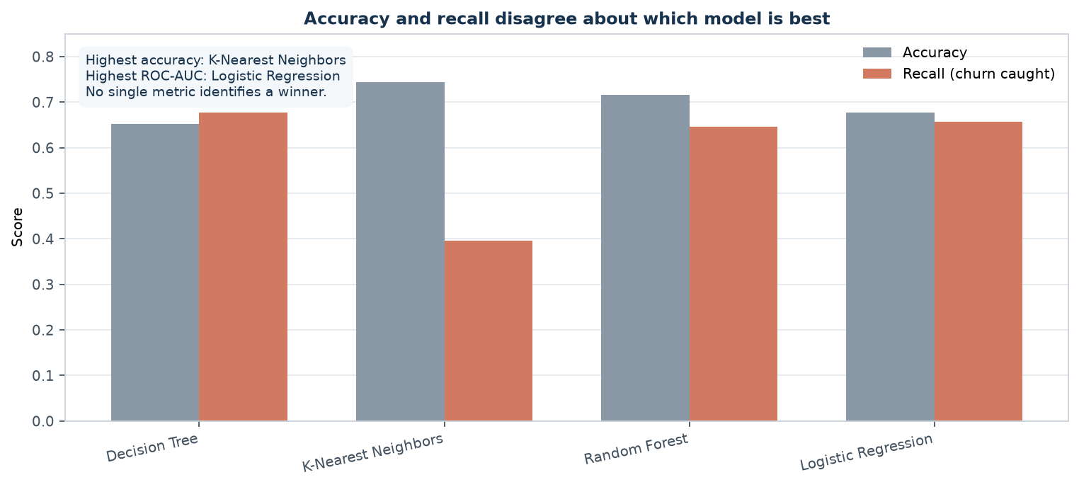
Figure 6 — Accuracy and recall disagree about which model is best. Reporting only accuracy would have selected the model that misses the most churners.

7.2 The baseline that beats two real models
The dummy classifier that never predicts churn scores 0.733 accuracy. Two real models — Logistic Regression and Random Forest and Decision Tree — score lower than that.
Why that is not a bug
Both of those models use class_weight='balanced', which reweights the loss so that a missed churner counts roughly 2.7 times a false alarm. The optimiser responds by predicting churn more often, which raises recall and lowers accuracy. The model is deliberately worse by one metric because it is better at the job. An evaluation that reported only accuracy would have rejected the most useful model in the table.

7.3 Confusion matrices
Accuracy collapses two very different mistakes into one number. A confusion matrix keeps them separate.
- False positive (FP) — predicted churn, customer stayed. Cost: a wasted retention offer.
- False negative (FN) — predicted loyal, customer left. Cost: that customer's entire future value, plus the acquisition cost of replacing them.
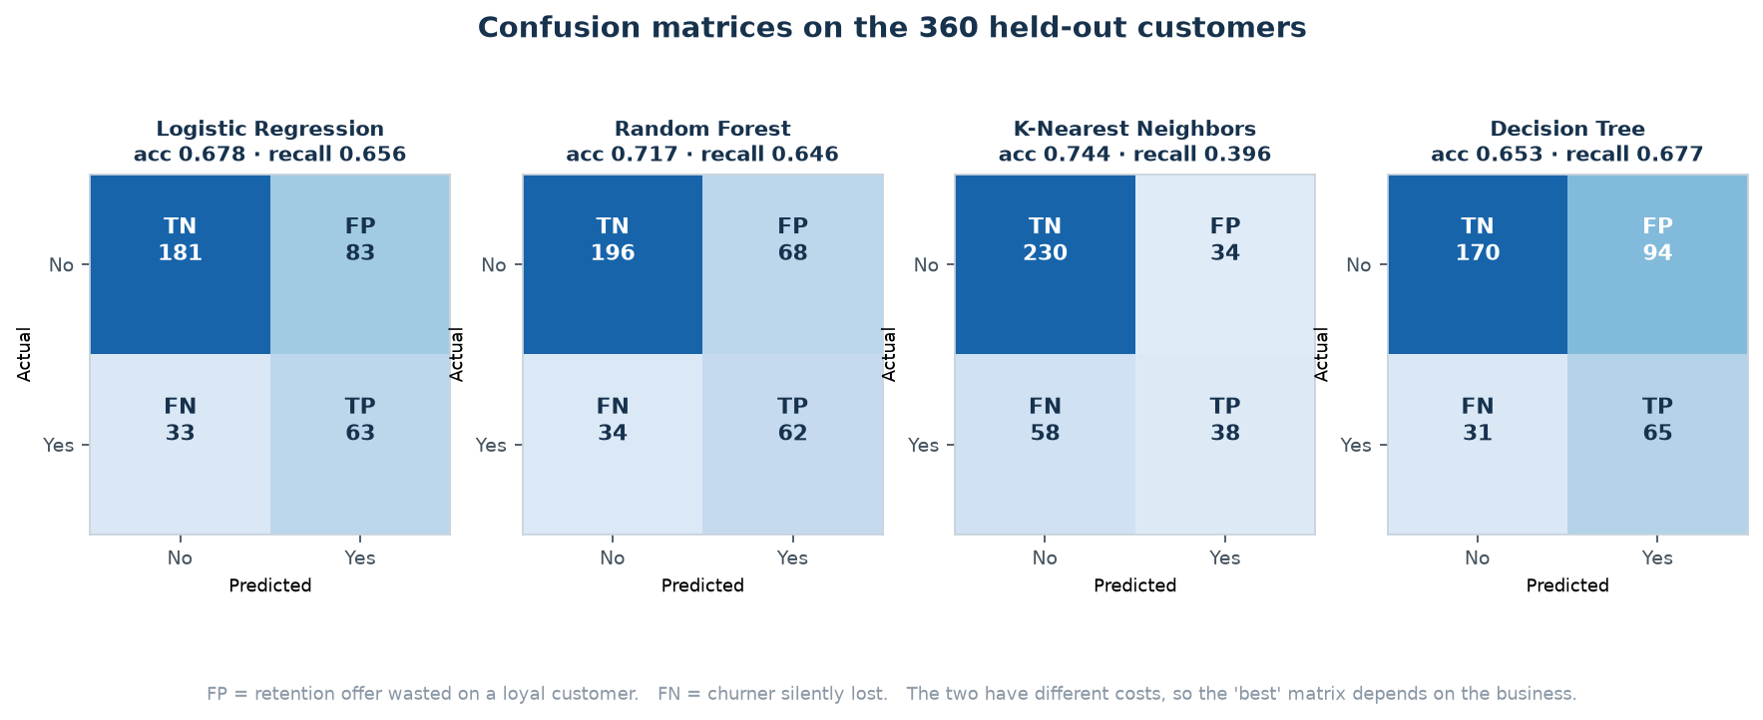
Figure 7 — Confusion matrices for all four classifiers on the same 360 held-out customers.
Model | True negatives | False positives | False negatives | True positives
Logistic Regression | 181 | 83 | 33 | 63
Random Forest | 196 | 68 | 34 | 62
K-Nearest Neighbors | 230 | 34 | 58 | 38
Decision Tree | 170 | 94 | 31 | 65

Table — Error decomposition behind each confusion matrix (of 267 non-churners and 93 churners).
The contrast between the two extremes is stark. K-Nearest Neighbors makes 34 false alarms and misses 58 churners. Logistic Regression makes 83 false alarms and misses 33. If a missed churner is the expensive error — which it usually is — then the second model is clearly preferable, despite having lower accuracy and a smaller number in the accuracy column.

7.4 ROC and precision-recall curves
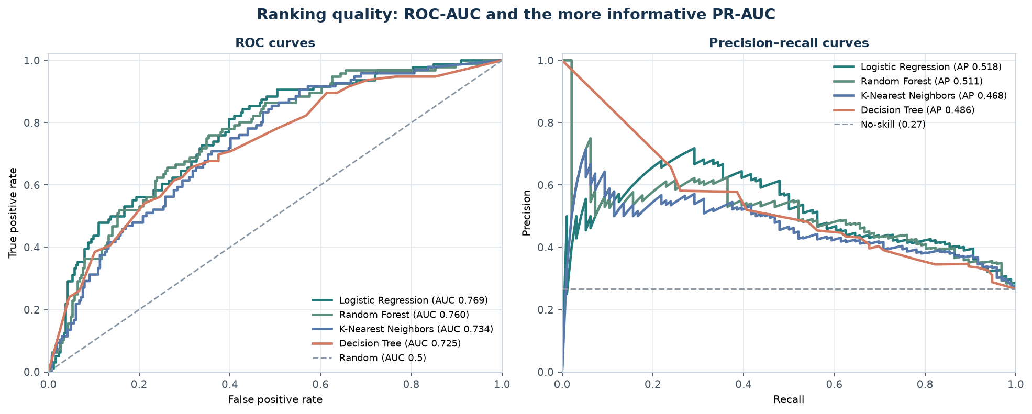
Figure 8 — Ranking quality. ROC curves (left) and precision-recall curves (right). The dashed line on the right is the no-skill baseline for this class balance.
ROC-AUC and PR-AUC both measure ranking and both ignore the threshold, but they behave differently when the positive class is rare. PR-AUC is the more honest summary here, because it focuses entirely on the minority class that the business cares about. The no-skill precision on the right-hand panel is 0.267 — the churn rate — not 0.5, which is another reminder that this is not a balanced problem.

8. Choosing honestly: cross-validation
Every score in Section 7 came from the test set. If the best of them were now used to pick a model, the test set would have become a validation set — and the final estimate would be optimistic, because the winner was selected partly by luck on those particular 360 rows.
Cross-validation avoids this. The training data is split into five folds; the model trains on four and validates on the fifth; the process rotates so every row is validated exactly once; the five scores are averaged. The test set stays untouched until the end.
Model | CV ROC-AUC mean | Std. dev. | CV F1 mean | Std. dev.
Logistic Regression | 0.805 | 0.025 | 0.599 | 0.022
Random Forest | 0.796 | 0.026 | 0.590 | 0.032
Decision Tree | 0.767 | 0.027 | 0.559 | 0.012
K-Nearest Neighbors | 0.766 | 0.030 | 0.451 | 0.052

Table — 5-fold stratified cross-validation on the training split (outputs/classification_cv_results.csv).
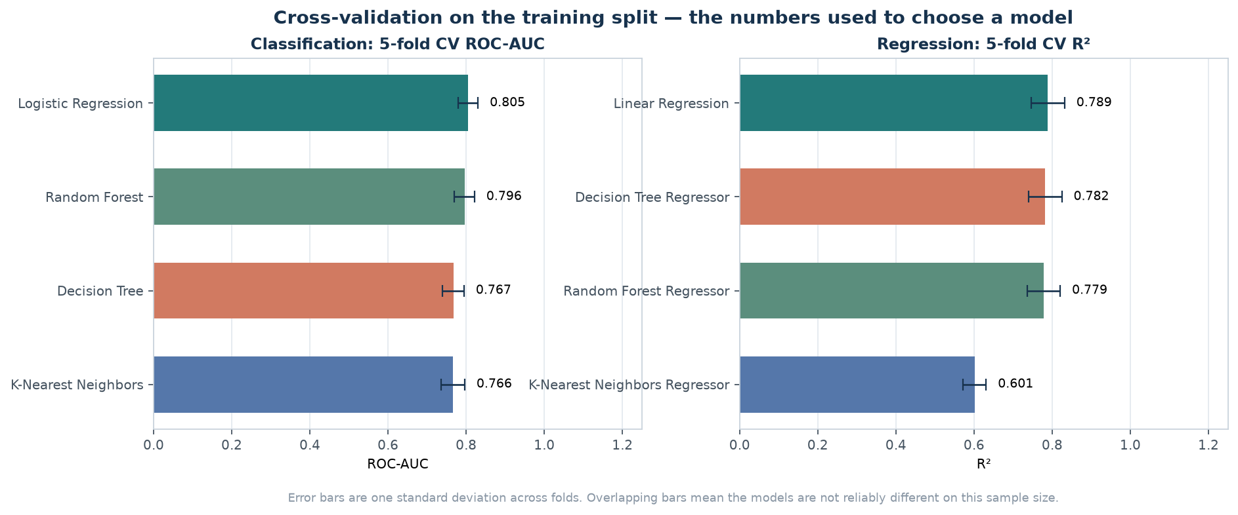
Figure 9 — Cross-validated scores for classification and regression. Error bars are one standard deviation across the five folds.
The selected model is **Logistic Regression**, with a mean cross-validated ROC-AUC of 0.805. But look at the standard deviations, and then at the gap: the leader is ahead of Random Forest by only 0.010 ROC-AUC, while the fold-to-fold standard deviation is 0.025. The difference is a fraction of the noise.
The honest conclusion
On 1,440 training rows, the top two classifiers are not reliably different. Reporting one as definitively better would over-claim. What the comparison does support is the weaker and more useful statement that Logistic Regression and Random Forest both perform well, and that both are preferable to an unweighted tree for churn because of their recall.

9. Thresholds and class weights: two levers on one trade-off
Precision and recall move in opposite directions. This is not a limitation of any particular algorithm; it is arithmetic. Every positive prediction is either a hit or a false alarm, so catching more of the positives necessarily means accepting more false alarms. There are two independent ways to slide along that curve, and they are often confused.

9.1 Lever one: the decision threshold
The model outputs a probability. The threshold decides how high that probability must be before a customer is labelled as a churn risk. The default of 0.5 is a convention inherited from balanced problems and has no special status here.
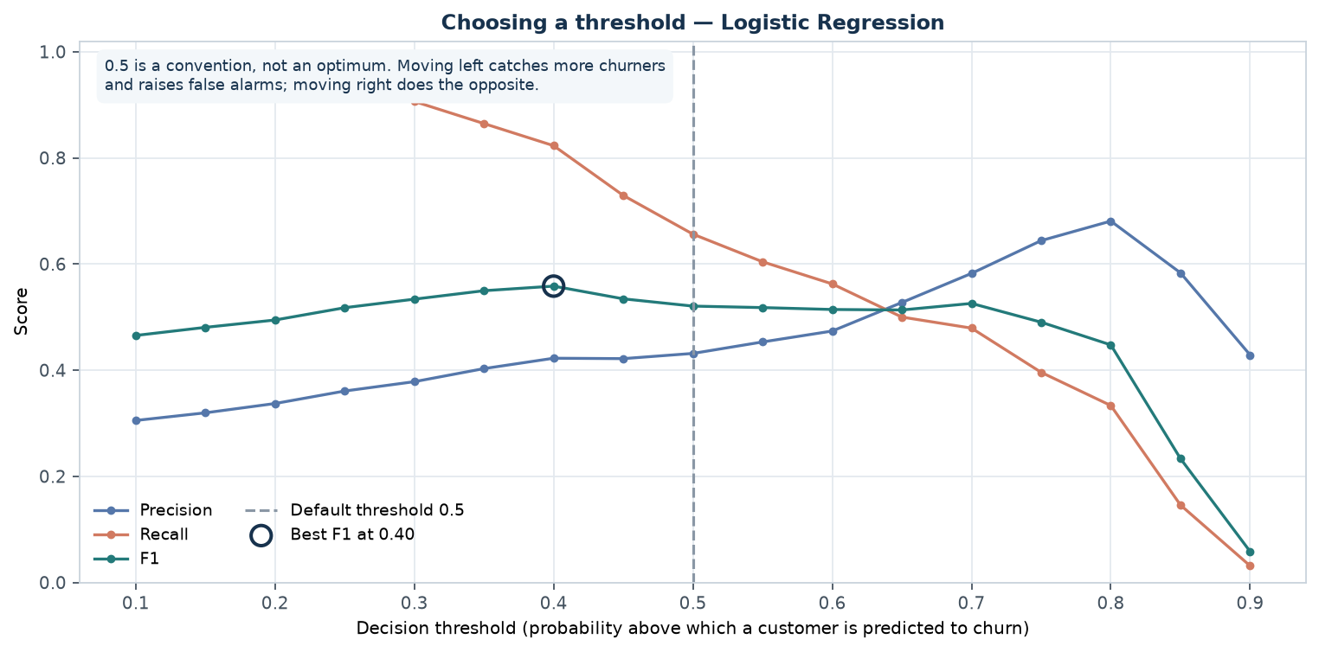
Figure 10 — Precision, recall and F1 as the threshold moves, for the selected model. The default 0.5 is marked; the best F1 sits to its left.
Threshold | Precision | Recall | F1 | Accuracy | Flagged as churn
0.10 | 0.305 | 0.979 | 0.465 | 0.400 | 85.6%
0.20 | 0.337 | 0.927 | 0.494 | 0.494 | 73.3%
0.30 | 0.378 | 0.906 | 0.534 | 0.578 | 63.9%
0.40 | 0.422 | 0.823 | 0.558 | 0.653 | 51.9%
0.50 | 0.432 | 0.656 | 0.521 | 0.678 | 40.6%
0.60 | 0.474 | 0.562 | 0.514 | 0.717 | 31.7%
0.70 | 0.582 | 0.479 | 0.526 | 0.769 | 21.9%
0.80 | 0.681 | 0.333 | 0.448 | 0.781 | 13.1%
0.90 | 0.429 | 0.031 | 0.058 | 0.731 | 1.9%

Table — Threshold sweep for Logistic Regression (outputs/threshold_analysis.csv).
At the default 0.5, the model flags about 41% of customers as churn risks. Dropping the threshold to 0.40 raises recall to 0.823 while cutting precision to 0.422 — it now catches most churners, but more than half of the customers it flags were never going to leave.
Which row is correct depends entirely on cost. If a retention offer costs 10 currency units and a lost customer's remaining value is 500, then false negatives are 50 times more expensive than false positives, and a low threshold is obviously right. If the offer is expensive and the customer base is large, the opposite holds. **The data cannot answer this question; only the business can.**

9.2 Lever two: class weights during training
The threshold acts after training. Class weighting acts during it, by changing the loss the optimiser minimises. `class_weight='balanced'` scales each class's contribution by its frequency, so a missed churner counts roughly 2.7 times a false alarm.
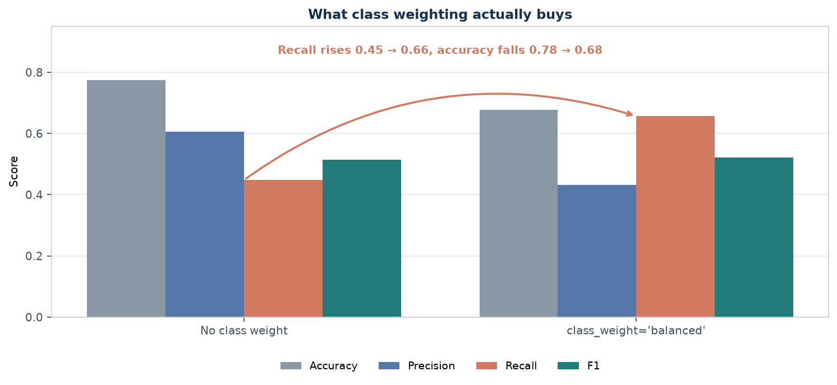
Figure 11 — What class weighting buys. Recall rises substantially; accuracy falls. Quality, measured properly, improves.
Setting | Accuracy | Precision | Recall | F1 | Customers flagged
No class weight | 0.775 | 0.606 | 0.448 | 0.515 | 19.7%
class_weight='balanced' | 0.678 | 0.432 | 0.656 | 0.521 | 40.6%

Table — Logistic Regression with and without balanced class weights (outputs/class_weight_comparison.csv).
Unweighted, the model flags 19.7% of customers and catches 44.8% of churners. Weighted, it flags 40.6% and catches 65.6% — 21 percentage points more churners. Accuracy falls from 0.775 to 0.678 while F1 rises from 0.515 to 0.521.
Accuracy fell while quality rose
That sentence is the reason this report uses ten metrics instead of one. If the evaluation had optimised accuracy, it would have selected the unweighted model, which finds fewer than half the churners.

10. Regression — predicting monthly charges
The brief lists Linear Regression, so the report applies it where it belongs: to a numeric target. Monthly charges is the natural choice — it is continuous, almost entirely observed, and commercially meaningful.

10.1 A leakage trap that had to be defused
total_charges is approximately monthly_charges multiplied by tenure. If it were included as an input while predicting monthly_charges, the model could nearly recover the answer from the input. R² would look excellent and the model would be worthless in production, where the whole point is to estimate a charge that is not yet known.
Excluded feature
total_charges is excluded from the regression inputs because it is derived from the target. This is a deliberate ceiling on achievable accuracy: dropping a highly informative column on purpose makes the score lower and the model usable.

10.2 Results
Model | MAE | RMSE | R² | MAPE | Median abs. error
Linear Regression | 7.59 | 9.65 | 0.818 | 15.3% | 5.96
Random Forest Regressor | 7.80 | 9.96 | 0.806 | 15.9% | 5.92
Decision Tree Regressor | 7.83 | 10.02 | 0.804 | 15.8% | 5.84
K-Nearest Neighbors Regressor | 10.87 | 13.74 | 0.631 | 29.5% | 9.00
Dummy (mean) | 18.50 | 22.80 | -0.017 | 53.1% | 15.99

Table — Regression on monthly charges, 345 held-out customers (outputs/regression_metrics.csv).
Model | CV R² mean | Std. dev.
Linear Regression | 0.789 | 0.043
Decision Tree Regressor | 0.782 | 0.043
Random Forest Regressor | 0.779 | 0.042
K-Nearest Neighbors Regressor | 0.601 | 0.030

Table — 5-fold cross-validated R² on the training split (outputs/regression_cv_results.csv).
Linear Regression performs best, with an MAE of 7.59, an RMSE of 9.65 and an R² of 0.818. Three things about that result are worth noting.
1. MAE of 7.59 against a mean charge of about 60 is roughly 12% — useful for triage and budgeting, not precise enough to bill a customer.
2. RMSE (9.65) exceeds MAE (7.59), so some predictions are badly wrong rather than all being mildly wrong. The residual plot in Figure 13 shows where.
3. The tree ensemble does not beat the linear model. That is informative: when a linear model wins, the underlying relationship is largely additive and linear, so extra capacity buys only noise.
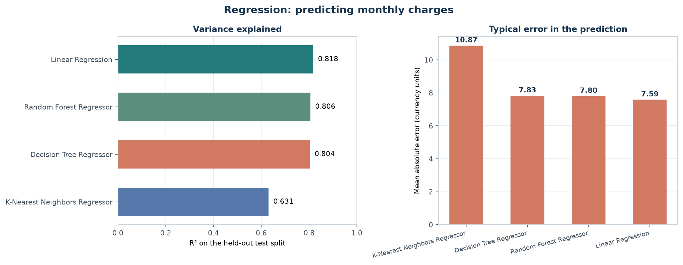
Figure 12 — Regression comparison by R² and by absolute error. Lower error and higher R² are both better; here the same model wins both.

10.3 Diagnostics, and what the bands mean
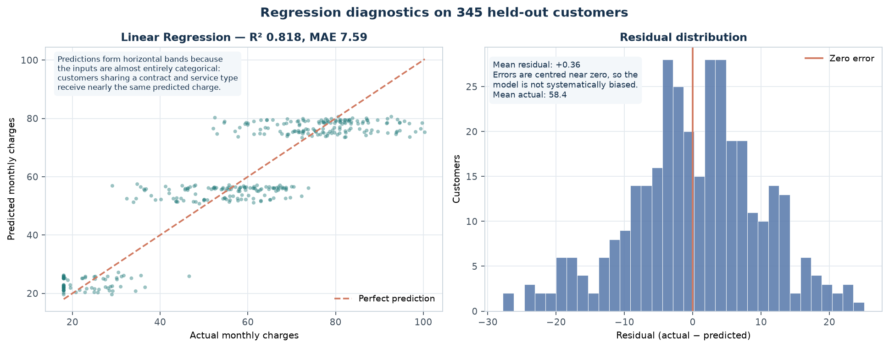
Figure 13 — Left: predicted versus actual monthly charges. Right: residual distribution.
The scatter plot is the most instructive panel in this report. Predictions form horizontal bands rather than a diagonal cloud. That is not a plotting artefact or a bug: monthly charges in this dataset are determined almost entirely by categorical inputs — contract type, internet service, payment method — so customers who share those categories receive nearly identical predictions.
The consequence is a ceiling on achievable accuracy that no model can break. When the true target is a step function of categorical features, the best possible regressor still produces bands. Recognising that saves hours of pointless tuning aimed at a problem the features cannot solve.
The residual histogram tells a related story. Residuals are centred near zero, so the model is not systematically biased in either direction — but they are clearly not normal, and they are not homoscedastic. That is a violation of the assumptions behind linear regression's confidence intervals, which is worth knowing before anyone quotes a prediction interval from this model.

11. Verification and quality assurance
Every claim in this report is backed by an assertion in code or by an exported artifact. The table below lists what was checked and how.
Check | How it is enforced | Result
Dataset schema | Required columns asserted at load; raises otherwise | Pass — 13/13
Target validity | Only No/Yes accepted | Pass — 1,800 labels
Stratification | Train and test churn rates compared | Pass — 0.267 / 0.267
No leakage | Preprocessing fitted inside a Pipeline on X_train only | Pass — by construction
Identical inputs | Every model uses the same ColumnTransformer | Pass
Test set isolation | Selection via CV on train; test scored once | Pass
Reproducibility | random_state=42 on every stochastic step | Pass — identical re-runs
Metrics computable | All ten classification and five regression metrics produced | Pass
Baselines present | Two dummy classifiers and one dummy regressor | Pass

Artifact | Contents
outputs/classification_metrics.csv | Ten metrics for six classifiers (4 real + 2 baselines)
outputs/regression_metrics.csv | Five metrics for five regressors
outputs/classification_cv_results.csv | Per-fold ROC-AUC and F1 for each classifier
outputs/regression_cv_results.csv | Per-fold R² for each regressor
outputs/classification_predictions.csv | Per-row predicted probability for every model
outputs/regression_predictions.csv | Per-row predicted charge for every regressor
outputs/confusion_matrix_*.csv | Four confusion matrices
outputs/threshold_analysis.csv | Precision/recall/F1 at 17 thresholds
outputs/class_weight_comparison.csv | Weighted versus unweighted Logistic Regression
outputs/feature_importance.csv | Random Forest impurity importance for all features
outputs/tree_depth_curve.csv | Train/test scores at depths 1–18
outputs/week2_summary.json | Machine-readable record; this report is generated from it

Table — Exported artifacts, all reproducible from src/train_models.py.

12. Limitations and responsible interpretation
These limitations are not disclaimers tacked onto the end. Each one changes how a number should be read, and each has a specific remedy before the work could support a real decision.
Limitation | Why it matters | What real use would require
Synthetic data | Relationships were generated by a probability model; every pattern found here is a property of that generator | Validate on representative, permitted production data
Small test set | 360 rows gives roughly ±2.5 percentage points of sampling noise on accuracy | A larger holdout, and confidence intervals on every reported metric
Hyperparameters fixed in advance | A proper search would likely improve scores, but tuning on the test set would invalidate them | Nested cross-validation: tune inside the training folds
Class imbalance handled by weighting only | Resampling, SMOTE or cost-sensitive learning might do better | Compare resampling strategies under the same CV protocol
No fairness analysis | Recall and precision can differ by subgroup, so a model can be accurate overall and harmful to one group | Audit error rates by subgroup before deployment
Accuracy ceiling from the features | Monthly charges are a step function of categorical inputs, so the regression cannot exceed its banded predictions | Collect continuous drivers (usage, add-ons) that vary within a category
Association is not causation | Contract type correlates with churn but does not prove that changing a contract reduces it | A controlled experiment or causal-inference design

13. Lessons learned
1. Build the baseline before the model. The dummy classifier scoring 0.733 accuracy redefined what the word good means, and it arrived in four lines of code.
2. A single metric is a decision waiting to go wrong. Three models won three metrics in this report; picking one metric would have silently picked one business strategy.
3. Leakage is invisible unless you design against it. Fitting the scaler before splitting produces a slightly better score and no error message. Only the Pipeline structure prevents it reliably.
4. Measured surprises beat asserted ones. The scaled-versus-unscaled KNN comparison (recall 0.396 versus 0.156) was more convincing than any paragraph explaining why scaling matters.
5. Cross-validation showed the top two models were statistically tied. Reporting a winner on a 0.01 difference would have been dishonest, and the standard deviation is what revealed it.
6. Sometimes the features cap the model. The banded regression plot showed that no algorithm can exceed what the inputs allow — worth discovering before tuning.

14. Conclusion
The Week 2 brief asked for two things: implement supervised algorithms including Linear Regression, Logistic Regression, Decision Trees, Random Forest and K-Nearest Neighbors, and compare at least two models using evaluation metrics. Both are delivered, and then some — eight models across two tasks, with two dummy baselines for calibration and a cross-validated selection protocol behind every conclusion.
The classification results do not produce a champion, and that is the honest finding. K-Nearest Neighbors wins accuracy at 0.744 while missing most churners; Logistic Regression wins ranking quality at 0.769 with roughly double the recall. Which one is right depends on the cost of a wasted retention offer versus a lost customer — a question the data cannot answer. The regression task does produce a clean winner: Linear Regression explains 81.8% of the variance in monthly charges with a mean error of 7.59 currency units.
The technical outcome is a set of trained models and metrics. The methodological outcome matters more: establish a baseline, evaluate with more than one metric, cross-validate before claiming a winner, and treat the threshold and the class weight as business decisions rather than defaults. Week 3 builds directly on this by tuning properly and by adding unsupervised structure to the same data.

Repository
Source, data, outputs and notebook: https://github.com/Dhanam33/Yuva_intern/tree/main/week-2

Appendix A — Reproducing these results
python -m venv .venv
source .venv/bin/activate # Windows: .venv\Scripts\activate
python -m pip install -r week-2/requirements.txt

python week-2/src/train_models.py # trains every model, writes all tables
python week-2/src/make_figures.py # builds the 13 figures
python week-2/docs/build_report.py # rebuilds this document

jupyter notebook week-2/notebooks/week2_supervised_learning.ipynb

Appendix B — Model configuration
Model | Configuration
Dummy (most frequent) | strategy='most_frequent'
Dummy (stratified) | strategy='stratified'
Logistic Regression | max_iter=2000, class_weight='balanced'
Decision Tree | max_depth=5, min_samples_leaf=20, class_weight='balanced'
Random Forest | n_estimators=300, min_samples_leaf=5, class_weight='balanced'
K-Nearest Neighbors | n_neighbors=15, weights='distance'
Linear Regression | default parameters
Decision Tree Regressor | max_depth=6, min_samples_leaf=20
Random Forest Regressor | n_estimators=300, min_samples_leaf=5
KNN Regressor | n_neighbors=15, weights='distance'

All models use random_state=42 where the estimator accepts it. Hyperparameters were fixed before any test-set score was examined.

Appendix C — The evaluation function
def classify_metrics(y_true, y_pred, y_prob):
tn, fp, fn, tp = confusion_matrix(y_true, y_pred, labels=[0, 1]).ravel()
return {
"accuracy": accuracy_score(y_true, y_pred),
"balanced_accuracy": balanced_accuracy_score(y_true, y_pred),
"precision": precision_score(y_true, y_pred, zero_division=0),
"recall": recall_score(y_true, y_pred, zero_division=0),
"f1": f1_score(y_true, y_pred, zero_division=0),
"roc_auc": roc_auc_score(y_true, y_prob),
"pr_auc": average_precision_score(y_true, y_prob),
"mcc": matthews_corrcoef(y_true, y_pred),
"log_loss": log_loss(y_true, y_prob),
"brier": brier_score_loss(y_true, y_prob),
"true_negative": int(tn), "false_positive": int(fp),
"false_negative": int(fn), "true_positive": int(tp),
}

Appendix D — Figure index
Figure | File | Shows
1 | 00_workflow_overview.png | Split / fit / predict / evaluate, and where CV lives
2 | 01_class_balance.png | Imbalance and the accuracy baseline
3 | 12_overfitting_tree_depth.png | Train vs test score as tree depth grows
4 | 08_feature_importance.png | Random Forest impurity importance
5 | 02_model_comparison.png | All four classifiers by six metrics
6 | 03_accuracy_vs_recall.png | Accuracy and recall disagreeing
7 | 04_confusion_matrices.png | Error decomposition per model
8 | 05_roc_and_pr_curves.png | Ranking quality
9 | 09_cross_validation.png | Cross-validated scores with error bars
10 | 06_threshold_tradeoff.png | Precision/recall/F1 across thresholds
11 | 07_class_weighting.png | Weighted versus unweighted model
12 | 10_regression_comparison.png | Regressor R² and MAE
13 | 11_regression_diagnostics.png | Predicted vs actual, and residuals

