Spring WEB MVC + JQuery AJAX EXAMPLE:-

**Folder System:**

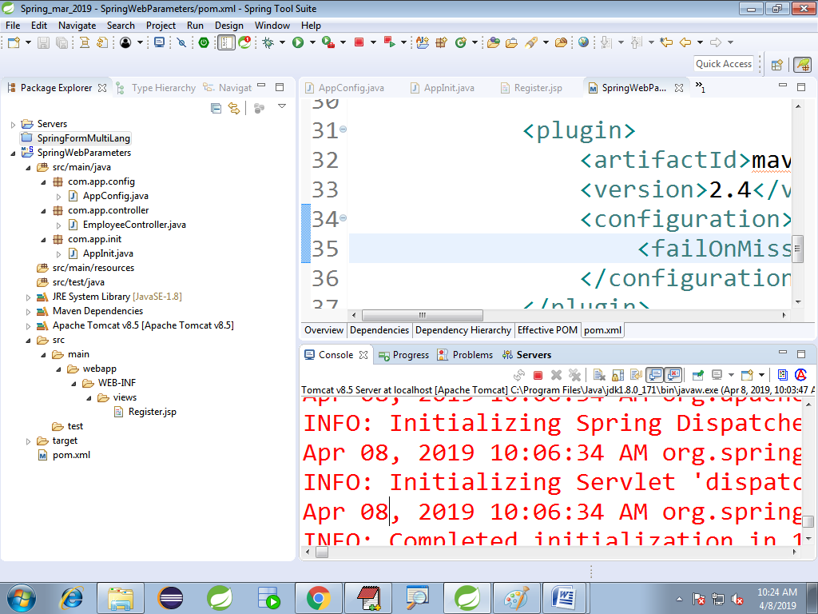

pom.xml

<dependencies>

<dependency>

<groupId>org.springframework</groupId>

<artifactId>spring-webmvc</artifactId>

<version>5.1.4.RELEASE</version>

</dependency>

</dependencies>

<build>

<plugins>

<plugin>

<groupId>org.apache.maven.plugins</groupId>

<artifactId>maven-compiler-plugin</artifactId>

<version>3.8.0</version>

<configuration>

<source>1.8</source>

<target>1.8</target>

</configuration>

</plugin>

<plugin>

<artifactId>maven-war-plugin</artifactId>

<version>2.4</version>

<configuration>

<failOnMissingWebXml>false</failOnMissingWebXml>

</configuration>

</plugin>

</plugins>

</build>

AppInit.java

**package** com.app.init;

**import** org.springframework.web.servlet.support.AbstractAnnotationConfigDispatcherServletInitializer;

**import** com.app.config.AppConfig;

**public** **class** AppInit **extends** AbstractAnnotationConfigDispatcherServletInitializer{

@Override

1 **protected** Class<?>[] getRootConfigClasses() {

**return** **new** Class[] {AppConfig.**class**};

}

@Override

**protected** Class<?>[] getServletConfigClasses() {

**return** **null**;

}

@Override

**protected** String[] getServletMappings() {

**return** **new** String[] {"/"};

}

}

AppConfig.java

**package** com.app.config;

**import** org.springframework.context.annotation.Bean;

**import** org.springframework.context.annotation.ComponentScan;

**import** org.springframework.context.annotation.Configuration;

**import** org.springframework.web.servlet.config.annotation.EnableWebMvc;

**import** org.springframework.web.servlet.view.InternalResourceViewResolver;

@Configuration

@EnableWebMvc

@ComponentScan("com.app")

**public** **class** AppConfig {

@Bean

**public** InternalResourceViewResolver vr() {

InternalResourceViewResolver v=**new** InternalResourceViewResolver();

v.setPrefix("/WEB-INF/views/");

v.setSuffix(".jsp");

**return** v;

}

}

Register.jsp

<%@ page language=*"java"* contentType=*"text/html; charset=ISO-8859-1"*

pageEncoding=*"ISO-8859-1"*

isELIgnored=*"false"*

%>

<!DOCTYPE html PUBLIC "-//W3C//DTD HTML 4.01 Transitional//EN" "http://www.w3.org/TR/html4/loose.dtd">

<html>

<head>

<meta http-equiv=*"Content-Type"* content=*"text/html; charset=ISO-8859-1"*>

<title>Insert title here</title>

<script src=*"http://code.jquery.com/jquery-1.11.2.min.js"*></script>

<script type=*"text/javascript"*>

$(document).ready(**function**()

{

$("#ename").change(**function**(){

$.ajax({

url:'check',

data:{'en':$("#ename").val()},

success:**function**(resTxt){

$("#msg").text(resTxt);

**if**(resTxt!=''){

$("#ename").val("");

$("#ename").focus();

}

}

});

});

});

</script>

</head>

<body>

<h3>Welcome to AJAX CALL</h3>

<form action=*"#"* method=*"post"*>

<pre>

Enter Name : <input type=*"text"* name=*"ename"* id=*"ename"*/> <span id=*"msg"*></span>

Enter Sal : <input type=*"text"* name=*"esal"*/>

Enter Dept : <input type=*"text"* name=*"edept"*/>

<input type=*"submit"* value=*"Register"*/>

</pre>

</form>

</body>

</html>

EmployeeController.java

**package** com.app.controller;

**import** org.springframework.stereotype.Controller;

**import** org.springframework.web.bind.annotation.RequestMapping;

**import** org.springframework.web.bind.annotation.RequestParam;

**import** org.springframework.web.bind.annotation.ResponseBody;

@Controller

**public** **class** EmployeeController {

@RequestMapping("/show")

**public** String showReg() {

**return** "Register";

}

@RequestMapping("/check")

**public** @ResponseBody String checkName(

@RequestParam("en")String name)

{

String msg="";

**if**(name.equalsIgnoreCase("AJAY")) {

msg="Name already exist";

}

**return** msg;

}

}

**FB:** [**https://www.facebook.com/groups/thejavatemple/**](https://www.facebook.com/groups/thejavatemple/)

**EMAIL:**

**javabyraghu@gmail.com**