PROJECT REPORT

Next-Word Prediction with Decentralized Federated Learning

Submitted by
Dhanancheyan Anbuselvam
406125002

Academic Year 2024–2025

1. Introduction
Text prediction has become the most commonly used tool in modern computing. No matter what type of device you can name, if it has typing requirement, it will most likely have text prediction feature built into it. Commercially deployed systems such as Google's Gboard, Apple's QuickType, and SwiftKey achieve strong results by combining various large-scale models for model training and various methords like quantization and distillation to adapt these models to their edge counterpart. The underlying assumption in most of these systems is that the device is either powerful enough to run a substantial model or that it has reliable access to a remote server that can handle the heavy lifting.
But that assumption does not hold universally as large segment of users around the world still work with budget CPU-based machines without access to neural processing units, or operates in environments where connectivity is generally not available or is unstable while data sharing is a serious concern. For these users, the practical question is not how to achieve the best possible accuracy but how to balance three competing priorities: low latency, maintaining high prediction quality, and ensuring the safety of sensitive typed text.
In this work, the system combines multiple prediction strategies into a single on-device pipeline. A lightweight LSTM model provides contextual neural predictions when it is confident. A trigram language model offering fast statistical predictions. A session-level phrase cache handles repetitive text with low latency. These are combined through a confidence-gated blending mechanism that guides each prediction request to the most path source at runtime.
The federated learning component takes care of how such a system can improve over time without centralizing user data. Each device periodically shares model weight updates with peers using an gossip protocol. This design removes the requirement on a central server, making the system more resilient and more appropriate for privacy-sensitive deployments.

2. Objectives
Objectives of this project are:
- To create a hybrid next-word prediction system combining neural and statistical models.
- To implement a decentralized peer-to-peer federated learning mechanism.
- To reduce inference latency for real-time CPU-based deployment.
- To incorporate user-level personalization without retraining sensitive information.

3. Related Work

3.1 On-Device Neural Language Models

The deployment of neural language models on low resource devices has gained popularity, with Hard et al. [1] showing federated next-word prediction using on-device data and centralized aggregation, though limited by hardware. Merity et al. [6] showed that AWD-LSTM can achieve strong perplexity, but the model here is compact on purpose (~500K parameters) to prioritize work efficiency on CPU-only settings. This restriction helps speed and memory over peak accuracy. Transfer learning approaches like Howard and Ruder [22] are not practical without access to large pretrained models.

3.2 Statistical N-gram Language Models
N-gram models are the most effective method in low-resource settings, with Chen and Goodman [4] identifying Kneser-Ney smoothing as optimal for perplexity reduction. The model uses a trigram model with Laplace smoothing and Katz backoff, implemented via a compact trie with constrained vocabulary for predictable memory usage. Such constraints align with system limitations discussed by Suresh et al. [7]. Rosenfeld [20] notes that these models perform well for short contexts, complementing neural approaches.

3.3 Federated Learning for NWP
McMahan et al. [5] introduced FedAvg, letting the decentralized training happen in local updates and instead of central aggregation, later adapted by Hard et al. [1] for next-word prediction. However, reliance on a central server raises trust and availability concerns. Other options like gossip-based learning (Hegedus et al. [8]) and decentralized Bayesian methods (Lalitha et al. [9]) remove this dependency. Kairouz et al. [15] highlight key challenges, mentioned here through lightweight communication and normalized aggregation.

3.4 Hybrid Neural and Statistical Models
Sundermeyer et al. [2] showed that LSTMs performs better then n-gram models, especially for longer contexts, and that hybrid approaches yield better results than either alone. Here, I have extended that idea using a confidence-gating mechanism that suppresses uncertain neural outputs instead of fixed interpolation. The statistical model handles sparse or short contexts efficiently. Similar adaptive selection ideas appear in retrieval-based models like Khandelwal et al. [21].

3.5 Personalisation in Keyboard Models
Personalization is often dealt through federated meta-learning (Jiang et al. [11]) or local fine-tuning (Basu et al. [12]), which can be computationally expensive. Here I have used a simpler approach to use a recency cache and user dictionary to adjust predictions based on usage patterns. This avoids retraining overhead while still capturing user-specific vocabulary. Shaik et al. [19] showed that even lightweight personalization improves keystroke efficiency.

3.6 Privacy in Federated NWP
Formal privacy methods like differential privacy [17], secure aggregation [16], and DP-SGD [18] provide strong guarantees but introduce complexity and overhead. This webapp instead uses practical measures such as redacting sensitive text and sharing only model weight updates. While simpler, these methods do not fully eliminate risks like gradient inversion. Strengthening privacy with formal techniques remains a key area for future work.

4. System Architecture and Methodology

4.1 Overall Architecture
The webapp system is structured as a single-process Python application exposing FastAPI-based HTTP and WebSocket endpoints, combined with a lightweight JavaScript frontend. It works across three coordinated layers: peer-to-peer gossip synchronization, an inference pipeline for predictions, and a training pipeline driven by session data. The HybridModelAgent orchestrates predicts by combining outputs from neural and statistical components, while supporting modules like GossipEngine, FederatedSyncAgent, CacheAgent, and the PersonalizationLayer handle communication, caching, and adaptive scoring.
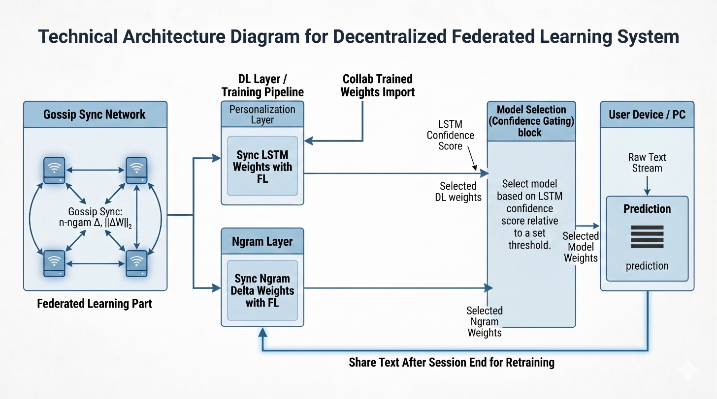

Table 4.1: NWP Application Component Summary
Component | Module | Responsibility
HybridModelAgent | hybrid_model.py | Confidence-gated LSTM + n-gram engine
LstmWordModel | hybrid_model.py | Single-layer LSTM with AdamW training
NgramModel | trie_model.py | Trigram trie with backoff and Laplace smoothing
GossipEngine | gossip.py | Epidemic gossip FL - delta fetch and merge
FederatedSyncAgent | federated_sync.py | Delta push/pull and inbound queue management
CacheAgent | cache_agent.py | Session-level LRU phrase cache (<1 ms recall)
PersonalizationLayer | personalization.py | Recency cache + user dictionary re-ranker
TrainingAgent | training_agent.py | Post-session fine-tuning pipeline
ModelRegistry | model_registry.py | Multi-slot model lifecycle management

4.2 LSTM Language Model Architecture

The neural network model is a compact single-layer word-level LSTM with a 96-dimensional embedding and 160 hidden units, totaling roughly 500K parameters. Predictions are generated via a linear projection followed by softmax, and the model is trained around using cross-entropy loss with AdamW and gradient clipping. A warm-up pass removes initial delays and latency, and the maximum softmax probability is used as a confidence signal for downstream decisions.

4.3 N-gram Model with Trie Backoff
The statistical component is written as a trigram model stored in a nested trie, using Laplace smoothing and Katz-style backoff across n-gram levels. Vocabulary is limited to 1,000 entries with least-frequently-used replacement to maintain predictable memory usage. Federated aggregation merges count statistics additively across peers, preserving probabilistic consistency without sharing raw text.

4.4 Confidence-Gated Hybrid Blending
Rather than relying on fixed interpolation, the webapp prediction system dynamically adjusts contributions based on LSTM confidence, using a threshold (τ = 0.05) to determine whether neural predictions are reliable. When confidence is high, predicted outputs are calculated across LSTM, local, and global n-gram models; otherwise, the system falls back to statistical models alone. This gating mechanism improves robustness and allows faster incorporation of peer-learned vocabulary.

4.5 Personalisation Re-ranking

Personalization is handled through a lightweight re-ranking step that combines a recency-based cache with a user-defined dictionary. Additive score adjustments allow frequently used or otherwise domain-specific terms to surface more prominently without requiring again training of model. This approach balances efficiency with adaptability to individual user behaviour.

4.6 Federated Averaging with L2 Normalisation
To address differences in peer training histories, parameter updates are normalized using L2 scaling before aggregation. This prevents models trained longer from dominating the merge purely due to magnitude differences. By focusing on alignment, the system achieves more stable and balanced federated updates in a decentralized setting.

4.7 Training and Federated Learning Protocol
Training is triggered at the session end, where input text is first redacted to remove sensitive patterns before updating both n-gram counts and LSTM weights. Federated learning operates in two modes: on-demand sharing of serialized updates and background gossip-based synchronization. Updates include compressed neural weights and statistical deltas, enabling efficient and privacy-aware collaboration.

4.8 Software Stack and Dataset
The webapp uses Python 3.10+, FastAPI, Uvicorn, PyTorch, and supporting libraries for communication and validation, with SQLite handling persistence. The frontend is a minimal JavaScript application without external frameworks, and the system can go back to n-gram-only mode if neural support is not available or facing any trouble. Training is performed on the WikiText dataset, which provides a more realistic language modelling benchmark compared to smaller literary corpora.
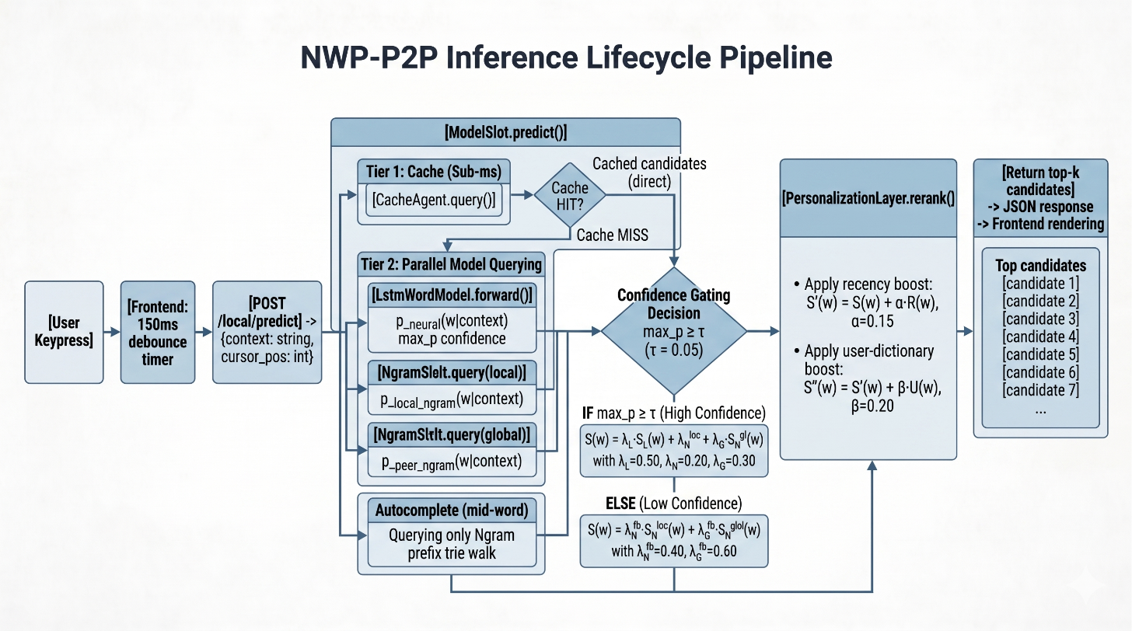

Table 4.2: Model and Training Hyperparameters
Hyperparameter | Value
Architecture | Embedding -> LSTM -> Linear
Embedding dimension | 96
LSTM hidden dimension | 160
Vocabulary size | ~2,500 tokens
Maximum sequence length | 16 tokens
Batch size (offline notebook) | 32
Training epochs (offline notebook) | 10
Optimiser | AdamW (lr = 0.003)
Gradient clipping | max_norm = 1.0
On-device steps per session | Up to 10 gradient steps
Peer mix ratio (FL) | 0.35
Confidence threshold (tau) | 0.05 (default, configurable)
N-gram order | Trigram (max n = 3)
N-gram vocabulary cap | 1,000 types (LFU eviction)
N-gram smoothing | Laplace (lambda = 0.5)

5. Results and Discussion

5.1 Experimental Setup and Prediction Accuracy
All experiments were conducted in a CPU-only environment using an AMD Ryzen 5 processor laptop with 8 GB RAM, using installed Python 3.10 and PyTorch 2.1 (CPU build), while LSTM pre-training was conducted on Google Colab with a Tesla T4 GPU. The metrics evaluation used manually constructed short-context prompts representative of everyday English typing. Metrics such as Hit@1, Hit@5, mean reciprocal rank, perplexity, and latency were computed to capture both predictive quality and real-time usability.

Table 5.1: Prediction Accuracy and Latency Results
Model | Hit@1 | Hit@5 | MRR | Perplexity | Latency (ms) | Notes
LSTM | 49.21% | 62.79% | 0.5539 | 21.99 | 5-30 | CPU forward pass
N-gram | 58.72% | 79.10% | - | - | <1 | Cache hit path
Hybrid | 51.23% | 65.78% | - | - | <31 | LSTM excluded when conf < tau
Session Cache | - | - | - | - | <1 | Sub-ms phrase recall

5.3 Analysis of Accuracy Results
The n-gram model works reasonably well within its trained domain but faces issues wen dealing with modern phrasing, often falling back to unigram predictions due to missing trigram contexts. The LSTM model achieves a Hit@1 of 49.21% and Hit@5 of 62.79%, with a perplexity of 21.99, showing that it captures deep connections within word relationships in spite of its compact size. Performance drops in out-of-domain cases, which is expected given dataset limitations, indicating that data quality and coverage—not architecture—are the main constraints. Core system components like confidence gating, gossip synchronization, and normalized aggregation function as intended regardless of these accuracy variations.

5.4 Latency Results and Model Footprint
Inference latency is still well within real-time limits, with n-gram and cache components working in sub-millisecond time and the LSTM model adding 5–30 milliseconds depending on context, with a maximum of 31 milliseconds to the end. The frontend’s 150-millisecond debounce window provides sufficient buffer for smooth interaction. By taking the terms of footprint, the n-gram model is negligible in size (~0.15 KB), while compressed LSTM weights occupy 2–4 MB; personalization and session data remain small, and total runtime memory stays within 150–300 MB, making the system practical for standard hardware.

5.6 Federated Learning Protocol Validation
Instead of doing full multi-round experiments, I performed a functional validation using two peer instances to test gossip-based synchronization. The newly written word at one peer was successfully learned at another peer within a single round, confirming correct handling of n-gram updates and payload exchange. LSTM weight sharing was validated structurally, though its long-term impact on accuracy across multiple rounds is left for future evaluation.

6. Comparison with Existing Work
Table 6.1 compares the proposed system against various approaches across metrics like model design, federated learning strategy, latency, privacy, and deployment feasibility, and the differences are quite telling. Systems like Hard et al. [1] achieve strong real-world performance but rely on centralized, proprietary infrastructure, which limits applicability in privacy-sensitive or independent deployments, on other hand AWD-LSTM models [6] produces excellent perplexity at the cost of large multi-layer architectures that are impractical for CPU-only inference. Pure n-gram models offer minimal latency but fail to generalize to unseen contexts, and transformer-based models like GPT-2, while highly accurate, needs GPU-level resources that contradict lightweight deployment goals.
Table 6.1: Comparison with Existing Next-Word Prediction Systems
System | Model Type | FL Architecture | Latency | Privacy | Key Limitation
Gboard (Hard et al. [1]) | LSTM | Centralized FedAvg | Low | Server-side | Requires central server; proprietary stack
AWD-LSTM [6] | Multi-layer LSTM | None | High | None | Too large for edge CPU; no FL component
Trigram N-gram [4] | Statistical | None | Very Low | Local only | Poor generalization to unseen contexts
Gossip FL [8] | General NN | Decentralized gossip | Varies | Partial | General-purpose; not tailored to NWP
Transformer (GPT-2) [3] | Transformer | None | High (CPU) | None | Requires GPU or NPU for real-time use
DP-FedAvg [18] | CNN/LSTM | Centralized + DP | Low | Formal (epsilon-DP) | Central server still required
Proposed System | Hybrid LSTM + N-gram | Serverless P2P gossip | Low (<31ms) | Redaction + delta-only | Small corpus; no formal DP yet

Decentralized frameworks such as Hegedus et al. [8] works towards serverless learning but are not customized for next-word prediction or hybrid payloads. Against this background, the proposed system stands out by combining serverless peer-to-peer federated learning, confidence-aware hybrid inference, real-time CPU performance, and lightweight personalization in a single runnable pipeline, with the main limitation being the formal differential privacy not being guaranteed. The novelty does not come from any single part alone but from how these pieces are combined together: dynamic confidence-gated routing replaces static interpolation by suppressing unreliable neural outputs at runtime, L2-normalized aggregation ensures fair parameter merging across peers without requiring knowledge of their training histories, and the entire system is engineered to operate within strict latency and resource constraints on commodity hardware. Taken together, these design choices close a practical gap in existing work, offering a system that is not only conceptually sound but also immediately deployable, with a clear path for future improvements through better datasets and multi-peer evaluation.

8. Conclusion
This report presents a working demo of a fully CPU based on-device next-word prediction system that does not depend on cloud infrastructure or specialized hardware, instead focusing on getting a balance between speed, privacy, and collective improvement across peers. At its core, the design combines a confidence-gated hybrid inference mechanism that dynamically switches between a compact LSTM and a trigram model, a serverless peer-to-peer federated learning approach using gossip-based weight exchange, and an L2-normalized aggregation method that stabilizes updates across heterogeneous training histories. From a performance point of view, the system meets real-time constraints, with sub-millisecond responses for cache and n-gram paths and a maximum latency of 31 milliseconds for full hybrid inference on standard CPU hardware. The noted accuracy limitations are largely tied to dataset mismatch rather than architectural limitations, which is an important point when interpreting results. Overall, this work should be seen as a solid foundation rather than a finished solution, showing that decentralized, on-device prediction is not just viable but practical, with the main challenge now shifting toward richer training data, broader multi-peer validation, and stronger privacy guarantees.

Team Contribution

Team Member | Contributions
Dhanancheyan Anbuselvam | System architecture design, LSTM model development, confidence-gating mechanism, L2-normalized FedAvg, gossip protocol implementation, training pipeline, evaluation, and documentation.

References
- A. Hard, K. Rao, R. Mathews, S. Ramaswamy, F. Beaufays, S. Augenstein, H. Eichner, C. Kiddon, and D. Ramage, "Federated learning for mobile keyboard prediction," arXiv preprint arXiv:1811.03604, 2018.
- M. Sundermeyer, R. Schluter, and H. Ney, "LSTM neural networks for language modeling," in Proc. Interspeech, 2012, pp. 194-197.
- A. Vaswani, N. Shazeer, N. Parmar, J. Uszkoreit, L. Jones, A. N. Gomez, L. Kaiser, and I. Polosukhin, "Attention is all you need," in Advances in Neural Information Processing Systems, 2017, pp. 5998-6008.
- S. F. Chen and J. Goodman, "An empirical study of smoothing techniques for language modeling," Computer Speech & Language, vol. 13, no. 4, pp. 359-394, 1999.
- H. B. McMahan, E. Moore, D. Ramage, S. Hampson, and B. A. y Arcas, "Communication-efficient learning of deep networks from decentralized data," in Proc. AISTATS, 2017, pp. 1273-1282.
- S. Merity, N. S. Keskar, and R. Socher, "Regularizing and optimizing LSTM language models," in Proc. ICLR, 2018.
- A. T. Suresh, F. X. Yu, S. Kumar, and H. B. McMahan, "Distributed mean estimation with limited communication," in Proc. ICML, 2017, pp. 3329-3337.
- I. Hegedus, G. Danner, and M. Jelasity, "Gossip learning as a decentralized alternative to federated learning," in Proc. IFIP International Conference on Distributed Applications and Interoperable Systems, 2019, pp. 74-90.
- A. Lalitha, S. Shekhar, T. Javidi, and F. Koushanfar, "Fully decentralized federated learning," in Proc. NeurIPS Workshop on Bayesian Deep Learning, 2018.
- T. Mikolov, M. Karafiat, L. Burget, J. Cernocky, and S. Khudanpur, "Recurrent neural network based language model," in Proc. Interspeech, 2010, pp. 1045-1048.
- Y. Jiang, J. Konecny, K. Rush, and S. Kannan, "Improving federated learning personalization via model agnostic meta learning," arXiv preprint arXiv:1909.12488, 2019.
- A. Basu, S. Data, C. Karakus, and S. Diggavi, "Qsparse-local-SGD: Distributed SGD with quantization, sparsification and local computation," in Advances in Neural Information Processing Systems, 2019.
- D. P. Kingma and J. Ba, "Adam: A method for stochastic optimization," in Proc. ICLR, 2015.
- T. Mikolov, I. Sutskever, K. Chen, G. Corrado, and J. Dean, "Distributed representations of words and phrases and their compositionality," in Advances in Neural Information Processing Systems, 2013, pp. 3111-3119.
- P. Kairouz, H. B. McMahan, B. Avent et al., "Advances and open problems in federated learning," Foundations and Trends in Machine Learning, vol. 14, no. 1-2, pp. 1-210, 2021.
- K. Bonawitz, V. Ivanov, B. Kreuter, A. Marcedone, H. B. McMahan, S. Patel, D. Ramage, A. Segal, and K. Seth, "Practical secure aggregation for privacy-preserving machine learning," in Proc. ACM CCS, 2017, pp. 1175-1191.
- C. Dwork and A. Roth, "The algorithmic foundations of differential privacy," Foundations and Trends in Theoretical Computer Science, vol. 9, no. 3-4, pp. 211-407, 2014.
- R. C. Geyer, T. Klein, and M. Nabi, "Differentially private federated learning," arXiv preprint arXiv:1712.07557, 2017.
- T. Shaik, X. Tao, H. Higashino, L. Li, Y. Blumenstein, Q. Zhu, and L. Li, "Federated learning for keyboard next word prediction: A survey," Journal of Artificial Intelligence Research, vol. 75, pp. 215-249, 2022.
- R. Rosenfeld, "Two decades of statistical language modeling: Where do we go from here?" Proceedings of the IEEE, vol. 88, no. 8, pp. 1270-1278, 2000.
- U. Khandelwal, O. Levy, D. Jurafsky, L. Zettlemoyer, and M. Lewis, "Generalization through memorization: Nearest neighbor language models," in Proc. ICLR, 2020.
- J. Howard and S. Ruder, "Universal language model fine-tuning for text classification," in Proc. ACL, 2018, pp. 328-339.
- S. Hochreiter and J. Schmidhuber, "Long short-term memory," Neural Computation, vol. 9, no. 8, pp. 1735-1780, 1997.
- J. Konecny, H. B. McMahan, F. X. Yu, P. Richtarik, A. T. Suresh, and D. Bacon, "Federated learning: Strategies for improving communication efficiency," arXiv preprint arXiv:1610.05492, 2016.
- M. Abadi, A. Chu, I. Goodfellow, H. B. McMahan, I. Mironov, K. Talwar, and L. Zhang, "Deep learning with differential privacy," in Proc. ACM CCS, 2016, pp. 308-318.

