Packages

The fundamentals of packages in Java include the following concepts:

**Package Declaration**: A package is declared at the top of the source file using the "package" keyword followed by the package name. This statement must be the first non-comment line in the file.

Package Naming Conventions: Package names typically use a reverse domain name notation, such as com.example, to ensure unique names across different projects.

Importing Packages: Classes and interfaces can be imported into a source file using the "import" keyword, allowing them to be used without specifying the full package name

In Java, a package is a way to organize related classes and interfaces. It is used to group classes and interfaces together and give them a unique namespace. Packages can also be used to provide access protection and namespace management. Classes and interfaces are placed in a package by including the package statement at the beginning of the source file, before any class or interface definitions. The package statement is followed by the name of the package. For example, the package statement for a class called MyClass in a package called com.example would be "package com.example;".

**Benefits of using packages in Java:**

**Namespace management:** Packages provide a way to organize classes and interfaces into a logical hierarchy, which helps to avoid naming conflicts and makes it easier to locate and use specific classes and interfaces.

**Access protection:** Packages can be used to control access to classes and interfaces, making it possible to restrict access to certain classes and interfaces to specific parts of a program or to other programs.

**Reusability:** Packages allow for the creation of reusable code, which can be used in multiple projects. Classes and interfaces in a package can be easily shared and reused by other developers.

**Versioning:** Packages can be versioned which makes it easier to manage and maintain different versions of a library or codebase.

**Organization:** Packages help organize your code in a logical and structured way, making it easier to navigate and understand the codebase.

**Improved Performance:** The Java Virtual Machine (JVM) can load classes more efficiently when they are organized into packages.

Overall, packages are a powerful tool for organizing and managing Java code, and they are an important aspect of writing maintainable, reusable, and efficient Java code.

package com.example;

public class MyClass {

// class code here

}

**Packages( protected members )**

In Java, the protected access modifier is used to control access to package-level members, such as classes, interfaces, and methods. When a member is declared as **protected**, it can be accessed within the package it is declared in and also by any subclasses of the class in any package.

Here is an example of how to use the protected access modifier:

package com.example;

public class MyClass {

protected int myVar;

protected void myMethod() {

// method code here

}

}

In this example, the variable myVar and the method myMethod are declared as protected. This means that they can be accessed within the package com.example and also by any subclasses of the class MyClass in any package.

package com.example.subpackage;

import com.example.MyClass;

public class MySubClass extends MyClass {

public void useProtectedMembers(){

myVar = 5; // accessible

myMethod(); // accessible

}

}

In this example, the class MySubClass is in the package com.example.subpackage and it extends MyClass, which is in the package com.example, so it can access the protected members myVar and myMethod of MyClass.

It's important to note that protected members are not accessible outside the package and by classes that don't extend the class that has the protected members, this means that protected members can't be accessed by other classes in the same package or by classes in a different package that don't extend the class with the protected member.

By using protected access, you can create a more flexible and maintainable codebase by encapsulating implementation details, while still allowing subclasses to access and utilize those details.

**Member Access in packages in java**

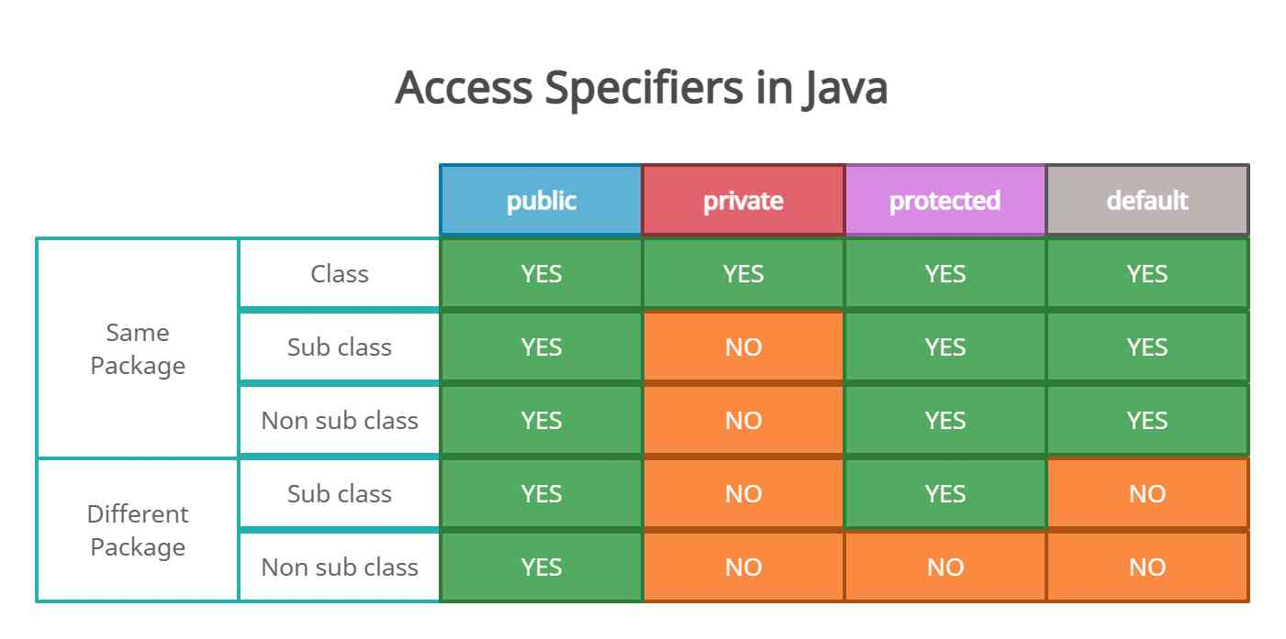

In Java, packages provide a way to organize classes and interfaces and control their visibility and accessibility. One aspect of this is controlling access to package-level members, such as classes, interfaces, and methods.

There are three types of access for package members:

**package-private (default) members**: These members have default access and are only accessible within the package they are declared in. They are not accessible from outside the package, even by subclasses.

**Public members**: These members have public access and can be accessed from anywhere, including outside the package they are declared in. They are denoted by the keyword public before the class, interface, method, or variable.

**Protected members**: These members have protected access and can be accessed within the package they are declared in and also by any subclasses of the class in any package. They are denoted by the keyword protected before the class, interface, method, or variable.

You can use access modifiers to change the default package-private access to public or protected access. This allows you to control which classes and interfaces can access a particular package member.

For example, you could make a class public so that it can be accessed from anywhere:

package com.example;

public class MyClass {

// class code here

}

Or you could make a method protected so that it can be accessed within the package and by subclasses:

package com.example;

public class MyClass {

protected void myMethod() {

// method code here

}

}

By controlling access to package members, you can ensure that your code is more maintainable, efficient, and secure.

**Moving a class to another package Java**

To move a class to another package in Java, you will need to do the following steps:

Create the new package: You will need to create the new package in your project where you want to move the class to. You can create a package using the package statement at the top of the source file. For example, to create a package called com.example.newpackage you would add the following line at the top of the file:

package com.example.newpackage;

Move the class to the new package: Once you have created the new package, you can move the class to it by changing the package statement at the top of the class's source file to match the new package name. For example, to move the class MyClass to the package com.example.newpackage, you would change the package statement to:

Move the class to the new package: Once you have created the new package, you can move the class to it by changing the package statement at the top of the class's source file to match the new package name. For example, to move the class MyClass to the package com.example.newpackage, you would change the package statement to:

Move the class to the new package: Once you have created the new package, you can move the class to it by changing the package statement at the top of the class's source file to match the new package name. For example, to move the class MyClass to the package com.example.newpackage, you would change the package statement to:

Update any imports or references to the class: If there are any other classes or files that reference or import the class you are moving, you will need to update those to reflect the new package name.

For example, if another class called Main imports MyClass, you would need to update the import statement to:

import com.example.newpackage.MyClass;

Re-compile the code: After making these changes, you will need to recompile the code in order for the changes to take effect.

Test the code: Finally, it's important to test your code to make sure that the class was moved correctly and that all references and imports were updated correctly.

By following these steps, you can move a class to another package in Java, which can help you to better organize and manage your code, improve its reusability, and ensure that it is more maintainable and efficient.

**Static import**

In Java, the static import feature allows you to import the static members of a class or an interface, instead of importing the entire class or interface. This allows you to access the static members directly, without having to qualify them with the class or interface name.

Here's an example of how to use static import:

In Java, the static import feature allows you to import the static members of a class or an interface, instead of importing the entire class or interface. This allows you to access the static members directly, without having to qualify them with the class or interface name.

Here's an example of how to use static import:

In this example, the static import statement is used to import the PI, max, and min static members of the Math class. This allows the code to use these members directly, without having to qualify them with the class name. For example, instead of writing Math.PI, you can just write PI.

It's important to note that, while static import can make code more readable and less verbose, it can also make it harder to understand where the imported members are coming from, especially if you are using a lot of static imports in a single file. It's also important to note that using wildcard imports (importing all the static members using import static java.lang.Math.*) is not a good practice, it can lead to naming collisions and make the code harder to understand.

Overall, static import is a useful feature that can be used to make code more readable and less verbose, but it should be used with caution to avoid naming collisions or making the code harder to understand.