Project Nickname: Shaktiman
CS 514

Applied Artificial Intelligence

Project 1

BANK LOAN APPLICATION EXPERT SYSTEM

!1

INDEX

TOPIC | PAGE NO
Abstract | 3
Features of Bank Loan Application Expert System | 3
Description and Rules | 4
Usage Manual | 5
Sample Runs Cases and Screenshots | 5
Test Cases | 7

!2

ABSTRACT:

Bank Loan Application Expert system is a rule based expert system designed using JESS wherein, information of a loan applicant is asserted by the user of the Bank, and finally concludes whether applicant is eligible to apply for a loan or not. System also provides suggestions to the user of the system to help him/her to decide in a very convenient manner. The expert system checks for all the parameters asserted by the user and finally claims the decision depending upon its interpretation and a few important rules set in the bank’s policy.

FEATURES:

- The system asks the bank’s user admin to input all the required details of an applicant applying for a business loan; such as name, age, number of businesses, amount owed, education, experience, credit score etc.

- The system first checks the age of an applicant whether if it’s above the minimum requirement.

- System provides the feature to check for the limit of total amount an applicant can owe.

- The system analyzes an applicant’s history like years of education, and experience in the relevant business.

- An applicant’s chance of approval increases if he/she have cleared all the previously borrowed loans.

- The system checks for the minimum number of businesses an applicant should possess as an asset to apply for the business loan.

- Bank always checks for the amount of investment an applicant has already made, or willing to make thereby making an interpretation if an investment made is above the threshold set or not.

- At the end, the system provides features to input the behavioral aspects of an applicant based on the information collected like, repayment ability and management capability.

- Finally, an important aspect called Credit Score is verified i.e. if he/she has a good or a poor credit score. If poor, the application is rejected straightaway.

- The rules of the system are sequenced in such a way that if any/all of the top 4 parameters (Legal age, Amount owed, previous loans paid, and credit score) do not meet the required values, then the applicant’s application is rejected.

- System provides suggestions to the bank employee related to every parameter that is not satisfied to provide employee with the in-depth reasoning about client's information and application status.

3

RULES & DESCRIPTION:

Template mentioned in the code describe variables used for storing applicant’s information

(deftemplate Business_loan_applicant

(slot applicant_name)

  - Applicant's age in number(Integer VALUE only) (slot age (type INTEGER))

- Amount currently owed by applicant in Dollars(Integer VALUE only) (slot current_owe (type INTEGER))

- Any pending payment of previously sanctioned loans?

(slot paid (allowed-values Yes No))

- Applicant's Years of experience in related business (slot exp (type FlOAT))

- Total number of businesses owned by applicant

(slot bus (type INTEGER))

- Years of education of an applicant (slot edu (type INTEGER))

- Total amount invested so far by the applicant in the business (slot inv (type INTEGER))

- Ability to repay loan

(slot repay (allowed-values Good Poor))

; Management Ability of an applicant

(slot mgmt (allowed-values Good Average Poor))

; Credit History of an applicant

(slot credit (allowed-values Good Poor))

)

In general, system uses 12 rules in total to decide for a loan application:

- initial: Outputs applicant information.

- ageCheck: Checks if applicants age satisfies the legal age set by loan.

- currentOwedAmountCheck: Checks if applicant’s currently owed amount to bank is higher than the threshold limit.

- borrowedLoansCheck: Checks if applicant has paid previously borrowed loans.

- experienceCheck: Checks for the number of years of experience applicant possess.

- businessesOwnedCheck: The bank needs minimum of businesses as an asset for the loan by applicant.

- educationCheck: Checks for the minimum education qualification.

- investmentCheck: Checks for the investment made by an applicant so far.

- repayAbilityCheck: Analyses the ability of an applicant to repay the loan amount.

- managementAbilityCheck: Analyses the ability of an applicant to manage the loan amount (paying interest and EMI’s).

- creditScoreCheck: Checks for the credit score rating of an applicant.

- finalDecision_Impparameters: Final rule to decide of approving a loan application or not on the basis of satisfiability of the top 4 parameters set.

!4

USAGE MANUAL:

- Copy the Shaktiman.clp into the bin folder inside the JESS directory.

- Open JESS and execute the following command:

(batch “Shaktiman.clp”)

(assert (Business_loan_applicant (applicant_name "shaktiman")

(age 17) (current_owe 100000) (paid Yes)

(exp 2) (bus 2) (edu 5) (inv 30000)

(repay Good) (mgmt Poor) (credit Good)))

Output from Eclipse console: RUN #1

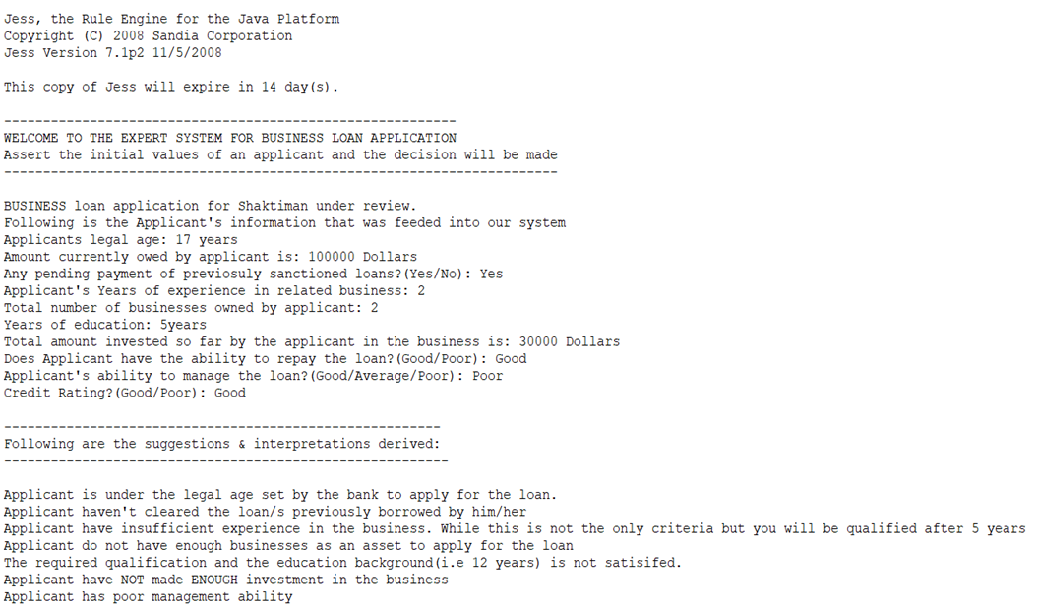

Note: In case the grader wants to change inputs and test new inputs (from test cases provided or his/her own values) please make changes that conform to the allowed values of the slots in the template defined. Also, make sure there is only one active case in each run i.e. the Shaktiman.clp file will have only one assert and one run statement at a time.

!5

RUN #2 : If we tweak assertion to following

(assert (Business_loan_applicant (applicant_name "shaktiman_2")

(age 18) (current_owe 5) (paid Yes)

(exp 7) (bus 1) (edu 5) (inv 30000)

(repay Good) (mgmt Poor) (credit Good)))

Output from Eclipse Console: RUN #2

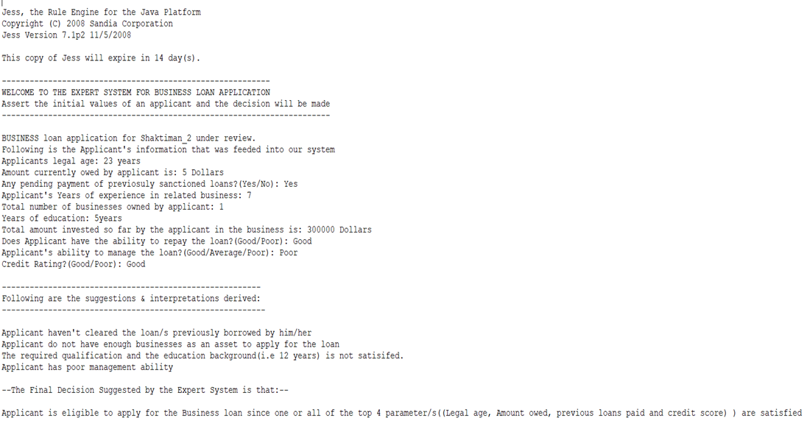

Note: While running the file on the terminal/ command prompt, if the output doesn’t fit the screen of your terminal / command prompt (i.e. if the content is unaligned), Kindly resize the width of your window size by using following instruction:

- Right Click on the prompt boarder and select Properties.

- Now select the layout tab and change the windows size width, by default is 80. Here you can change the Screen Buffer Size Width and Window Position. When you are finished click OK.

- Now the window is wider, if not; restart the JESS and run the same command: (batch “Shaktiman.clp”)

- We can now see all the data in a much easier to read format.
TEST CASES: Please use only one test case at a time in the Megamind.clp file

(assert (Business_loan_applicant (applicant_name "shaktiman_3")

(age 17) (current_owe 100000) (paid Yes)

(exp 2.0) (bus 2) (edu 5) (inv 30000)

(repay Good) (mgmt Poor) (credit Good)))

(assert (Business_loan_applicant (applicant_name "shaktiman_4")

(age 18) (current_owe 100000) (paid Yes)

(exp 2.0) (bus 2) (edu 5) (inv 30000)

(repay Good) (mgmt Poor) (credit Good)))

(assert (Business_loan_applicant (applicant_name "shaktiman_5")

(age 18) (current_owe 105000) (paid No)

(exp 2.0) (bus 6) (edu 13) (inv 45000)

(repay Good) (mgmt Poor) (credit Poor)))

(assert (Business_loan_applicant (applicant_name "shaktiman_6")

(age 18) (current_owe 90000) (paid Yes)

(exp 8.0) (bus 1) (edu 5) (inv 4000)

(repay Good) (mgmt Average) (credit Good)))

Thank You

