LOAN REPAYMENT DECISION SYSTEM

PROJECT TO PREDICT IF LOAN WILL BE REPAID WITH EXTENSION USING BAYESIAN NETWORKS AND DECISION NETS

SHAKTIMAN

CS 514


Applied Artificial Intelligence

Project 4

1

 | INDEX
TOPIC |  | PAGE NO
Abstract |  | 3
Usage Manual |  | 4
Sample Output |  | 4
Test Cases |  | 5

2

ABSTRACT:

Loan Repayment Decision system is a combination of Bayesian Network and influence Diagram designed using NETICA wherein information of different type of loan applicants and types of loan is asserted by the user of the Bank, and finally concludes whether applicant will be to repay loan or not.Accurately predicting whether a loan will be repaid (credit" scoring) is an important task for any bank.Furthermore, the decision regarding the deadline if it needs to be extended or not is made using the utility and decision node in influence diagram. High accuracy benefits both the banks and the loan applicants.

FEATURES:

- The created is designed for a generic credit scoring scenario using 20 nodes.

- Nodes within the net are based upon the intuition.

- The resultant network had 12 evidence variables which do not depend on any external nodes and have their prior probabilities feed, feeding into 6 inner nodes, which, in turn, feed into the outcome node, LoanRepaid.

- The inner nodes serve two purposes: they group data into qualitative conceptual categories, making interpretation of the BayesianNetwork easier, and they reduce the size of the CPTs in the network (via “divorcing”). However, even when using these inner nodes, the CPT was still too large to fill in manually.

- CPT i.e conditional probability table for each independent variable were used by Netica to generate the CPTs for dependent variables.

- The node, IndividualCreditworthiness, used a weighted average of its parents.

- Note: While some of the probabilities are as close to reality as possible, many have been formulated with hypothesizing and following the general trend defined by banks.

- Most important variables like IndividualCreditWorthiness and FinancialStability decides the posterior probabilities of every other factors.

- The decision node “Deadline_Extension” is a parameter used to define if the extension is to be given after deadline for the loan repayment.

- The utility node “Existing_Credit_WithBank” is used to model the change in the utility value for the deadline_extension node. It depends on the factors like “loan_duration” and “loan_purpose”.

3

USAGE MANUAL:

- Download and place the “shaktiman.dne” file in any directory and open it through NETICA application. Compile the project and after the network is initialized, modify and

set the values accordingly and see how the network adapts to the change.
SAMPLE OUTPUT:
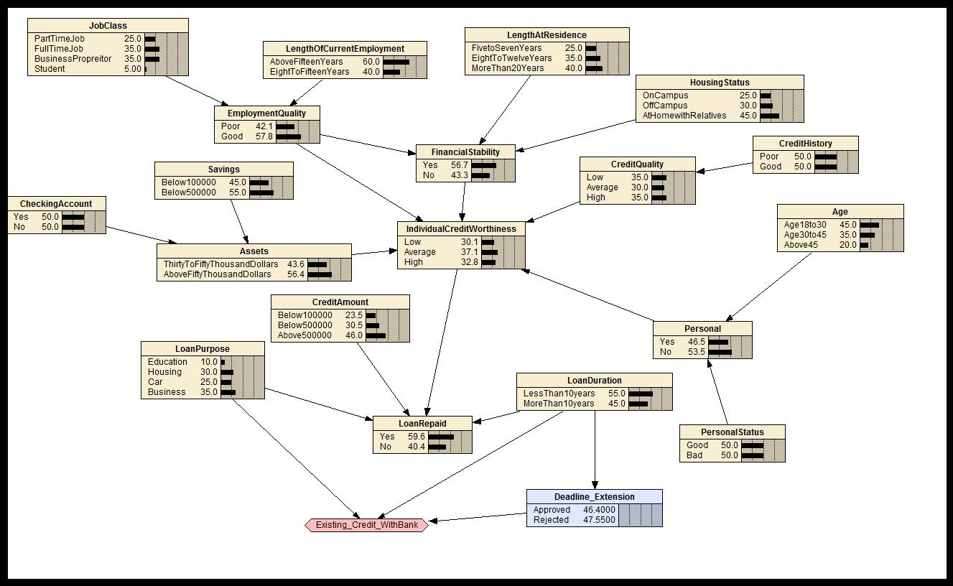

4

SAMPLE TEST CASES TO TRY:

- Set different loanPurpose to 100 and see the utility value getting back propagated to the decision node accordingly. Changes reflected in Deadline_Extension.

- If LoanDuration = “Less Than 10years” and LoanRepaid=“Yes”, you will see that the utility value of the decision node value for “approved” is greater (approx 36.77) as compared to the rejected value(approx. 20.653).

- If LoanDuration = “Less Than 10years” and LoanRepaid=“No”, you will see that the utility value of the decision node value for “approved” is still more than the “rejected” since the time to repay loan was less.

- The utility value changes when the LoanPurpose changes for e.g.: if LoanDuration = “Less Than 10years” and LoanRepaid=“No”
and LoanPurpose=“Education”, deadline extension:approved=45, rejected=35

- Similarly, you can try for various purposes and other nodes in the network.

5

