Dictionaries

1. Consider the following dictionary:  
   color_code = {'red': '#FF0000',  
    'green': '#00FF00',

'blue': '#0000FF'}

What will be printed for the following expressions? If an expression generates an error write “error”.

|  |  |
| --- | --- |
| **Expression** | **Value** |
| color_code['red'] |  |
| color_code['black'] |  |
| color_code['#00FF00'] |  |
| color_code[2] |  |

1. Consider the following dictionary:

person = {}

person['name'] = 'Adalbert Gerald Soosai Raj'

person['age'] = 30

person['isAlive'] = True

person['phone'] = [  
 {'type': 'office', 'number': '608-123-4567'},   
 {'type': 'home', 'number': '608-987-6543'}  
]

person['address'] = {'street': '1210 West Dayton Street', 'city': 'Madison', 'state': 'WI', 'zip': 53706}

What is the **type** (int, float, bool, str, list, dict) of the following expressions?

|  |  |  |  |
| --- | --- | --- | --- |
| **Expression** | **Type** | **Expression** | **Type** |
| person |  | person['isAlive'] |  |
| person['name'] |  | person['phone'] |  |
| person['age'] |  | person['address'] |  |

1. For this wacky code, what is printed if we replace **????** in each case (use diagram)?

webster = {

"a": ["apple", "and", "ada"],

"b": ["bike", "deBug"],

"z": {"name": "zebra", "kind": "mammal"}

}

luny_l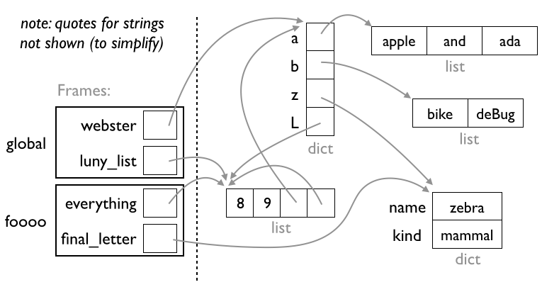ist = [8, 9, webster]

|  |  |  |  |
| --- | --- | --- | --- |
| **????** | **result** | **????** | **result** |
| luny_list[1] |  | luny_list[3][1] |  |
| webster["a"][-1] |  | everything[3][3][3][2]["z"]["kind"] |  |
| webster["z"]["name"] |  | final_letter["name"][-1] |  |
| webster["L"][1] |  | luny_list[3][-1][3][-1][3][-1][3][-1][0] |  |
| luny_list[2]["b"][1] |  | webster["L"][2]["L"][2]["L"][2]["L"][1] |  |

luny_list.append(luny_list) # *what?????*

webster["L"] = luny_list

def foooo(everything):

final_letter = everything[2]["z"]

print(**????**)

foooo(luny_list)

1. What is the output of the following code snippet?

capitals = {'India': 'New Delhi',  
 'USA': 'Washington DC',  
 'China': 'Beijing'}

for item in capitals:

print(item)

1. What is the output of the following code snippet?

word = "Happiness"

d = dict()

for letter in word:

if letter in d:

d[letter] += 1

else:

d[letter] = 1

print(d)

1. Consider the following dictionary:

d = {}

d[0] = 'zero'

d[1] = 'one'

d[2] = 'two'

What will be printed for the following expressions? If an expression generates an error

write “error”.

|  |  |
| --- | --- |
| **Expression** | **Value** |
| 1 in d |  |
| '2' in d |  |
| 2 not in d |  |
| 'zero' in d |  |