**Table of Contents**

**1. Introduction**

**2. Type of e-commerce**

* **Business to Consumer**
* **Business to Business**

**3. Goal**

**4. Need of the e-commerce**

**5. Specification of e-commerce project**

**6. System Requirement Analysis**

* **Information Gathering**
* **Economic Feasibility**
* **Behavioral Feasibility**

**7. ER-diagram**

**8. Data flow diagram**

**9. Design Goals**

**10. Testing**

**Type of testing**

* **Validation Testing**
* **Functional Testing**

**11. Conclusions**

* **Limitations**

**Reference.**

1.1Introduction

E-commerce means electronic commerce. The **buying and selling of goods or services using the internet**, and the transfer of money and data to execute these transactions.E-commerce is the buying and selling of good or services via the internet, and the transfer of money and data to complete the sales. It’s also known as electronic commerce or internet commerce.

## **2. Types of e-commerce**

1. **Business to Consumer (B2C):** B2C e-commerce is the most popular e-commerce model. Business to consumer means that the sale is taking place between a business and a consumer, like when you buy a rug from an online retailer.
2. **Business to Business (B2B):** B2B e-commerce refers to a business selling a good or service to another business, like a manufacturer and [wholesaler](https://www.the-future-of-commerce.com/2021/04/22/what-is-wholesale-distribution-definition-examples/), or a wholesaler and a retailer. Business to business e-commerce isn’t consumer-facing, and usually involves products like raw materials, software, or products that are combined. Manufacturers also sell directly to retailers via B2B ecommerce.

**3. Goal**

* The goal of this application is to develop a web based interface for online retailers.
* Reduce management costs.

### Increasing the number of loyal customer

### 4. Needs Of E-commerce:

There are large numbers of commercial Online Shopping websites offering large number of products tailored to meet the shopping interests of large number of customers. These online marketplaces have thousands of products listed under various categories. Problem:

• The basic problems with the existing systems are the non-interactive environment they provide to the users.

• The use of traditional user interfaces which make continuous post backs to the server; each post back makes a call to the server, gets the response and then refreshes the entire web form to display the result. This scenario adds an extra trade off causing a delay in displaying the results • A search engine that would display the results without allowing the users to further filter the results based on various parameters. • Use of traditional and non user friendly interfaces that are hard to use

**Solution:**

• The motive of this Online Shopping Web Application is to allow the user to play with the search tool and create different combinatorial search criterion to perform exhaustive search.

• Making the application AJAX enabled gets rid of these unnecessary delays letting the user to perform exhaustive search. The users of this application can easily feel the difference between the Ajax empowered user interfaces vs. traditional user interfaces.

• Provide Interactive interface through which a user can interact with different areas of application easily.

• A search engine that provides an easy and convenient way to search for products specific to their needs.

## **E-commerce can expand your Brand Name.**

* Low entry cost, satisfies your budget.
* Reduce transaction costs.
* Allow prospective customer to shop where, how, and when they want.
* Track your customers.

**Scope**

• The users could subscribe for price alerts which would enable them to receive messages when price for products fall below a particular level.

• The current system is confined only to the shopping cart process. It can be extended to have a easy to use check out process.

**5. Specification of e-commerce project:**

* Establish an agreement between the client and IT team/development agency on the deliverables of the project.
* Reduce miscommunication, rework time, and development efforts/resources.

Reduce the need to redesign, recode, and retest.

* Ensure that you have a realistic timeline and budget expectation.
* Define the project’s success criteria.

**6. System Requirement Analysis**

The goal of the application is ease of use and to provide an interactive interface, extensive research has been done to gain an insight into the needs and of various users.

The users should be able to view the complete specification of the product and various images at different Zoom levels. The user should be able to read the customer reviews for the product and the ratings provided. They should be able to write their own reviews.

**Information Gathering**

As the goal of the application is ease of use and to provide an interactive interface, extensive research has been done to gain an insight into the needs and behaviors of various users.

The users should be able to view the complete specification of the product and various images at different Zoom levels. The user should be able to read the customer reviews for the product and the ratings provided. They should be able to write their own reviews. They should be able to print out the specifications for a product or email the product page to a friends etc.

**Economic Feasibility**

The project is economically feasible as the only cost involved is having a computer with the minimum requirements mentioned earlier. For the users to access the application, the only cost involved will be in getting access to the Internet.

**Behavioral Feasibility**

The application requires no special technical guidance and all the views available in the application are self explanatory. The users are well guided with warning and failure messages for all the actions taken.

**7. ER-diagram**

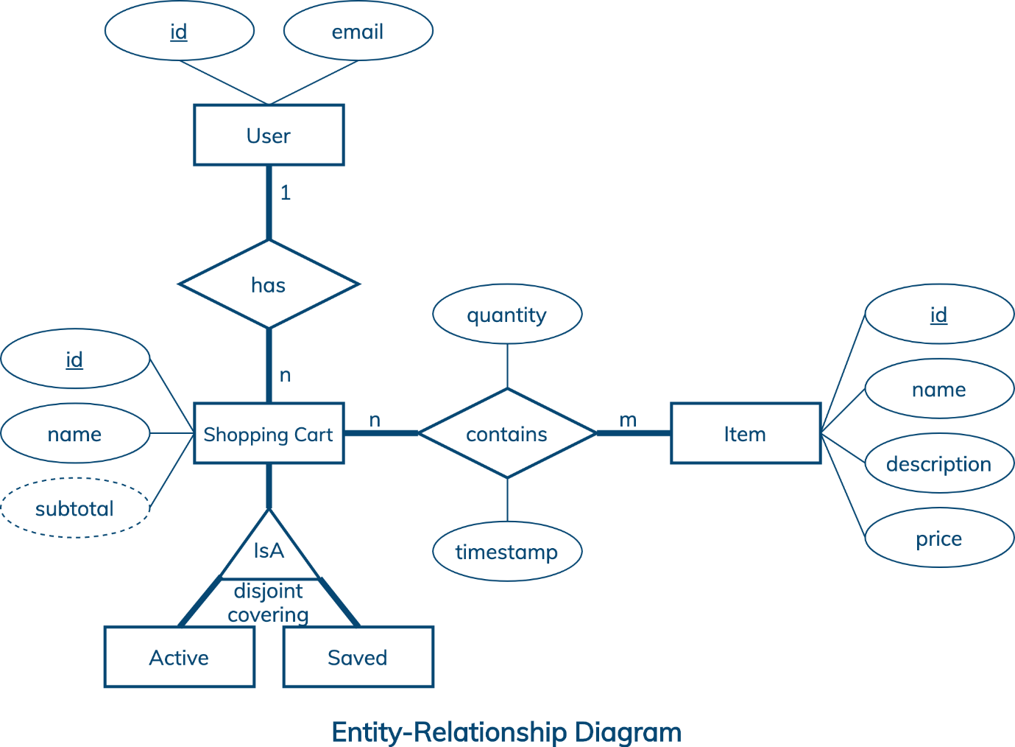

**8. Data flow diagram**

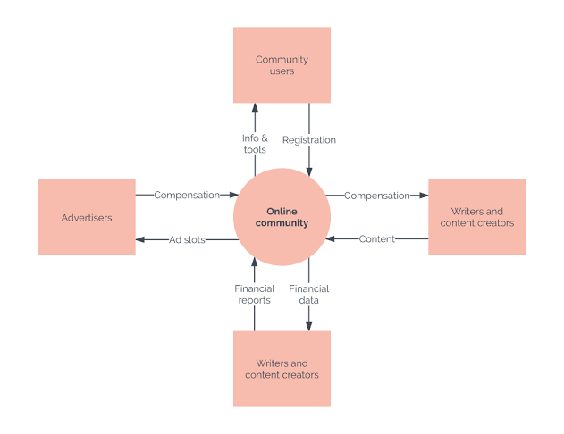

**9. Design Goals**

• The design of the web application involves the design of the forms for listing the products, search for products, display the complete specification for the product, and design a shopping cart that is easy to use.

• Design of an interactive application that enables the user to filter the products based on different parameters.

• Design of an application that has features like drag and drop etc.

• Design of application that decreases data transfers between the client and the server.

Shop Products Module

The user can then filter these products based on various parameters like manufacturer, product type, operating system supported or a price range. The user browse through the products and each product would be displayed with an image and its features like operating system supported, number of user licenses and if it is a full version or an upgrade version. Product Description Module

This module starts when a user visits the product description page. A user can view various images of the product of different sizes. The use can see an enlarged image in a popup window. The user can view the complete specification of the product like its features, operating system supported, system requirements etc.

**10.Testing**

Software testing is a process of running with intent of finding errors in software. Software testing assures the quality of software and represents final review of other phases of software like specification, design, code generation etc.

Unit Testing

Unit testing emphasizes the verification effort on the smallest unit of software design i.e.; a software component or module. Unit testing is a dynamic method for verification, where program is actually compiled and executed. Unit testing is performed in parallel with the coding phase. Unit testing tests units or modules not the whole software. I have tested each view/module of the application individually. As the modules were built up testing was carried out simultaneously, tracking out each and every kind of input and checking the corresponding output until module is working correctly.

### Functional testing to maintain quality

Quality is essential for customer satisfaction and retention.

Imagine an e-commerce application that lets you add products into the shopping cart but doesn’t allow you to place the order or apply a valid promo code to your purchase. These are just a couple of examples of functionality ‘faux pas’ and why integrating functional testing into the engineering workflow is crucial.

**Functional testing** helps identify glitches and uncover critical bugs that can ruin the customer experience. It sets the groundwork for a well-functioning application, validating that all features work according to requirements.

For an e-commerce application critical features that need functional testing include:

* Login system
* Search and filters
* Search result page
* Order details page
* Shopping cart
* Deals and promo codes
* Order confirmation page
* Order tracking

**Validation Testing**

It provides final assurances that software meets all functional, behavioral & performance requirement. Black box testing techniques are used.

There are three main components –

Validation test criteria (no. in place of no. & char in place of char) –

Configuration review (to ensure the completeness of s/w configuration.)

Alpha & Beta testing-Alpha testing is done at developer’s site i.e. at home & Beta testing once it is deployed. Since I have not deployed my application, I could not do the Beta testing

**11. Conclusions**

The ‘Online Shopping’ is designed to provide a web based application that would make searching, viewing and selection of a product easier. The search engine provides an easy and convenient way to search for products where a user can Search for a product interactively and the search engine would refine the products available based on the user’s input. The user can then view the complete specification of each product.

**Limitations**

This application does not have a built in check out process. An external checkout package has to be integrated in to this application. Also users cannot save the shopping carts so that they can access later i.e. they cannot create wish lists which they can access later.

**11.Reference.**

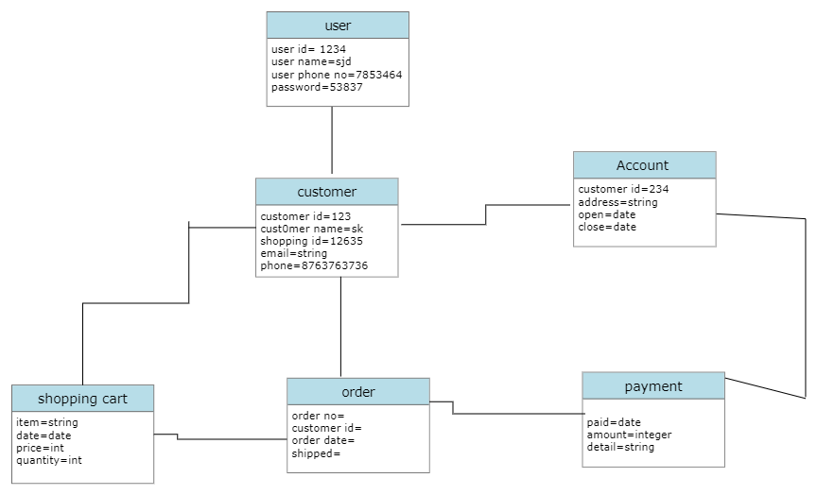class diagram

Pakage diagram

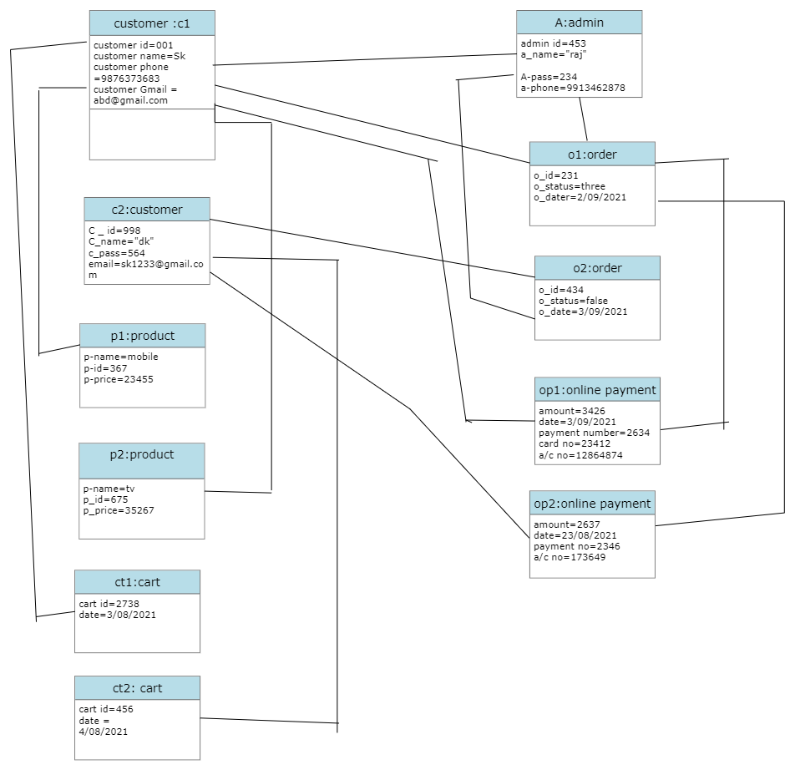 uml diagram

