Virtual Environment in Django

What is a Virtual Environment?
A virtual environment is an isolated space for a Django project where all required Python packages are stored separately.

Why Virtual Environment is Important

1. Avoid Package Conflicts
Different projects may use different Django versions.

Example:
- Project A → Django 4.2
- Project B → Django 5.0
Virtual environment keeps them separate.

2. Keeps System Clean
Packages stay inside the project only.
They do not affect the main Python installation.

3. Easy to Share Projects
Save all installed packages:
pip freeze > requirements.txt
Install them later:
pip install -r requirements.txt

4. Safe Testing
You can install or test packages without affecting other projects.

5. Professional Practice
Most Django developers use virtual environments because they:
- manage dependencies properly
- avoid version issues
- make deployment easier

Create Virtual Environment
python -m venv venv

Activate Virtual Environment

Windows
venv\Scripts\activate

Linux / Mac
source venv/bin/activate

Install Django
pip install django

Create Django Project
django-admin startproject config .

Simple Analogy
A virtual environment is like a separate toolbox for each project.
Each project gets:
- its own packages
- its own versions
- its own setup
This avoids conflicts between projects.
2.How Django Works with HTML, CSS & JavaScript
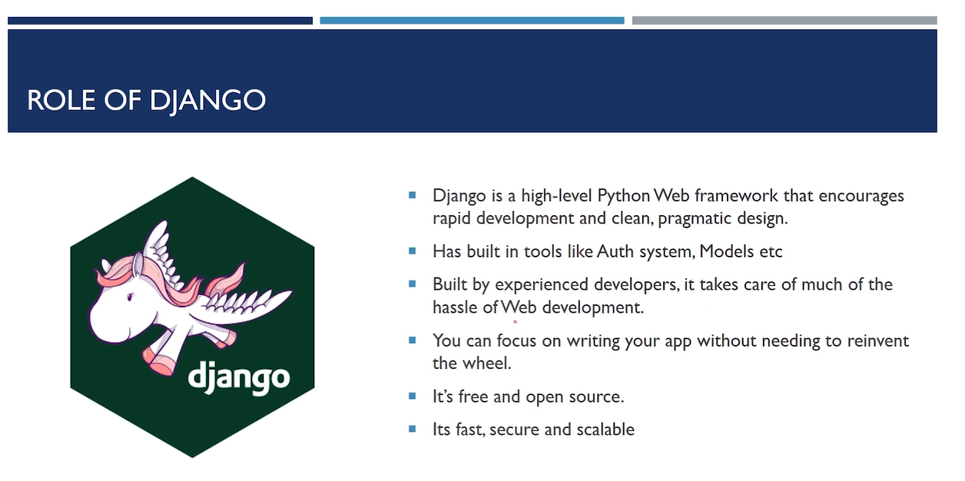

3.Folder Structure of a Django Application

What is manage.py in Django?
manage.py is a command-line utility automatically created when you create a Django project.
It helps you manage and control your Django project easily.

Main Purpose of manage.py
Using manage.py, you can:
- run the server
- create apps
- apply migrations
- create admin users
- test the project
- open Django shell

Example Commands

Run Development Server
python manage.py runserver
Starts the Django website locally.

Create App
python manage.py startapp myapp
Creates a new Django app.

Apply Database Changes
python manage.py migrate
Creates database tables.

Create Admin User
python manage.py createsuperuser
Creates login for Django admin panel.

Where is manage.py Located?
It stays in the main project folder.
Example:
project/
│
├── manage.py
├── db.sqlite3
└── project_name/

Why is manage.py Important?
It connects your project settings with Django commands.
Without it, managing the Django project becomes difficult.
manage.py
Main control file of Django project.
Used to run commands like:
python manage.py runserver

settings.py
Contains all project settings:
- database
- installed apps
- security
- static files

urls.py
Handles website URLs.
Example:
home/ → Home Page
admin/ → Admin Page

asgi.py
Used for asynchronous servers and real-time features.
Mainly used in modern deployment.

wsgi.py
Used for deploying Django project on servers.
Connects Django with web servers.

__init__.py
Makes the folder a Python package.
Usually kept empty.

__pycache__
Stores compiled Python files for faster execution.
Automatically created by Python.

db.sqlite3
Default SQLite database file.
Stores project data:
- users
- tables
- records

Simple Structure
project/
│
├── manage.py
├── db.sqlite3
│
└── project_name/
├── __init__.py
├── settings.py
├── urls.py
├── asgi.py
└── wsgi.py

4.Apps, Projects and UrlPatterns in Django
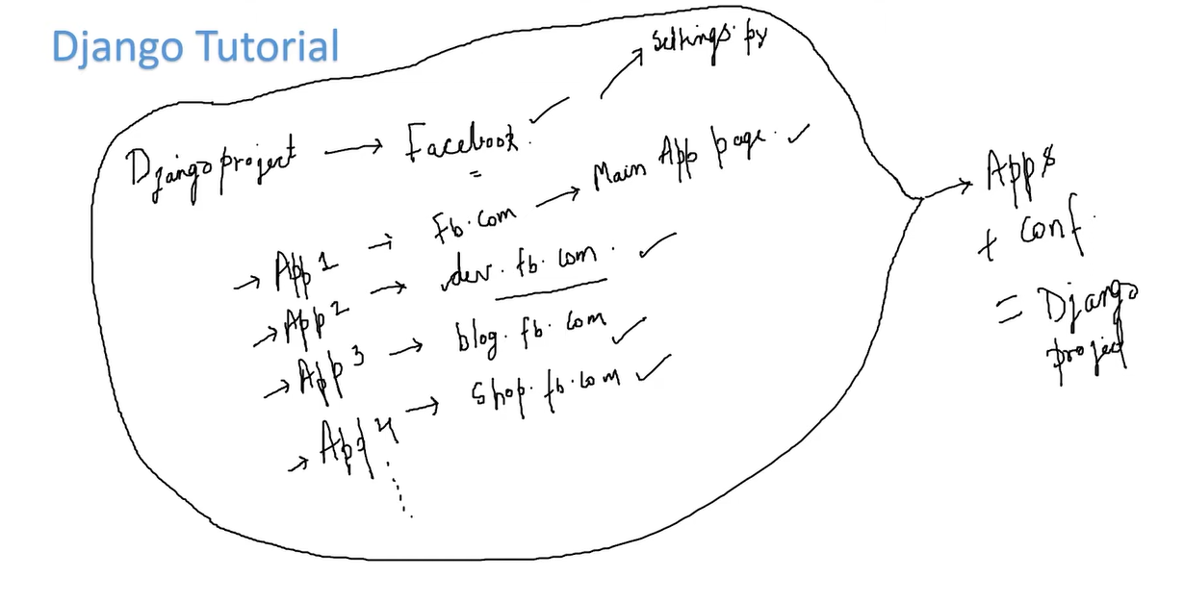
What is a Django Project?
A Django project is the complete web application created using Django.
It contains:
- project settings
- configurations
- apps
- database connection
- URL handling

Simple Definition
A Django project is the main container that manages the entire website.

Example
If you create:
django-admin startproject Harry
Then Harry becomes your Django project.

Django Project Contains
- settings.py → project settings
- urls.py → website URLs
- manage.py → control commands
- apps → website features

Real Example
Website = YouTube
Inside it:
- login system
- videos
- comments
- search
All together form one Django project.
Difference Between Project and App
Project
Complete website.
App
A single feature/module inside the project.
Example:
- authentication app
- camera app
- chat app
Many apps can exist inside one Django project.
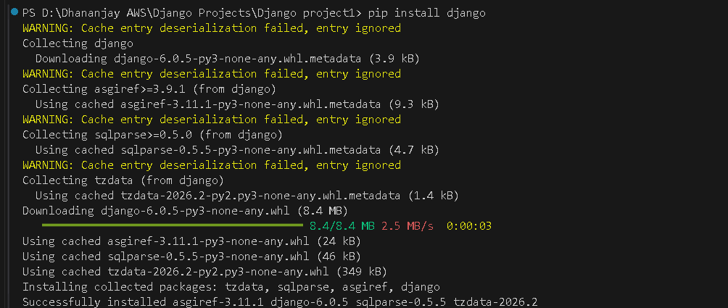
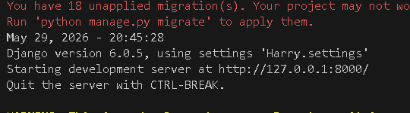
Click on the http://127.0.0.1:8000/

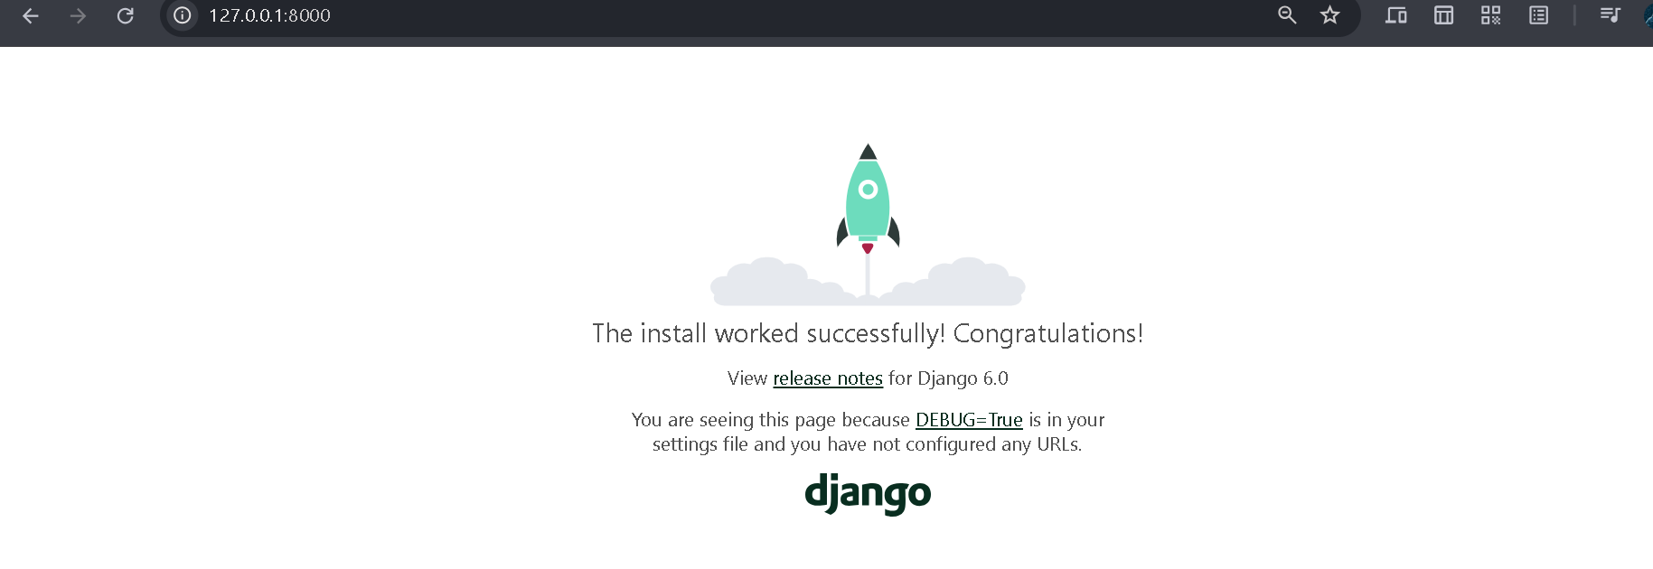
Django App
An app is a single feature/module inside the project.
Examples:
- login app
- camera app
- chat app
One project can contain many apps.
Create App
python manage.py startapp camera
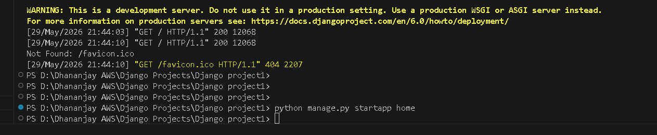

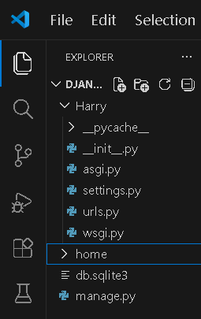
It will create a home app

3. URL Patterns
URL patterns connect website URLs to views.
Example:
localhost:8000/home
Django checks urls.py and decides which page to show.

Project Structure
myproject/
│
├── manage.py
│
├── myproject/
│ ├── settings.py
│ ├── urls.py
│ └── wsgi.py
│
└── camera/
├── views.py
└── models.py
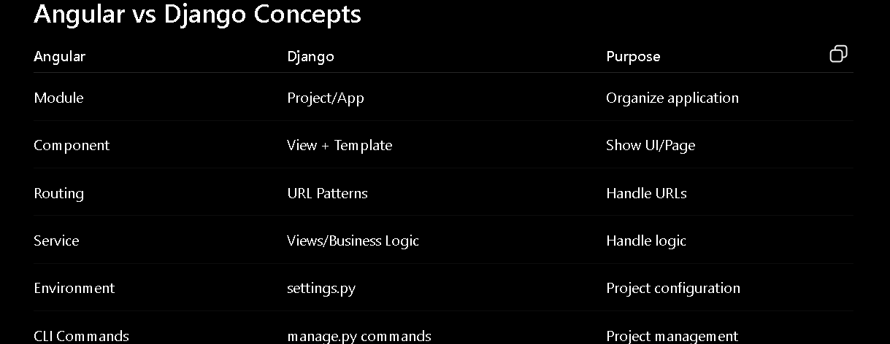
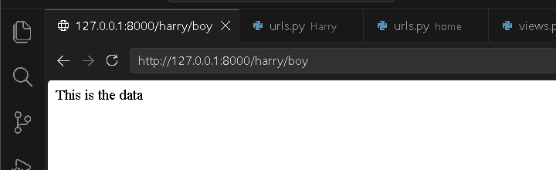

This will through the error
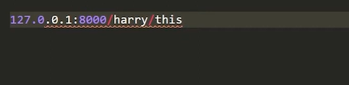
Gives the Project Folder
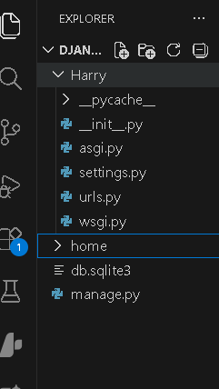
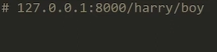
now it will match the path

5.MVT Pattern in Django

MVT Pattern in Django
Django follows the MVT architecture.
MVT stands for:
Model → View → Template

1. Model
Handles database operations.
Used to:
- create tables
- store data
- fetch data
Example:
class Student(models.Model):
name = models.CharField(max_length=100)

2. View
Contains business logic.
Views:
- receive requests
- process data
- send response
Example:
from django.http import HttpResponse
def home(request):
return HttpResponse("Hello")

3. Template
Handles frontend/UI.
Uses:
- HTML
- CSS
- JavaScript
Example:
<h1>Welcome</h1>

Flow of MVT
User Request
↓
URLs
↓
View
↓
Model (Database)
↓
Template
↓
Response to User

Simple Understanding

Model
Database part.

View
Logic part.

Template
Frontend/UI part.

Real Example

Login Page

Model
Stores user data.

View
Checks username/password.

Template
Shows login form.

Difference Between MVC and MVT
MVC | Django MVT
Model | Model
View | Template
Controller | View
Django combines Controller logic inside Views.

How MVT Works in Django
Django works step-by-step using the MVT pattern.

Flow of Django MVT
User → URL → View → Model → Template → User

Step-by-Step Working

1. User Sends Request
Example:
http://127.0.0.1:8000/home/
User opens a webpage.

2. URL Handles Request
urls.py checks the URL.
Example:
path('home/', views.home)
Django sends request to home view.

3. View Processes Logic
views.py contains logic.
Example:
def home(request):
return render(request, 'home.html')
View:
- processes request
- talks to model/database
- sends data to template

4. Model Handles Database
models.py communicates with database.
Example:
class Student(models.Model):
name = models.CharField(max_length=100)
Model:
- stores data
- fetches data
- updates data

5. Template Shows Frontend
HTML page displays data.
Example:
<h1>Welcome</h1>

6. Response Sent Back
Django sends final webpage to browser.
User sees output on screen.

Complete Flow Example

User Opens:
localhost:8000/home/

URL
Receives request.
↓

View
Processes logic.
↓

Model
Gets data from database.
↓

Template
Creates HTML page.
↓

Browser
Shows webpage to user.
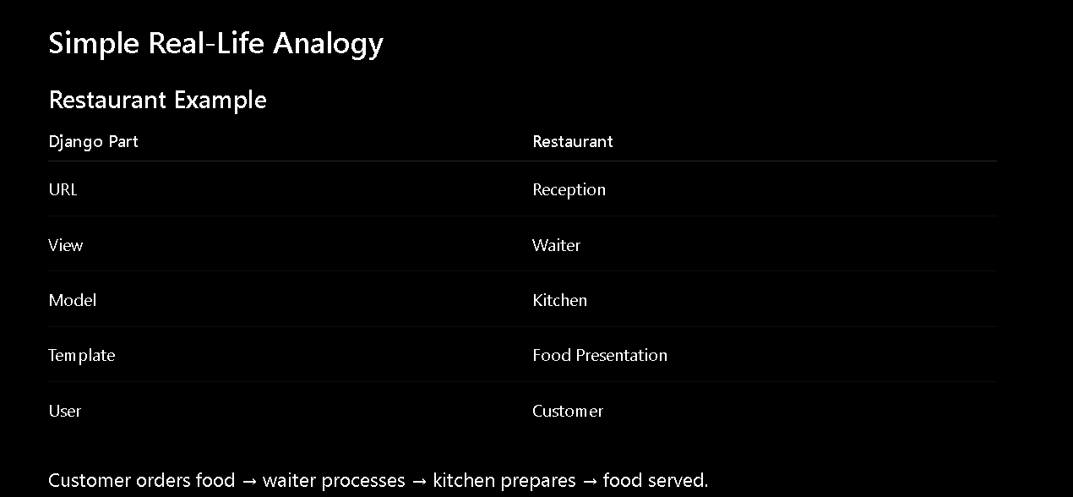
Steps to Open a Django Project on a Mobile Phone

1. Find Your Laptop IP Address
Open Command Prompt and run:
ipconfig
Under Wireless LAN adapter Wi-Fi, note the IPv4 Address.
Example:
192.168.0.106

2. Update ALLOWED_HOSTS
Open settings.py and set:
ALLOWED_HOSTS = ['*']
or
ALLOWED_HOSTS = ['192.168.0.106']

3. Start the Django Server
Run:
python manage.py runserver 0.0.0.0:8000
This allows Django to accept connections from other devices on the same network.

4. Keep the Terminal Running
Do not close the terminal after starting the server.
You should see:
Starting development server at http://0.0.0.0:8000/

5. Connect Phone and Laptop to the Same Wi-Fi
Ensure both devices are connected to the same Wi-Fi network.

6. Open the Website on Your Phone
Open a browser on your phone and enter:
http://192.168.0.106:8000
Replace 192.168.0.106 with your laptop's actual IPv4 address.

Important Notes
- Do not open http://0.0.0.0:8000 in a browser.
- On the laptop, use:
- http://127.0.0.1:8000
or
http://localhost:8000
- On the phone, use:
- http://<Laptop_IP_Address>:8000
- If the phone cannot connect, check Windows Firewall and allow Python/Django through the firewall.

Django Project Deployment on Render – Complete Steps
Step 1: Create a Django Project
django-admin startproject portfolio
cd portfolio
python manage.py runserver

Step 2: Create a GitHub Repository
- Login to GitHub.
- Click New Repository.
- Enter repository name:
portfolio
- Click Create Repository.

Step 3: Initialize Git
git init
git add .
git commit -m "Initial Commit"

Step 4: Connect GitHub Repository
git remote add origin https://github.com/USERNAME/portfolio.git
git branch -M main
git push -u origin main
Example:
git remote add origin https://github.com/Dhananjaynarwade/portfolio.git
git branch -M main
git push -u origin main

Step 5: Create requirements.txt
pip freeze > requirements.txt

Step 6: Install Gunicorn
pip install gunicorn
Update requirements file:
pip freeze > requirements.txt

Step 7: Create Procfile
Create a file named:
Procfile
Add:
web: gunicorn portfolio.wsgi:application

Step 8: Push Changes to GitHub
git add .
git commit -m "Added deployment files"
git push

Step 9: Login to Render
Website:
https://render.com
- Sign Up / Login
- Continue with GitHub
- Authorize Render

Step 10: Create a Web Service
- Click New +
- Select Web Service
- Choose your GitHub repository:
portfolio

Step 11: Configure Render
Root Directory
Leave Blank
Build Command
pip install -r requirements.txt
Start Command
gunicorn portfolio.wsgi:application

Step 12: Deploy
Click:
Create Web Service
Wait for the deployment to finish.

Step 13: Get Live Website URL
Render provides a URL similar to:
https://portfolio-xxxx.onrender.com
You can open it on:
- Laptop
- Mobile Phone
- Any Internet Connection

Updating the Website
Whenever you make changes:
git add .
git commit -m "Updated Website"
git push
Render automatically redeploys the latest version.

Useful Git Commands
Check Status
git status
Check Remote Repository
git remote -v
Push Code
git push
Pull Latest Code
git pull

Deployment Flow
Create Django Project
↓
Create GitHub Repository
↓
Push Code to GitHub
↓
Create requirements.txt
↓
Install Gunicorn
↓
Create Procfile
↓
Push Changes
↓
Login to Render
↓
Create Web Service
↓
Deploy
↓
Get Live URL

6.Creating a Developer Portfolio Website Using Django

7.

11.Understanding the Django Admin Interface

python manage.py createsuperuser

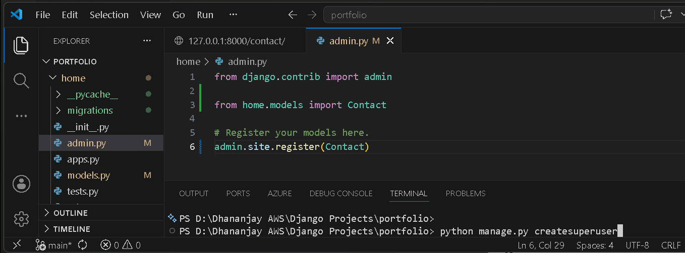
Username – adminK
Password:admin
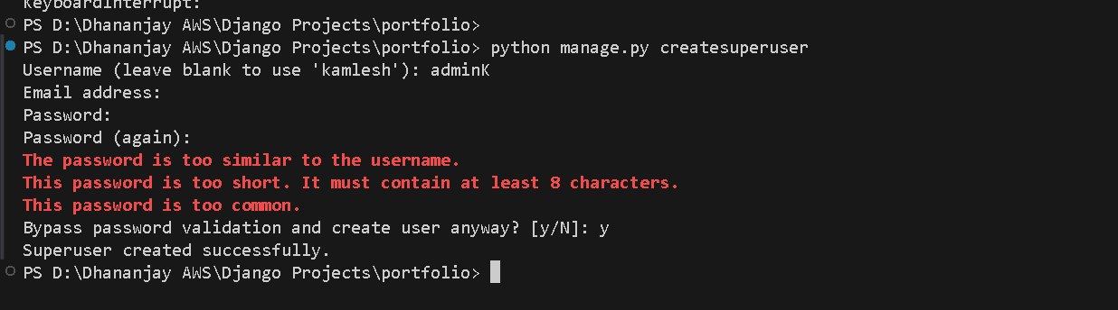
Run the server again
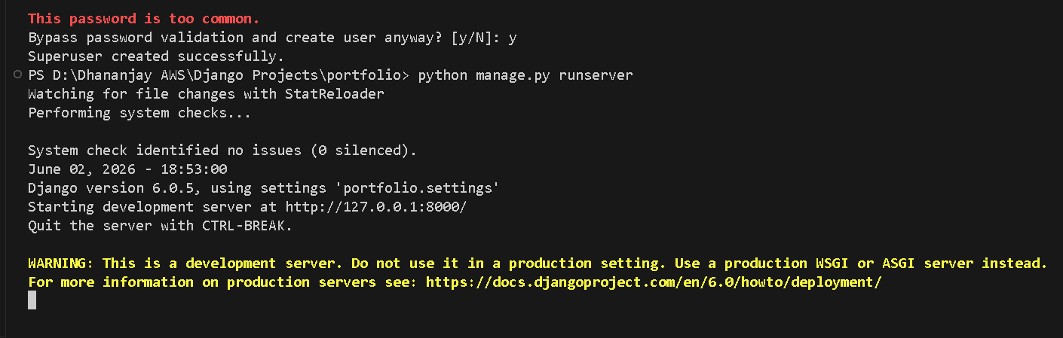
Type -admin
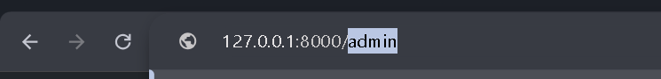

After clicking n that this window will come enter unsername and password enter
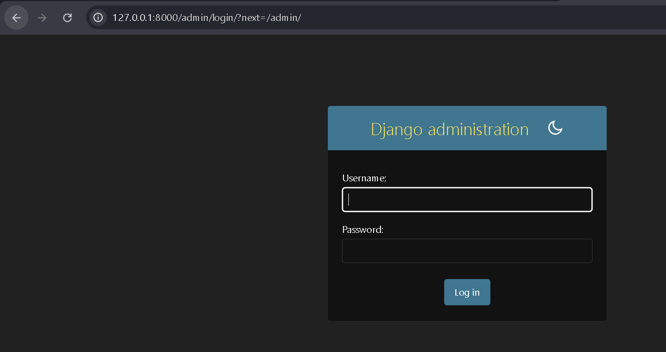
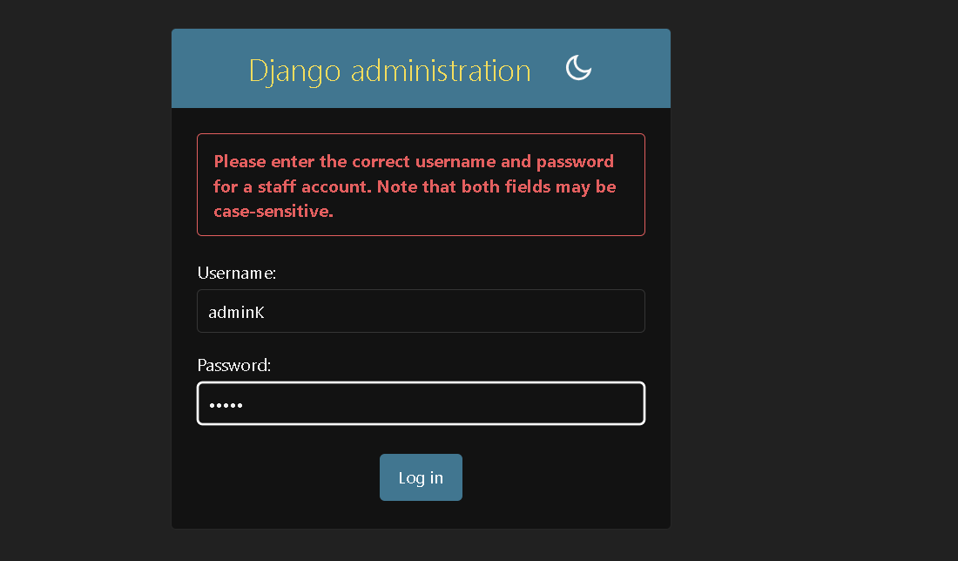
Click login after enter the details.

This interface will come.
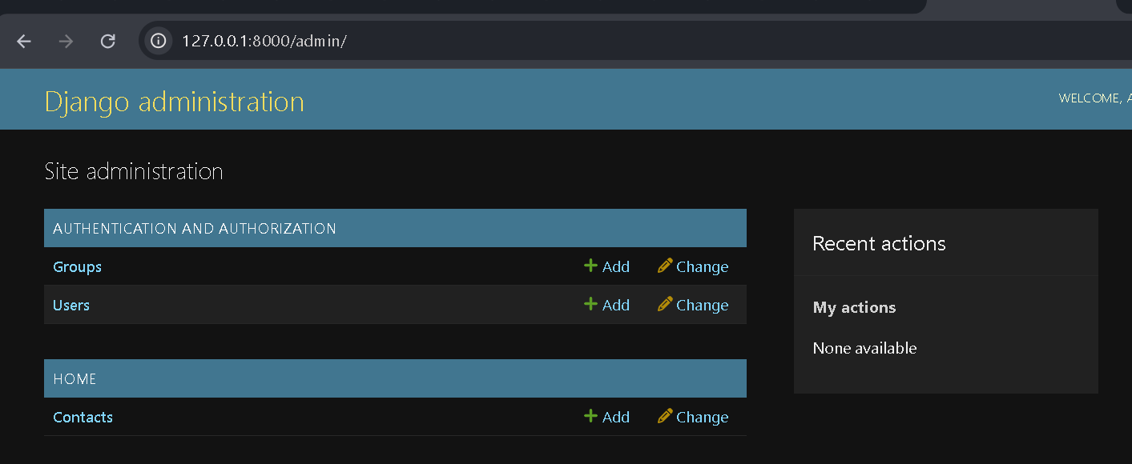

Models .py
def __str__(self):
return self.name

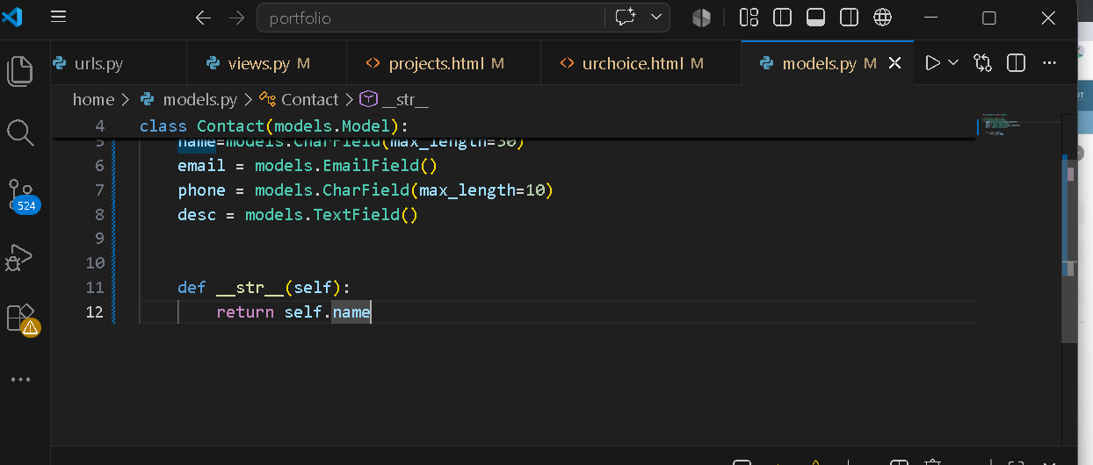

For using we can see the image as well
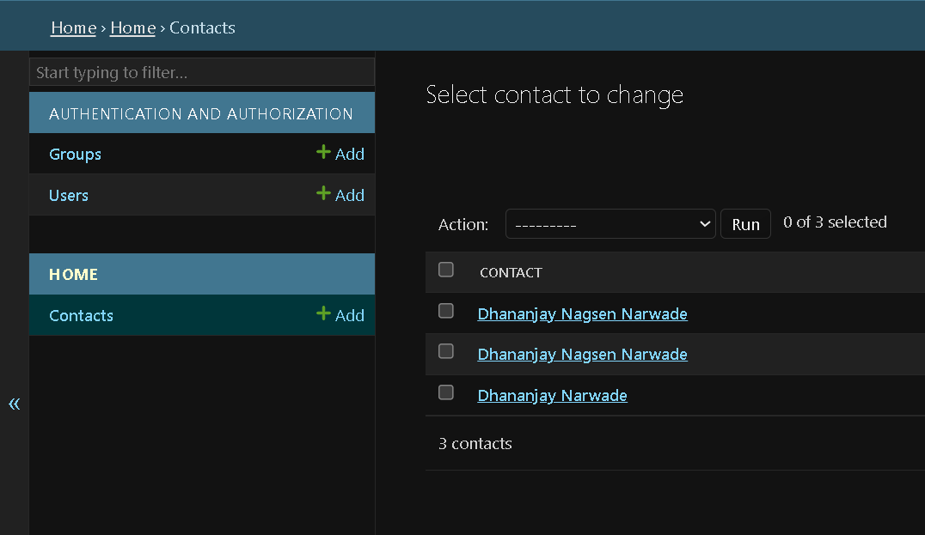

def __str__(self):
return self.name + " - " + self.email

this code do this
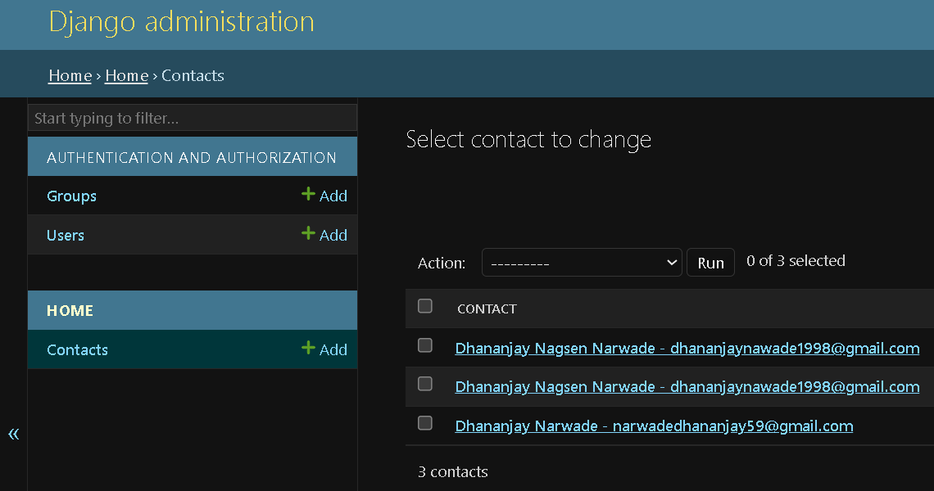

this code do this
# Django admin header customization
admin.site.site_header = "Devops Platform Admin"
admin.site.site_title = "Devops Platform Admin Portal"
admin.site.index_title = "Welcome to Devops Platform Admin Portal"

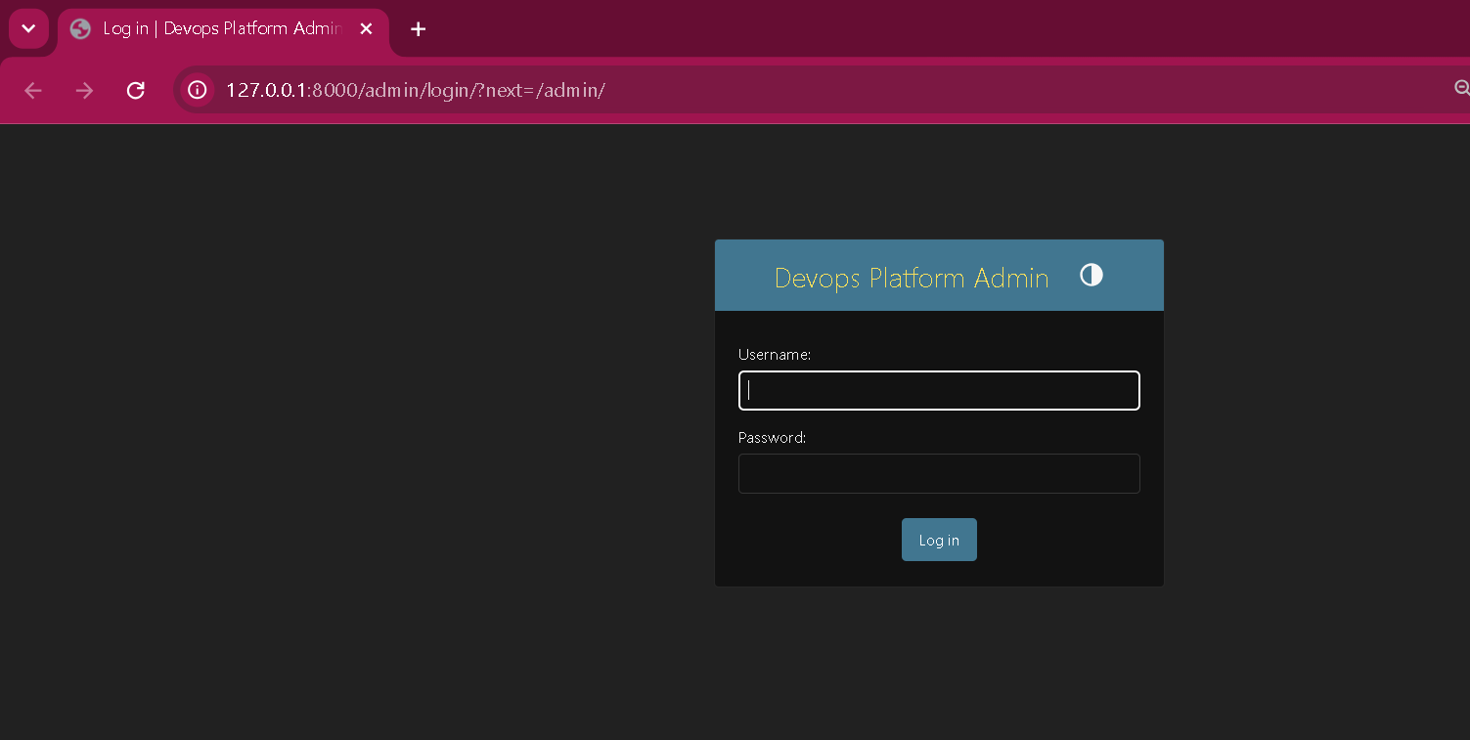
How to give the css
With class and the id

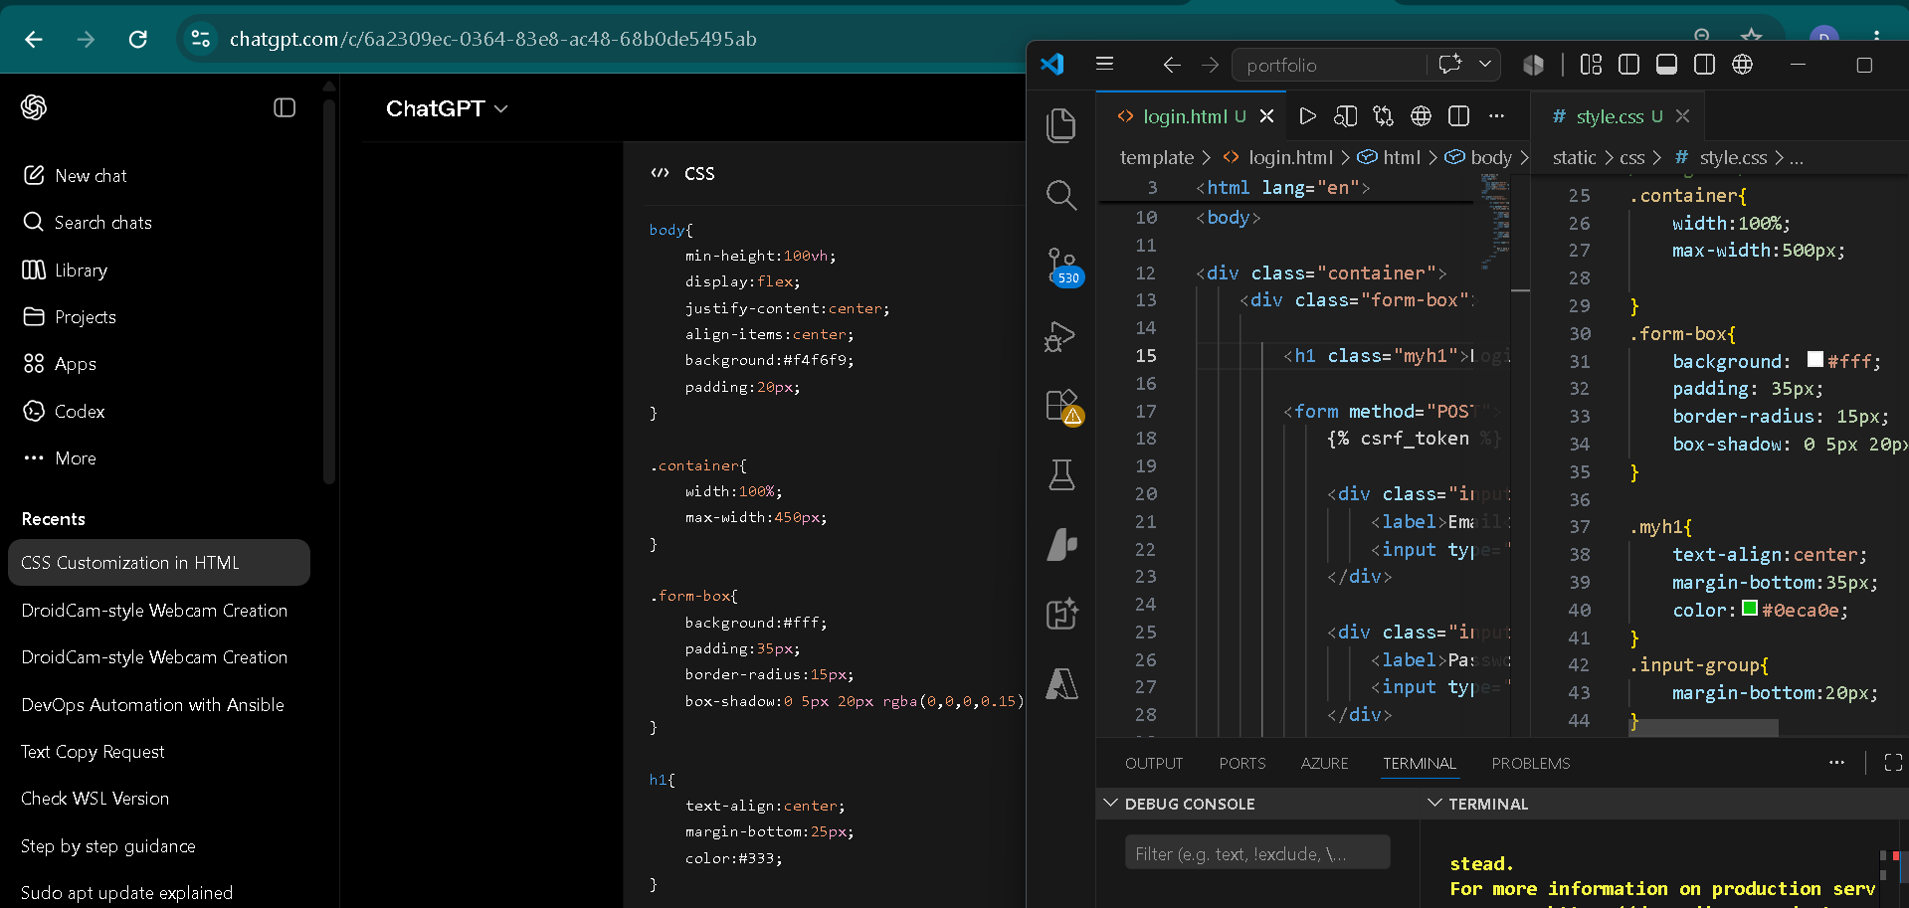

Css give button
<div class="dropdown">
<button class="btn btn-primary dropdown-toggle" data-bs-toggle="dropdown">
User

</button>

.btn.bt-primary -- > this class name

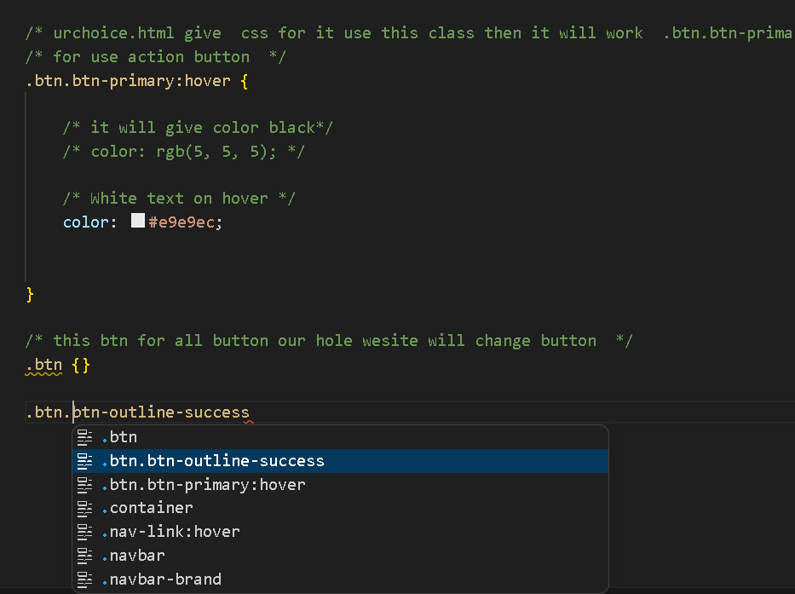

/* Base styling for the button */
.btn {
display: inline-block;
font-weight: 400;
text-align: center;
white-space: nowrap;
vertical-align: middle;
user-select: none;
border: 1px solid transparent;
padding: 0.375rem 0.75rem;
font-size: 1rem;
line-height: 1.5;
border-radius: 0.25rem;
cursor: pointer;
transition: color 0.15s ease-in-out, background-color 0.15s ease-in-out, border-color 0.15s ease-in-out, box-shadow 0.15s ease-in-out;
}

/* Custom .btn-outline-success logic */
.btn-outline-success {
color: #198754; /* Bootstrap success green text */
background-color: transparent; /* No initial background */
border-color: #198754; /* Green outline border */
}

/* Hover state behavior */
.btn-outline-success:hover {
color: #fff; /* White text on hover */
background-color: #198754; /* Solid green fill on hover */
border-color: #198754;
}

/* Focus / Active state shadow behavior */
.btn-outline-success:focus, .btn-outline-success:active {
box-shadow: 0 0 0 0.25rem rgba(25, 135, 84, 0.5); /* Subtle green glow */
outline: none;
}

* ==========================================
1. SEARCH INPUT STYLES (.form-control)
========================================== */
.form-control {
font-family: Arial, sans-serif;
font-size: 1rem;
line-height: 1.5;
color: #495057;
background-color: #fff;
border: 1px solid #ced4da;
border-radius: 0.25rem;
padding: 0.375rem 0.75rem;
transition: border-color 0.15s ease-in-out, box-shadow 0.15s ease-in-out;
}

/* Spacing between input and button */
.me-2 {
margin-right: 0.5rem;
}

/* Input focus (click) state */
.form-control:focus {
color: #495057;
background-color: #fff;
border-color: #80bdff;
outline: 0;
box-shadow: 0 0 0 0.2rem rgba(0, 123, 255, 0.25);
}

/* Input placeholder text color */
.form-control::placeholder {
color: #6c757d;
opacity: 1;
}

/* ==========================================
2. GREEN OUTLINE BUTTON STYLES
========================================== */
.btn-outline-success {
font-family: Arial, sans-serif;
font-size: 1rem;
line-height: 1.5;
font-weight: 400;
color: #28a745;
background-color: transparent;
border: 1px solid #28a745;
border-radius: 0.25rem;
padding: 0.375rem 0.75rem;
cursor: pointer;
text-align: center;
vertical-align: middle;
user-select: none;
transition: color 0.15s ease-in-out, background-color 0.15s ease-in-out, border-color 0.15s ease-in-out;
}

/* Button hover state */
.btn-outline-success:hover {
color: #fff;
background-color: #28a745;
border-color: #28a745;
}

/* Button active/focus state */
.btn-outline-success:focus {
outline: 0;
box-shadow: 0 0 0 0.2rem rgba(40, 167, 69, 0.5);
}

SO now ill have to do same size as a input form
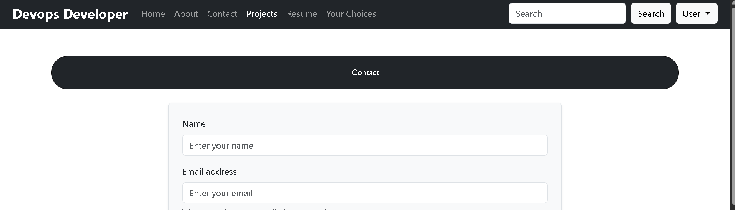
Looks the border now both are same
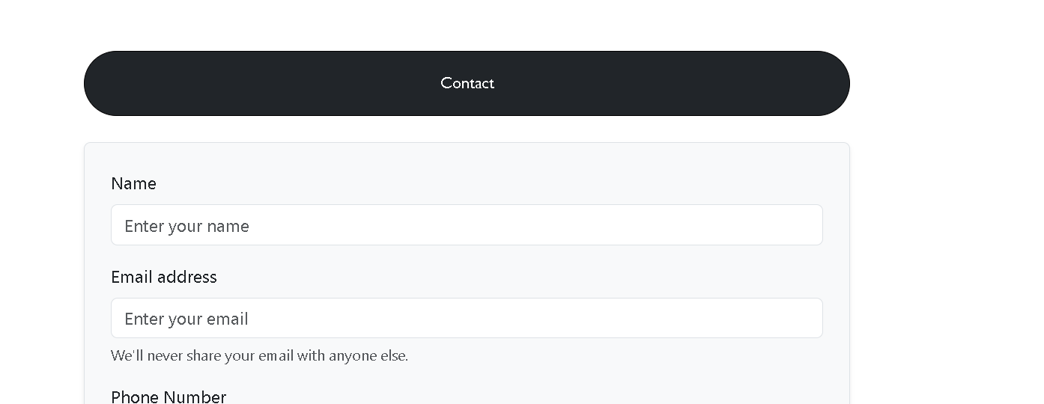
<h2 class=" h2contact text-center mb-4">Contact</h2>
class h2contact I will take

css file I only take this
max-width: 700px;
margin: 0 auto;

.h2contact {
border: 1px solid rgb(1, 0, 0) !important;
border-radius: 50px 50px;
color: white;
align-items: end;
size-adjust: initial;
max-width: 700px;
margin: 0 auto;
background-color: #212529;
/* same as bg-dark */
color: white;
}

