System Architecture Document

High-Level Architecture Diagram

Streamlit UI
(Text / Image / Audio)
API Layer (UI → n8n)
Hidden Webhook URL

HTTP POST
n8n Backend
----------------------------------------
1. Request Extractor
2. Model Splitter (per model)
3. Router (Switch Node)
4. Parallel Model Execution
5. Response Formatter (latency, text)
6. Aggregator (JSON array)
7. Respond to Webhook
Streamlit Results Panel
Model-wise responses

2. Component Explanation
API Layer:
- Streamlit UI sends prompt, file, and model selection to n8n webhook.
- Webhook URL hidden via environment variable.
Orchestration Layer (n8n workflow):
- Extracts prompt, inputType, models.
- Splits models → parallel branches.
- Routes each model to correct OpenAI node.
- Formats responses.
- Aggregates response array.
Model Adapters:
- GPT-4o
- GPT-4o-mini
- Whisper (audio-to-text)
- GPT-4o Vision (image analysis)
Storage:
- No DB required for prototype.
- Can use Redis for caching responses.
Logging:
- n8n execution logs.
- UI request/response logs.
Caching:
- Redis recommended for repeated prompts.

3. Request Flow Diagrams
Single Model Mode Flow:
Streamlit → Webhook → Extract → Route → Model Node → Format → Aggregate → UI
Multi-Model Parallel Mode Flow:
Streamlit → Webhook
↓
Extract fields
↓
Split into N models
╱ ╲ ╲ ╲
Model A Model B Model C Model D (executed in parallel)
╲ ╱ ╲ ╱
Format Results
↓
Aggregate JSON
↓
Streamlit UI

4. Scaling Strategy
- UI: Stateless → deploy multiple replicas.
- n8n: Run multiple workflow worker nodes behind load balancer.
- Parallel execution already handled via split node.
- Add Redis caching for frequent prompts.
- Add queue system (RabbitMQ) for long-running tasks.

5. User Management Strategy
- Authentication: API keys, OAuth, JWT.
- Authorization: Per-user permitted model access.
- Request limits: Rate limiting via n8n rate-limit node.

6. Application Uptime Considerations
High Availability:
- Multiple Streamlit servers.
- Multiple n8n workflow executors.
- Retry logic for model failures.
Monitoring:
- n8n logs.
- Prometheus + Grafana.
- Error alerts.
Fault Tolerance:
- If a model fails, others still return results.
N8N flow :
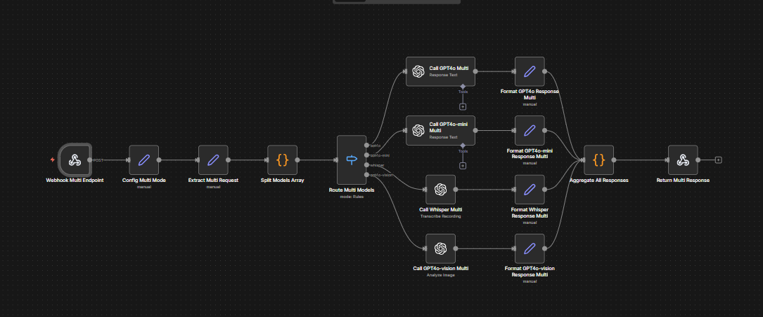

UI preview:
