Feasibility Study
AI-Powered Campus Virtual Assistant
A Retrieval-Augmented Generation (RAG) + Tool-Calling Architecture Proof of Concept
Prepared as a technical feasibility document
August 2026

1. Executive Summary
This document evaluates the technical feasibility of building an AI-powered virtual assistant for the college. The assistant is intended to answer three distinct categories of questions: (1) static, reference-style questions about campus facilities and policies, (2) dynamic, personalized questions that require live data such as timetables and attendance, and (3) indoor navigation questions that require step-by-step directions between rooms.
The conclusion of this study is that the project is technically feasible using well-established, freely available tools. No category of question requires a novel algorithm or unproven technology — the engineering challenge is in correctly routing each question to the right retrieval mechanism, not in the mechanism itself. The core architectural insight is that a single large language model (LLM) call is not sufficient by itself: the system must be a hybrid of Retrieval-Augmented Generation (RAG) for static content and structured tool-calling for live data and pathfinding, with the LLM acting as an orchestrator and a natural-language interface rather than as the source of truth.
This document presents the architecture, walks through the feasibility of each component individually, and lays out technology options with their tradeoffs. Final tool selection (LLM provider, vector database, hosting model) is left open for the reader to decide based on budget and infrastructure constraints available at the time of implementation.

2. Objective and Scope
The assistant must be able to answer, in natural language, three kinds of questions:
- Static / reference questions — e.g. “Where is the placement cell?”, “What are the hostel timings?”, “How many computers are in the CSE lab?”
- Dynamic / personal questions — e.g. “What is my timetable today?”, “Is a given student present today?”, sourced from tables that may be updated by a separate, already-existing service.
- Navigation questions — e.g. “How do I get from the main entrance to the placement cell?”, within a single building across multiple floors, for any pair of rooms (any-to-any), using existing floor plans.
Out of scope for this feasibility study: multi-building / outdoor campus navigation, and any question requiring real-time sensor data (e.g. live occupancy). These can be layered on top of the same architecture later without a redesign.

3. System Architecture Overview
The system is best understood as a router sitting in front of three independent subsystems. The LLM's first job on receiving a question is to classify which subsystem(s) are relevant, call the appropriate tool(s), and then phrase the returned data as a natural-language answer. This pattern — LLM as orchestrator, not as data source — is what makes all three categories of question technically feasible with current, off-the-shelf technology.
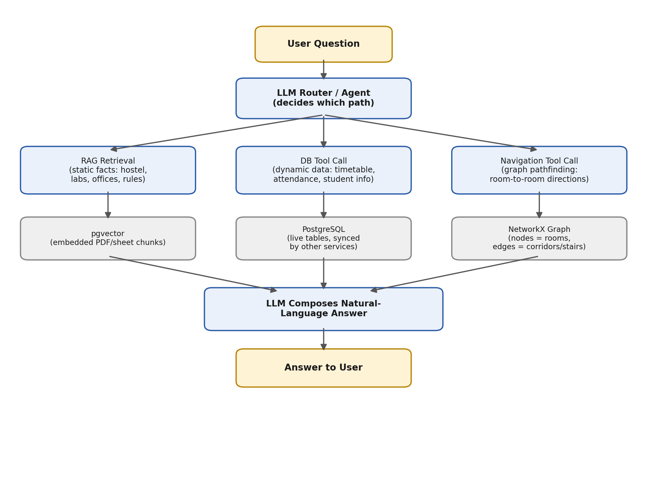
Figure 1: Hybrid RAG + tool-calling architecture. The router directs each question down one or more of three paths, and a final LLM call composes the natural-language response from whichever data was retrieved.

4. Feasibility Analysis by Component

4.1 Static Knowledge Base (RAG)
Feasibility: High — this is the most mature and well-documented pattern in the current LLM ecosystem.
Source material (facility descriptions, PDFs such as handbooks and prospectus, and spreadsheet-based reference data) is split into small text chunks, converted into vector embeddings, and stored in a vector database. When a user asks a question, their query is embedded the same way and the closest-matching chunks are retrieved and handed to the LLM as context, which then answers grounded in that retrieved text rather than from its own memory. This directly addresses hallucination risk for facility and policy questions and is the standard architecture used by production RAG assistants today.
Risk factors: retrieval quality depends on chunking strategy and embedding model quality; this is a tuning problem, not a feasibility blocker.

4.2 Dynamic Data (Timetable, Attendance, Student Records)
Feasibility: High, but requires a different mechanism than RAG.
Because this data changes frequently (attendance updates daily, timetables are maintained by a separate existing service) and answers must be exact rather than “semantically similar,” this category is implemented as LLM tool-calling / function-calling against the live database, not as embedded RAG content. Both major LLM API providers (and open-source frameworks) support defining callable functions with a schema; the LLM decides when to call a function such as get_timetable(student_id, date), the backend executes a normal SQL query against PostgreSQL, and the result is returned to the LLM to phrase in natural language. This is a deterministic, well-tested pattern and requires no research risk.
Important dependency: because this path touches personal student data, it requires an authentication layer (tied into the college's existing student login/SSO if available) before it can be exposed. This is an implementation requirement, not a feasibility blocker.

4.3 Indoor Navigation (Room-to-Room Directions)
Feasibility: High — this is a solved problem in computer science (shortest-path graph search), and does not require the LLM to perform any spatial reasoning itself.
The floor plan is modeled as a weighted graph: rooms, corridor junctions, and stairwells become nodes; corridors, doors, and stairs become edges with an associated distance. A shortest-path algorithm (Dijkstra's algorithm, available out-of-the-box in the Python networkx library) computes the optimal route between any two nodes — satisfying the “any-to-any” requirement directly. Multi-floor routing falls out naturally by modeling each stairwell as two nodes (one per floor) connected by a “stairs” edge, so no special-case logic is needed for vertical movement.
The one-time setup cost is digitizing the existing floor plans into a node/edge graph, which can be done with a small internal admin tool (click on the floor plan image to place nodes and connect them). This is a bounded, one-time effort rather than an ongoing engineering risk. The LLM's role is limited to resolving room names from natural language and phrasing the algorithm's output as directions — it does not calculate the path.

5. Technology Options and Tradeoffs
The following options are presented neutrally, without a preferred recommendation, so that final selection can be made against actual budget and hosting constraints at implementation time.

5.1 LLM Provider
Option | Pros | Cons
API-based  (Claude, GPT, Gemini — small/mini tier) | High answer quality out of the box; no GPU/infra to manage; built-in function-calling support; scales automatically with provider infrastructure | Ongoing per-token cost; requires internet connectivity to provider; student data leaves the campus network unless a privacy-focused provider/agreement is used
Self-hosted open-weight  (e.g. Llama 3.1 8B, Phi-3 via Ollama/vLLM) | No per-query cost after setup; data never leaves campus infrastructure; full control over model version | Requires a GPU (cost, procurement, maintenance); noticeably lower answer quality than top API models at small sizes; team owns uptime, latency, and inference tuning

5.2 Vector Database (for RAG)
Option | Pros | Cons
pgvector  (PostgreSQL extension) | Reuses the same PostgreSQL instance already needed for student/timetable data; one database to operate instead of two; sufficient performance at this data scale | Slightly less specialized than a dedicated vector database at very large scale (not a concern at college-corpus size)
Dedicated vector DB  (Qdrant, Pinecone, Weaviate) | Purpose-built for vector search; more advanced filtering/indexing features; some offer managed hosting | Adds a second database system to operate and keep in sync; unnecessary complexity at this project's data volume

5.3 Navigation Graph Tooling
Option | Pros | Cons
networkx (Python) | Free, well-documented, integrates directly into the existing FastAPI backend; Dijkstra/BFS built in | Pure-Python performance is more than sufficient at building scale, so no real downside here
Custom-built pathfinding | Full control over instruction phrasing and edge-weight logic | Reinventing a solved algorithm; more code to test and maintain for no functional benefit over networkx

5.4 Backend Framework and Data Stores
FastAPI (Python) is assumed as the backend framework based on prior discussion, chosen for native async support (important for handling concurrent chatbot requests) and first-class integration with both RAG tooling and networkx. PostgreSQL is assumed as the primary data store, holding application data (users, conversations, feedback), the dynamic student/timetable tables, and — if the pgvector option above is chosen — the RAG embeddings as well, avoiding a second database system.

6. Scalability and Deployment Considerations
For an initial deployment sized around 100 concurrent users, a single backend instance is sufficient provided persistent resources (embedding model, database connections, LLM client) are initialized once at server startup rather than per-request. The three components that most affect perceived performance and cost are:
- The LLM call itself, which is typically the slowest step in the pipeline — mitigated with response streaming (Server-Sent Events) so the user sees the answer forming instead of waiting for the full response.
- Repeated identical or near-identical questions (e.g. “what are the library hours” asked by many students) — mitigated with a caching layer, with semantic caching as a later enhancement.
- Abuse or runaway request loops — mitigated with basic rate limiting per user/IP.
None of these require Kubernetes, load balancers, or a multi-server setup for the initial pilot. The architecture is designed so that horizontal scaling (multiple backend instances behind a load balancer) can be added later without changing the core RAG / tool-calling / navigation design.

7. Implementation Roadmap
Phase | Deliverable | Key Dependency
Phase 1 | RAG pipeline for static facility/policy data (ingest PDFs & sheets, chunk, embed, retrieve) | Collected source documents
Phase 2 | Tool-calling integration for timetable/attendance (read access to live PostgreSQL tables) | Access/sync agreement with the existing service that owns this data
Phase 3 | Authentication layer for personalized queries | Decision on SSO integration vs. standalone login
Phase 4 | Navigation graph tool: admin mapping UI + networkx pathfinding + direction phrasing | Digitized floor plans (already available)
Phase 5 | Router/orchestration layer tying all three paths together behind one chat interface | Phases 1–4 complete
Phase 6 | Load testing (Locust/k6), caching, and rate limiting before go-live | Pilot user group identified

8. Risks and Mitigations
Risk | Mitigation
LLM hallucinating facts not present in source documents | RAG grounding with retrieved context; instruct the model to decline when no relevant chunk is retrieved
Stale or inconsistent data if the timetable-owning service and the assistant read from different stores | Read directly from the same PostgreSQL tables the other service writes to, or establish a defined sync contract
Personal data exposure (attendance, records) to the wrong user | Mandatory authentication and per-user authorization checks on every tool call before executing a query
Navigation graph becoming out of date after building changes | Keep the admin mapping tool simple enough that graph edits are a low-effort, ongoing task rather than a one-off
Cost overrun from LLM API usage at scale | Use small/mini-tier models for this use case, add caching, and monitor token usage from day one

9. Conclusion
All three required capabilities — static knowledge retrieval, live personal/academic data lookup, and indoor navigation — map cleanly onto mature, well-supported technology: Retrieval-Augmented Generation, LLM tool/function-calling against a relational database, and classical graph shortest-path search, respectively. No component of this system relies on unproven or experimental technology. The main engineering effort is in integration — correctly routing questions to the right subsystem, keeping the dynamic data path in sync with the existing service that owns it, and building the one-time floor-plan-to-graph mapping tool — rather than in inventing new algorithms. On this basis, the project is assessed as technically feasible for implementation.

