ABSTRACT:
This abstract outlines a study focused on stock market prediction using both traditional statistical models and machine learning techniques. Specifically, it investigates the effectiveness of the ARIMA model for predicting stock prices of major technology companies such as AMZN(Amazon), META(Meta Network), TSLA(Tesla), JPM(JP Morgan) The ARIMA model incorporates auto regressive, differencing and moving average components to capture temporal patterns in stock prices. The study involves data collection, preprocessing and model evaluation using performance metrics like Mean Absolute Error (MAE) and Root Mean Square Error(RMSE). Prior research has utilized opening and closing prices as major new forecasts for financial markets, however excesses and sizes may provide additional information about as an end result, the index of the three shares represented inside the Chinese stock marketplace are used as research material and the key records gathered from them includes the outlet rate, remaining price, lowest price, maximum charge, date and everyday trading quantity. .Key parameters for ARIMA, such as p, d and q are selected through auto-correction and partial correlation plots and using Akaike Information Criterion(AIC) and Bayesian Information Criterion(BIC).
In addition to ARIMA, the study compares the performance of machine learning techniques, specifically LSTM(Long Short-Term Memory) neural networks, in handling non-linear problems in stock price forecasting. Data from the National Stock Exchange(2010-2019) is used to train and predict stock prices using both ARIMA and LSTM models. While ARIMA handles linear patterns, LSTM is optimized for more complex relationships in the data, showcasing its ability to forecast stock prices. It should be added that comparative study with more complicated models such as ARIMA, The study puts ARIMA models in a strong pro-active position and ends with ARIMA model further research into the hybrid model that combines ARIMA with advanced machine learning techniques aimed at improving predictive accuracy. The study’s conclusions are relevant for investors, financial analysts and researchers, offering insights into time series forecasting techniques for better decision-making in stock markets.

INTRODUCTION:
The stock market serves as a vital artery within the global financial system, facilitating the buying and selling of securities that represent ownership stakes in publicly traded companies. This complex ecosystem plays a crucial role in capital distribution, fostering economic growth and shaping production (Malkiel,2003). The ever-changing nature of the stock market makes accurate price prediction a significant challenge for the investors and financial institutions alike. For both investors and the governments, the ability to accurately assess stock price trends is paramount. Investors seek to maximize profits while minimizing risks, while governments strive to maintain economic stability and prevent financial crises (Barbaries & Thaler, 2003). Traditional systems often struggle to capture the complex dynamics at play, leading to unsatisfactory results. This paper proposes a novel approach that leverages the power of machine learning, specifically Long Short-Term Memory (LSTM) networks, to enhance stock price prediction accuracy. By incorporating sentiment analysis and model decomposition techniques, the model aims to extract valuable insights from historical data and investors sentiment, ultimately leading to more informed investment decisions. This research not only contributes to the field of financial forecasting but also holds the potential to empower investors with a valuable tool for navigating the complexities of the stock market. On the other hand, stock distribution lets in sales and income to be extra green. The decision regarding the particular markers is made based on the prediction model, which is based on information collected from prior executions in addition to an expert course that is subject to the individual’s level of expertise. In order to be able to provide projections in the financial markets, apps that seek to predict stock prices utilize technical analysis in order to be able to do so. It could be beneficial to have the ability to make accurate projections on the future value of the index that serves as the basics for the price of a stock. The information presented in offers projections regarding the future course that the market price of cryptocurrencies will take in the future. The capability of artificial intelligence to make correct forecasts. As a result, many scientists and practitioners combine multiple individual models to greatly improve the accuracy and consistency of their predictions. In addition, the coefficient of association between a stock index and its constituents may reflect the sensitivity of the constituents to changes in the stock index. By utilizing CEEMDAN to preprocess and decompose original stock price data, the LSTM network can focus on predicting each IMF individually, thus enhancing prediction accuracy and robustness. These techniques combine the predictions of multiple base models to improve generalizability and reduce the risk of overfitting. The integration of ensemble methods with the CEEMDAN-LSTM framework promises to yield superior predictive performance, as evidenced by recent studies. Therefore, whether the prospectors of the future can make precise predictions of stock prices or it is just of academic significance is of even greater practical value to the investors as well as portfolio managers and policymakers. This study was aimed at twofold objectives. First, to build a dynamic ARIMA model that examines time-dependent structure and volatility in the stock prices of TESLA,AMZN and etc. Secondly, it shows that the model is more accurate in predicting than other forecasting ways and it’s useful and efficient in practical life. The current study will utilize the ARIMA model as its predictive dynamic instrument in such a way that the non-stationary of the data that depends on financial time series can be fully analyzed. Here, in this paper the recent research literature covering classical and modern forecasting methods, and their advantages and disadvantages will be carefully discussed in the framework of predicting stock prices. In undertaking this research we intend to add to the frontier of research in financial econometrics by evidence that the ARIMA models can work well in forecasting the stock market movements that are keenly observed by market participants all around the globe.

LITERATURE REVIEW:
Our literature review’s primary objective was to evaluate various algorithms and models to determine whether stock price predictions can be effectively made based on real-time inventory prices. However, we could not find a viable alternative stock rate forecast, leading us to reassess our current methods, identify critical issues, and work on improving them. In this way, our results are compared against the ARIMA model and reveal that neural networks perform much better than a traditional linear forecasting methodology in stock market analysis. Through our initial research, we discovered Long Short-Term Memory (LSTM) neural networks, a model that showed significant promise in making inventory forecasts using time-series data. In our analysis, the aspects that we pay attention to include how these methods can perform in copying with this dynamic and volatile nature of the stock market. LSTM neural networks have become popular in the realm of stock price prediction because they can capture the temporal dependencies of sequential data. Notwithstanding its relative newness and the possibility of further developments, SVM has distinct features when compared to LSTM which performs better with large datasets. In the beginning, the practice of stock price forecasting was based mainly on fundamental and technical analysis. Nevertheless, as the business dynamics become more complex, these approaches usually fail to work because they cannot capture and process data in real-time or account for global economic changes instantly. Lin, Guo, and their team extended the use of neural networks for market price predictions by focusing on deep learning techniques, which are particularly effective in the age of big data. Using data from the Chinese stock market, they proposed a comprehensive deep learning model to predict stock price fluctuations. Their method involved preprocessing market data and developing sophisticated functional tools that demonstrated high accuracy in forecasting stock market trends. This work contributes significantly to both the financial and technical domains, as it offers a robust method for predicting market movements based on deep learning. ARIMA model, an indispensable tool in times series forecasting, combines the two, namely autoregressive(AR) and moving average(MA) components. For the AR part, the analysis uses the relation between the current observation and several lagged observations, while the MA part models the observation error as a linear summation of the errors from the previous time points. Using high frequency intraday inventory return as enter records, we investigate the effects of three unsupervised feature extraction methods- essential aspect analysis, automatic encoding, and the restrained Boltzmann device-on the community’s overall capability to carry out. Our research provides meaningful insights and potentially useful guidance for fate research on how deep network insights can be effectively used in stock market analysis and forecasting. Martin, Schluter and Ney’s work on neural networks in language modeling further supports the utility of recurrent neural networks like LSTM in handling sequential data. Many researchers use machine mastering techniques to effectively predict the cost of an entity using facts from monetary time collections from different markets. While traditional models like ARIMA have been widely used in time series forecasting, neural networks, particularly LSTM have shown superior performance in capturing non-linear relationships and long term dependencies in financial data. As a stock market continues to evolve, these advanced models will likely play a crucial role in improving the accuracy and reliability of stock price prediction.

RESULT:
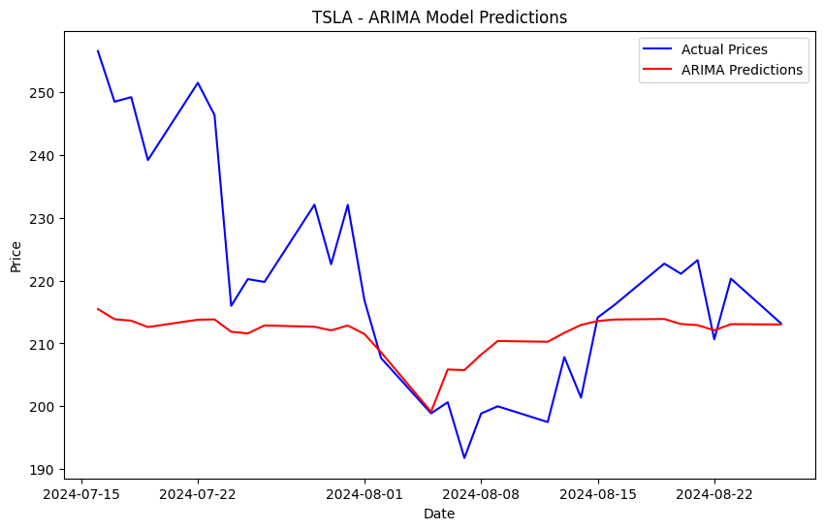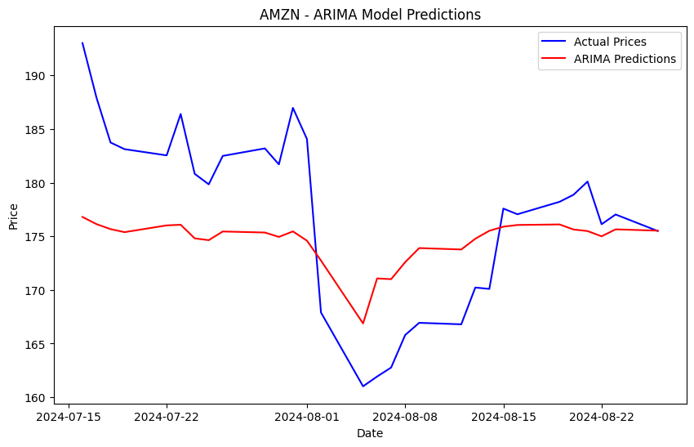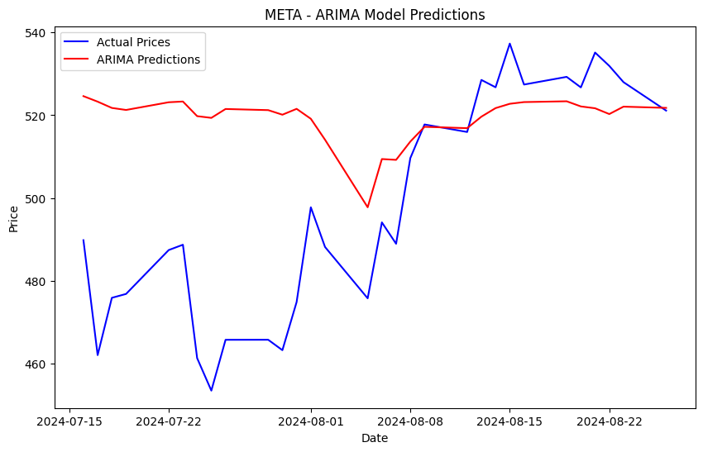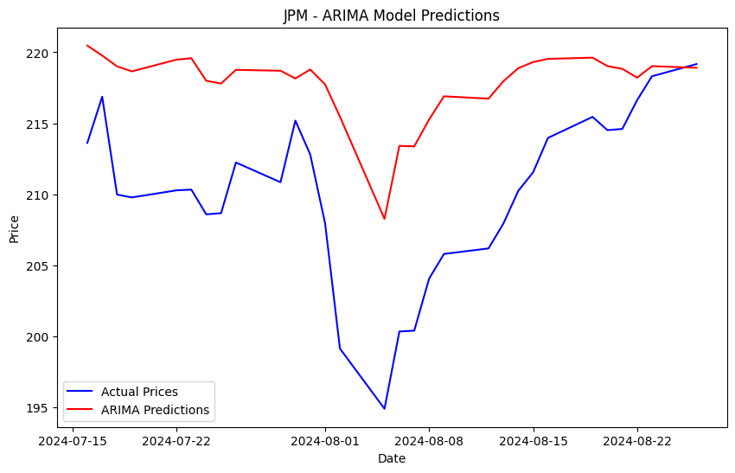

METHODOLOGY:
We built a primary stock prediction model which basically helps in predicting future stock prices with the help of historical data. Using Linear regression and root mean squared values we are able to analyze the historical data to produce predicted data and compare it with the training dataset. Long Term Short Memory (LTSM) known as Recurrent neural network for learning long term dependencies . We used this algorithm to process and predict time-series data. Data's are being cleaned and kept ready to make analysis and predictions with help of various data visualization toolkit libraries (Scikit Learn, Plotly, Numpy, pandas and Matplotlib)We are using historical data, trading volumes and the relative economic indicators such as day to day news sentiment and social media trends. We are including Finance API’s and news websites for daily updates and understanding the trends now and then .Traders can enter their point of view about the stock market so that their input would help the new traders We are building a user friendly web application for the traders to analyze the stock pattern with efficient prediction values This methodology procures 75% accuracy with low error rate. ARIMA Model encapsulates the need of traders in procuring profit at constant phase.

CONCLUSION:
Eventually, the conclusions of this paper state that both ARIMA model and LSTM neural networks provide useful means in predicting stock prices though the two models differ in their advantages. Employing the strength of pattern and amplitude of the neural network, the paper describes the stock where the aim is to predict such behaviors. Due to the straightforward nature of an ARIMA model, it manages to capture the linear tendencies embedded in the stock price data more efficiently than most models, thus making it a model of choice particularly where time and simple code are priorities. LSTMs, however, are better positioned to tackle high levels of nonlinearities prevalent in stock market data but coupled with high computational abilities. This study draws attention to the typical econometric models for predicting financial time series. In addition, it invites further investigation into hybrid models that integrate traditional econometric modeling with new computational approaches. In practical terms, these findings help to deal with issues relating to stock market forecasting and therefore improving the investment decision process. The outcome of a stock prediction model can include predicted future stock prices, the direction of price movement (up or down), or actionable recommendations such as buy, sell, or hold. This algorithm predicts 75% of the stock value precisely for the given stock tickers and the other 30% is decided by the knowledge and experience of the trader. This paper analyzes the efficiency of ARIMA and LSTM models which helps the investors to make meaningful conclusions. This model ensures accurate and fast predictions which enables usability and time management factors.

FUTURE WORKS:
Applying machine learning in predicting stock markets is emerging and has unlimited opportunities for research and development. Exploring one such aspect, Deep Reinforcement Learning (DRL) gets the models to evolve over time and develop better and better trading strategies through experience with the market only, where the problem is in optimization between exploration and a risky market. Another is Explainable AI (XAI), which is concerned with increasing the two-way interaction as well as the understandability of machine learning models, which currently resembles ‘black boxes’ of several deep learning systems. Sentiment analysis could be enhanced with stock data utilizing Natural Language Processing (NLP) technologies to assess how news or social media affects stock prices. Multimodal learning is integrating with other available sources for more predictive accuracy such as technical analysis and news into comprehensive predictive models. A Dependent Learning Model in stocks may consist of learning against a Transfer learning concept and practically allow the models to work across markets trained in another region. As well, hybrid models, integrating the economies of statistical models such as ARIMA and those of artificial intelligence such as LSTM, will work to improve predictions in time series errors. Last, but not least, quantum machine learning is supposed to help with global optimization but still is at the theoretical stage of development. Adversarial machine learning could be particularly useful for spotting these types of market abuse. Also imitative models like GANs could forecast the market.

REFERENCE:
[1] A. L. Awad, S. M. Elkaffas, and M. W. Fakhr, ‘‘Stock market prediction using deep reinforcement learning,’’ Appl. Syst. Innov., vol. 6, no. 6, p. 106, Nov. 2023.
[2] Yu Sun, Sofianita Mutalib, Nasiroh Omar and Liwei Tain, “ A Novel Integrated Approach for Stock Prediction Based on Modal Decomposition Technology and Machine Learning, vol 12, pp.95209, July 2024.
[3] J. Duan and X. Xu, “Stock Price Trend Prediction using MRCM-CNN,” 2020 Chinese Automation Congress (CAC).2020. doi: 10.1109/cac51589.2020.9326600.
[4] W. Lertyingyod and N. Benjamas, “Stock price trend prediction using Artificial Neural Network techniques: Case study: Thailand stock exchange,”(ICSEC).2016.doi icsec.2016.7859878.
[5] A. Durgapal and V. Vimal, "Prediction of Stock Price Using Statistical and Ensemble Learning Models: A Comparative Study," in 2021 IEEE 8th Uttar Pradesh Section International Conference on Electrical, Electronics and Computer Engineering (UPCON), 2021, pp. 1-6.
[6] R. Sharma, V. Kukreja, and S. Vats, "A New Dawn for Tomato-spotted Wilt virus Detection and Intensity Classification: A CNN and LSTM Ensemble Model," in Proc. 4th Int. Conf. Emerg. Technol. (INCET), 2023, pp. 1-6.
[7] S. Mehta, V. Kukreja and S. Vats, "Advancing Agricultural Practices: Federated Learning-based CNN for Mango Leaf Disease Detection,"2023 3rd International Conference on Intelligent Technologies (CONIT), Hubli, India, 2023, pp. 1-6.
[8]V. Kukreja, R. Sharma, and S. Vats, "Sustainable Fabric Recycling using Hybrid CNN-LSTM Multi-Classification Model," in Proc. 2nd Int. Conf. Edge Comput. Appl. (ICECAA), 2023, pp. 415-420.
[9] S. Mehta, V. Kukreja and R. Gupta, "Empowering Precision Agriculture: Detecting Apple Leaf Diseases and Severity Levels with Federated Learning CNN," 2023 3rd International Conference on Intelligent Technologies (CONIT), Hubli, India, 2023, pp. 1-6.
[10] V. Kukreja, R. Sharma, and S. Vats, "Revolutionizing Rice Farming: Automated Identification and Classification of Rice Leaf Blight Disease Using Deep Learning," in Proc. 3rd Int. Conf. Secure Cyber Comput. Commun. (ICSCCC), 2023, pp. 586-591.

