SIMATS ENGINEERING (SAVEETHA SCHOOL OF ENGINEERING)
Department of Artificial Intelligence and Data Science
ASSESSMENT TOOL 1 – ANALYTICAL PROBLEM SOLVING

Course Code: | DSA03 | Course Title: | Natural Language Processing
CO Assessed: | CO2 – Manipulation | Assessment: | Assessment Tool 1 – ANALYTICAL PROBLEM SOLVING
Weightage: | 35% of CIA
CO2 Statement: | Design inflectional, derivational, finite-state parsing, stemming algorithms and for analyse morphological methods. (BL-3)
Student Name: | S.Dhanashree | Reg. No.: | 192325082
Section / Batch: | AIML | Date:

Code of Conduct
I _Dhanashree-192325082_ (Name / Reg No) certify that this submission is my original work and that I have adhered to the guidelines specified for this assessment. I understand that any violation of academic integrity rules will result in disciplinary action.
Signature of the Student: _S.Dhanashree_

Instructions
- Read all questions carefully before attempting the answers.
- Answer all five questions. Each question carries equal marks.
- Show all intermediate steps, calculations, probability computations, tagging decisions, and justifications wherever applicable.
- Duration: 30 minutes.

Section / Topic | Focus | Q Nos
English Word Classes, Part of Speech Tagging | Morphological decomposition of connected, connecting, and connection; identification of roots, suffixes, inflectional vs. derivational forms, and normalization for document indexing. | Q1
English Word Classes, Tagsets for English, Rule-Based Part of Speech Tagging | Morphological parsing of unhappy, happiness, and happily; identification of prefixes, suffixes, base forms, and semantic effects of derivational morphology. | Q2
Counting Words, Part of Speech Tagging, English Word Classes | Stemming and root extraction for played, player, and playing; handling grammatical variations and word formation changes for search preprocessing. | Q3
Finite-State Morphological Analysis, Rule-Based Part of Speech Tagging, Transformation-Based Tagging | Finite-state parsing of writes, writing, and written; modeling regular and irregular verb inflections and root normalization. | Q4
English Word Classes, Rule-Based Part of Speech Tagging, Counting Words | Porter Stemmer-based processing of relational, relation, and relate; application of derivational suffix removal and stem extraction for retrieval. | Q5
Annexure A – ANALYTICAL PROBLEM SOLVING
1. Given the input words: “connected”, “connecting”, “connection”, design a morphological analysis pipeline for a document indexing system.
- Apply rules to decompose each word into root and suffix components.
- Differentiate between inflectional and derivational forms within the dataset.
- Normalize all variants to a common base form for efficient retrieval.
- Determine the parsed structure and normalized output for each word.
- Write a Python program to implement the above morphological analysis pipeline. The program should accept the given input words, perform decomposition, classify each suffix as inflectional or derivational, normalize the words to their common base form, and display the parsed structure and normalized output in a tabular format.

2.Given the input words: “unhappy”, “happiness”, “happily”, design a morphological parsing module for sentiment analysis.
- Identify prefixes, suffixes, and base forms using rule-based decomposition.
- Ensure semantic consistency across derived word forms.
- Classify each transformation as inflectional or derivational.
- Produce the root and morphological breakdown for each word.
- Write a Python program to implement the above morphological parsing module. The program should accept the given input words, identify the prefixes, suffixes, and base forms, classify each transformation as inflectional or derivational, and display the morphological breakdown and normalized root word in a tabular format.

3. Given the input words: “played”, “player”, “playing”, design a stemming-based preprocessing module for a search engine.
- Apply morphological rules to strip affixes and identify the base form.
- Handle both grammatical variations and word formation changes.
- Ensure consistent root extraction across all forms.
- Determine the stem and classification for each input word.
- Develop a Python program for a stemming-based preprocessing module used in a search engine. The program should process the input words "played", "player", "playing" by applying appropriate stemming rules to remove prefixes/suffixes where applicable, identify the stem of each word, distinguish between grammatical inflections and word-formation changes, and generate a structured output showing the original word, extracted stem, removed affix (if any), transformation type (inflectional/derivational), and the final normalized form suitable for indexing and information retrieval.

4. Given the input words: “writes”, “writing”, “written”, design a finite-state morphological parsing module for a text processing system.
- Apply state transitions to represent suffix transformations and irregular forms in verb inflection.
- Differentiate between regular and irregular inflectional patterns within the dataset.
- Ensure consistent mapping of all forms to a common root representation.
- Determine the state transitions, morphological breakdown, and normalized output for each word.
- Develop a Python program that implements a finite-state morphological parser for the input words "writes", "writing", "written". The program should construct a finite-state transition model to process regular suffixes and irregular verb forms, identify the corresponding root word, classify each input as a regular or irregular inflection, trace the sequence of state transitions during parsing, and display the state transition path, morphological components, root form, and normalized representation for each input word in a well-formatted output.

5. Given the input words: “relational”, “relation”, “relate”, design a Porter Stemmer-based preprocessing module for document retrieval.
- Apply stemming rules step-by-step to remove derivational suffixes and obtain base forms.
- Handle variations in suffix patterns while preserving semantic consistency.
- Ensure uniform root extraction across all derived forms.
- Determine the stemming steps, intermediate forms, and final stem for each input word.
- Develop a Python program that implements the Porter Stemming algorithm for the input words "relational", "relation", "relate". The program should apply the Porter stemming rules sequentially to remove derivational suffixes, display the intermediate form obtained after each stemming step, handle different suffix patterns while preserving the word meaning, and generate the final stem for each word. The output should clearly present the original word, applied stemming rule(s), intermediate forms, and the final normalized stem in a structured format suitable for document retrieval applications.

Rubrics for Calculation

Numerical Problems
Criteria | Weightage | Level 4 (Exemplary) | Level 3 (Proficient) | Level 2 (Developing) | Level 1 (Beginning)
Problem Understanding | 20% | Clearly interprets problem, identifies all parameters and requirements accurately | Understands problem with minor gaps | Partial understanding; misses key elements | Misinterprets or unable to understand problem
Method Selection | 20% | Selects most appropriate method/formula with strong justification | Selects correct method with minor errors | Inappropriate or partially correct method | Unable to select method
Solution Process | 25% | Logical, systematic steps with correct approach throughout | Mostly correct steps with minor mistakes | Disorganized steps; multiple errors | No clear process
Accuracy of Calculation | 20% | All calculations accurate; correct final answer | Minor calculation errors | Frequent errors; incorrect final answer | No valid calculations
Interpretation of Results | 15% | Clearly interprets results with units and engineering relevance | Basic interpretation with minor omissions | Limited or unclear interpretation | No interpretation

Q. No. / Criteria Level | Problem Understanding | Method Selection | Solution Process | Accuracy of Calculation | Interpretation of Results | Sub. Total | Total %
1 | 20 | 20 | 25 | 15 | 12 | 92 | 92

Faculty In-charge | Course Coordinator | Program Director
Signature: _______________ | Signature: _______________ | Signature: _______________
Date: ___________________ | Date: ___________________ | Date: ___________________

Q1. Morphological Analysis Pipeline

Input Words:
connected, connecting, connection

Morphological Analysis
Word | Root | Suffix | Type | Parsed Structure | Normalized Form
connected | connect | -ed | Inflectional | connect + ed | connect
connecting | connect | -ing | Inflectional | connect + ing | connect
connection | connect | -ion | Derivational | connect + ion | connect

Explanation
- -ed → Past tense (Inflectional)
- -ing → Present participle (Inflectional)
- -ion → Forms noun from verb (Derivational)
- All are normalized to connect for indexing.
Python Program :

words = ["connected", "connecting", "connection"]

print("{:<12} {:<10} {:<10} {:<15} {:<15}".format(
"Word","Root","Suffix","Type","Normalized"))

for word in words:
if word.endswith("ed"):
root = word[:-2]
suffix = "-ed"
t = "Inflectional"

elif word.endswith("ing"):
root = word[:-3]
suffix = "-ing"
t = "Inflectional"

elif word.endswith("ion"):
root = "connect"
suffix = "-ion"
t = "Derivational"

else:
root = word
suffix = "-"
t = "-"

print("{:<12} {:<10} {:<10} {:<15} {:<15}".format(
word, root, suffix, t, "connect"))

OUTPUT:
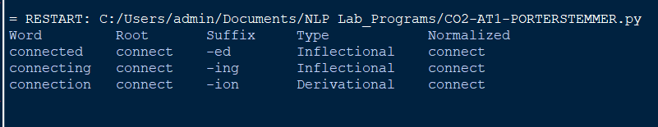

Q2. Morphological Parsing

Input Words:
unhappy, happiness, happily

Morphological Breakdown
Word | Prefix | Base Form | Suffix | Type | Root
unhappy | un | happy | - | Derivational | happy
happiness | - | happy | -ness | Derivational | happy
happily | - | happy | -ly | Derivational | happy

Explanation
- un- → Negative prefix
- -ness → Converts adjective to noun
- -ly → Converts adjective to adverb
- All are derivational.
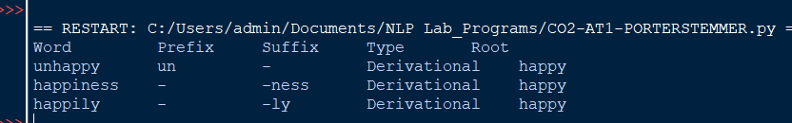
OUTPUT:

Q3. Stemming-Based Preprocessing

Input Words:
played, player, playing

Morphological Analysis
Word | Stem | Removed Affix | Type | Normalized
played | play | -ed | Inflectional | play
player | play | -er | Derivational | play
playing | play | -ing | Inflectional | play

Explanation
- -ed → Past tense
- -ing → Present participle
- -er → Forms noun

Python Program :

words = ["played", "player", "playing"]

print("{:<10} {:<10} {:<15} {:<15} {:<12}".format(
"Word","Stem","Removed","Type","Normalized"))

for word in words:

if word.endswith("ed"):
stem = word[:-2]
affix = "-ed"
t = "Inflectional"

elif word.endswith("er"):
stem = word[:-2]
affix = "-er"
t = "Derivational"

elif word.endswith("ing"):
stem = word[:-3]
affix = "-ing"
t = "Inflectional"

print("{:<10} {:<10} {:<15} {:<15} {:<12}".format(
word,stem,affix,t,stem))

OUTPUT:
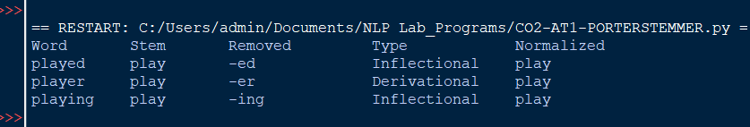

Q4. Finite-State Morphological Parser

Input Words:
writes, writing, written

Finite State Diagram
(Start)
|
v
Read Root "write"
|
+---- s -------> Accept (writes)
|
+---- ing -----> Accept (writing)
|
+---- tten ----> Accept (written)

Word | Transition Path | Pattern | Root | Normalized
writes | S0→Root→s→Final | Regular | write | write
writing | S0→Root→ing→Final | Regular | write | write
written | S0→Root→tten→Final | Irregular | write | write

Python Program :

words = ["writes", "writing", "written"]

print("{:<10} {:<25} {:<12} {:<10} {:<12}".format(
"Word","State Path","Pattern","Root","Normalized"))

for word in words:

if word == "writes":
path = "S0->write->s->F"
pattern = "Regular"

elif word == "writing":
path = "S0->write->ing->F"
pattern = "Regular"

else:
path = "S0->write->tten->F"
pattern = "Irregular"

print("{:<10} {:<25} {:<12} {:<10} {:<12}".format(
word,path,pattern,"write","write"))

OUTPUT:
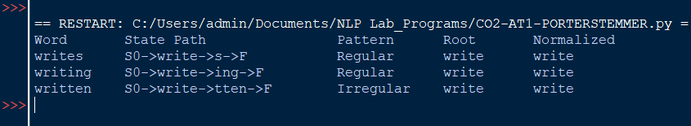

Q5. Porter Stemmer

Input Words:
relational, relation, relate
Porter Stemming Steps

Word | Rule Applied | Intermediate Form | Final Stem
relational | Step 2: ational → ate | relate | relat
relate | Step 5: remove e | relat | relat
relation | Step 4: ion → remove | relat | relat
relate | Step 5: remove e | relat | relat

Final Stems
Word | Final Stem
relational | relat
relation | relat
relate | relat

Python Program :

from nltk.stem import PorterStemmer

ps = PorterStemmer()

words = ["relational", "relation", "relate"]

print("{:<12} {:<20} {:<15}".format(
"Word","Rule Applied","Final Stem"))

for word in words:

if word == "relational":
rule = "ational -> ate"

elif word == "relation":
rule = "remove ion"

else:
rule = "remove e"

stem = ps.stem(word)

print("{:<12} {:<20} {:<15}".format(
word,rule,stem))

OUTPUT:

