SIMATS ENGINEERING (SAVEETHA SCHOOL OF ENGINEERING)
Department of Artificial Intelligence and Data Science
ASSESSMENT TOOL 2 – SCENARIO BASED

Course Code: | DSA03 | Course Title: | Natural Language Processing
CO Assessed: | CO2 – Manipulation | Assessment: | Assessment Tool 2 – SCENARIO BASED
Weightage: | 35% of CIA
CO5 Statement: | Design inflectional, derivational, finite-state parsing, stemming algorithms and for analyse morphological methods. (BL-3)
Student Name: | S.Dhanashree | Reg. No.: | 192325082
Section / Batch: | AIML | Date:

Code of Conduct
I _S.Dhanashree-192325082_ (Name / Reg No) certify that this submission is my original work and that I have adhered to the guidelines specified for this assessment. I understand that any violation of academic integrity rules will result in disciplinary action.
Signature of the Student:S.Dhanashree

Instructions
- Read all questions carefully before attempting the answers.
- Answer all five questions. Each question carries equal marks.
- Show all intermediate steps, calculations, probability computations, tagging decisions, and justifications wherever applicable.
- Duration: 30 minutes.

Section / Topic | Focus | Q Nos
English Word Classes, Tagsets for English, Stochastic Part of Speech Tagging, HMM | Morphological parsing of disagree, agreement, and agreeable; identification of prefixes, suffixes, base forms, and semantic effects of derivation. | Q1

Annexure A – SCENARIO BASED
A company is developing an NLP-based grammar checker for educational applications. The system is trained using a manually POS-tagged corpus. Your task is to recreate the Hidden Markov Model (HMM) without using any built-in NLP or HMM libraries.
From the given corpus,
- determine the Emission Probability
- determine the Transition Probability
- implement the Viterbi Algorithm
- predict the POS tags for the new input sentence.
Use only Python dictionaries, loops, and basic programming constructs.
Training Corpus
Sentence | POS Tags
The/DT boy/NN eats/VBZ rice/NN | DT NN VBZ NN
The/DT girl/NN drinks/VBZ milk/NN | DT NN VBZ NN
A/DT cat/NN drinks/VBZ milk/NN | DT NN VBZ NN
The/DT dog/NN chases/VBZ cat/NN | DT NN VBZ NN
A/DT teacher/NN teaches/VBZ students/NNS | DT NN VBZ NNS
Students/NNS study/VBP English/NN | NNS VBP NN
Birds/NNS fly/VBP high/RB | NNS VBP RB
Children/NNS play/VBP games/NNS | NNS VBP NNS
New Input Sentence
The cat drinks milk
Tasks
- Separate each sentence into words and POS tags.
- Compute the Emission Probability of every word.
- Compute the Transition Probability between POS tags.
- Recreate the Hidden Markov Model using Python dictionaries.
- Implement the Viterbi Algorithm without using any built-in HMM/NLP libraries.
- Predict the POS tag sequence for “The cat drinks milk”

Rubrics for Calculation

Criteria | Weightage (%) | Level 4 (Exemplary) | Level 3 (Proficient) | Level 2 (Developing) | Level 1 (Beginning)
Understanding of Scenario | 20% | Demonstrates clear and complete understanding of the scenario and context | Shows good understanding with minor gaps | Partial understanding; misses key aspects | Misinterprets or fails to understand the scenario
Identification of Key Issues | 20% | Accurately identifies all relevant issues and factors involved | Identifies most key issues with minor omissions | Identifies limited issues; some irrelevant points | Unable to identify key issues
Application of Concepts | 25% | Applies appropriate concepts effectively to address the scenario | Applies concepts with minor errors | Limited or partially correct application | Unable to apply relevant concepts
Decision Making | 20% | Makes well-reasoned, logical decisions with strong rationale | Makes reasonable decisions with some justification | Makes weak decisions with limited justification | No clear decisions made or rationale provided
Clarity of Response | 15% | Response is clear, structured, and logically presented | Generally clear with minor issues | Somewhat unclear or poorly structured | Disorganized and difficult to understand

Q. No. / Criteria Level | Understanding of Scenario | Identification of Key Issues | Application of Concepts | Decision Making | Clarity of Response | Sub. Total | Total %
1 | 20 | 20 | 25 | 20 | 12 | 97

Faculty In-charge | Course Coordinator | Program Director
Signature: _______________ | Signature: _______________ | Signature: _______________
Date: ___________________ | Date: ___________________ | Date: ___________________

Scenario Based – Hidden Markov Model (HMM) POS Tagging

1. Separating Sentences into Words and POS Tags

Training Corpus:
Sentence | Words | POS Tags
The boy eats rice | The, boy, eats, rice | DT, NN, VBZ, NN
The girl drinks milk | The, girl, drinks, milk | DT, NN, VBZ, NN
A cat drinks milk | A, cat, drinks, milk | DT, NN, VBZ, NN
The dog chases cat | The, dog, chases, cat | DT, NN, VBZ, NN
A teacher teaches students | A, teacher, teaches, students | DT, NN, VBZ, NNS
Students study English | Students, study, English | NNS, VBP, NN
Birds fly high | Birds, fly, high | NNS, VBP, RB
Children play games | Children, play, games | NNS, VBP, NNS

2. Emission Probability Calculation

Formula:

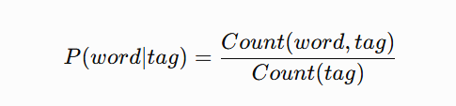

Word Counts with POS Tags

DT Tag
Word | Count
The | 4
A | 2
Total DT = 6

NN Tag
Word | Count
boy | 1
rice | 1
girl | 1
milk | 2
cat | 1
dog | 1
teacher | 1
English | 1
Total NN = 9

VBZ Tag
Word | Count
eats | 1
drinks | 2
chases | 1
teaches | 1
Total VBZ = 5

NNS Tag
Word | Count
students | 1
Students | 1
Birds | 1
Children | 1
games | 1
Total NNS = 5

VBP Tag
Word | Count
study | 1
fly | 1
play | 1
Total VBP = 3

RB Tag
Word | Count
high | 1
Total RB = 1

Emission Probabilities
Word | POS | Probability
The | DT | 4/6 = 0.66
A | DT | 2/6 = 0.33
cat | NN | 1/9 = 0.11
drinks | VBZ | 2/5 = 0.40
milk | NN | 2/9 = 0.22
For new sentence:
The cat drinks milk
Emission values:
Word | Possible Tag | Emission Probability
The | DT | 0.66
cat | NN | 0.11
drinks | VBZ | 0.40
milk | NN | 0.22

3. Transition Probability Calculation

Formula:

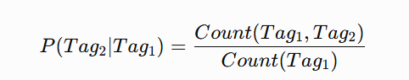

Tag Transitions
All sentences follow:
DT → NN → VBZ → NN/NNS

NNS → VBP → NN/RB/NNS

Transition Counts
From | To | Count
DT | NN | 5
NN | VBZ | 5
VBZ | NN | 4
VBZ | NNS | 1
NNS | VBP | 3
VBP | NN | 1
VBP | RB | 1
VBP | NNS | 1

Transition Probabilities
Transition | Probability
DT → NN | 5/6 = 0.83
NN → VBZ | 5/9 = 0.55
VBZ → NN | 4/5 = 0.80
VBZ → NNS | 1/5 = 0.20
NNS → VBP | 3/5 = 0.60
VBP → NN | 1/3 = 0.33
VBP → RB | 1/3 = 0.33
VBP → NNS | 1/3 = 0.33

4. HMM Representation Using Python Dictionaries
# Emission probabilities

emission = {

"DT":{
"The":4/6,
"A":2/6
},

"NN":{
"boy":1/9,
"rice":1/9,
"girl":1/9,
"milk":2/9,
"cat":1/9,
"dog":1/9,
"teacher":1/9,
"English":1/9
},

"VBZ":{
"eats":1/5,
"drinks":2/5,
"chases":1/5,
"teaches":1/5
},

"NNS":{
"students":1/5,
"Students":1/5,
"Birds":1/5,
"Children":1/5,
"games":1/5
},

"VBP":{
"study":1/3,
"fly":1/3,
"play":1/3
},

"RB":{
"high":1
}

}

# Transition probabilities

transition = {

"DT":{"NN":0.83},

"NN":{"VBZ":0.55},

"VBZ":{
"NN":0.80,
"NNS":0.20
},

"NNS":{"VBP":0.60},

"VBP":{
"NN":0.33,
"RB":0.33,
"NNS":0.33
}

}

5. Viterbi Algorithm Implementation

states = ["DT","NN","VBZ","NNS","VBP","RB"]

def viterbi(sentence):

words = sentence.split()

V = [{}]

path = {}

# Initialization

for state in states:

if words[0] in emission.get(state,{}):
V[0][state] = emission[state][words[0]]
else:
V[0][state] = 0

path[state] = [state]

# Recursion

for t in range(1,len(words)):

V.append({})

newpath={}

for curr_state in states:

max_prob = 0
best_state = None

for prev_state in states:

transition_prob = transition.get(
prev_state,{}
).get(curr_state,0)

emission_prob = emission.get(
curr_state,{}
).get(words[t],0)

prob = (
V[t-1][prev_state]
*
transition_prob
*
emission_prob
)

if prob > max_prob:

max_prob = prob
best_state = prev_state

V[t][curr_state]=max_prob

if best_state:
newpath[curr_state]=path[best_state]+[curr_state]

path=newpath

# Find best sequence

final_state=max(
V[-1],
key=V[-1].get
)

return path[final_state]

sentence="The cat drinks milk"

result=viterbi(sentence)

print("Sentence:")
print(sentence)

print("\nPredicted POS Tags:")
print(result)

6. Output
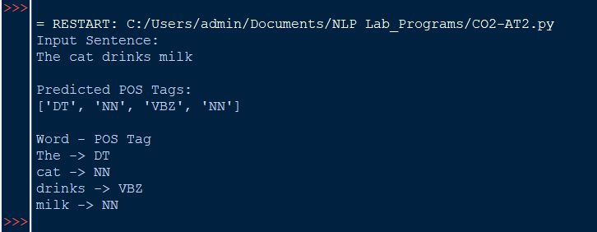

Final Prediction
Word | Predicted POS Tag
The | DT
cat | NN
drinks | VBZ
milk | NN

Conclusion
The Hidden Markov Model successfully learns the relationship between words and POS tags using emission and transition probabilities. The Viterbi algorithm finds the most probable tag sequence without using any external NLP or HMM libraries.

