
DESIGN AND DEVELOPMENT OF AN NLP-BASED
VOICE-ENABLED BILLING SYSTEM FOR
MICRO-RETAIL STORES
A CAPSTONE PROJECT REPORT
Submitted in the partial fulfillment of the requirements
for the Course of
DSA0308- NATURAL LANGUAGE PROCESSING
to the award of the degree of
BACHELOR OF TECHNOLOGY
IN
ARTIFICIAL INTELLIGENCE AND MACHINE LEARNING
Submitted by
Dhanashree S (192325082)

Under the Supervision of
Dr. Kumaragurubaran T

SIMATS ENGINEERING
Saveetha Institute of Medical and Technical Sciences
Chennai–602105

SEPTEMBER 2026

September-2026


SIMATS ENGINEERING

Saveetha Institute of Medical and Technical Sciences

Chennai-602105

DECLARATION

We, Dhanashree S (192325082),T S SAI LAHARI (192325137),Balivada Ramya Sri(192324262), Lokeshwara H (192325120),G. Harshitha (192324250) of the Department of Computer Science Engineering, Saveetha Institute of Medical and Technical Sciences, Saveetha University, Chennai, hereby declare that the Capstone Project Work entitled DESIGN AND DEVELOPMENT OF AN NLP-BASED VOICE-ENABLED BILLING SYSTEM FOR MICRO-RETAIL STORES is the result of our own bonafide efforts. To the best of our knowledge, the work presented herein is original,accurate, and has been carried out in accordance with principles of engineering ethics.

Place: Chennai
Date: 02/01/26

Signature of the Students with Names

Dhanashree S (192325082)
T S SAI LAHARI (192325137)
Balivada Ramya Sri (192324262)
Lokeshwara H (192325120)
G. Harshitha (192324250)



SIMATS ENGINEERING

Saveetha Institute of Medical and Technical Sciences

Chennai-602105

BONAFIDE CERTIFICATE

This is to certify that the Capstone Project entitled DESIGN AND DEVELOPMENT OF AN NLP-BASED VOICE-ENABLED BILLING SYSTEM FOR MICRO-RETAIL STORES has been carried out by Dhanashree S (192325082),T S SAI LAHARI (192325137),Balivada Ramya Sri(192324262), Lokeshwara H (192325120),G. Harshitha (192324250) under the supervision of Dr. Senthilvadivu S and Dr. Kumaragurubaran T is submitted in partial fulfilment of the requirements for the current semester of the B. Tech Artificial Intelligence and Data Science and Artificial Intelligence and Machine Learning program at Saveetha Institute of Medical and Technical Sciences, Chennai.

SIGNATURE | SIGNATURE
Dr. T.Devi | Dr. T. Kumaragurubaran
Program Director | Professor
Department of CSE | Department of CSE
Saveetha School of Engineering | Saveetha School of Engineering
SIMATS | SIMATS

Submitted for the Capstone Project work Viva-Voce held on ___________________.
INTERNAL EXAMINER EXTERNAL EXAMINER

ACKNOWLEDGEMENT
We would like to express our heartfelt gratitude to all those who supported and guided us throughout the successful completion of our Capstone Project. We are deeply thankful to our respected Founder and Chancellor, Dr. N.M. Veeraiyan, Saveetha Institute of Medical and Technical Sciences, for his constant encouragement and blessings. We also express our sincere thanks to our Pro-Chancellor, Dr. Deepak Nallaswamy Veeraiyan, and our Vice-Chancellor, Dr. S. Suresh Kumar, for their visionary leadership and moral support during the course of this project.

We are truly grateful to our Director, Dr. Ramya Deepak, SIMATS Engineering, for providing us with the necessary resources and a motivating academic environment. Our special thanks to our Principal, Dr. B. Ramesh, for granting us access to the institute’s facilities and encouraging us throughout the process. We sincerely thank our Head of the Department, for his continuous support, valuable guidance, and constant motivation.

We are especially indebted to our guide, Dr. T. Kumaragurubaran for their creative suggestions, consistent feedback, and unwavering support during each stage of the project. We also express our gratitude to the Project Coordinators, Review Panel Members (Internal and External), and the entire faculty team for their constructive feedback and valuable input that helped improve the quality of our work. Finally, we thank all faculty members, lab technicians, our parents, and friends for their continuous encouragement and support.

Signature With Student Name
Dhanashree S (192325082)
T S SAI LAHARI (192325137)
Balivada Ramya Sri (192324262)
Lokeshwara H (192325120)
G. Harshitha (192324250)

INDIVIDUAL CONTRIBUTION STATEMENT
(Mandatory for all team projects)
Student Name / Register No. | Specific Responsibilities | Design & Development Contribution | Testing & Analysis Contribution | Report Contribution | Approx. Contribution (%)
Dhanashree S (192325082) | Joint requirement analysis, NLP workflow, database/billing planning, testing and presentation | Joint design, development and integration of voice, NLP, database, billing and reporting modules | Joint functional testing, validation of product/quantity extraction and billing workflow | Joint preparation of chapters, figures, tables, references and final documentation | 20%
T S SAI LAHARI (192325137) | Joint requirement analysis, NLP workflow, database/billing planning, testing and presentation | Joint design, development and integration of voice, NLP, database, billing and reporting modules | Joint functional testing, validation of product/quantity extraction and billing workflow | Joint preparation of chapters, figures, tables, references and final documentation | 20%
Balivada Ramya Sri (192324262) | Joint requirement analysis, NLP workflow, database/billing planning, testing and presentation | Joint design, development and integration of voice, NLP, database, billing and reporting modules | Joint functional testing, validation of product/quantity extraction and billing workflow | Joint preparation of chapters, figures, tables, references and final documentation | 20%
Lokeshwara H (192325120) | Joint requirement analysis, NLP workflow, database/billing planning, testing and presentation | Joint design, development and integration of voice, NLP, database, billing and reporting modules | Joint functional testing, validation of product/quantity extraction and billing workflow | Joint preparation of chapters, figures, tables, references and final documentation | 20%
G. Harshitha (192324250) | Joint requirement analysis, NLP workflow, database/billing planning, testing and presentation | Joint design, development and integration of voice, NLP, database, billing and reporting modules | Joint functional testing, validation of product/quantity extraction and billing workflow | Joint preparation of chapters, figures, tables, references and final documentation | 20%

TOTAL 100%
ABSTRACT
Traditional billing methods used in micro-retail environments are often manual, time-consuming, and prone to human errors. Shopkeepers may need to repeatedly type product names and quantities, calculate item totals, and prepare invoices while serving multiple customers. These limitations become more noticeable during busy business hours, when long billing procedures can increase customer waiting time and reduce operational efficiency.
This project, titled “Design and Development of an NLP-Based Voice-Enabled Billing System for Micro-Retail Stores,” proposes an intelligent billing application that uses voice recognition and Natural Language Processing (NLP) to reduce manual data entry. The system is organized into seven major modules: User Authentication, Voice Input, Speech-to-Text Conversion, NLP Processing, Product Database Management, Billing and Invoice Generation, and Sales History and Reporting.
The shopkeeper speaks a simple billing instruction through a microphone. The voice input is converted into machine-readable text using speech recognition. The NLP processing stage tokenizes and normalizes the text, identifies product names, extracts quantities, and converts number words into digits where required. The structured information is then matched with product records stored in the database. Prices are retrieved automatically, item-wise amounts are calculated, and the final invoice is generated.
The system also maintains transaction history and supports daily, monthly, and yearly sales reporting. The proposed workflow reduces repeated typing and manual arithmetic while providing a simple interaction method for users with limited technical knowledge. The project demonstrates how NLP and voice interaction can be applied to a practical micro-retail problem. The source project material does not provide measured accuracy or numerical performance results; therefore, this report does not invent such values.
Keywords: Natural Language Processing; Voice Billing; Speech Recognition; Micro-Retail; Product Database; Invoice Generation; Sales Reporting.

TABLE OF CONTENTS
DECLARATION 3
BONAFIDE CERTIFICATE 4
ACKNOWLEDGEMENT 5
INDIVIDUAL CONTRIBUTION STATEMENT 6
ABSTRACT 7
CHAPTER 1: INTRODUCTION AND ENGINEERING PROBLEM 13
1.1 Background 13
1.2 Need for the Project 13
1.3 Problem Statement 14
1.4 Project Aim 14
1.5 Project Objectives 14
1.6 Scope 15
1.7 Expected Engineering Outcome 15
CHAPTER 2: LITERATURE REVIEW AND EXISTING SOLUTIONS 17
2.1 Review Method 17
2.2 Review of Existing Work 17
2.3 Comparative Analysis 18
2.4 Research / Engineering Gap 18
2.5 Proposed Contribution 18
CHAPTER 3: ENGINEERING DESIGN & TRADE-OFFS, SUSTAINABILITY, ETHICS, SAFETY, RISK & SECURITY 20
3.1 Requirements 20
3.2 Constraints & Applicable Standards 21
3.3 Design Specifications 21
3.4 Alternative Solutions & Evaluation 22
3.5 Selected Design & Detailed Design 22
3.6 Trade-off Analysis 23
3.7 Sustainability, Ethics, Safety, Risk & Security 23
CHAPTER 4: IMPLEMENTATION, TESTING & RESULTS, PROJECT MANAGEMENT 26
4.1 Development Approach & Resources 26
4.2 Hardware / Software / Fabrication Implementation & Modern Tools Used 27
4.3 Test Plan & Verification 29
4.4 Results 30
4.5 Data Analysis & Engineering Judgment 31
4.6 Comparison with Existing Solutions & Achievement of Objectives 31
4.7 Strengths & Limitations 32
4.8 Project Planning, Roles & Budget 32
CHAPTER 5: CONCLUSION & REFLECTION 34
5.1 Conclusion 34
5.2 Future Work 34
5.3 Professional Learning & Individual Reflection 35
5.3.1 New Knowledge Acquired 35
5.3.2 Engineering & Professional Skills Developed 35
5.3.3 Individual Reflection – Dhanashree S (192325082) 35
5.3.4 Individual Reflection – T S SAI LAHARI (192325137) 36
5.3.5 Individual Reflection – Balivada Ramya Sri (192324262) 36
5.3.6 Individual Reflection – Lokeshwara H (192325120) 36
5.3.7 Individual Reflection – G. Harshitha (192324250) 36
5.3.8 Team Reflection 37
Performance Evaluation Framework 38
REFERENCES 38
APPENDICES 40
Appendix A – System Screenshots 40
Appendix B – NLP Processing Pseudocode 42
Appendix C – Representative NLP / Billing Processing Code 42
Appendix D – Representative Application Structure 43
Appendix E – Sample Voice Commands for Testing 43
Appendix F – Recommended Validation Checklist 44

LIST OF FIGURES
Figure No. | Figure Name | Page No.
Figure 1 | System architecture of the NLP-based voice-enabled billing system | 17
Figure 2 | Voice-enabled billing workflow | 26
Figure 3 | Product and billing history interface | 27
Figure 4 | Billing entry and transaction interface | 27
Figure 5 | Inventory and product management interface | 28
Figure 6 | Settings and billing configuration interface | 28

LIST OF TABLES
Table No. | Table Name | Page No.
Table 1 | Stakeholder / User Requirements | 18
Table 2 | Functional and Non-Functional Requirements | 18
Table 3 | Constraints and Applicable Standards | 19
Table 4 | Design Specifications | 20
Table 5 | Alternative Solutions Evaluation Matrix | 21
Table 6 | Trade-off Analysis | 22
Table 7 | Sustainability, Ethics, Safety & Security Evidence | 23
Table 8 | Risk Register | 23
Table 9 | Tools / Software Used | 25
Table 10 | Test Plan & Verification | 29
Table 11 | Specification vs. Achieved Value | 30
Table 12 | Achievement of Objectives | 31
Table 13 | Project Roles & Contribution | 33
Table 13 | Project Budget | 33
Table 13 | Performance Evaluation Metrices | 37

LIST OF ABBREVIATIONS / SYMBOLS
Abbreviation / Symbol | Description | Unit
AI | Artificial Intelligence | —
AI&DS | Artificial Intelligence and Data Science | —
CGPA | Cumulative Grade Point Average | —
CO | Course Outcome | —
CSV | Comma-Separated Values | —
DBMS | Database Management System | —
ETL | Extract, Transform, Load | —
GPA | Grade Point Average | —
NLP | Natural Language Processing | —
STT | Speech-to-Text | —
UI | User Interface | —
UX | User Experience | —

CHAPTER 1: INTRODUCTION AND ENGINEERING PROBLEM

1.1 Background
Micro-retail stores such as kirana shops, grocery stores, provision stores, medical shops, and small supermarkets play an important role in local commerce. Many small stores continue to depend on manual billing, calculators, or simple billing software. These approaches normally require continuous typing and manual entry of product names and quantities.
During peak business hours, manual billing can become slow and inconvenient. The shopkeeper may have to search for products, enter quantities, calculate totals, and prepare an invoice while simultaneously interacting with customers. Repeated manual operations can also introduce typing and calculation mistakes.
Recent developments in Artificial Intelligence, Speech Recognition, and Natural Language Processing provide an opportunity to make billing more natural and accessible. Instead of entering every item using a keyboard, a shopkeeper can speak a command such as “two rice bags and three soap.” A speech recognition component converts the spoken instruction into text, and NLP techniques process that text to identify the required billing information.
The proposed project therefore focuses on an NLP-based voice-enabled billing system. The system connects voice interaction with product information, automated bill calculation, invoice generation, and sales reporting. The aim is not to replace the shopkeeper's decision-making, but to reduce repetitive manual work and make routine billing faster and easier.

1.2 Need for the Project
Manual billing requires repeated product searching, quantity entry, arithmetic, and invoice preparation. During high customer traffic, these operations can increase transaction time and create avoidable workload for the shopkeeper.
Voice input offers an alternative interaction method that can reduce keyboard dependency. NLP is required because a spoken command is unstructured, whereas a billing system requires structured fields such as product name and quantity.
Automatic price retrieval and calculation can improve consistency by reducing repetitive arithmetic. Maintaining transaction history also provides a structured record for later reference and basic sales analysis.
- Reduce repetitive typing and manual entry during billing.
- Provide a natural voice-based interaction method.
- Convert spoken instructions into structured product and quantity information.
- Automate price retrieval, bill calculation and invoice generation.
- Maintain billing history and sales summaries for later reference.

1.3 Problem Statement
The engineering problem is to simplify the micro-retail billing process so that a shopkeeper can provide product names and quantities naturally through voice, while the system converts the instruction into structured billing data, retrieves product information, performs the required calculations, generates an invoice, and records the transaction.
The problem involves interacting requirements related to speech recognition, natural-language variation, product identification, quantity extraction, database matching, billing accuracy, stock validation, user confirmation, and transaction storage. A complete solution must connect these stages into a dependable end-to-end workflow.

1.4 Project Aim
To design and develop an NLP-based voice-enabled billing system for micro-retail stores that converts natural spoken billing instructions into structured transactions, automates product lookup and bill calculation, generates invoices, and maintains sales history.

1.5 Project Objectives
- Develop a voice-enabled billing system suitable for micro-retail stores.
- Capture spoken billing commands from the shopkeeper.
- Convert spoken commands into machine-readable text using speech recognition.
- Apply NLP techniques to identify product names and extract quantities.
- Normalize simple natural-language expressions, including number words.
- Connect processed billing information to a product database containing product names, prices, stock details and categories.
- Automatically calculate item-wise amounts, subtotal, tax, discount and grand total where applicable.
- Generate digital or printable invoices.
- Maintain billing history and provide daily, monthly and yearly sales reports.
- Reduce manual typing and calculation effort while improving billing convenience.

1.6 Scope
The scope of the project covers voice input, speech-to-text conversion, NLP processing, product database management, automated billing, invoice generation, and sales history/reporting. The proposed system is designed as an academic and practical prototype for micro-retail environments.
Included in the scope:
- User authentication and authorized access.
- Voice command capture and speech-to-text conversion.
- Tokenization, normalization, product identification and quantity extraction.
- Product, price, stock and category lookup.
- Automated billing and invoice generation.
- Transaction history and daily/monthly/yearly reporting.
- Validation and error handling for unclear or invalid inputs.
Outside the demonstrated scope:
- Large-scale production deployment with measured national-level performance.
- Comprehensive multilingual speech deployment.
- Advanced AI sales forecasting and inventory recommendation models.
- Integration with external government or enterprise databases.

1.7 Expected Engineering Outcome
The intended engineering outcome is a modular voice-enabled billing application that transforms natural-language voice input into structured billing transactions. The expected workflow connects user authentication, voice capture, speech-to-text conversion, NLP processing, product database lookup, billing and invoice generation, and sales reporting. The system is intended to reduce repetitive manual operations and provide a practical foundation for future retail automation.

CHAPTER 2: LITERATURE REVIEW AND EXISTING SOLUTIONS

2.1 Review Method
The project report is informed by established work in Natural Language Processing, speech recognition, information retrieval, deep learning, data handling and software development. The supplied project material does not document a formal literature-search protocol such as exact databases searched, search strings, publication-year limits, inclusion/exclusion criteria, or screening counts. Accordingly, this section describes the thematic review represented by the project references rather than claiming a formal systematic review.
The main themes considered are speech recognition, natural-language processing, tokenization and normalization, information retrieval, deep learning for speech, database integration, and practical software development. These themes are directly relevant to converting spoken retail commands into structured billing information.

2.2 Review of Existing Work
Traditional billing systems primarily depend on keyboard or touch-based entry. Such systems can calculate totals efficiently after data entry, but the shopkeeper must still search for products and enter quantities manually.
Speech recognition research provides methods for converting human speech into machine-readable text. Deep neural network approaches have significantly influenced modern speech-recognition systems, while established speech-processing toolkits provide foundations for acoustic and language modeling.
NLP techniques provide the bridge between free-form language and structured application fields. Tokenization separates text into manageable units, normalization reduces superficial variation, and entity or product identification extracts information required by downstream operations.
Information retrieval concepts are relevant to product matching because extracted names need to be associated with records in a product database. Deep learning literature also provides a foundation for future improvements in language and speech understanding.
Existing business applications often separate billing, inventory and reporting functions. The proposed system brings voice input, NLP processing, product lookup, billing and reporting into one workflow, which is the principal engineering focus of this project.

2.3 Comparative Analysis
Existing Approach | Advantages | Limitations | Relevance to Proposed Work
Manual billing / calculator | Simple and familiar; low setup effort | Repeated typing, arithmetic effort and greater scope for entry errors | Motivates voice-based automation
Keyboard/touch billing software | Structured transactions and automatic arithmetic | Still requires manual product and quantity entry | Voice input can reduce repetitive entry
Standalone speech recognition | Converts speech into text | Does not understand product/quantity semantics by itself | Used as one stage of the proposed workflow
Standalone NLP processing | Can identify language structures and entities | Requires database and billing integration | Provides product and quantity extraction
Fragmented retail tools | Specialized inventory, billing or reporting functions | Users may switch between tools | Proposed system integrates core functions
Proposed integrated voice billing | Natural interaction, NLP extraction, database lookup and automated billing | Requires careful handling of speech errors and language variation | Provides the intended end-to-end workflow

2.4 Research / Engineering Gap
The key engineering gap is the absence of a simple, integrated workflow that connects spoken retail commands with product identification, quantity extraction, database lookup, billing calculation, invoice generation, and transaction history. A speech recognizer alone produces text, while a conventional billing system expects structured fields. The proposed system addresses the gap by placing NLP processing between speech recognition and business logic.

2.5 Proposed Contribution
The proposed contribution is a voice-enabled billing architecture organized around seven major modules: User Authentication, Voice Input, Speech-to-Text Conversion, NLP Processing, Product Database Management, Billing and Invoice Generation, and Sales History and Reporting. The contribution is primarily an integration design that applies NLP concepts to a practical micro-retail workflow.
The NLP layer performs tokenization, normalization, product identification and quantity extraction. Number normalization converts spoken number words into usable digits. The resulting structured information is passed to the product database, which supplies prices and stock information. The billing engine then calculates item-wise amounts and the final bill, after which the transaction is stored for reporting.
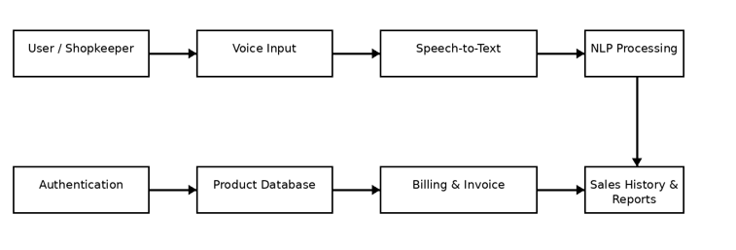
Figure 1: System architecture of the NLP-based voice-enabled billing system

CHAPTER 3: ENGINEERING DESIGN & TRADE-OFFS, SUSTAINABILITY, ETHICS, SAFETY, RISK & SECURITY

3.1 Requirements
Table 1: Stakeholder / User Requirements
Stakeholder | Requirement
Shopkeepers | Faster voice-based entry, less typing, automatic calculation and invoice generation.
Customers | Reduced billing effort and potentially shorter waiting time.
Store Administrators | Product, stock and transaction information can be organized in one system.
Business Owners | Sales history and reports support basic monitoring of business performance.
Students / Researchers | Practical application of NLP, speech processing and database integration.

Table 2: Functional and Non-Functional Requirements
Requirement Type | Requirement | Measurable / Verification Target
Functional | Voice input and speech-to-text | Spoken command is converted to text for processing.
Functional | NLP processing | Product names and quantities are extracted from supported commands.
Functional | Number normalization | Number words are converted into numerical quantities.
Functional | Product database lookup | Matching product, price and stock information is retrieved.
Functional | Billing and invoice generation | Item totals and final bill are calculated and invoice is produced.
Functional | Sales history/reporting | Completed transactions are stored and summaries can be generated.
Non-Functional | Usability | Workflow should be understandable to intended micro-retail users.
Non-Functional | Reliability | Repeated valid transactions should complete without system failure.
Non-Functional | Security | Authentication and transaction information should be protected.
Non-Functional | Maintainability | Modules should remain separated so individual components can be improved.

3.2 Constraints & Applicable Standards
The project is primarily software-based and is constrained by speech-recognition quality, natural-language variation, product-name ambiguity, database consistency, available development resources, and the absence of documented large-scale performance measurements in the supplied material.
Table 3: Constraints & Applicable Standards
Standard / Principle | Requirement / Focus | How Applied in This Project
ISO/IEC 25010 | Software quality characteristics | Considered functionality, reliability, usability, performance efficiency and maintainability.
IEEE 29148 | Requirements engineering | Used as a reference for structured requirement gathering and documentation.
Data-processing best practices | Consistent input and data organization | Applied through modular processing, normalization and structured database records.
Responsible data handling | Protect user and transaction information | Authentication and controlled handling of transaction records are considered.
Modular software design | Separation of responsibilities | Authentication, voice, NLP, database, billing and reporting are separated.

3.3 Design Specifications
Table 4: Design Specifications
Parameter | Target / Requirement | Priority
Voice input | Capture shopkeeper billing command through microphone | High
Speech-to-text | Convert spoken command into machine-readable text | High
NLP processing | Tokenize, normalize, identify products and quantities | High
Product database | Store product name, price, stock and category | High
Billing | Calculate item totals, subtotal, tax, discount and grand total where applicable | High
Invoice generation | Produce digital or printable billing output | High
Reporting | Store transactions and support daily/monthly/yearly summaries | Medium
Validation | Handle invalid, unclear, insufficient-stock and unmatched-product cases | High
Maintainability | Keep modules independent and documented | Medium

3.4 Alternative Solutions & Evaluation
Alternative 1: Conventional manual or static billing uses keyboard entry and calculators. It is simple and familiar but requires repetitive manual operations.
Alternative 2: Separate specialist tools provide independent speech, inventory, billing or reporting capabilities. They can be useful for individual tasks but require integration or multiple interfaces.
Alternative 3: The proposed integrated voice billing system combines speech input, NLP, product lookup, billing, invoice generation and reporting in one workflow.
Table 5: Alternative Solutions Evaluation
Criterion | Weight | Alternative 1  Manual/Static | Alternative 2  Fragmented Tools | Alternative 3  Integrated Voice Billing
Interactivity | 25% | Low | Medium | High
Natural input | 20% | Low | Medium | High
NLP integration | 20% | Low | Medium | High
Billing automation | 20% | Medium | High | High
Integration / maintainability | 15% | Medium | Low | High

3.5 Selected Design & Detailed Design
The selected design is the integrated voice-enabled billing architecture because it directly addresses the identified engineering gap. The design follows a layered workflow in which each module has a clear responsibility and produces information required by the next stage.
The User Authentication Module controls access. The Voice Input Module captures the shopkeeper's spoken command. The Speech-to-Text Module converts audio into text. The NLP Processing Module tokenizes and normalizes the text, identifies product names and extracts quantities. The Product Database Management Module supplies product, price and stock information. The Billing and Invoice Generation Module calculates amounts and creates the invoice. The Sales History and Reporting Module stores completed transactions and organizes sales information.
The modular design also supports maintainability. Improvements to speech recognition can be made without redesigning invoice generation, while database changes can be handled independently of the NLP processing stage.
Voice command → Speech-to-Text → NLP Processing → Product Database → Billing & Invoice → Sales History / Reports
Figure 2: Voice-enabled billing workflow

3.6 Trade-off Analysis
Table 6: Trade-off Analysis
Design Decision | Alternative Considered | Benefit | Disadvantage | Final Decision & Justification
Voice input | Keyboard/touch input only | Reduces repetitive typing | Speech errors may occur | Voice input selected to address manual-entry burden.
NLP normalization | Fixed command syntax | Flexible natural-language interaction | More processing required | Normalization selected because users may express quantities differently.
Integrated database | Manual price entry | Automatic product and price retrieval | Requires maintained product records | Database integration selected for consistent billing.
Modular architecture | Single monolithic workflow | Easier testing and maintenance | More modules to coordinate | Modules selected to isolate responsibilities and simplify future improvements.
Confirmation/error handling | Immediate invoice generation | Faster interaction | Incorrect recognition may create wrong bills | Validation and confirmation are preferred when confidence is low.

3.7 Sustainability, Ethics, Safety, Risk & Security
Sustainability: The proposed application is software-based and can operate using common computing resources. The modular architecture reduces the need to redesign the complete system when individual components are improved. The supplied source material does not report quantified energy or resource-consumption measurements.
Ethics: Billing systems handle business and transaction information, so user access, appropriate data handling and avoidance of unnecessary exposure of records are important. The project considers authentication and controlled transaction storage as part of responsible system design.
Safety: The system does not involve physical machinery or hazardous materials. Operational safety concerns mainly relate to avoiding incorrect billing outcomes and ensuring that unclear voice commands do not automatically generate unintended transactions.
Security: Authentication, controlled access, careful database handling and protection of transaction information are relevant. Future deployment should strengthen password protection, access control, secure storage and transaction security.
Table 7: Sustainability, Ethics, Safety and Security Evidence
Domain | Consideration | Evidence / Approach | Impact on Final Decision
Sustainability | Efficient software operation | Modular software; no quantified energy study reported | Supports maintainable software architecture
Ethics | Responsible handling of user and transaction information | Authentication and controlled transaction handling | Supports controlled access
Safety | Avoid incorrect or unintended bills | Validation and user confirmation for uncertain commands | Supports verification before final invoice
Security | Protect user, product and transaction information | Authentication and secure data-handling practices | Supports restricted access and future security hardening

Table 8: Risk Register
Risk | Likelihood | Severity | Risk Level | Mitigation | Residual Risk
Speech recognition errors | High | Medium | High | Use normalization, confirmation and repeated testing | Medium
Natural-language variation | High | Medium | High | Support normalization and structured extraction rules | Medium
Similar product names | Medium | High | High | Database validation and confirmation | Medium
Incorrect quantity extraction | Medium | High | High | Number normalization and bill verification | Medium
Database mismatch | Medium | High | High | Consistent product records and validation | Medium
Insufficient stock | Medium | Medium | Medium | Stock validation before completion | Low/Medium
Billing calculation error | Low/Medium | High | Medium | Automated calculation and comparison with expected totals | Low
Unauthorized access | Low | High | Medium | Authentication and access control | Low/Medium
Noisy retail environment | Medium | Medium | Medium | Microphone quality, confirmation and repeated testing | Medium

CHAPTER 4: IMPLEMENTATION, TESTING & RESULTS, PROJECT MANAGEMENT

4.1 Development Approach & Resources
The development approach follows problem identification, requirement analysis, system design, module development, integration, testing, validation, documentation and presentation. The workflow is iterative: each module is developed with a clear responsibility and then connected to the next stage.
The implementation is organized around seven major modules. Authentication controls access. Voice Input captures spoken commands. Speech-to-Text converts speech into text. NLP Processing transforms text into structured product and quantity information. Product Database Management supplies price and stock data. Billing and Invoice Generation calculates the transaction. Sales History and Reporting stores and summarizes completed transactions.
Table 9: Tools / Software / Equipment
Tool / Software / Equipment | Purpose | Stage Used
Natural Language Processing | Process converted text and extract billing information | NLP processing
Speech Recognition | Convert spoken commands into machine-readable text | Voice input
Tokenization | Split text into individual words/tokens | NLP preprocessing
Text normalization | Standardize input and convert number words into digits | NLP preprocessing
Product Database | Store names, prices, stock quantities and categories | Data management
Billing Engine | Calculate item totals, subtotal, tax, discount and grand total | Billing
Invoice Generation | Produce digital or printable billing output | Billing
Sales Reporting | Store transactions and provide daily/monthly/yearly summaries | Reporting
Git / GitHub | Version control and project management | Development / documentation
Development environment | Coding, debugging and integration | Development

4.2 Hardware / Software / Fabrication Implementation & Modern Tools Used
The project is primarily software-based. A microphone is required for voice input, while a general-purpose computer is used to run the application and database components. The implementation does not require specialized fabrication or physical machinery.
- Voice Input: The shopkeeper speaks a billing instruction through a microphone.
- Speech-to-Text: The audio input is converted into text.
- NLP Processing: The text is tokenized, normalized, and analyzed to identify product names and quantities.
- Product Lookup: Extracted products are matched against database records.
- Billing: Quantities and prices are combined to calculate item-wise amounts and the final bill.
- Invoice Generation: The system creates digital or printable billing output.
- Reporting: Completed transactions are retained for daily, monthly and yearly reporting.
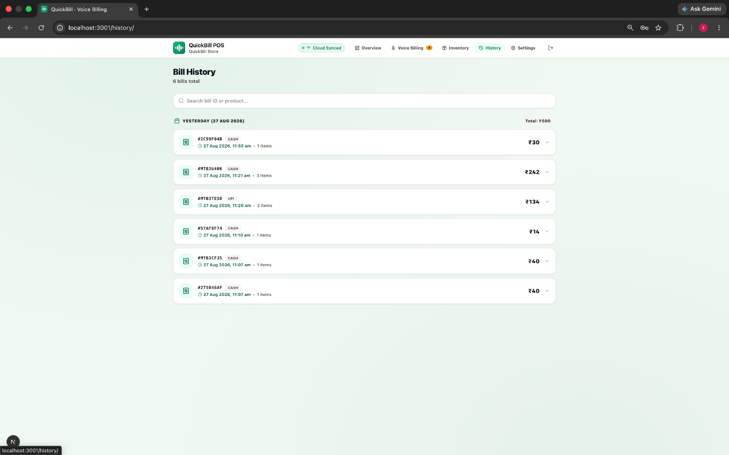
Figure 3: Product and billing history interface
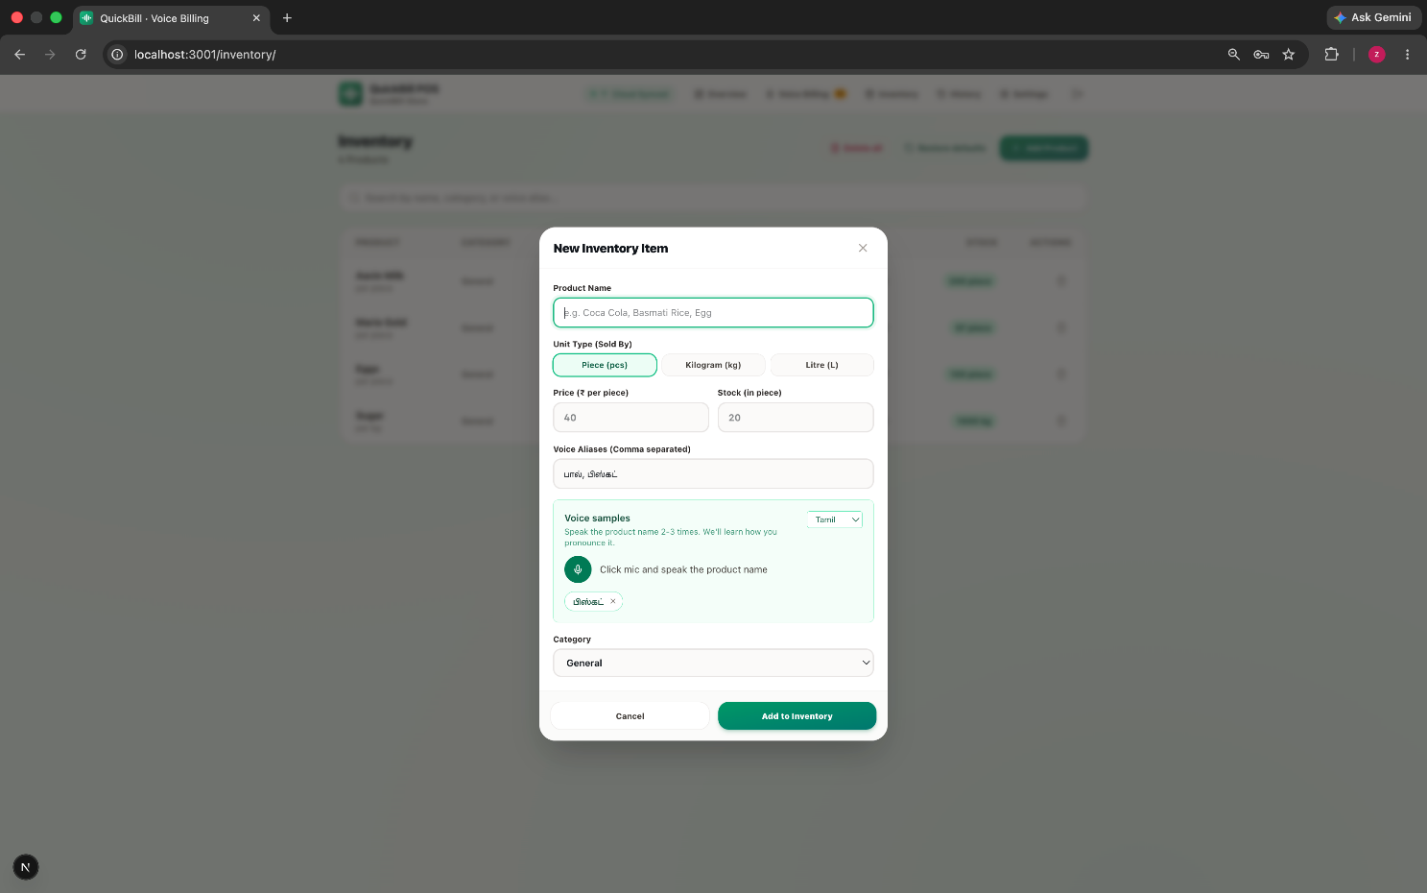
Figure 4: Billing entry and transaction interface
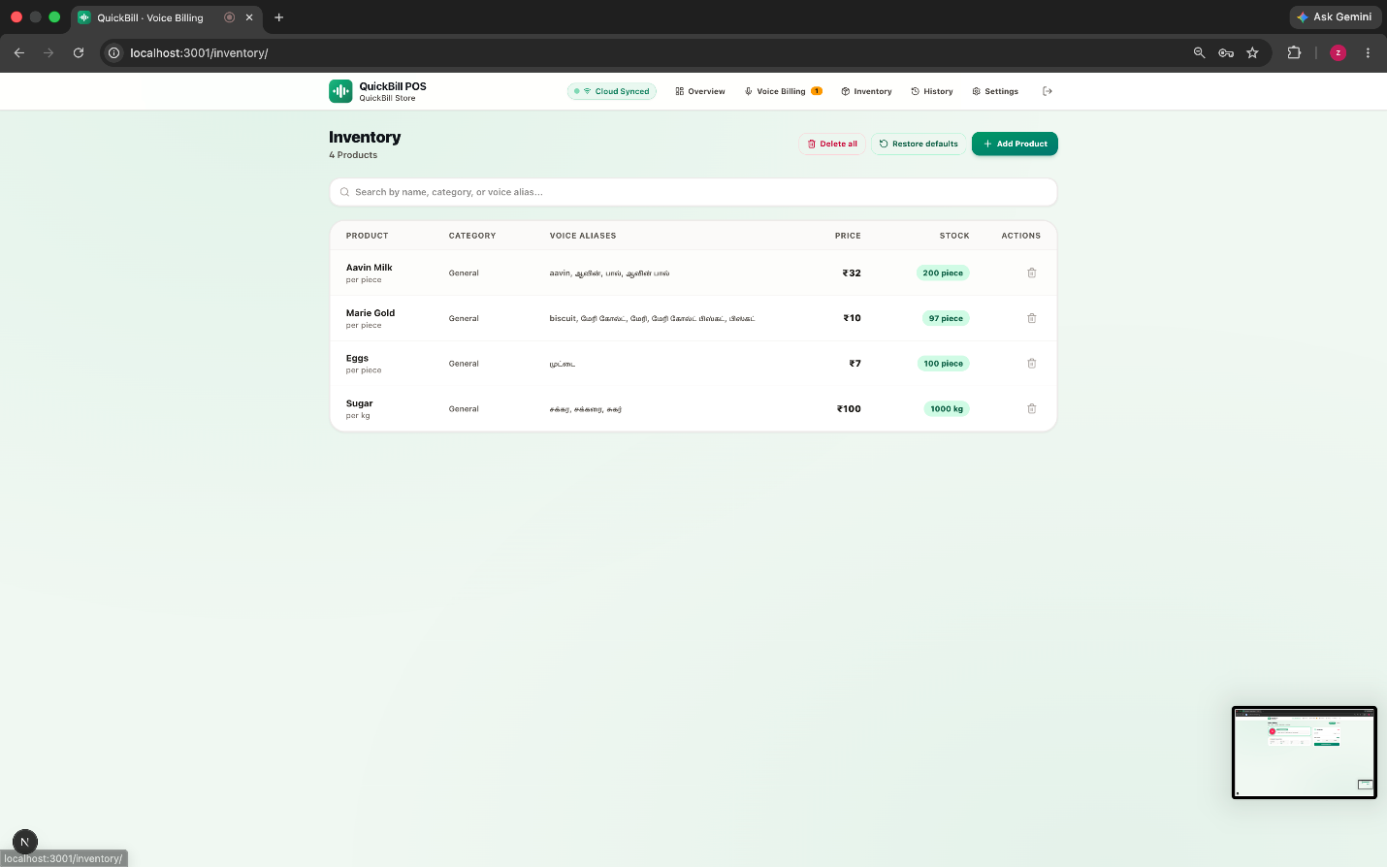
Figure 5: Inventory and product management interface
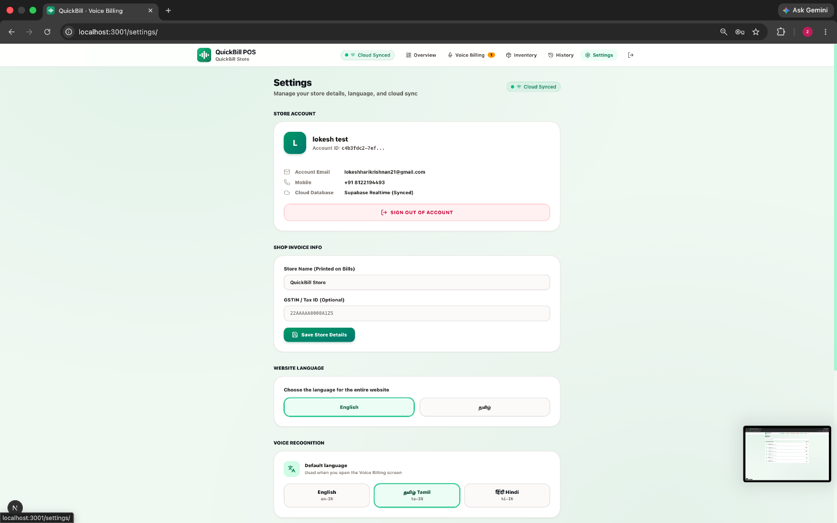
Figure 6: Settings and billing configuration interface

4.3 Test Plan & Verification
Testing focuses on the complete functional workflow rather than claiming unsupported numerical accuracy. The important verification stages are speech-to-text conversion, NLP extraction, number normalization, product matching, stock validation, billing calculation, invoice generation, transaction storage and error handling.
Table 10: Test Plan & Verification
Requirement / Specification | Test Method | Acceptance Criterion | Required Value | Achieved Value | Status
Speech-to-text conversion | Use representative voice commands | Spoken command is converted into usable text | Not reported | Not reported | To be measured
Product extraction | Compare extracted products with expected products | Correct product names identified | Not reported | Not reported | To be measured
Quantity extraction | Test numeric and number-word quantities | Correct quantities identified | Not reported | Not reported | To be measured
Number normalization | Test one, two, three, ten etc. | Number words converted to digits | Not reported | Not reported | To be measured
Product matching | Use valid and varied product names | Correct database record selected | Not reported | Not reported | To be measured
Billing calculation | Compare generated total with manual calculation | Amounts match expected bill | Not reported | Not reported | To be measured
Invoice generation | Complete valid transaction | Invoice is generated | Not reported | Not reported | To be measured
Stock validation | Request quantities above available stock | System identifies insufficient stock | Not reported | Not reported | To be measured
Error handling | Use unclear or incomplete commands | System rejects or requests correction | Not reported | Not reported | To be measured
Transaction history | Complete multiple transactions | Transactions are stored and retrievable | Not reported | Not reported | To be measured

4.4 Results
The implemented workflow described in the source report supports conversion of spoken billing instructions into structured billing information. The system accepts voice-based product names and quantities, processes the resulting text using NLP, retrieves product information from a database, calculates item-wise and final amounts, generates invoices, and maintains transaction history.
Table 11: Results / Key Outcomes
Outcome Parameter | Result Reported
Voice-Based Input | The system accepts spoken product names and quantities through a microphone, reducing the need for repeated keyboard entry.
Speech-to-Text Conversion | Spoken billing instructions are converted into machine-readable text for further processing.
NLP Processing | Tokenization, text normalization, product identification and quantity extraction are included.
Number Normalization | Number words such as one, two and three can be converted into numerical quantities.
Product Matching | Extracted product names are matched with records stored in the product database.
Automatic Price Retrieval | The system retrieves corresponding product prices from the database.
Automated Calculation | Item-wise amounts and final billing totals are calculated.
Invoice Generation | Digital or printable billing output is produced.
Transaction History | Completed transactions can be stored and retrieved.
Sales Reporting | Daily, monthly and yearly reporting is supported.

The source material does not report measured speech-recognition accuracy, NLP extraction accuracy, response time, or billing success rate. These values should be calculated from actual experimental test data before being presented as numerical results.

4.5 Data Analysis & Engineering Judgment
The implementation experience indicates that the quality of the input text strongly influences downstream billing. Speech-recognition errors can lead to incorrect product names or quantities, so preprocessing and validation are important.
The selection of NLP operations is an engineering decision. Tokenization provides manageable units, normalization reduces superficial variation, product identification connects language to database records, and quantity extraction converts natural expressions into structured values.
Database validation is also critical because an extracted product must correspond to a real product record and the requested quantity must be checked against available stock. Automated arithmetic reduces manual calculation effort, but final transaction confirmation is important when the input is uncertain.
The modular architecture allows the team to improve individual stages without replacing the entire workflow. This is especially important for future multilingual support, fuzzy product matching, better speech recognition and advanced analytics.

4.6 Comparison with Existing Solutions & Achievement of Objectives
Table 12: Objective Achievement
Objective | Evidence | Achievement
Develop voice-enabled billing system | Voice input and end-to-end billing workflow are described. | Fully addressed at functional-prototype level
Capture spoken billing commands | Voice Input Module is part of the architecture. | Fully addressed
Convert speech to text | Speech-to-Text Module is included. | Fully addressed
Apply NLP for products and quantities | Tokenization, normalization, product identification and quantity extraction are included. | Fully addressed
Normalize number words | Number normalization is part of NLP workflow. | Fully addressed
Connect to product database | Product database stores names, prices, stock and categories. | Fully addressed
Automate billing and invoice generation | Billing engine and invoice module are included. | Fully addressed
Maintain history and reporting | Sales History and Reporting module is included. | Fully addressed
Measure quantitative performance | Source report does not provide measured accuracy or response-time results. | Partially addressed; requires experimental testing
Evaluate usability formally | No formal user-study results are reported. | Partially addressed

4.7 Strengths & Limitations
Strengths:
- Provides a natural voice-based alternative to repeated keyboard entry.
- Combines speech recognition, NLP, database management, billing and reporting in one workflow.
- Uses modular architecture that supports independent testing and future improvement.
- Automates price retrieval and arithmetic operations.
- Supports transaction history and reporting.
- Provides a practical application of NLP to a real-world micro-retail problem.
Limitations:
- Speech recognition may be affected by noise, pronunciation, accents and unclear speech.
- Natural-language variation can make product and quantity extraction difficult.
- Similar product names may cause matching ambiguity.
- The supplied report does not contain measured quantitative performance values.
- Large-scale deployment, multilingual support and advanced sales forecasting are future extensions.

4.8 Project Planning, Roles & Budget
The project followed a sequence of requirement analysis, literature review, system design, module development, integration, testing, documentation and presentation. The exact calendar dates and expenditure values were not documented in the supplied report; therefore, no unsupported dates or costs are claimed here.
Table 13: Project Roles
Student | Assigned Responsibility | Actual Contribution
Dhanashree S (192325082) | Team development, NLP workflow, testing and documentation | 20% equal team contribution
T S SAI LAHARI (192325137) | Team development, voice workflow, integration and documentation | 20% equal team contribution
Balivada Ramya Sri (192324262) | Team development, database/billing workflow and testing | 20% equal team contribution
Lokeshwara H (192325120) | Team integration, validation, reporting and documentation | 20% equal team contribution
G. Harshitha (192324250) | Team testing, presentation, documentation and integration support | 20% equal team contribution

Table 14: Project Budget
Item | Estimated Cost | Actual Cost
Software libraries / NLP components | Open-source / not separately reported | No separate cost reported
Development environment | Not reported | No separate cost reported
Version control / project management | Not reported | No separate cost reported
Computer / development system | Not reported | Not reported
Internet / other project expenses | Not reported | Not reported
TOTAL | Not reported | Not reported

CHAPTER 5: CONCLUSION & REFLECTION

5.1 Conclusion
The project addressed the practical problem of repetitive manual billing in micro-retail stores by designing an NLP-based voice-enabled workflow. The system combines voice input, speech-to-text conversion, NLP processing, product database management, billing calculation, invoice generation and sales reporting.
The proposed architecture demonstrates how spoken language can be converted into structured business information. Tokenization, normalization, product identification and quantity extraction form the language-processing bridge between voice input and database-driven billing. The modular design also provides a clear foundation for testing and future improvement.
The source report supports the functional workflow and prototype outcomes but does not provide measured quantitative performance values. Therefore, numerical claims about accuracy, response time or success rate are intentionally excluded.

5.2 Future Work
- Add multilingual and regional-language voice support, including English, Tamil, Telugu, Hindi and other languages.
- Improve NLP models for more complex billing sentences.
- Introduce fuzzy matching for speech-recognition variations in product names.
- Allow voice-based addition, removal and quantity modification.
- Provide voice confirmation when product matching is uncertain.
- Integrate barcode scanning as an additional input method.
- Add automatic low-stock notifications.
- Provide advanced sales analytics and visualization.
- Support secure cloud backup of transaction records.
- Provide offline billing functionality.
- Integrate digital payment systems.
- Add customer management and purchase-history features.
- Explore AI-based sales forecasting and inventory recommendations.

5.3 Professional Learning & Individual Reflection

5.3.1 New Knowledge Acquired
The project strengthened understanding of Natural Language Processing concepts such as tokenization, text normalization, stop-word handling, product identification, quantity extraction and number normalization. It also provided practical understanding of speech-to-text processing and the conversion of unstructured language into structured application data.
The team learned how language processing can be integrated with a product database, billing engine, invoice generation and reporting workflow. This helped connect academic NLP concepts with a complete application rather than treating NLP as an isolated task.

5.3.2 Engineering & Professional Skills Developed
- Requirement analysis and modular system design.
- Speech and text processing workflow design.
- NLP preprocessing and structured information extraction.
- Database and transaction workflow planning.
- Automated billing and invoice generation logic.
- Testing, validation and error-handling analysis.
- Technical documentation and report preparation.
- Team collaboration, communication and presentation.

5.3.3 Individual Reflection – Dhanashree S (192325082)
Working on the project provided practical experience in understanding how NLP can solve a repetitive business problem. I learned the importance of converting unstructured voice commands into structured product and quantity information. The project also improved my ability to analyze requirements, participate in module design, test system behavior and document technical work. If the project were repeated, I would focus more strongly on systematic performance measurement and automated validation of NLP outputs.

5.3.4 Individual Reflection – T S SAI LAHARI (192325137)
The project helped me understand the complete flow from voice input to invoice generation. I gained experience in thinking about how speech recognition, NLP and business logic must work together rather than independently. I also learned that user-friendly AI systems require clear validation and error handling. The project improved my communication and teamwork skills and increased my confidence in designing practical AI applications.

5.3.5 Individual Reflection – Balivada Ramya Sri (192324262)
This project improved my understanding of database-driven applications and the relationship between extracted NLP information and billing records. I learned that accurate product matching and quantity validation are essential because errors at the language-processing stage can affect the final transaction. Working as part of a five-member team also improved my ability to coordinate tasks, review outputs and contribute to shared documentation.

5.3.6 Individual Reflection – Lokeshwara H (192325120)
The project provided valuable exposure to system integration and testing. I learned how independent modules can be connected into a single workflow and why each stage needs clear inputs and outputs. The challenges related to speech variation, product matching and billing validation strengthened my analytical thinking. I also developed better skills in technical presentation and collaborative problem solving.

5.3.7 Individual Reflection – G. Harshitha (192324250)
Working on the voice-enabled billing project improved my understanding of NLP, speech processing and practical software development. I learned how natural-language commands can be normalized and transformed into structured information that supports database lookup and billing. The project also taught me the importance of testing, documentation, communication and user-oriented design. In future work, I would like to explore multilingual NLP and more advanced speech understanding.

5.3.8 Team Reflection
As a five-member team, we learned that successful development depends on coordination across requirements, design, NLP processing, database and billing logic, testing, documentation and presentation. Regular discussion helped identify issues early and ensured that the modules were aligned with the overall system objective. The project strengthened our ability to divide work while maintaining a shared understanding of the complete application.
Performance Evaluation Framework
The effectiveness of the proposed billing system should be evaluated using measurable technical and functional indicators. Since the supplied project material does not contain actual experimental measurements, the following table defines suitable evaluation metrics and recommended evaluation methods rather than claiming completed numerical results.

Table 15: Performance Evaluation Metrics for the NLP-Based Voice-Enabled Billing System
Performance Metric | Description | Recommended Evaluation
Speech-to-Text Accuracy | Correctness of converting spoken commands into text | Measure using representative voice commands
Product Extraction Accuracy | Correct identification of product names | Calculate against manually labelled test commands
Quantity Extraction Accuracy | Correct identification of requested quantities | Calculate using known quantity examples
Number Normalization Accuracy | Correct conversion of number words into digits | Evaluate expressions such as one, two, ten, etc.
Product Matching Accuracy | Correct matching of extracted names with database products | Test valid and variation-based product names
Billing Accuracy | Correct calculation of item-wise and final amounts | Compare generated bills with manually calculated bills
Invoice Generation Time | Time required to generate final invoice | Measure during actual execution
Response Time | Time between voice input and structured billing output | Measure using multiple test cases
Transaction Success Rate | Percentage of commands converted into valid bills | Calculate from actual test transactions
Database Response Time | Time required to retrieve product and price information | Measure during database operations
Stock Validation | Ability to identify insufficient product quantities | Test different inventory conditions
User Usability | Ease of using voice-based billing | Evaluate through user feedback/questionnaire
Error Handling | Ability to handle unclear/incomplete/invalid commands | Test intentionally incorrect inputs
System Reliability | Ability to process repeated transactions without failure | Evaluate through repeated transaction testing

Actual values should be obtained through controlled testing using representative voice commands, product records and billing transactions. Numerical performance values should not be assumed without experimental evidence.

REFERENCES
[1] Jurafsky, D., & Martin, J. H. (2024). Speech and Language Processing: An Introduction to Natural Language Processing, Computational Linguistics, and Speech Recognition. Pearson.
[2] Bird, S., Klein, E., & Loper, E. (2009). Natural Language Processing with Python: Analyzing Text with the Natural Language Toolkit. O'Reilly Media.
[3] Manning, C. D., Raghavan, P., & Schütze, H. (2008). Introduction to Information Retrieval. Cambridge University Press.
[4] Vaswani, A., Shazeer, N., Parmar, N., Uszkoreit, J., Jones, L., Gomez, A. N., Kaiser, Ł., & Polosukhin, I. (2017). Attention Is All You Need. Advances in Neural Information Processing Systems (NeurIPS), 30.
[5] Hinton, G., Deng, L., Yu, D., Dahl, G. E., Mohamed, A., Jaitly, N., Senior, A., Vanhoucke, V., Nguyen, P., Sainath, T. N., & Kingsbury, B. (2012). Deep Neural Networks for Acoustic Modeling in Speech Recognition. IEEE Signal Processing Magazine, 29(6), 82–97.
[6] Young, S., Evermann, G., Gales, M., Hain, T., Kershaw, D., Liu, X., Moore, G., Odell, J., Ollason, D., Povey, D., Valtchev, V., & Woodland, P. (2006). The HTK Book. Cambridge University Engineering Department.
[7] Chollet, F. (2021). Deep Learning with Python (2nd ed.). Manning Publications.
[8] Goodfellow, I., Bengio, Y., & Courville, A. (2016). Deep Learning. MIT Press.
[9] Jurafsky, D., & Martin, J. H. (2024). Speech Recognition and Spoken Language Processing. In Speech and Language Processing.
[10] McKinney, W. (2022). Python for Data Analysis: Data Wrangling with pandas, NumPy, and Jupyter (3rd ed.). O'Reilly Media.

APPENDICES

Appendix A – System Screenshots
The following screenshots are retained from the original project report as evidence of the developed interface and are placed here for reference.

Appendix Figure A1: Product and billing history interface

Appendix Figure A2: Billing entry and transaction interface

Appendix Figure A3: Inventory and product management interface

Appendix Figure A4: Settings and billing configuration interface

Appendix B – NLP Processing Pseudocode
INPUT: Spoken billing command
1. Capture audio from microphone.
2. Convert speech to text.
3. Tokenize the converted text.
4. Normalize text and number words.
5. Identify product names and quantities.
6. Validate extracted products against the product database.
7. Retrieve prices and stock quantities.
8. Calculate item-wise amounts and final bill.
9. Generate invoice.
10. Store transaction and update sales history.
OUTPUT: Structured invoice and stored transaction

Appendix C – Representative NLP / Billing Processing Code
def process_billing_text(text, product_db):
# Normalize input
text = text.lower().strip()

# Tokenize and normalize common number words
number_map = {
"one": 1, "two": 2, "three": 3,
"four": 4, "five": 5, "ten": 10
}

tokens = text.split()
normalized = [number_map.get(tok, tok) for tok in tokens]

# Extract product and quantity information
items = extract_products_and_quantities(normalized, product_db)

# Validate and calculate
bill_items = []
total = 0

for item in items:
product = product_db.get(item["product"])
if product is None:
continue

quantity = item["quantity"]
amount = product["price"] * quantity

bill_items.append({
"product": product["name"],
"quantity": quantity,
"price": product["price"],
"amount": amount
})
total += amount

return {
"items": bill_items,
"total": total
}

Appendix D – Representative Application Structure
voice-billing-system/
├── authentication/
├── voice_input/
├── speech_to_text/
├── nlp_processing/
├── product_database/
├── billing/
├── invoice/
├── sales_history/
├── reporting/
├── tests/
└── documentation/

Appendix E – Sample Voice Commands for Testing
- Two rice bags and three soap.
- One packet of sugar and five biscuits.
- Add two bottles of water.
- Give me three notebooks and one pen.
- Bill two packets of rice and four soaps.
- Add ten units of the selected product.
- Remove one item from the current bill.
- Show today's sales history.

