**Assignment4.3**

**Problem Statement:**

Perform and explain the code flow and the associated result for the below tasks. Candidates should

create and use their own employee dataset for the same. Share the screenshot of the commands used

and its associated result.

● Transfer data between Mysql and HDFS (Import and Export) using Sqoop.

● Transfer data between Mysql and Hive (Import and Export only selected columns) using Sqoop.

Transfer data between Mysql and HDFS (Import and Export) using Sqoop.

*Import*

Employee dataset:

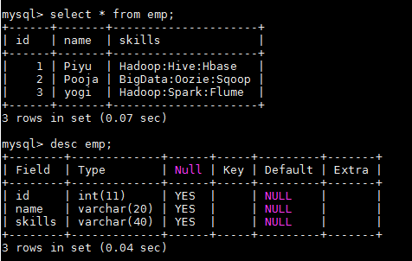

Sqoop Import command:

**target-dir** - HDFS directory where the data from MySQL would be loaded

**m** - to specify the number of mappers involved in this import(in this case -1)



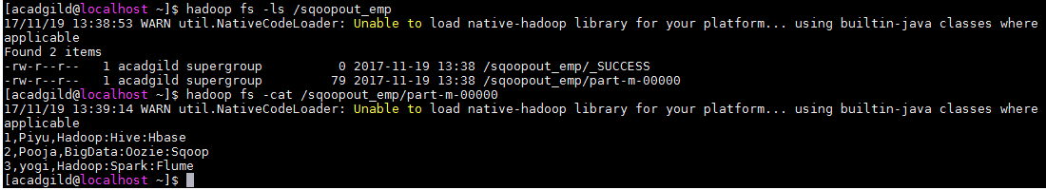

Sqoop Export command:

**export-dir** - HDFS directory where the source data resides

**input-fields–terminated-by**- to specify delimiter

**m** - to specify the number of mappers involved in this import(in this case -1)

**columns** - columns to be exported(Mysql)



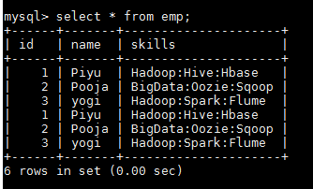

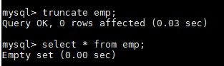



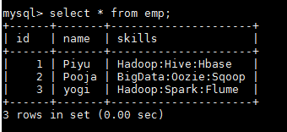

Transfer data between Mysql and Hive (Import and Export only selected columns) using Sqoop.

*Import*

Employee dataset:

]



Sqoop Import command:

**warehouse-dir** - Hive metastore directory where the data for hive tables resides

**fields-terminated-by** – to specify delimiter

**m** - to specify the number of mappers involved in this import(in this case -1)

**columns** - specify particular columns to be exported(Mysql)

**hive-import**– for importing to hive

**create –table** -to create a hive table if not exists employeehive in default db



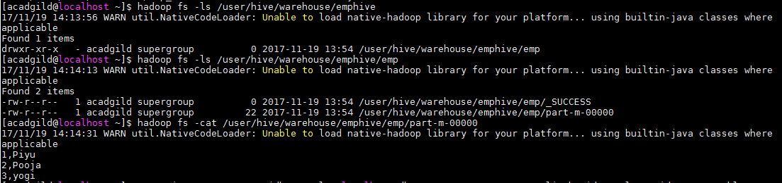

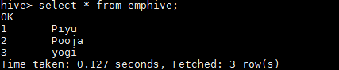

Sqoop Export command:

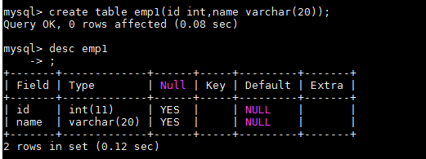

**export-dir** - Hive metastore directory where the data for hive tables resides(source data)

**input-fields-terminated-by**  – to specify delimiter

**m** - to specify the number of mappers involved in this import(in this case -1)

**columns** - specify columns to be exported(Mysql)



