**Assignment 2 -linux commands with an example.**

1. pwd - [print work directory]prints the full path name of the current working directory.



2. vi – It is the default editor that comes with the UNIX operating system is called vi (visual editor).

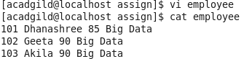

3. touch – it is used to create new or empty files.

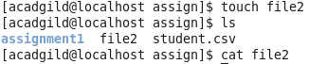

4. mkdir –make directory – it is used to create directories on a file system.



5. rm – remove – it used to remove files and directories.

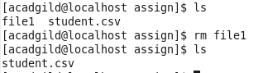

6. ls – List it lists the directory content of files and directories.



7. echo-it is used to display a line of text/string on a standard output or a file.



8. cat - allows us to create single or multiple files, view contain of file, concatenate files and redirect output in terminal or files

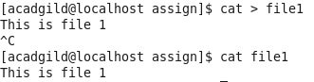

9. who -displays a list of users who are currently logged into the computer



10.cd -change directory it used to change the current working directory.

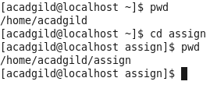

11.date – displays the current date



12.cal –displays the calendar

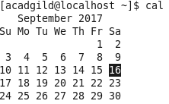

13.mv -moves files or directories from one place to another

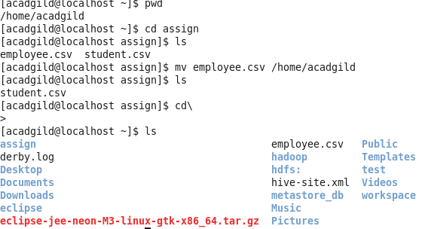

14.cp - for copying files and directories.

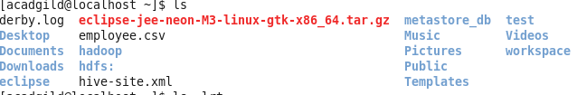







15.which -used to identify the location of executables.

