**Assignment2.3**

**Problem Statement**

Write a program to implement wordcount using Pig.

Share the screenshots of the commands used with its associated output.









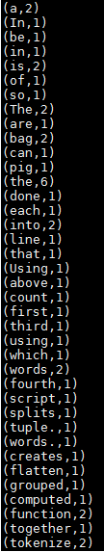



The above pig script, first splits each line into words using the TOKENIZE operator. The tokenize function creates a bag of words. Using the FLATTEN function, the bag is converted into a tuple. In the third statement, the words are grouped together so that the count can be computed which is done in fourth statement.