**ASSIGNMENT 3.4**

**Problem Statement**

**Get a list of employees who receive a salary less than 100, compared to their immediate employee with higher salary in the same unit**

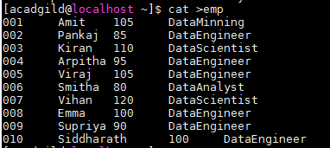

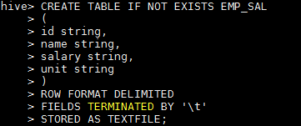

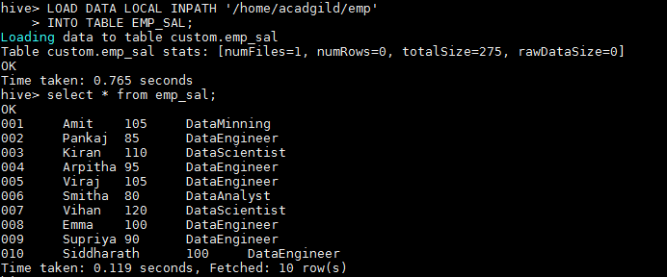

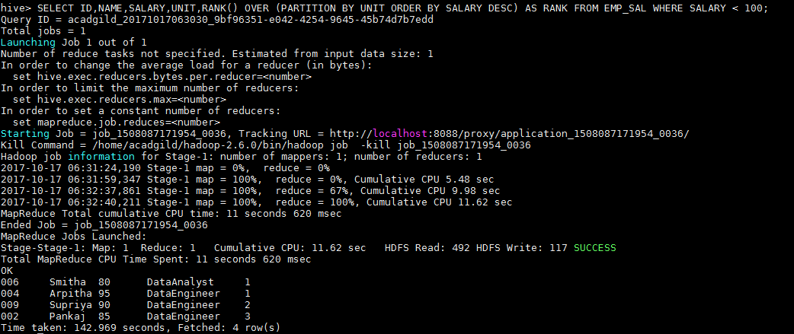

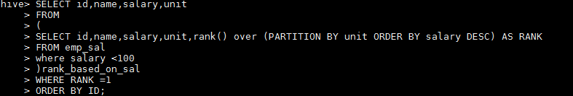



**List of all employees who draw higher salary than the average salary of that department**

