**Assignment4.1**

**Problem Statement**

Implement the concept given in below blog link and share the complete steps along withscreenshots.

<https://acadgild.com/blog/oozie-job-scheduling-in-hive/>

To schedule Hive job using Oozie, you need to write a Hive-action. Your Oozie job will consist of mainly three things.

1. workflow.xml
2. job.properties
3. Hive script

Job.properties

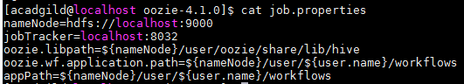

Workflow.xml

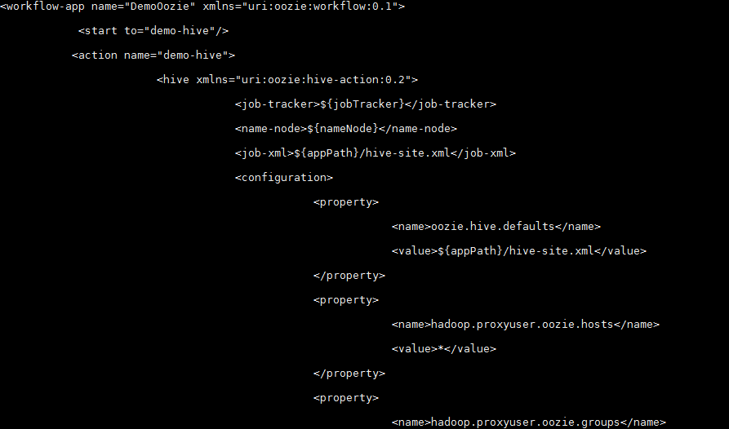

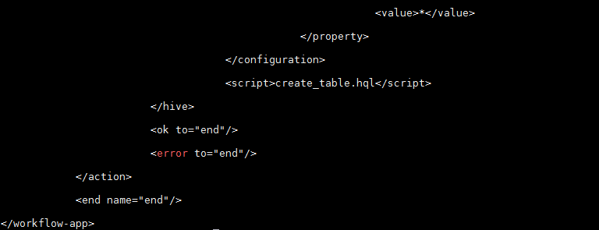

create_table.hql

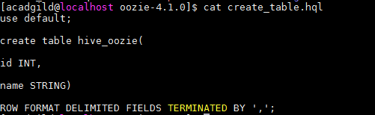

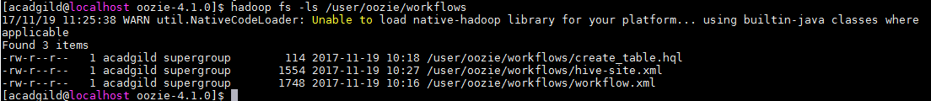



Unable to adduser ..

<http://127.0.0.1:11000/oozie/>