**Assignment4.2**

**Problem Statement**

**Implement the concept given in below blog link and share the complete steps along with**

**screenshots.**

[**https://acadgild.com/blog/loading-data-into-hbase-using-pig-scripts/**](https://acadgild.com/blog/loading-data-into-hbase-using-pig-scripts/)

**DataSet:**

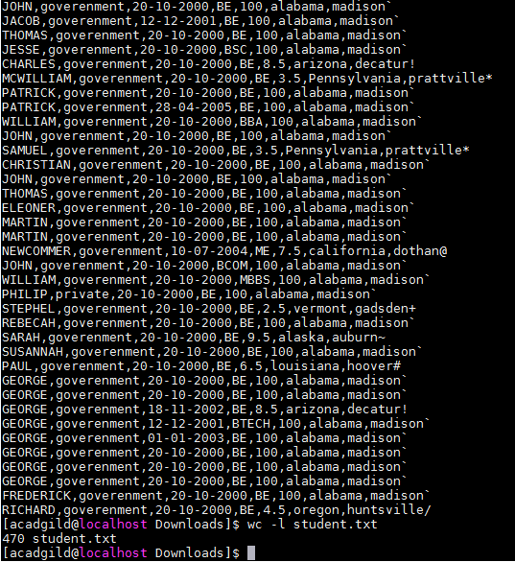

**We will be copying the data set in to HDFS which will be further loaded into HBase.**



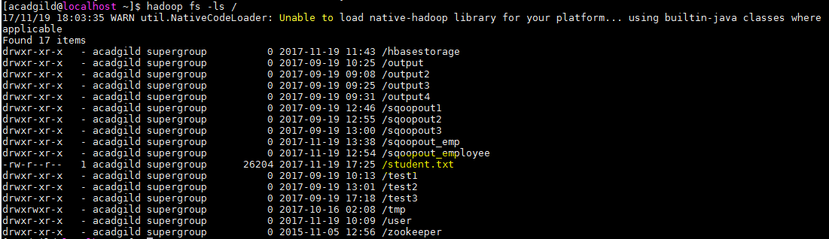

**We will be including few jar files of HBase to the Pig classpath.**



**We will now start HBase shell and create a table.**

**We only need this table as skeleton so PIG can Store data inside this by referring the table name.**

