**Assignment4.7**

**Problem Statement**

**Given a list of strings - List[String] (“alpha”, “gamma”, “omega”, “zeta”, “beta”)**

**1. find count of all strings with length 4**

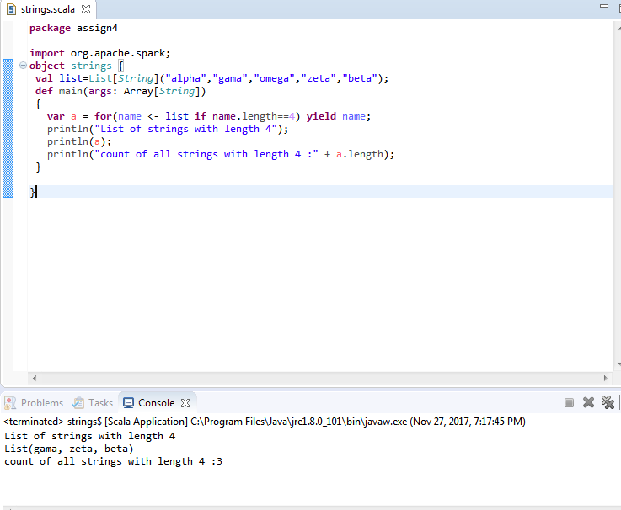

**2.convert the list of string to a list of integers, where each string is mapped to its**

**corresponding length**

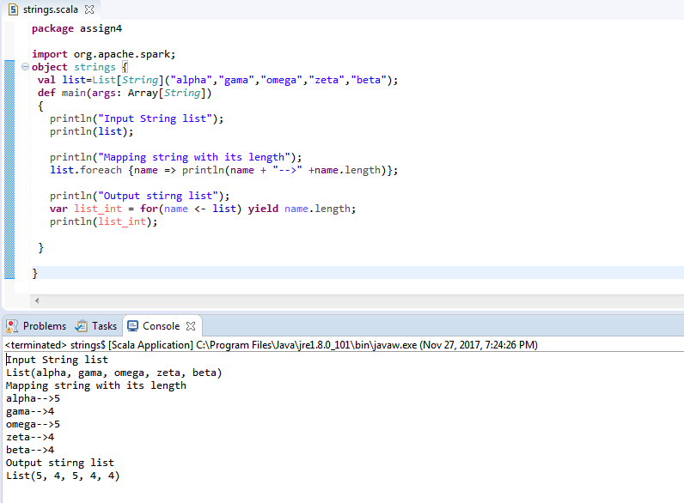

**3. find count of all strings which contain alphabet ‘m’**

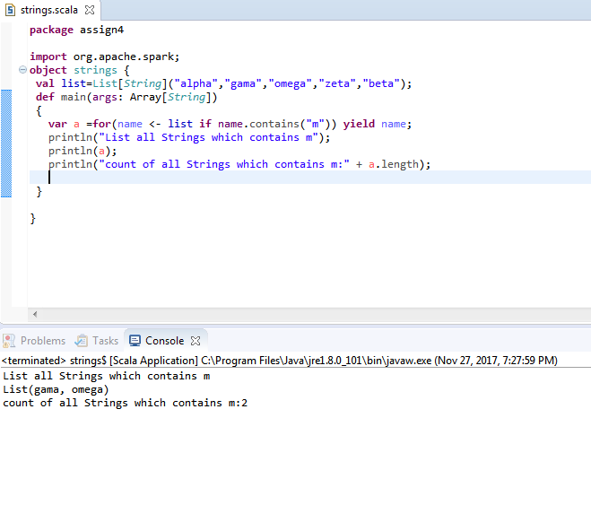

**4. find the count of all strings which start with the alphabet ‘a’**

