**Assignment5.2**

**Problem Statement**

**A Fibonacci series (starting from 1) written in order without any spaces in between, thus**

**producing a sequence of digits.**

**Write a Scala application to find the Nth digit in the sequence.**

**○ Write the function using standard for loop**

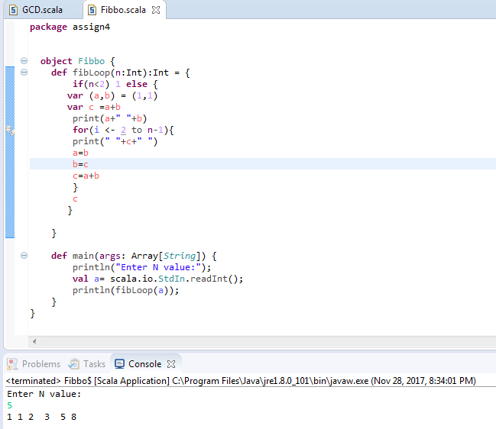

**○ Write the function using recursion**

