**Assignment5.5**

**Problem Statement**

1.Write a simple program to show inheritance in scala.

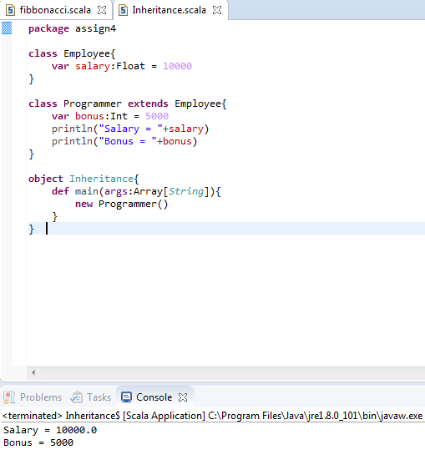

2.Write a simple program to show multiple inheritance in scala.

You can achieve multiple inheritances by using trait.

