**Assignment 4**

**Task1:**

**Create a file max-temp.txt in local FS.**

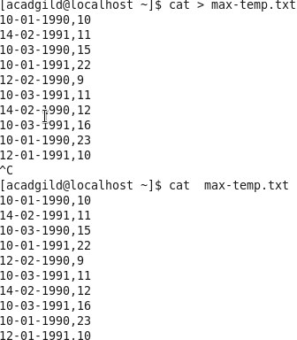

**Move this file to HDFS at /user/acadgild/hadoop.**



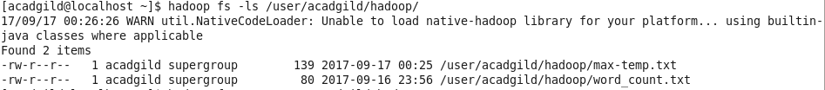

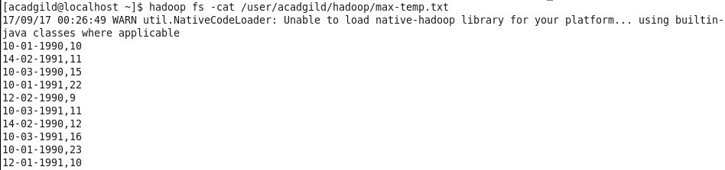

**Tasks:2**

**Change the permission of the file /user/acadgild/hadoop/max-temp.txt, such that**

**only the owner and the group members have full control over the file.**

**Others do not have any control over it.**

