**Assignment2.1**

**1) Write a java code with the class named ‘acad’ and a method ‘main’. Hard Code the program**

**with two integers and print the sum of those two.**

acad.java

class acad

{

public static void main(String args[])

{

int x=10,y=20,z;

z=x+y;

System.out.println("The Sum of X: "+x+" and Y: "+y+" is = "+z);

}

}

OUTPUT:

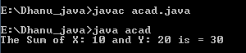

………………………………………………………………………………………………………………………………………………………….

**2) Rewrite the above code, where, inputs are provided by the user at runtime and the output is**

**printed.**

acad.java

import java.util.Scanner;

class acad

{

public static void main(String args[])

{

int x,y,z;

System.out.println("Enter the two numbers to perform addition");

Scanner in =new Scanner(System.in);

x=in.nextInt();

y=in.nextInt();

z=x+y;

System.out.println("The Sum of X: "+x+" and Y: "+y+" is = "+z);

}

}

OUTPUT:

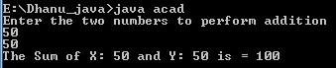

...........................................................................................................................................................

**3) Write a program with method name sum() that accepts two parameters from user and print**

**the sum of two numbers. Output format should be as:**

**First number is:**

**Second number is:**

**Sum is:**

acad.java

import java.util.Scanner;

class acad

{

public static void main(String[] arg)

{

int a,b,c;

Scanner sc=new Scanner(System.in);

System.out.println("Enter first number");

a=sc.nextInt();

System.out.println("Enter second number");

b=sc.nextInt();

c=sum(a,b);

System.out.println("Frist number is :" +a);

System.out.println("Second number is :" +b);

System.out.println("Sum of two numbers is : "+c);

}

static int sum(int x,int y)

{

return x+y;

}

}

OUTPUT:

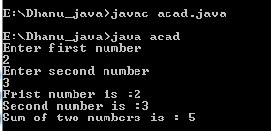

...................................................................................................................................................

**4) Write a program to accepts two numbers from stdin and find all the odd as well as even**

**numbers present in between them.**

import java.util.Scanner;

class Even_Odd

{

public static void main(String[] args)

{

int x,y;

Scanner s = new Scanner(System.in);

System.out.print("Enter the first number :");

x = s.nextInt();

System.out.print("Enter the Second number :");

y = s.nextInt();

System.out.print("Odd numbers:");

for(int i = x ; i < y ; i++)

{

if(i % 2 != 0)

{

System.out.print(i+" ");

}

}

System.out.println("");

System.out.print("Even numbers:");

for(int i = x ; i < y ; i++)

{

if(i % 2 == 0)

{

System.out.print(i+" ");

}

}

}

}

OUTPUT:

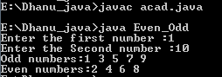

………………………………………………………………………………………………………………………………………………….

**5) Joe is scared to go to school. When her dad asked the reason, joe said she is unable to**

**complete the task given by her teacher. The task was to find the “first 10 multiples” of the**

**number entered from stdin . Eg:**

**Input: 3**

**O/p:**

**3 x 1 = 3**

**3 x 2 = 6**

**………**

**………**

**…….**

**….**

**3 x 10 = 30**

**Help Joe in completing the task!**

import java.util.Scanner;

class MultiTable

{

public static void main(String args[])

{

int n, c;

System.out.println("Enter an integer to print it's multiplication table");

Scanner in = new Scanner(System.in);

n = in.nextInt();

System.out.println("Multiplication table of "+n+" is :-");

for ( c = 1 ; c <= 10 ; c++ )

System.out.println(n+"*"+c+" = "+(n*c));

}

}

OUTPUT:

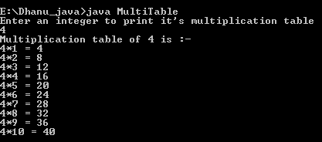

…………………………………………………………………………………………………………………………………………………….

**6) Write a program consisting method sum() and demonstrate the concept of method**

**overloading using this method.**

import java.util.Scanner;

class Sum

{

void add(int a, int b)

{

System.out.println("Sum of " +a+ " and " +b+ " is " +(a+b));

}

void add(int a, int b,float c)

{

System.out.println("Sum of " +a+ "," +b+ "," +c+ "is" +(a+b+c));

}

}

class Demo

{

public static void main(String args[])

{

int x,y;

float z;

Scanner s = new Scanner(System.in);

System.out.print("Enter the first number :");

x = s.nextInt();

System.out.print("Enter the Second number :");

y = s.nextInt();

System.out.print("Enter the Second number :");

z = s.nextFloat();

Sum n=new Sum();

n.add(x,y); //Function with two integer parameters

n.add(x,y,z); //Function with different data type

}

}

OUTPUT:

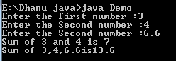

……………………………………………………………………………………………………………………………………………………

**7) Can you overload a method with same return type.? Explain your answer with proper logic.**

No we can’t overload a method with same return type.

*A very simple rule exists for the signature of the methods in java:*

Method signature only includes the name of the method + input parameter(s).So the return type of the method is not included in the method signature.

*On the other hand overloading means:*

Having two or more mathods in a class with the exact same name but different parameter types or different number of parameters or both.

Compiler does not indicate the return types of your methods, so can not understand the difference between two show methods with two int parameters. Same mistake happens for your two show methods without parameters.

Example:

class HelloWorld{

static int show()

{

int c = 5+10;

System.out.println("hello");

return c;

}

static void show()

{

int c = 5+10;

System.out.println("void"+c);

}

static int show(int a,int b)

{

int c = a+b;

System.out.println("hello");

return c;

}

static void show(int a,int b)

{

int c = a+b;

System.out.println("hello void args"+c);

}

public static void main(String []args){

int a=5,b=5;

int c=show();

System.out.println("hello"+c);

show();

c= show(a,b);

System.out.println("hello"+c);

show(a,b);

}

}

OUTPUT

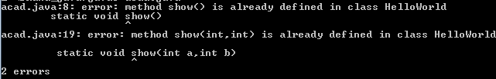

…………………………………………………………………………………………………………………………………………………………………

**8) Write a program in java using Arrays, that sorts the element in descending order.**

import java.util.Scanner;

class Descending_Order

{

public static void main(String[] args)

{

int n, temp;

Scanner s = new Scanner(System.in);

System.out.print("Enter no. of elements you want in array:");

n = s.nextInt();

int a[] = new int[n];

System.out.println("Enter all the elements:");

for (int i = 0; i < n; i++)

{

a[i] = s.nextInt();

}

for (int i = 0; i < n; i++)

{

for (int j = i + 1; j < n; j++)

{

if (a[i] < a[j])

{

temp = a[i];

a[i] = a[j];

a[j] = temp;

}

}

}

System.out.print("Descending Order:");

for (int i = 0; i < n - 1; i++)

{

System.out.print(a[i] + ",");

}

System.out.print(a[n - 1]);

}

}

OUTPUT

