**Assignment2.2**

**Problem Statement**

Create a sample dataset and implement the below Pig commands on the same dataset.

1) Concat

2) Tokenize

3) Sum

4) Min

5) Max

6) Limit

7) Store

8) Distinct

9) Flatten

10) IsEmpty

**Sample Dataset**

**student_data.txt**

001,Rajiv,Reddy,21,9848022337,Hyderabad,89

002,siddarth,Battacharya,22,9848022338,Kolkata,78

003,Rajesh,Khanna,22,9848022339,Delhi,90

004,Preethi,Agarwal,21,9848022330,Pune,93

005,Trupthi,Mohanthy,23,9848022336,Bhuwaneshwar,75

006,Archana,Mishra,23,9848022335,Chennai,87

007,Komal,Nayak,24,9848022334,trivendram,83

008,Bharathi,Nambiayar,24,9848022333,Chennai,72

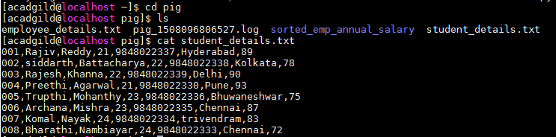

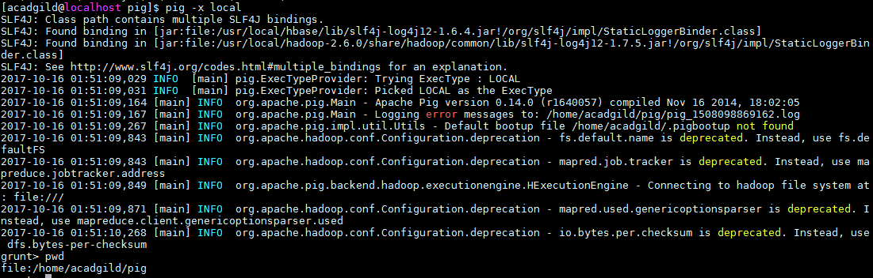





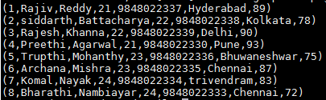



**1) Concat**





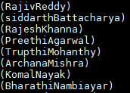





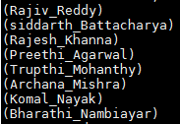

**2) Tokenize**



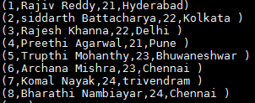





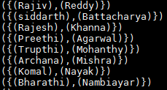











**3) Sum**



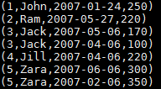











**4) Min**



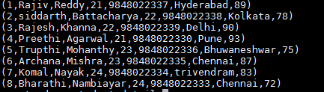











**5) Max**









**6) Limit**



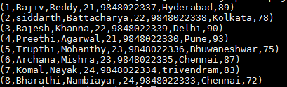



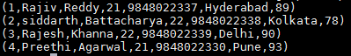

**7) Store**





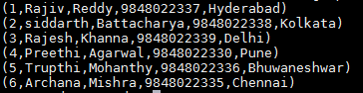

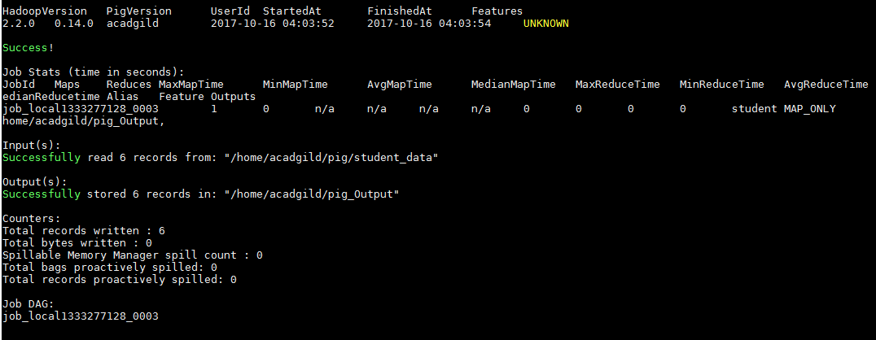

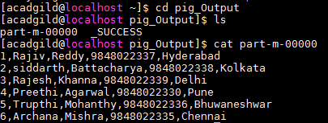

**8) Distinct**



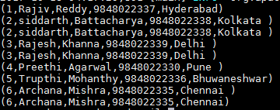





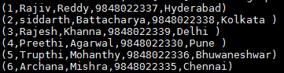

**9) Flatten**

















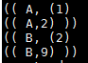

**10) IsEmpty**



















