**Assignment2.6**

**Problem Statement**

Implement the use case present in below blog link and share the complete steps along with

screenshot(s) from your end.

[**https://acadgild.com/blog/pig-use-case-pokemon-data-analysis/**](https://acadgild.com/blog/pig-use-case-pokemon-data-analysis/)

**DATASET**:

Pokemon.csv



**Ques 1: Find the list of players that have been selected in the qualifying round (DEFENCE>55).**



The dataset is filtered, and hence out of all the 800 Pokémons, only 544 are eligible to take part in the tournament

**Ques 2: State the number of players taking part in the competition after getting selected in the qualifying round.**





So, All the 544 players taking part will be alphabetically arranged and two teams of 5 Pokémons need to be extracted out randomly from the earlier list.

Seems like,this way we will have 2 lists containing 5 Pokémon each so to fight each other.

**Ques 3: Using random() generate random numbers for each Pokémon on the selected list.**



Hence sample for the list after adding random numbers:

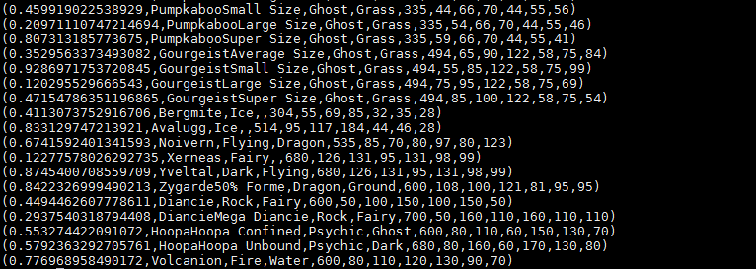

**Ques 4: Arrange the new list in a descending order according to a column randomly.**

This will give us consequently a layer arranged to pick the random list which 1st player will choose.



Hence the sample for the list after the query.

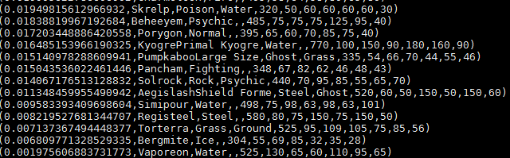

Yet we want 1 more list with random arrangements of Pokémons which will be therefore chosen by the 2nd player later on.

**Ques 5: Now on a new relation again associate random numbers for each Pokémon and arrange in descending order according to column random.**

We will be repeating above two steps again to form the 2nd list.



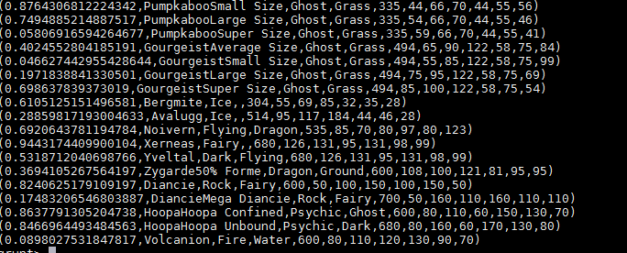



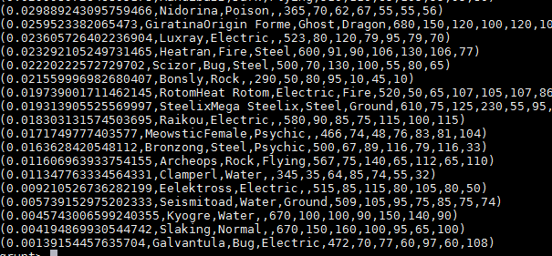

**Ques: From the two different descending lists of random Pokémons, select the top 5 Pokémons for 2 different players.**



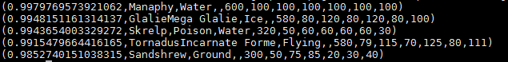



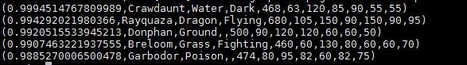

**Ques: Store the data on a local drive to announce for the final match. By the name player1 and player2 (only show the NAME and HP).**



