**Assignment2.8**

**Problem Statement**

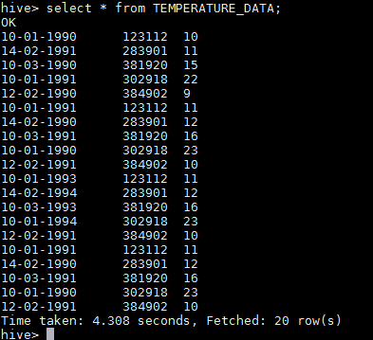

1.Fetch date and temperature from temperature_data where zip code is greater than300000 and less than 399999.

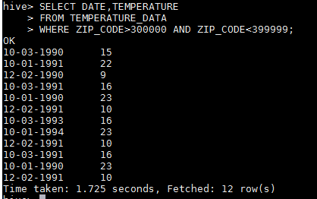

2.Calculate maximum temperature corresponding to every year from temperature_datatable.

USING GROUP_BY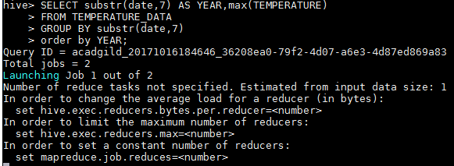

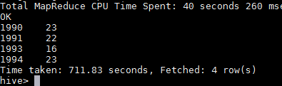

USING WINDOWING_FUNCTION



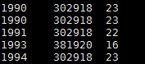

3.Calculate maximum temperature from temperature_data table corresponding to those years which have at least 2 entries in the table.





4.Create a view on the top of last query, name it temperature_data_vw.

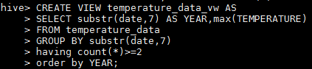





5.Export contents from temperature_data_vw to a file in local file system, such that eachfile is '|' delimited.



