**ASSIGNMENT 3.2**

**Problem Statement**

**1.Write a Hive program to find the number of medals won by each country in swimming.**

**2.Write a Hive program to find the number of medals that India won year wise.**

**3.Write a Hive Program to find the total number of medals each country won.**

**4.Write a Hive program to find the number of gold medals each country won.**

**DATE SET**

Olympix_data.csv

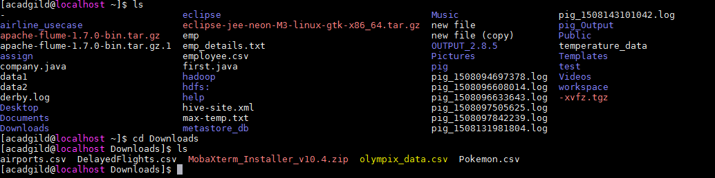

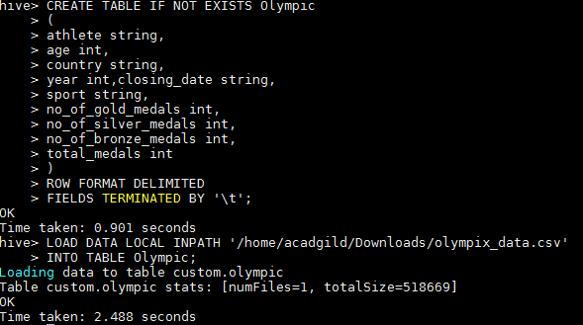

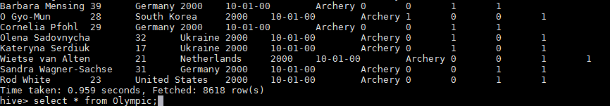

**1.Write a Hive program to find the number of medals won by each country in swimming.**



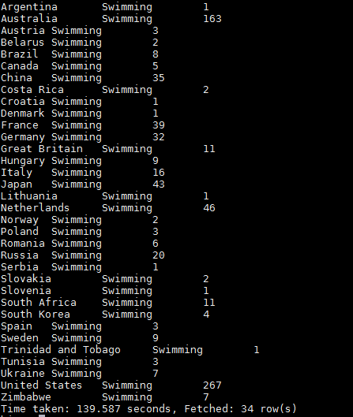

OR



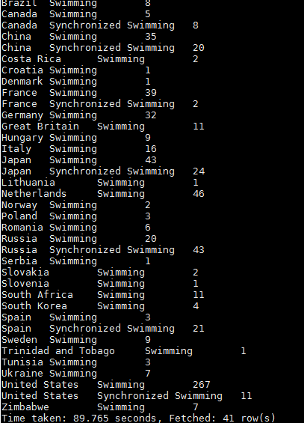

**2.Write a Hive program to find the number of medals that India won year wise.**





**3.Write a Hive Program to find the total number of medals each country won.**



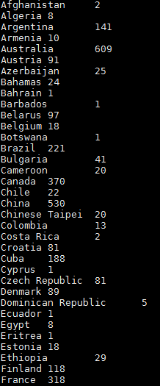

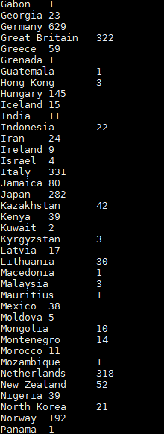

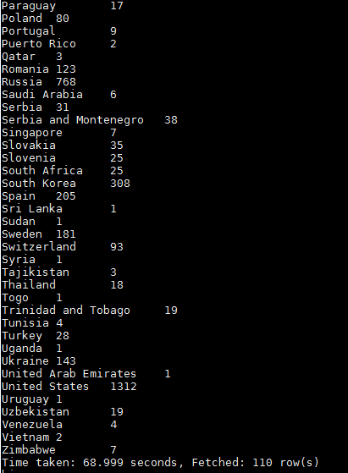

**4.Write a Hive program to find the number of gold medals each country won.**



