Assignment3.3
Problem Statement:
Explain the below concepts with an example in brief.
● Hive Data Definitions
● Hive Data Manipulations
● HiveQL Manipulations

Hive Data Definitions
Hive Data Definition Language (DDL) is a subset of Hive SQL statements that describe the data structure in Hive by creating, deleting, or altering schema objects such as databases, tables, views, partitions, and buckets. Most HIVE DDL statements start with keywords CREATE,DROP, or ALTER. The syntax of hive DDL is very similar to the DDL in SQL. There are two types of DDLs in Hive: database level and table level.
Create Database
The Create Database statement is used to create a database in Hive. By default, there is a database in Hive named default.
Syntax:
CREATE (DATABASE|SCHEMA) [IF NOT EXISTS] database_name
[COMMENT database_comment]
[LOCATION hdfs_path]
[WITH DBPROPERTIES (property_name=property_value, ...)];
Example:
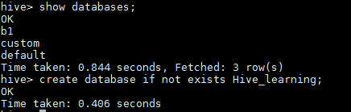

Drop Database
Drop Database statements drop the database and the objects inside that database. When a database is dropped, its directory is also deleted.
Syntax:
DROP (DATABASE|SCHEMA) [IF EXISTS] database_name [RESTRICT|CASCADE];
Example:
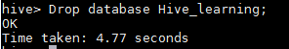
ALTER DATABASE
The ALTER DATABASE command in Hive is used to alter dbproperties or set the dbproperties of a database. Using the ALTER DATABASE command, we can only alter dbproperties and nothing else (not even the name and directory location of a database can be altered). No other metadata about the database can be changed.
Syntax:
ALTER (DATABASE|SCHEMA) database_name SET DBPROPERTIES (property_name=property_value, ...);
USE DATABASE
The USE DATABASE command is used to switch to the database, or it sets the database as the working database. It is analogous to the one used in the other RDBMS.
Syntax:
USE (DATABASE|SCHEMA) database_name;
SHOW DATABASE
The SHOW DATABASE command is used to list all the databases in the Hive metastore.
Syntax:
SHOW (DATABASES|SCHEMAS) [LIKE identifier_with_wildcards];
DESCRIBE DATABASE
The DESCRIBE DATABASE command is used to get information about the database, such as the name of the database, its comment (if attached during the creation of the database), its location on the filesystem, and its dbproperties.
Syntax:
DESCRIBE DATABASE [EXTENDED] db_name;
DESCRIBE SCHEMA [EXTENDED] db_name;
Example:
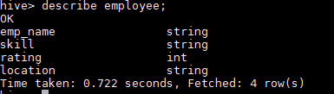
CREATE TABLE
The CREATE TABLE statement creates metadata in the database. The table in Hive is the way to read data from files present in HDFS in the table or a structural format.
Syntax:
CREATE [TEMPORARY] [EXTERNAL] TABLE [IF NOT EXISTS]
[db_name.] table_name
[(col_name data_type [COMMENT col_comment], ...)]
[COMMENT table_comment]
[PARTITIONED BY (col_name data_type [COMMENT col_comment], ...)]
[CLUSTERED BY (col_name, col_name, ...) [SORTED BY (col_name [ASC|DESC], ...)] INTO num_buckets BUCKETS]
[SKEWED BY (col_name, col_name, ...)
ON ((col_value, col_value, ...), (col_value, col_value, ...), ...)
[STORED AS DIRECTORIES]
[
[ROW FORMAT row_format]
[STORED AS file_format]
| STORED BY 'storage.handler.class.name' [WITH SERDEPROPERTIES (...)]
]
[LOCATION hdfs_path]
[TBLPROPERTIES (property_name=property_value, ...)]
[AS select_statement];
Example:
CREATE TABLE IF NOT EXISTS EMPLOYEE
(
emp_name String,
skill String,
rating int,
location String
)
ROW FORMAT DELIMITED
FIELDS TERMINATED BY ',';
DROP TABLE
DROP TABLE command removes the table from the database, including the data from the table. This is equivalent to the SQL DROP command, but the only difference is that the data is moved to the Trash folder in the home directory (if Trash is configured). If Trash is not configured, data is removed from the filesystem as well and is lost forever.
Syntax:
DROP TABLE [IF EXISTS] table_name [PURGE];
TRUNCATE
The TRUNCATE command removes all rows from the table as well as from the partition, but keeps the table structure as it is. Truncating a table in Hive is indirectly removing the files from the HDFS as a table in Hive is just a way of reading the data from the HDFS in the table or structural format.
Syntax:
TRUNCATE TABLE table_name [PARTITION partition_spec];
The ALTER TABLE properties command alters the table properties.
Syntax:
ALTER TABLE table_name SET TBLPROPERTIES table_properties;
View
A view is a virtual table that acts as a window to the data for the underlying table commonly known as the base table. It consists of rows and columns but no physical data. So when a view is accessed, the underlying base table is queried for the output.
Syntax:
CREATE VIEW [IF NOT EXISTS] view_name [(column_name [COMMENT column_comment], ...)]
[COMMENT view_comment]
[TBLPROPERTIES (property_name = property_value, ...)]
AS SELECT ...;
Example:
CREATE VIEW temperature_data_vw AS
SELECT substr(date,7) AS YEAR,max(TEMPERATURE)
FROM temperature_data
GROUP BY substr(date,7)
having count(*)>=2
order by YEAR;
The DROP VIEW command removes the view from the database. It removes the metadata, but the base table remains intact. If a base table is a view that is dropped, then the dependent view remains in an invalid state, which is either dropped or recreated.
Syntax:
DROP VIEW [IF EXISTS] view_name;
SHOW TABLES
This command lists all the tables and views in a database. We can also use wildcards for listing specific tables.
SHOW TABLES [IN database_name] ['identifier_with_wildcards'];
Hive Data Manipulations
Loading data into a Hive
Loading data into a Hive table is one of the variants of inserting data into a Hive table. In this method, the entire file is copied/moved to a directory that corresponds to Hive tables. If the table is partitioned, then data is loaded into partitions one at a time.
Syntax:
LOAD DATA [LOCAL] INPATH 'filepath' [OVERWRITE] INTO TABLE tablename [PARTITION (partcol1=val1, partcol2=val2 ...)]
Example:
LOAD DATA LOCAL INPATH '/home/acadgild/dataset_2.7.txt'
INTO TABLE TEMPERATURE_DATA;
Inserting data into Hive table
This is another variant of inserting data into a Hive table. Data can be appended into a Hive table that already contains data. Data can also be overwritten in the Hive table. Data can also be inserted into multiple tables through a single statement only.
Syntax:
INSERT OVERWRITE TABLE tablename [PARTITION (partcol1=val1, partcol2=val2 ...) [IF NOT EXISTS]] select select_statement FROM from_statement;
syntax of inserting data into multiple partitions is as follows:
FROM tablename
INSERT OVERWRITE TABLE tablename1 PARTITION(root_partition_name='value',child_partition_name)
SELECT select_statment;
Writing data into files from queries
Insert data into a file with the help of a query; that is, the output of a query to be saved into a file.
Syntax:
Standard syntax:
INSERT OVERWRITE [LOCAL] DIRECTORY directory1 [ROW FORMAT row_format] [STORED AS file_format]SELECT select_statment FROM from_statment.

Hive extension (multiple inserts):
FROM from_statement
INSERT OVERWRITE [LOCAL] DIRECTORY directory1 select_statement1
[INSERT OVERWRITE [LOCAL] DIRECTORY directory2 select_statement2] ...
Enabling transactions in Hive
to configure the Hive metastore to enable Atomicity, Consistency, Isolation, Durability (ACID) properties for a Hive table. Insert, Update and Delete are not possible in Hive until the ACID properties are not enabled. Also table must to be Bucketed in Hive if Insert, Update and Delete feature are to be used.Transactions including inserts, updates, and deletes are available from Hive 1.0.0 and above.
To allow the user to execute transactional commands, the user needs to configure the metastore with transactional tables.
Inserting values into tables from SQL
Inserting data into a Hive table through a SQL statement is the third variant of inserting data. This is the traditional way of inserting data into a table in any RDBMS. Inserting in a table through SQL statements can only be performed if the table supports ACID.
Syntax:
INSERT INTO TABLE table_name [PARTITION (partcol1[=val1], partcol2[=val2] ...)] VALUES values_row [, values_row ...]
Updating data
Updating data in a Hive table is the traditional way of updating data in a table in any RDBMS. Updating data in a table can only be performed if the table supports Atomicity, Consistency, Isolation, Durability (ACID) properties.
Syntax:
UPDATE tablename SET column = value [, column = value ...] [WHERE expression]
Deleting data
Deleting data from a Hive table is the traditional way of deleting data in a table in any RDBMS. Deleting data in a table can only be performed if the table supports ACID properties.
Syntax:
DELETE FROM tablename [WHERE expression]
HiveQL Manipulations
The Hive query language, focusing on the data manipulation language parts that are used to put data into tables and to extract data from tables to the filesystem.
To understand the Hive DML commands, let's see the employee and employee_department table first.

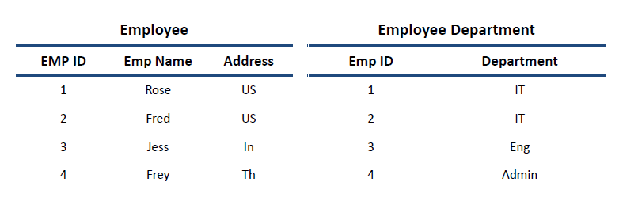
LOAD DATA
hive> LOAD DATA LOCAL INPATH './usr/Desktop/kv1.txt' OVERWRITE INTO TABLE Employee;
SELECTS and FILTERS
hive> SELECT E.EMP_ID FROM Employee E WHERE E.Address='US';
GROUP BY
hive> hive> SELECT E.EMP_ID FROM Employee E GROUP BY E.Addresss;

