Jenkins

## **What is Jenkins?**

Jenkins is an open source automation tool written in Java programming language that allows continuous integration.

**Pre-requisite**

Make sure set the path of Maven and JDK

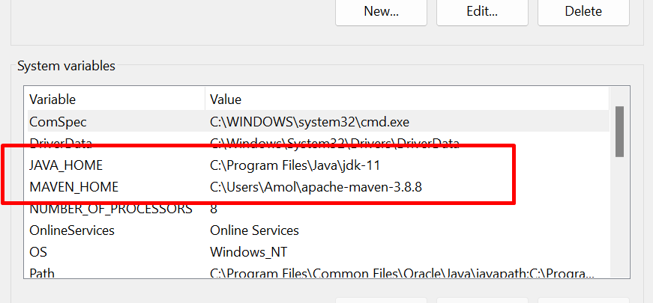

Download Jenkins

[**https://www.jenkins.io/download/**](https://www.jenkins.io/download/)

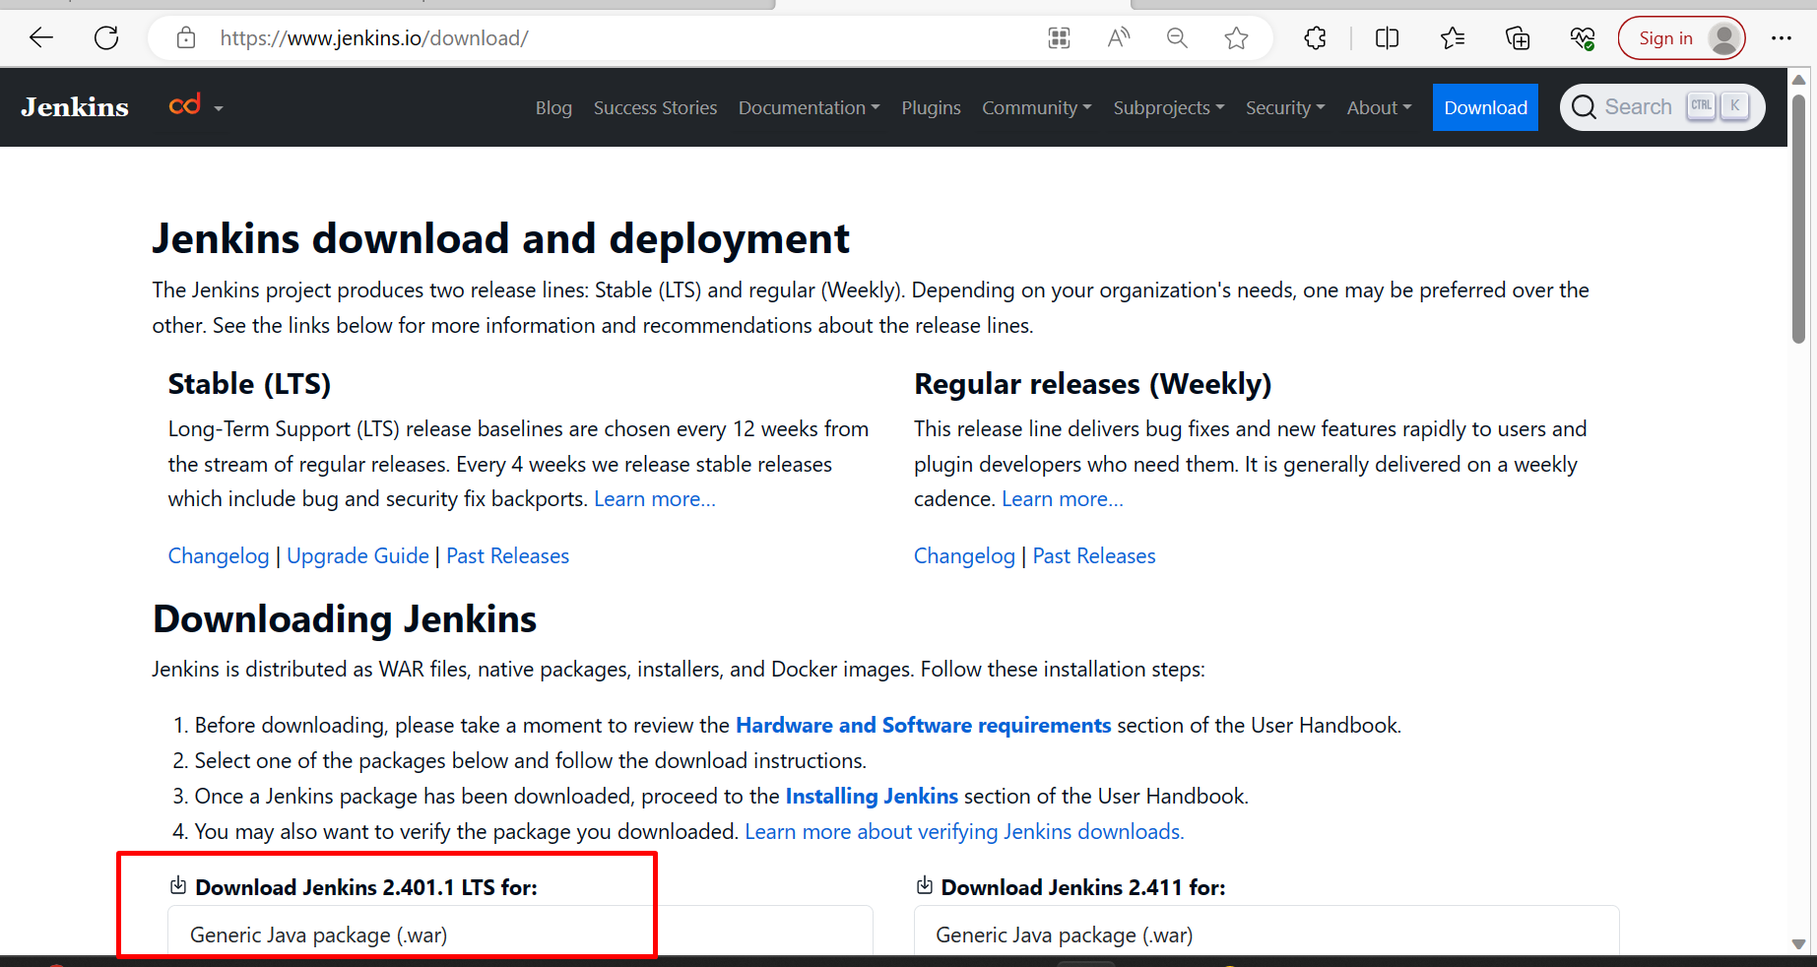

After that

Go to the command prompt

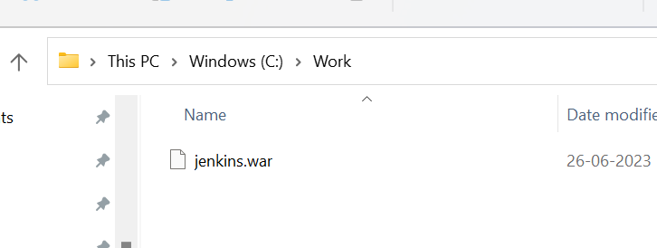

**java -jar jenkins.war -httpPort=8080**

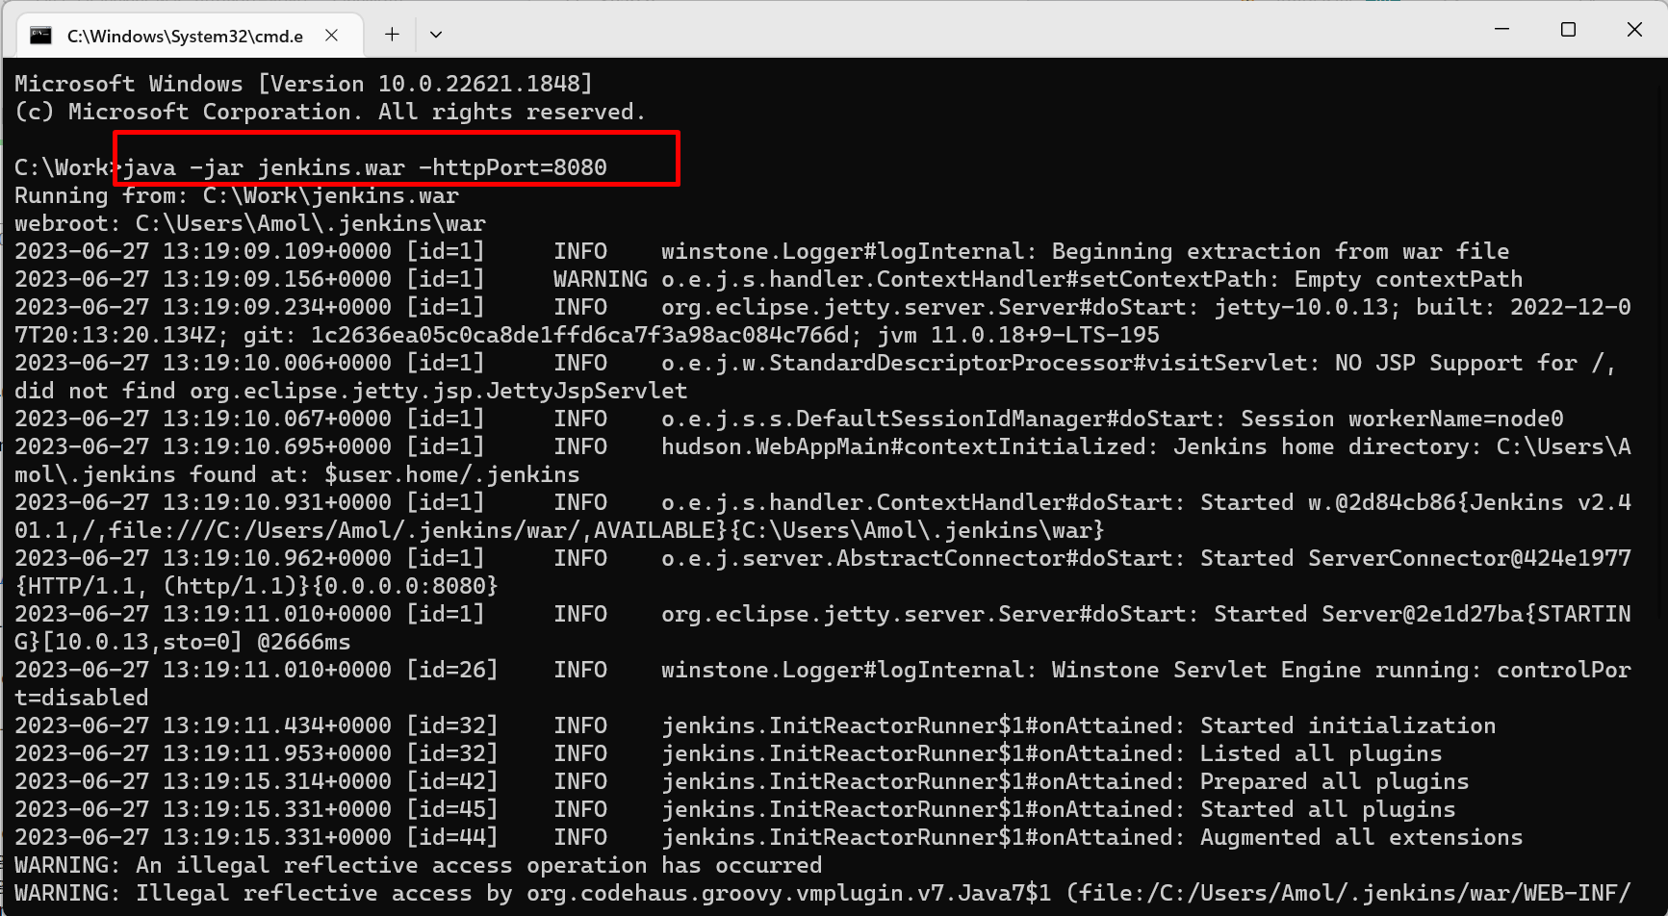

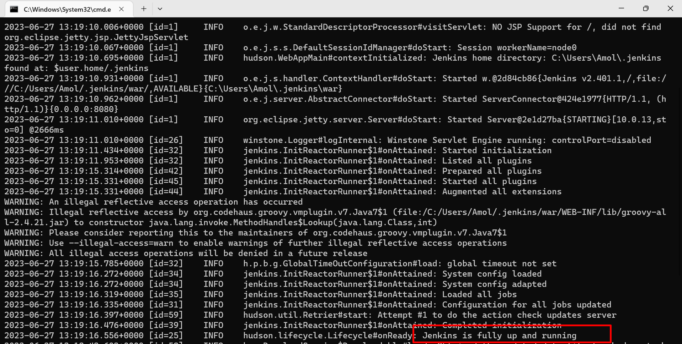

**http://localhost:8080/**

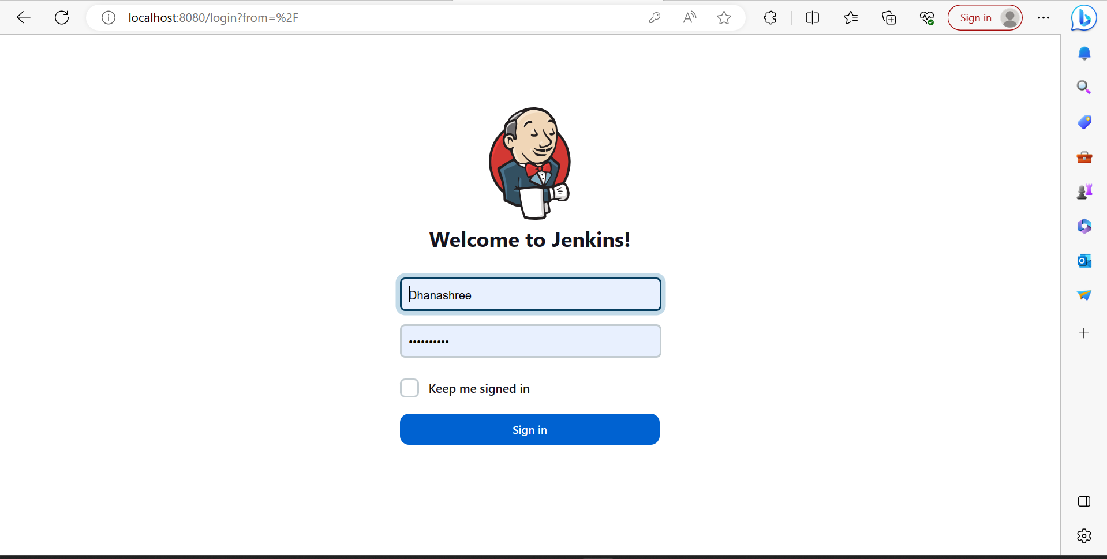

Go to Manage jenkins

Tools

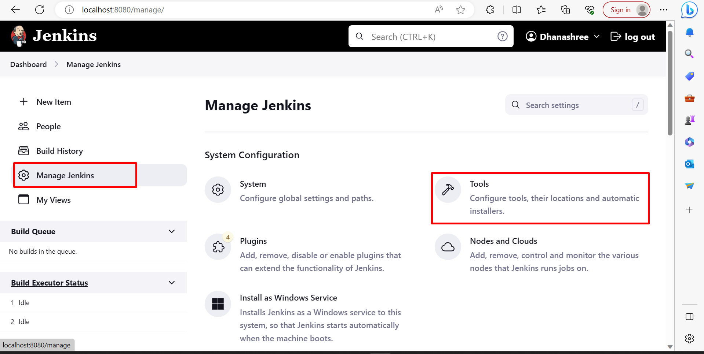

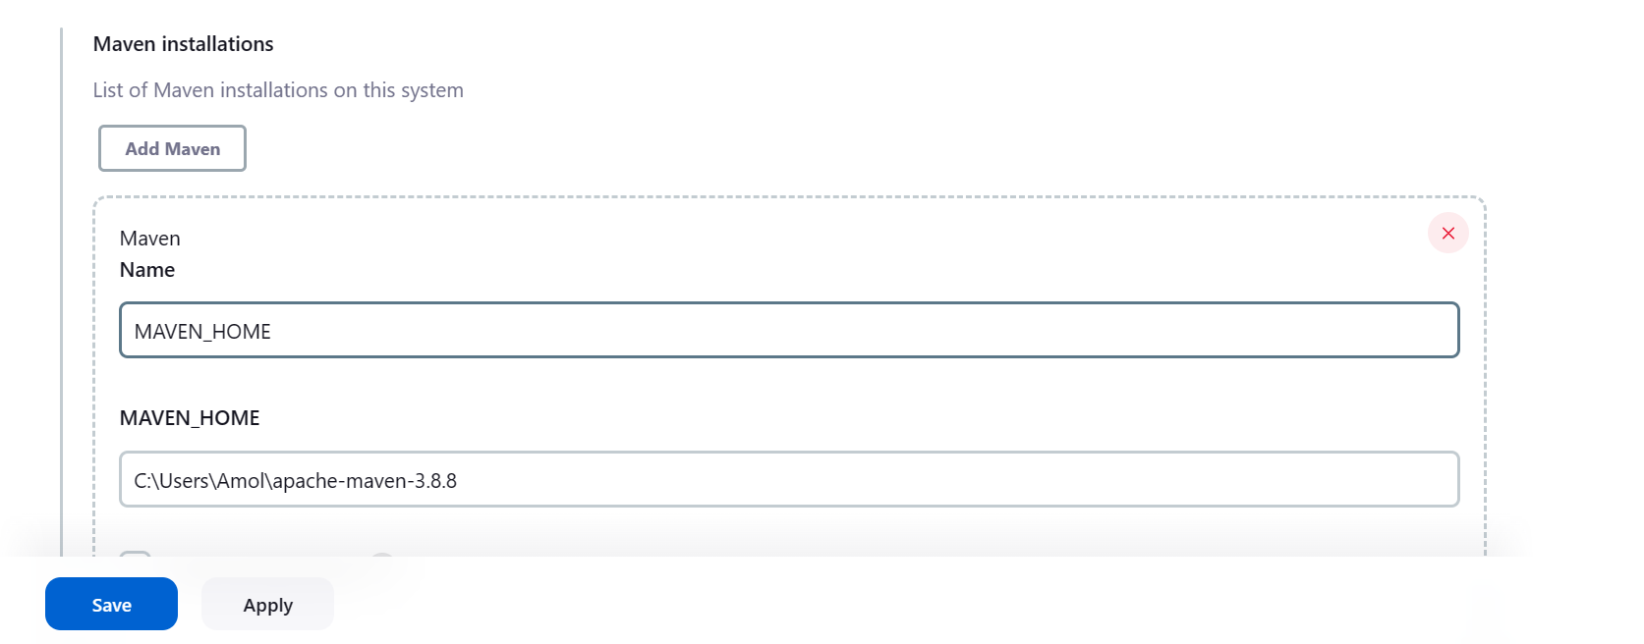

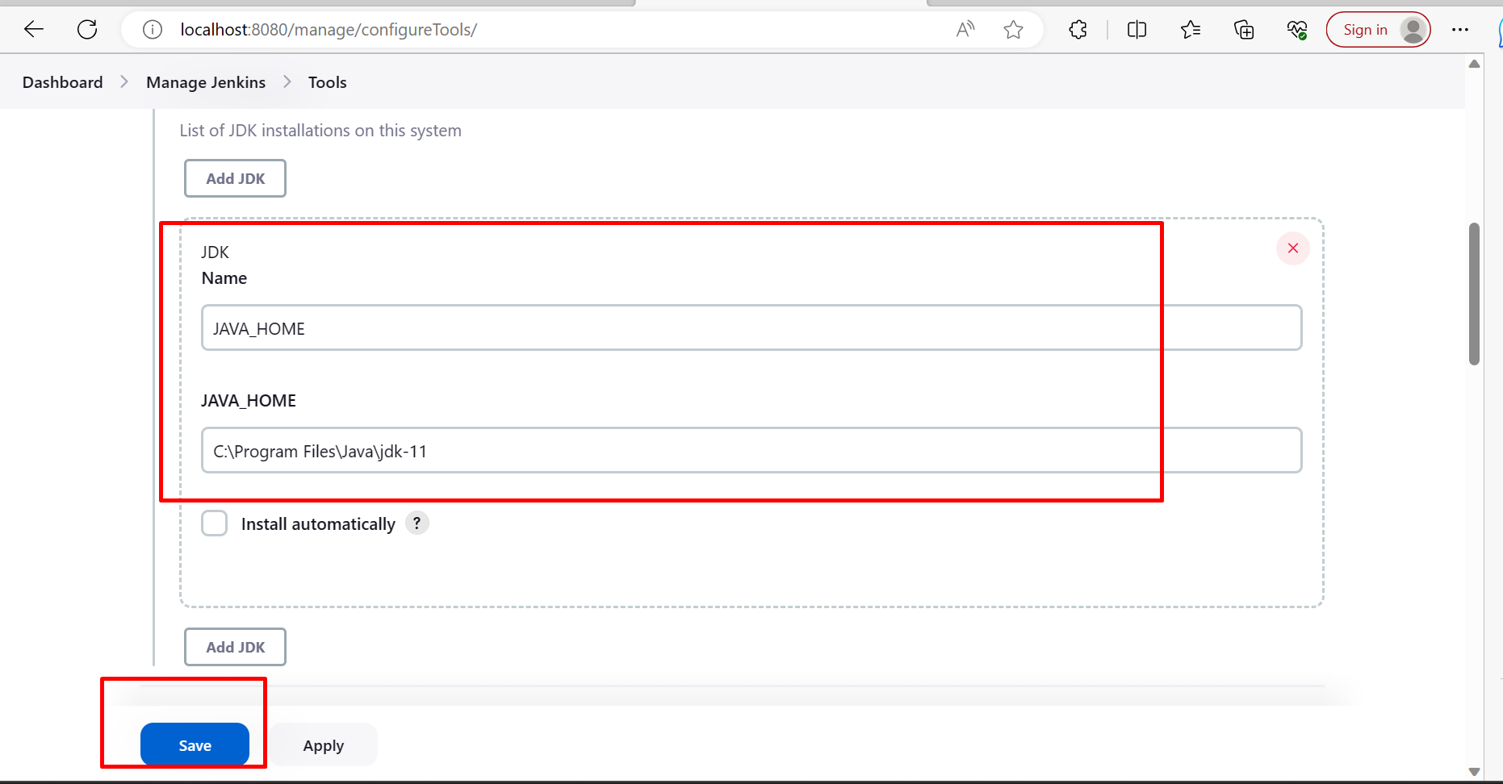

Click on New Item

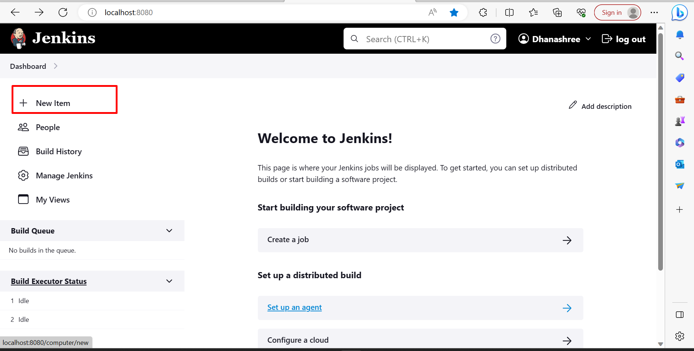

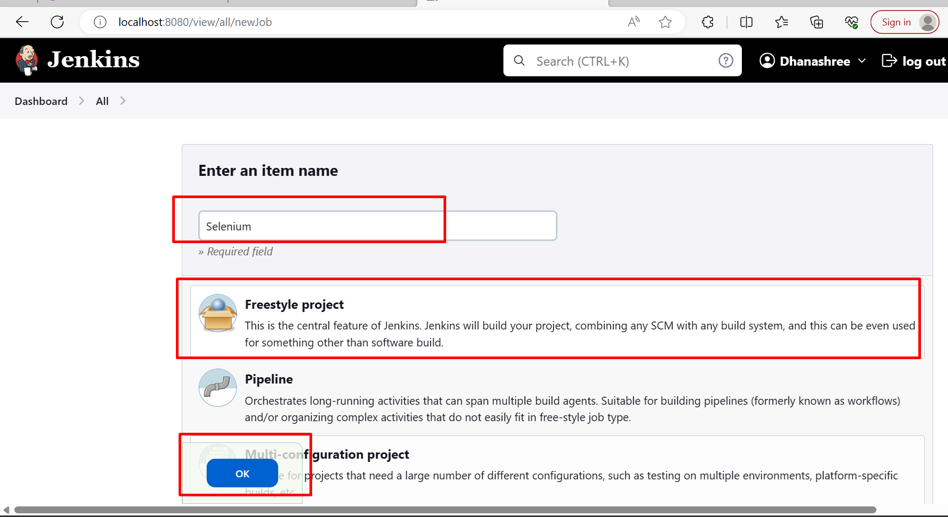

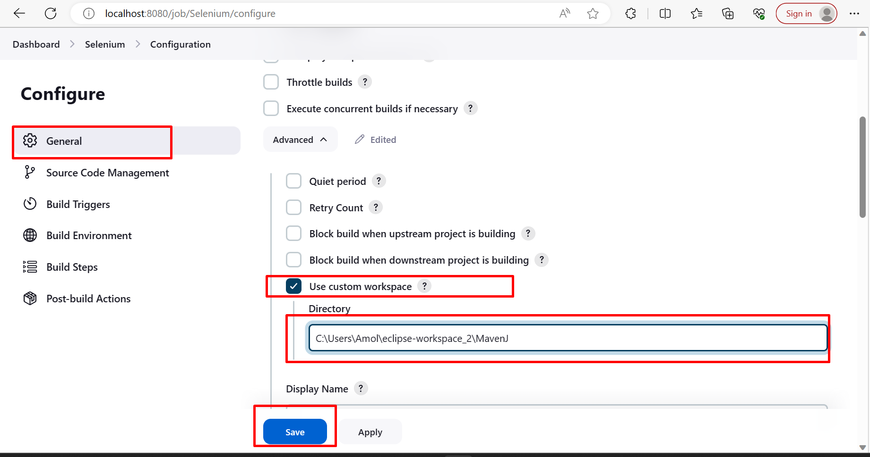

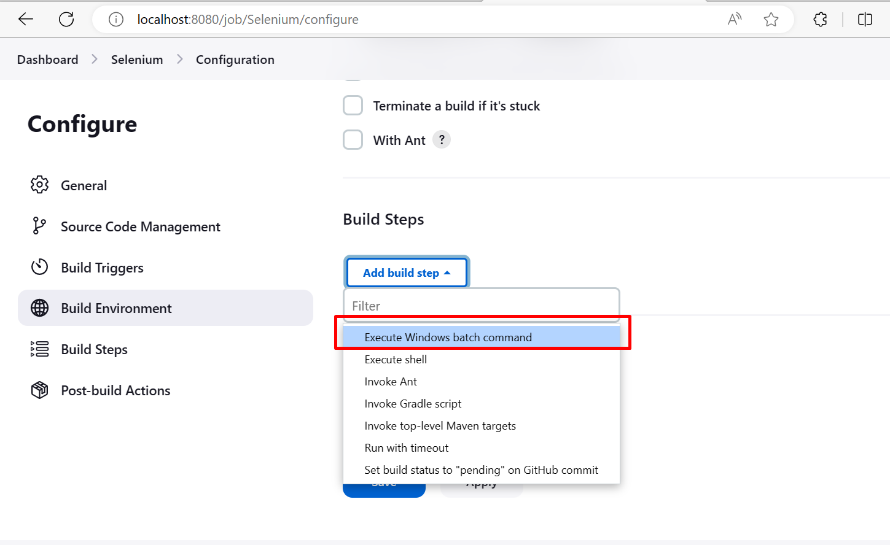

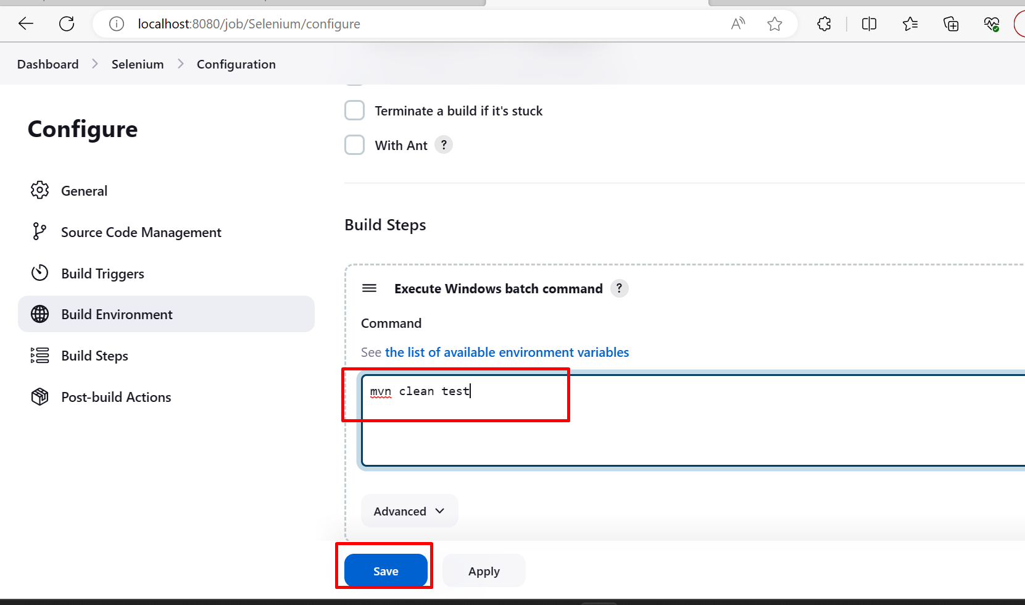

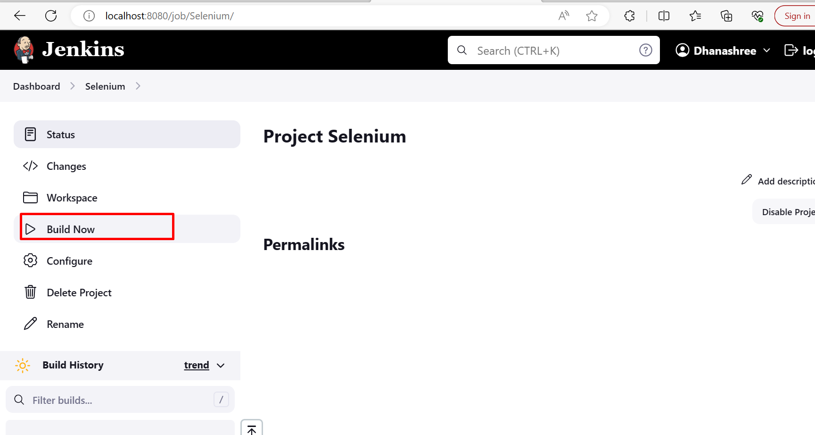

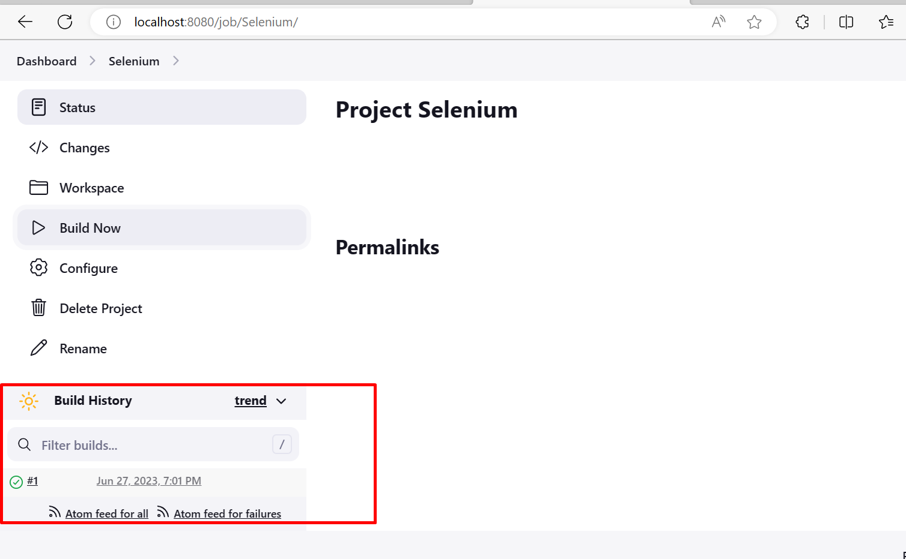

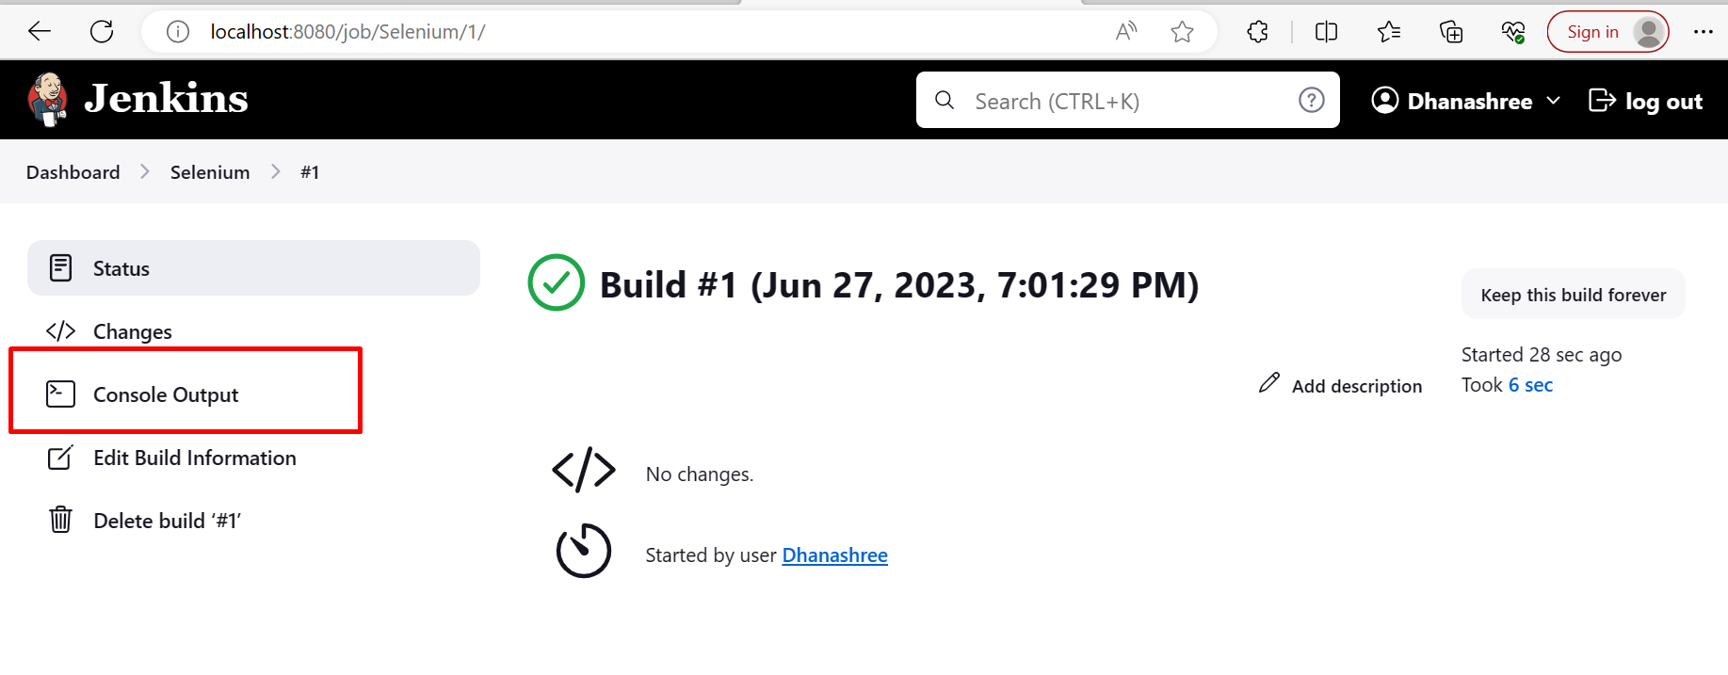

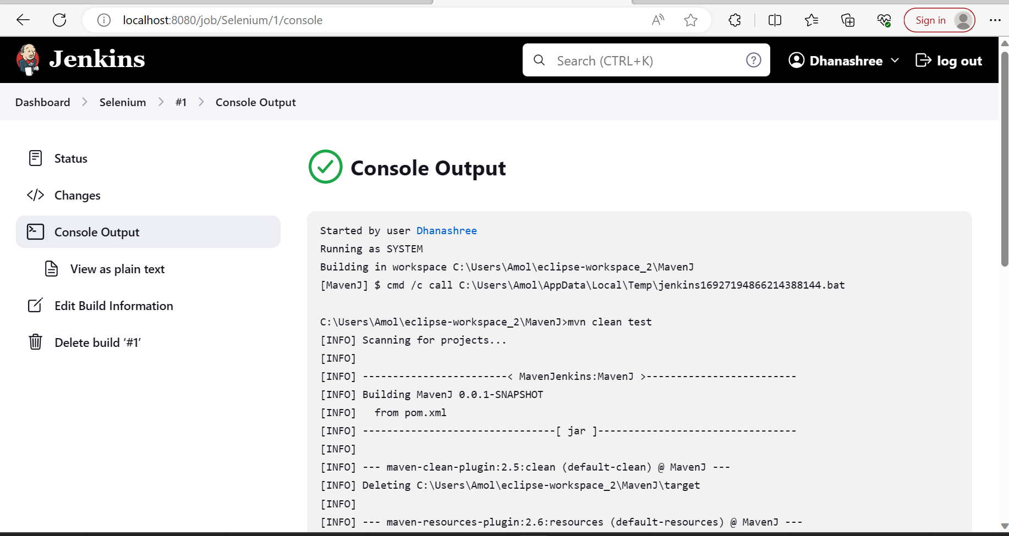

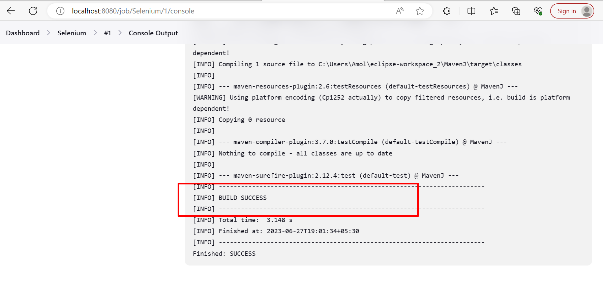

**How to Schedule a Jenkins Job**

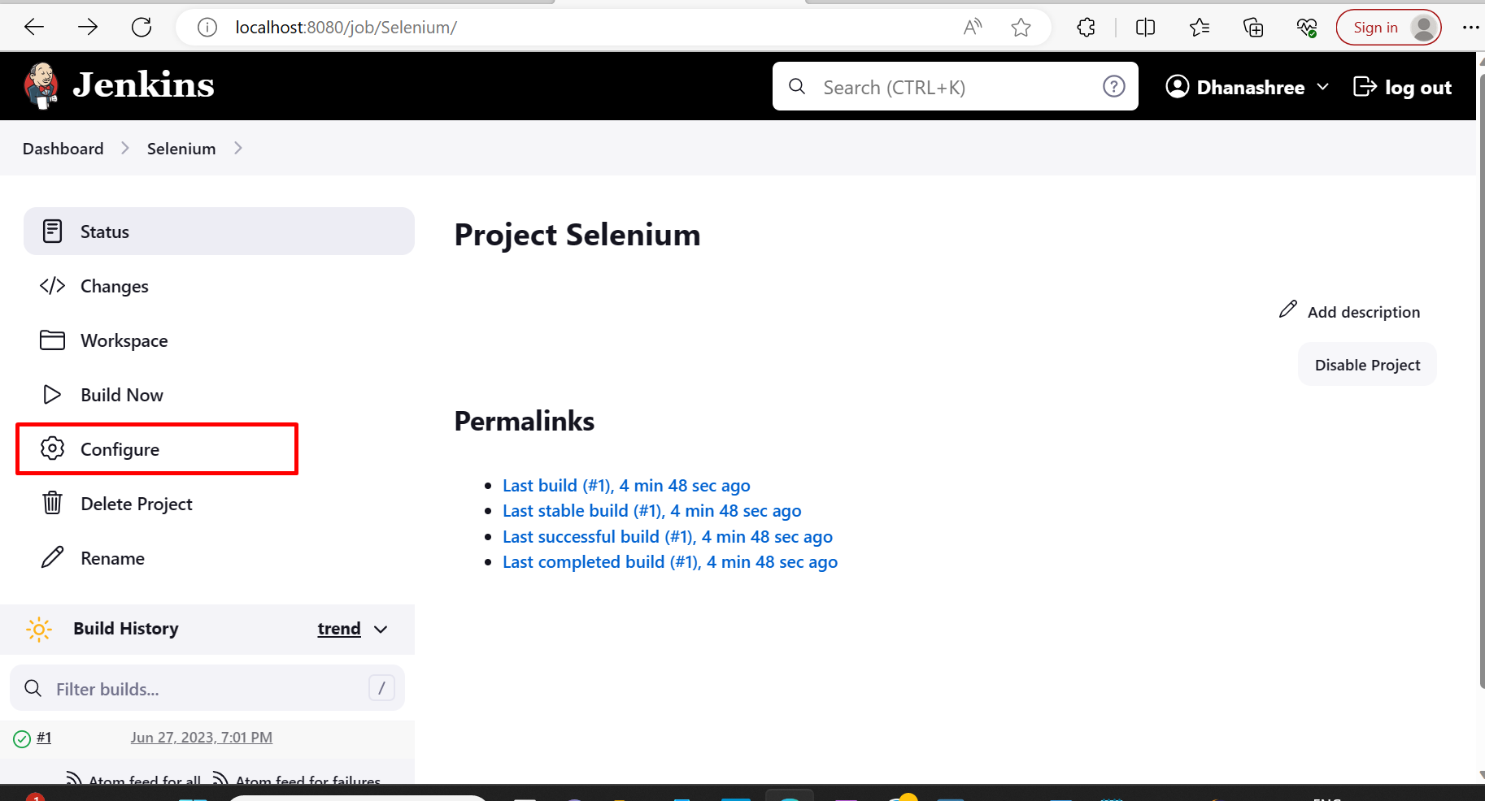

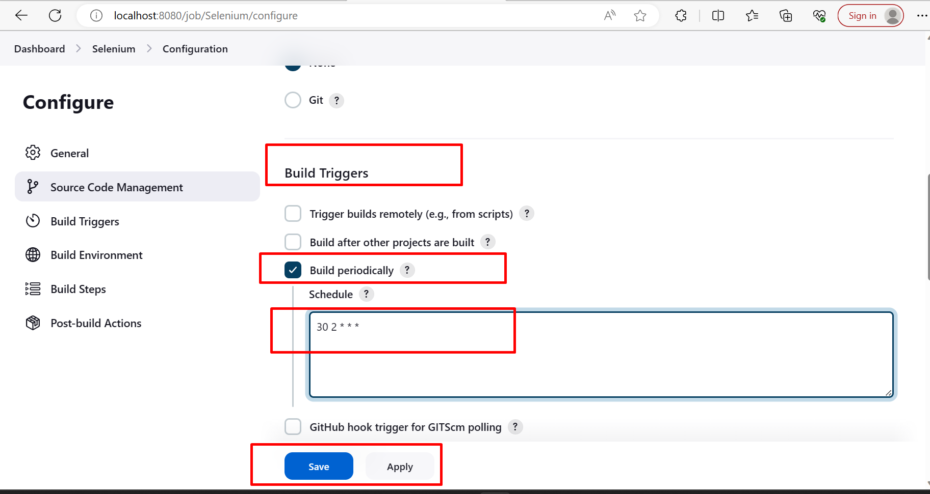

A CRON job is an instruction that repeatedly schedules a task for a particular time. CRON is the ideal option for ongoing tasks and performs non-interactive tasks in the background. A daemon is constantly inactive and awaits a command request to perform a specific task. A CRON job could save time by performing tasks automatically.



How to Run POM.xml

Click on Manage Jenkins->Plugin->Available Plugins->install Maven Integration Plugin

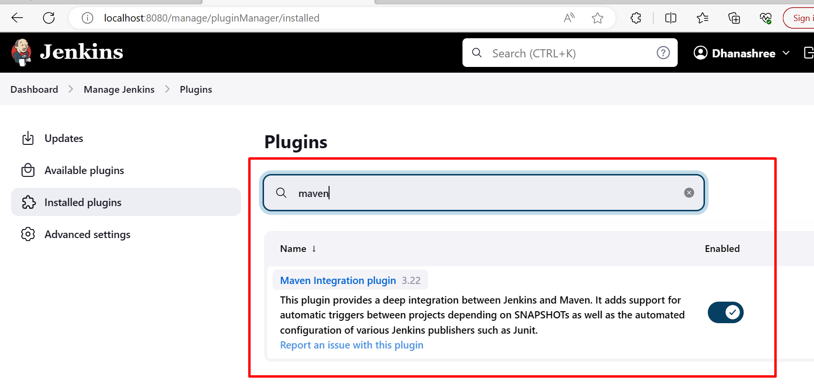

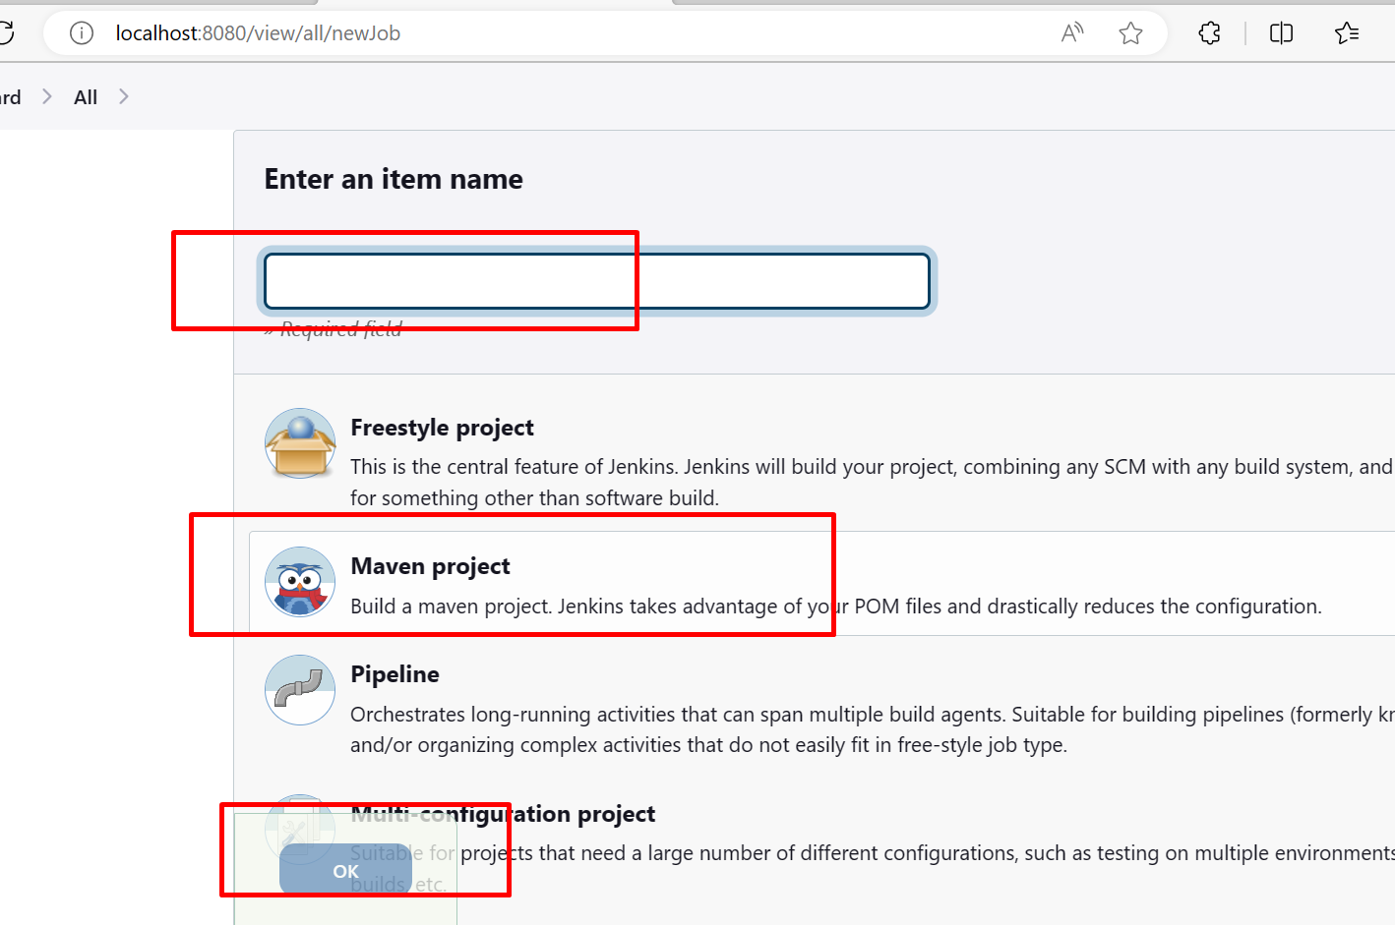

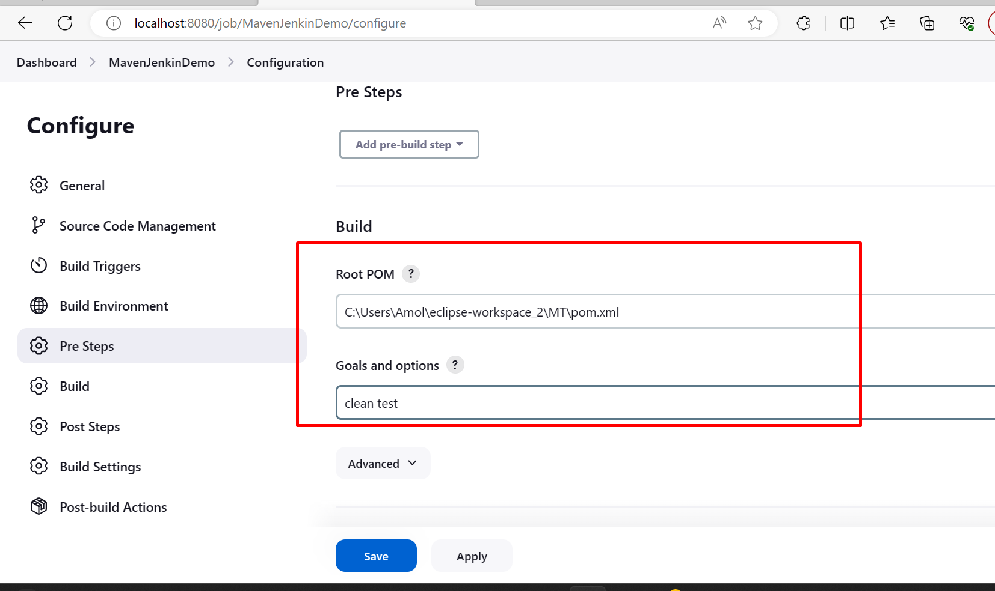

Also install test Result Analyzer plugin

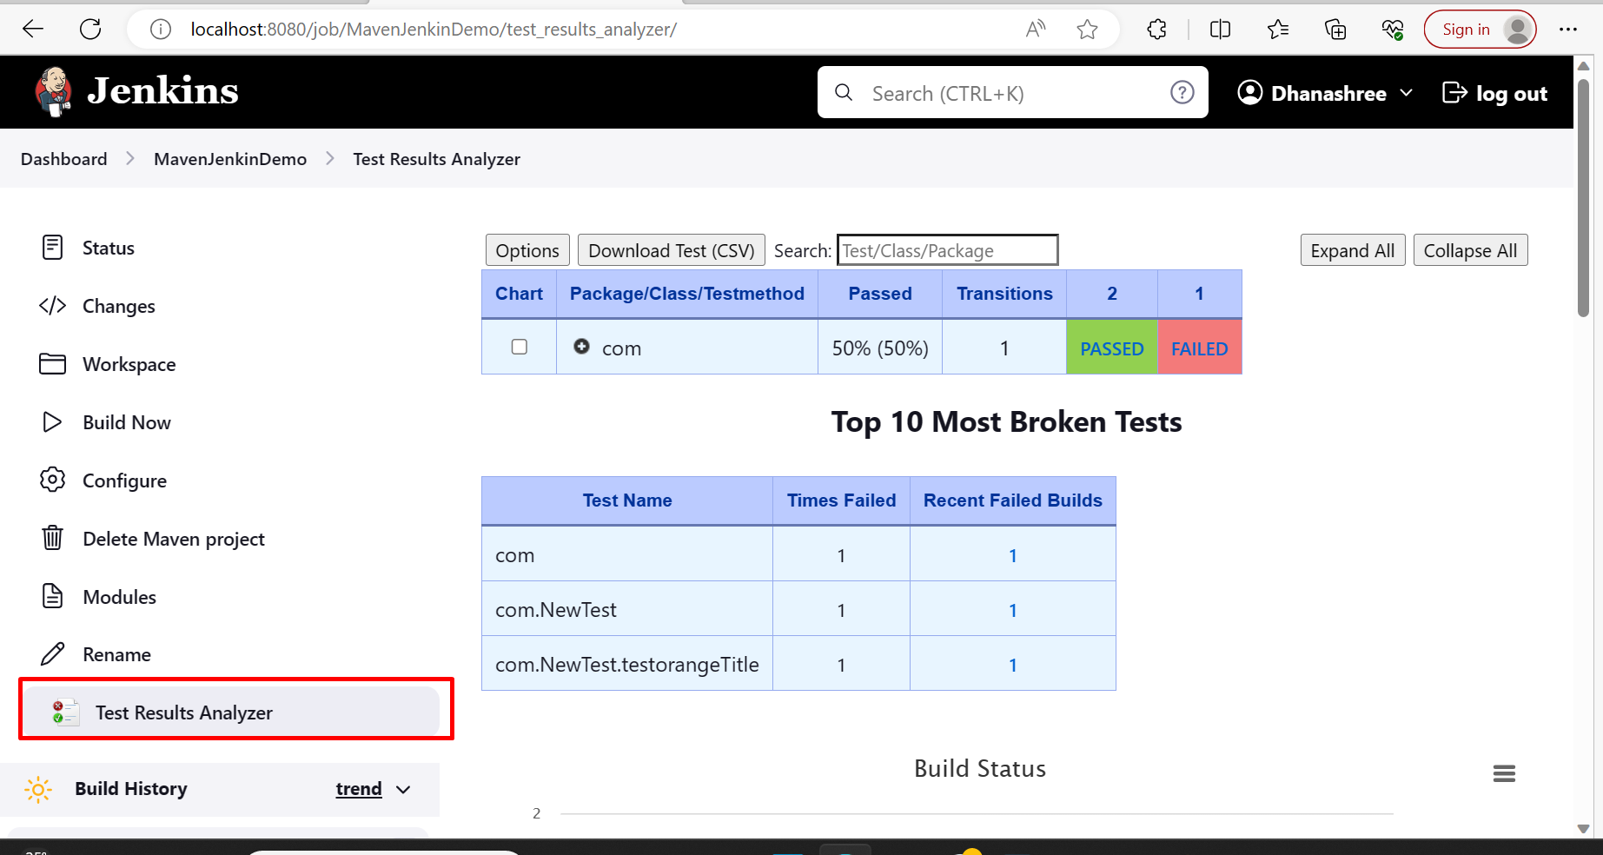

POM.xml

<project xmlns="http://maven.apache.org/POM/4.0.0" xmlns:xsi="http://www.w3.org/2001/XMLSchema-instance" xsi:schemaLocation="http://maven.apache.org/POM/4.0.0 https://maven.apache.org/xsd/maven-4.0.0.xsd">

<modelVersion>4.0.0</modelVersion>

<groupId>MavenTestNG</groupId>

<artifactId>MT</artifactId>

<version>0.0.1-SNAPSHOT</version>

<build>

<plugins>

<plugin>

<groupId>org.apache.maven.plugins</groupId>

<artifactId>maven-compiler-plugin</artifactId>

<version>3.11.0</version>

<configuration>

<source>1.8</source>

<target>1.8</target>

</configuration>

</plugin>

<plugin>

<groupId>org.apache.maven.plugins</groupId>

<artifactId>maven-surefire-plugin</artifactId>

<version>3.1.2</version>

<inherited>true</inherited>

<configuration>

<suiteXmlFiles>

<suiteXmlFile>testng.xml</suiteXmlFile>

</suiteXmlFiles>

</configuration>

</plugin>

</plugins>

</build>

<dependencies>

<!-- https://mvnrepository.com/artifact/io.github.bonigarcia/webdrivermanager -->

<dependency>

<groupId>io.github.bonigarcia</groupId>

<artifactId>webdrivermanager</artifactId>

<version>5.3.2</version>

</dependency>

<!-- https://mvnrepository.com/artifact/org.seleniumhq.selenium/selenium-java -->

<dependency>

<groupId>org.seleniumhq.selenium</groupId>

<artifactId>selenium-java</artifactId>

<version>4.8.3</version>

</dependency>

<!-- https://mvnrepository.com/artifact/org.testng/testng -->

<dependency>

<groupId>org.testng</groupId>

<artifactId>testng</artifactId>

<version>7.4.0</version>

<scope>compile</scope>

</dependency>

</dependencies>

</project>

TestNG.xml

<?xml version="1.0" encoding="UTF-8"?>

<!DOCTYPE suite SYSTEM "https://testng.org/testng-1.0.dtd">

<suite name="Suite">

<test thread-count="5" name="Test">

<classes>

<class name="com.NewTest"/>

</classes>

</test> <!-- Test -->

</suite> <!-- Suite -->

Java Program

**package** com;

**import** org.openqa.selenium.WebDriver;

**import** org.openqa.selenium.chrome.ChromeDriver;

**import** org.testng.Assert;

**import** org.testng.annotations.Test;

**import** io.github.bonigarcia.wdm.WebDriverManager;

**public** **class** NewTest {

@Test(priority=0)

**public** **void** testorangeTitle() {

WebDriverManager.*chromedriver*().setup();

WebDriver driver = **new** ChromeDriver();

driver.get("https://opensource-demo.orangehrmlive.com/");

Assert.*assertTrue*(driver.getTitle().contains("Orange"), "Title does not match");

}

}

