X Tester

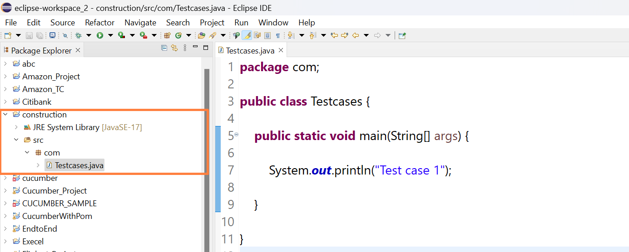

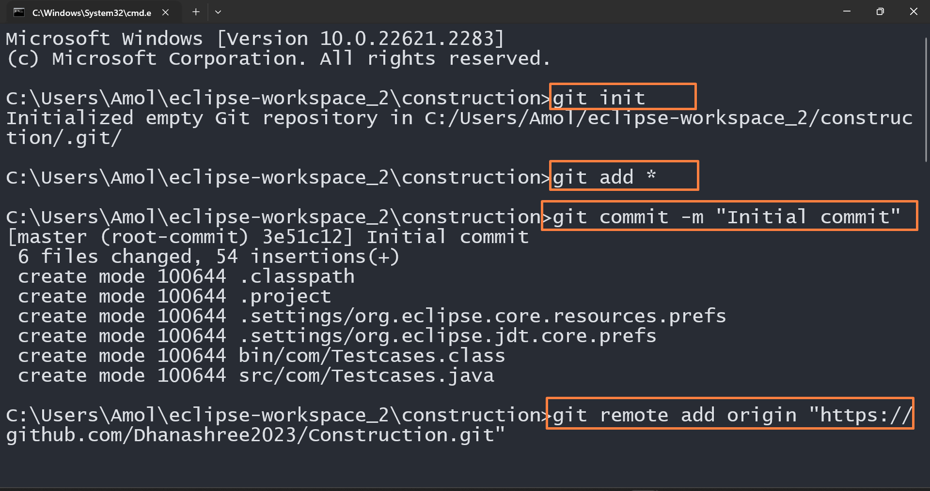

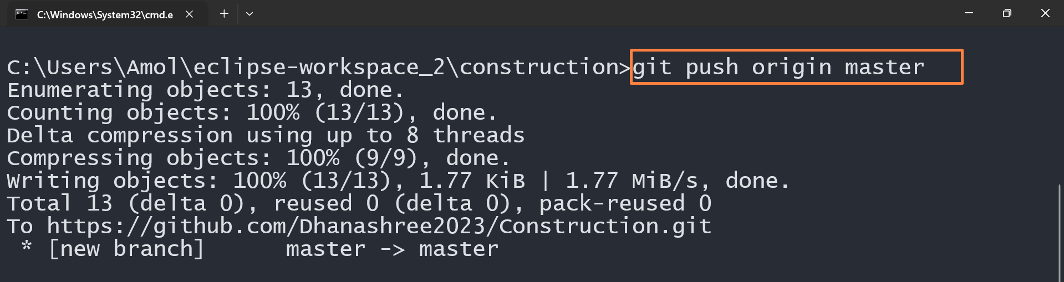

Create another workspace – Y Tester

Means both tester working on same project

Import same project code

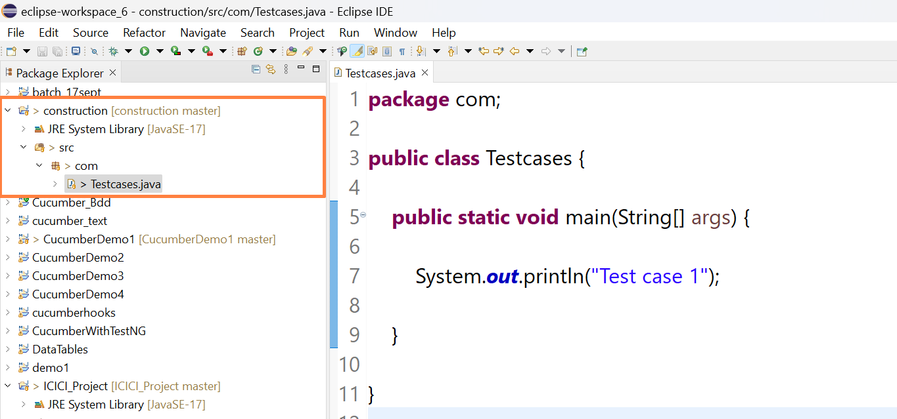

**Now X tester updated code in Eclipse and push the code in Github**

**By using commands**

**Git add \***

**Git commit -m “commit”**

**Git push origin master**

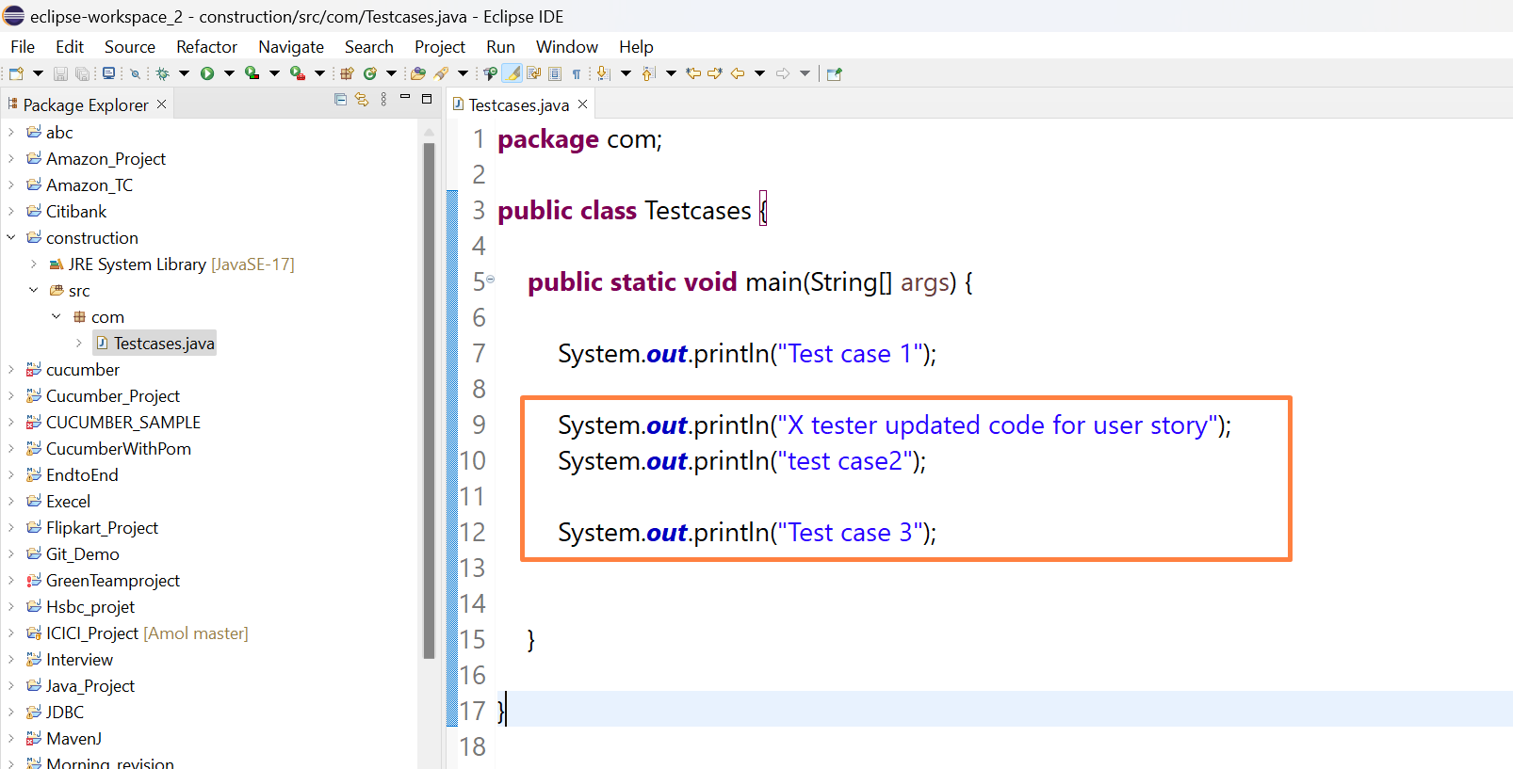

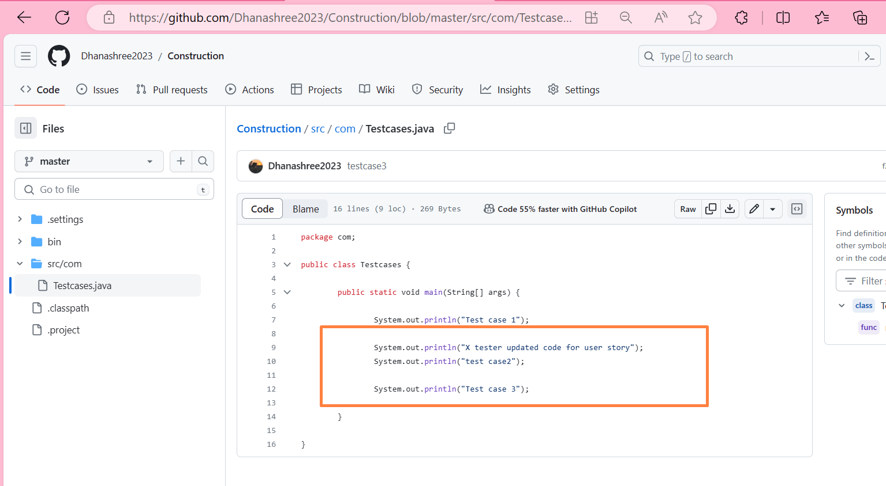

**Now Y tester want the updated Code so he pull the code**

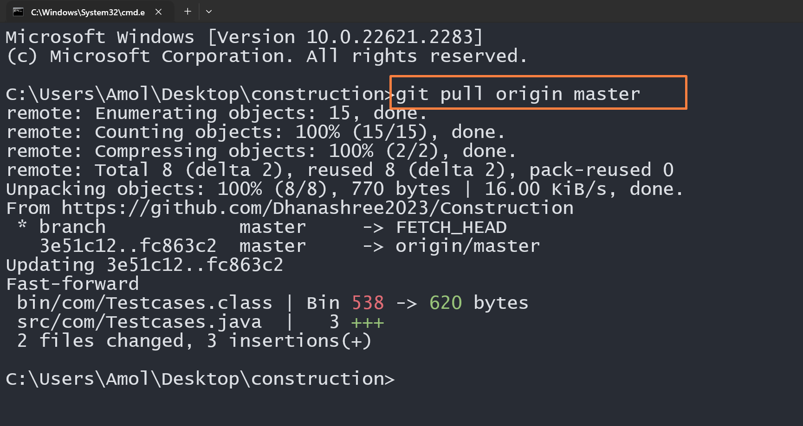

**Updated Code reflected in Eclipse**

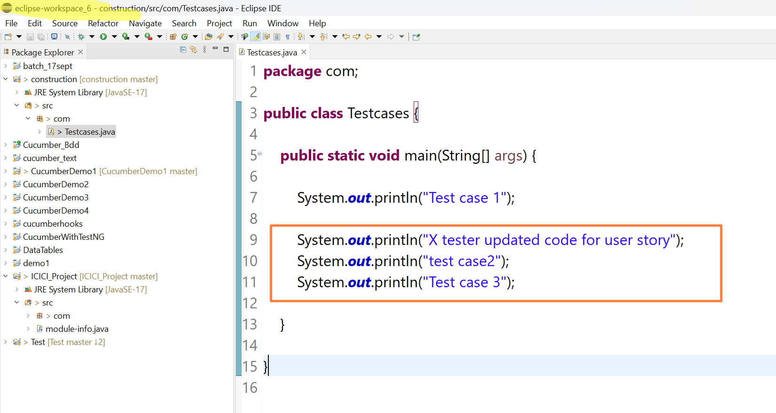

**Note : How to Import**

