SBA1:
- Created Repository on github with name “version-control-simulation-dhanashree”
- Cloned the repository to local by using git in VS code. Using command:
“$ git clone https://github.com/DhanashreeKharade451/version-control-simulation-dhanashree.git”
- Started my work in same folder by using :
$ cd version-control-simulation-dhanashree/
- Created new branch called “feature/header” and added header in HTML file:
$ git checkout -b feature/header
saved and committed the changes.

$ git commit -m "added header in header branch"
[feature/header (root-commit) 1046352] added header in header branch
1 file changed, 13 insertions(+)
create mode 100644 index.html

- Created branch feature/footer by checking out to main branch.and added footer section in HTML file . added file and committed changes.
$ git checkout -b feature/header

$ git commit -m "Added footer section to index.html"
[feature/footer b62f880] Added footer section to index.html
1 file changed, 4 insertions(+)

- Checkout to header branch again and added footer in “feature/header” branch to get a conflict.added footer in index.html file and commiter
git commit -m "added header in header branch"
[feature/header (root-commit) 1046352] added header in header branch
1 file changed, 13 insertions(+)
create mode 100644 index.html
- Merged code from header branch to main branch and pushed main branch to github.
$ git push origin main
Enumerating objects: 13, done.
Counting objects: 100% (13/13), done.
Delta compression using up to 8 threads
Compressing objects: 100% (6/6), done.
Writing objects: 100% (9/9), 946 bytes | 473.00 KiB/s, done.
Total 9 (delta 3), reused 0 (delta 0), pack-reused 0 (from 0)
remote: Resolving deltas: 100% (3/3), completed with 1 local object.
To https://github.com/DhanashreeKharade451/version-control-simulation-dhanashree.git
c32e31f..f4ddf77 main -> main

- Created branch review main and pushed it to remote :
$ git push origin review/main
Total 0 (delta 0), reused 0 (delta 0), pack-reused 0 (from 0)
remote:
remote: Create a pull request for 'review/main' on GitHub by visiting:
remote: https://github.com/DhanashreeKharade451/version-control-simulation-dhanashree/pull/new/review/main
remote:
To https://github.com/DhanashreeKharade451/version-control-simulation-dhanashree.git
* [new branch] review/main -> review/main

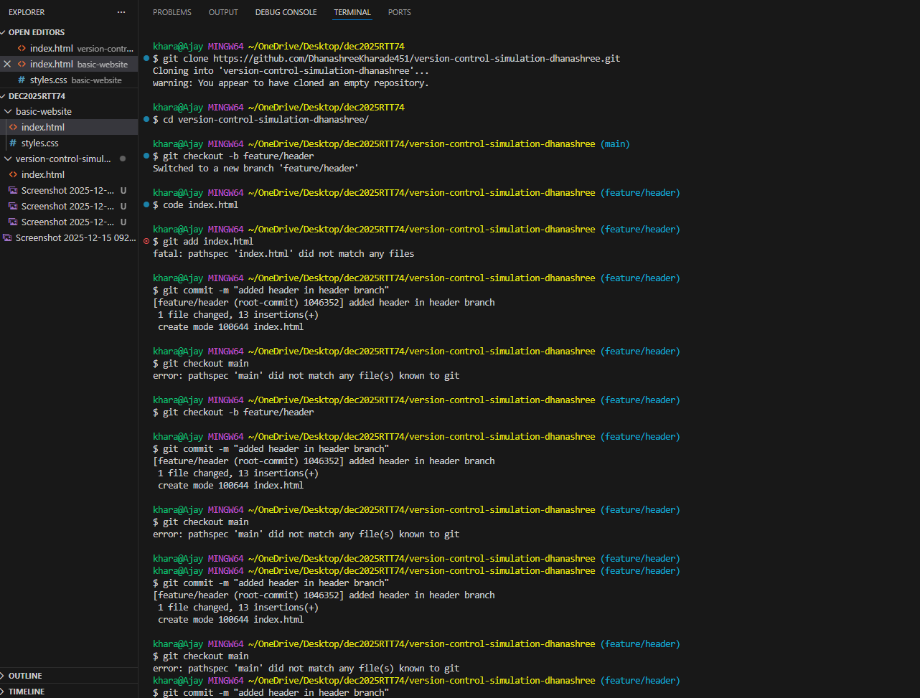

- Pulled code successfully from main branch to “review main branch”
$ git pull origin main
From https://github.com/DhanashreeKharade451/version-control-simulation-dhanashree
* branch main -> FETCH_HEAD
Already up to date.

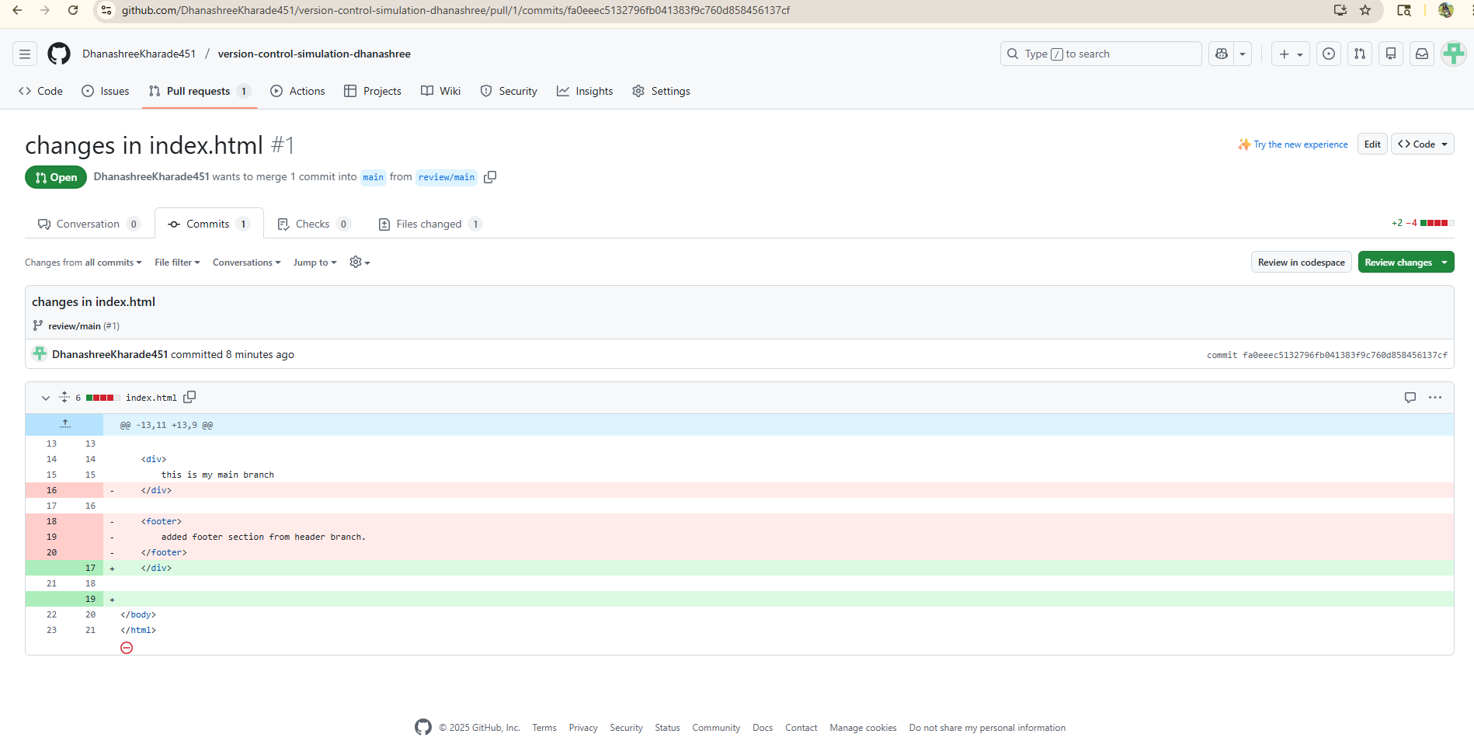

10.Pull request successfully merged and closed.

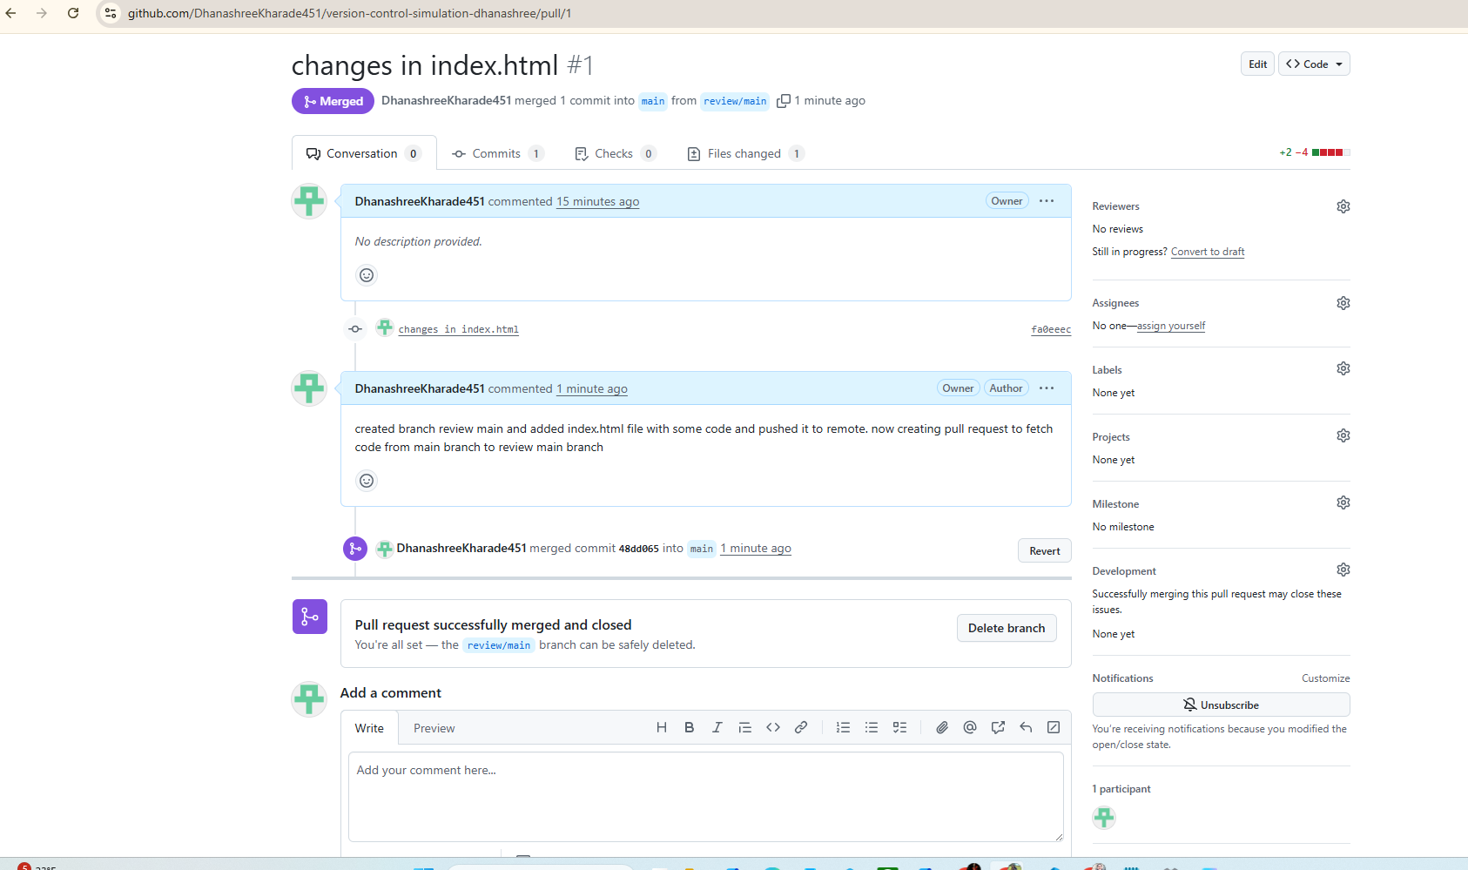

- Pushed code from feature footer to remote
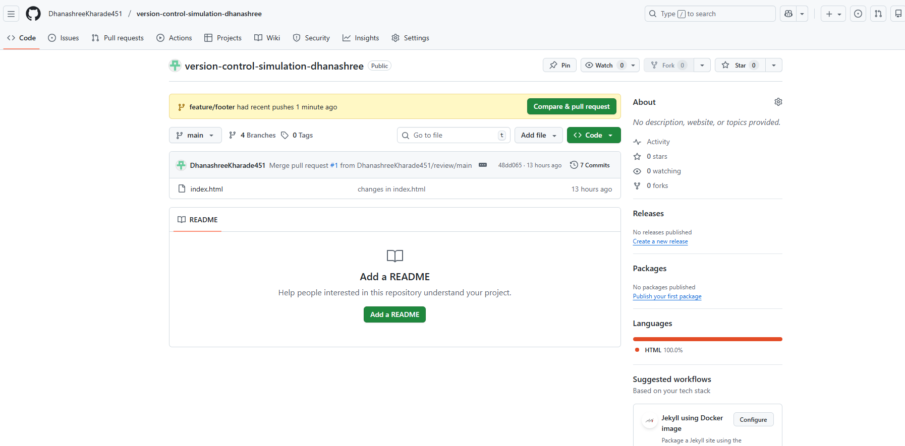

- Sending pull request to feature/footer branch to main branch:

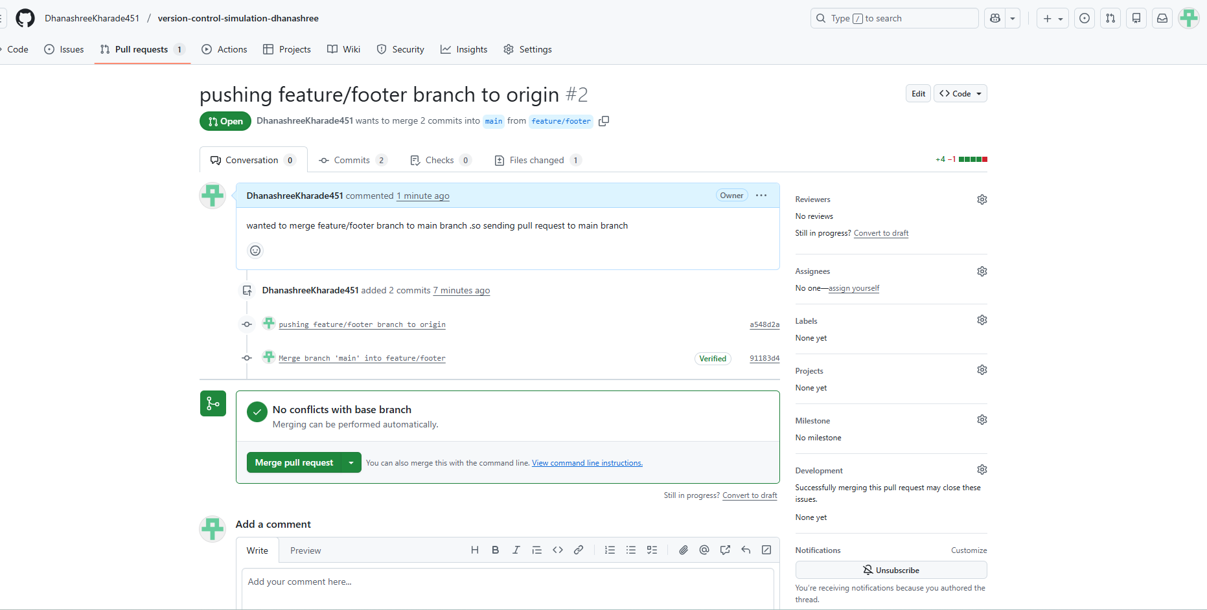

Added comment to merge:
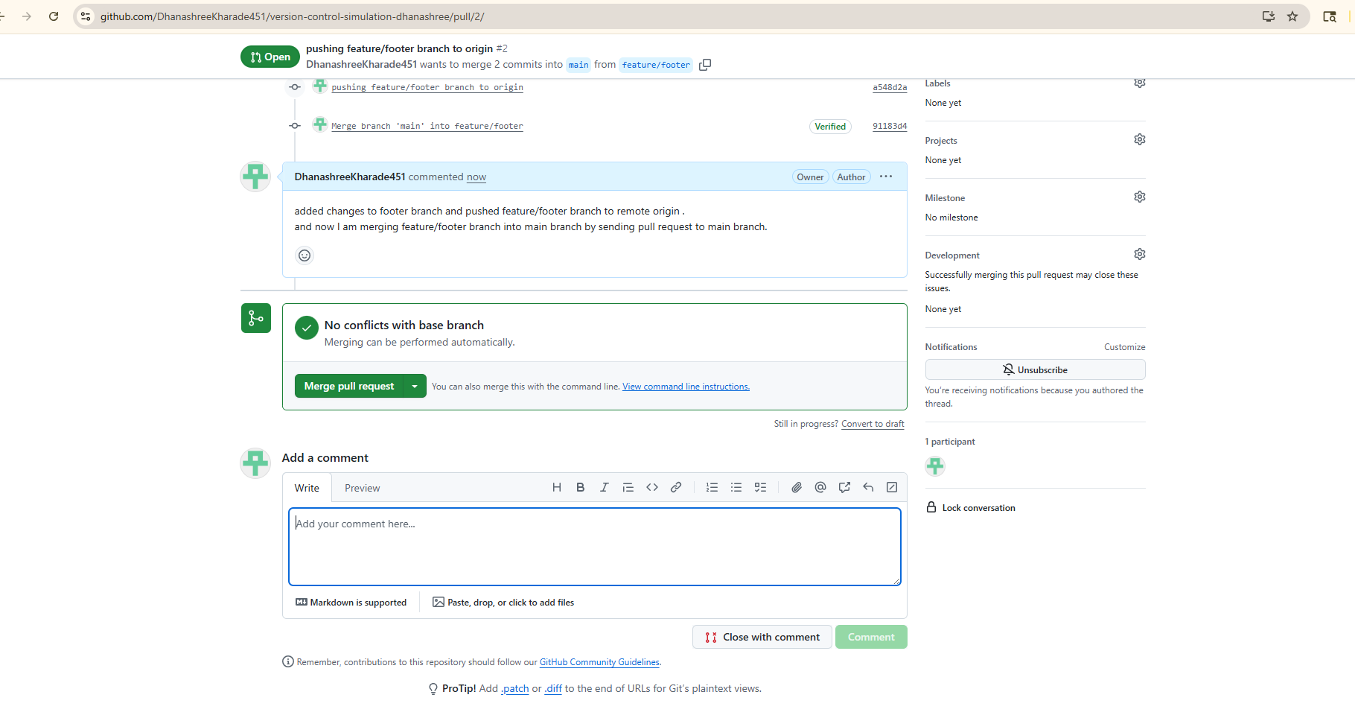

Successfully merged “feature/footer” branch to “main” branch:

