**Date:18-07-2024**

**Day_3_linux_Assignments:**





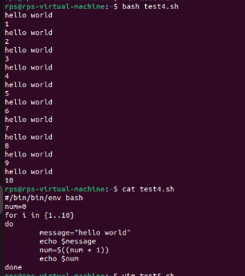

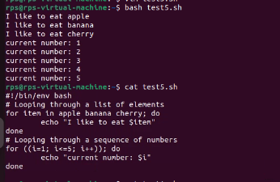

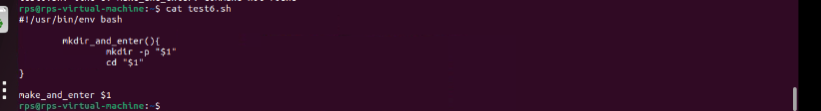

**1.File Search: Write a command to find all files with the extension .txt in the /home directory and its subdirectories.**

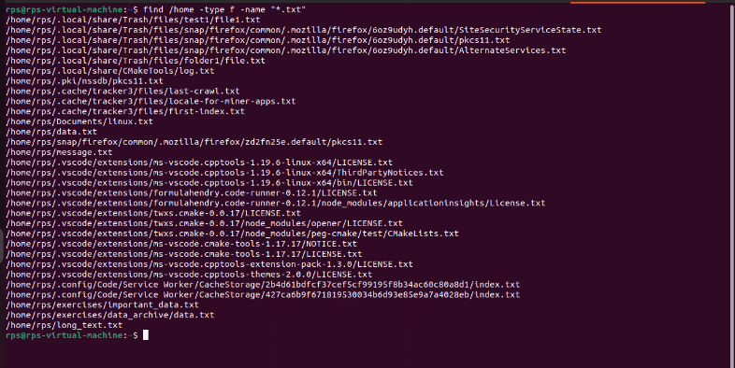

**2.File Permissions:**

**Write a command to change the permissions of all files in the /var/log directory to 644.**

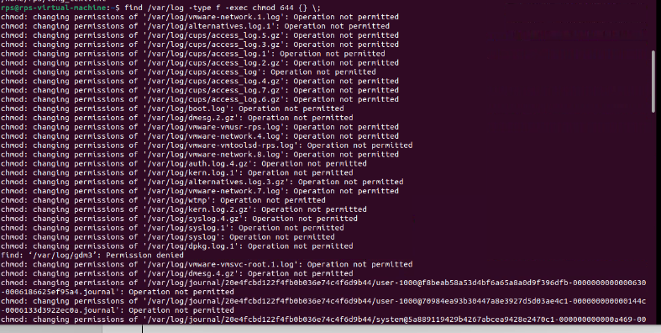

**3.** **Disk Usage:**

**Write a command to display the disk usage of all directories in the /home directory in a human-readable format.**



**4.** **Process Management:**

**Write a command to list all running processes that contain the name "apache" in their command line.**



**5.** **Text Processing:**

**Write a command to count the number of lines in a file named error.log.**



**6.** **Network Configuration:**

**Write a command to display the IP address of all network interfaces on the system.**

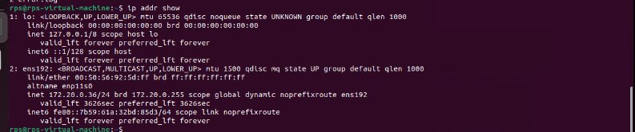

**7.** **Package Management:**

**Write a command to install a package named htop using the package manager.**

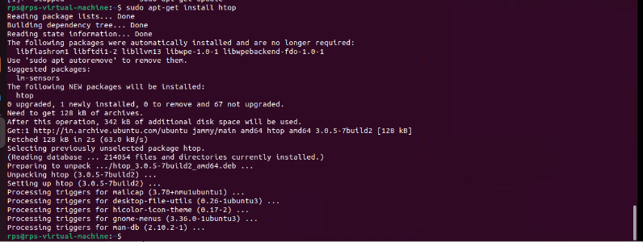

**8.** **User Management:**

**Write a command to add a new user named developer to the system.**

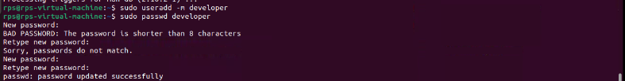

**9.** **File Compression:**

**Write a command to compress a directory named backup into a .tar.gz file.**

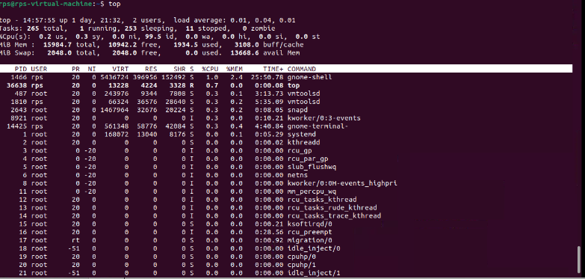

**11.** **User Report:**

**Write a shell script to generate a report of all users currently logged into the system and save it to a file named user_report.txt.**

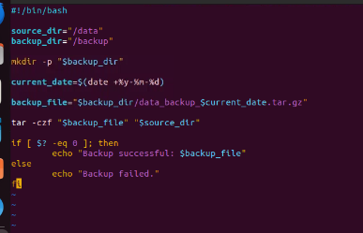

**12.** **Disk Space Alert:**

**Write a shell script to check the disk usage of the /home directory and send an email alert if the usage exceeds 80%.**

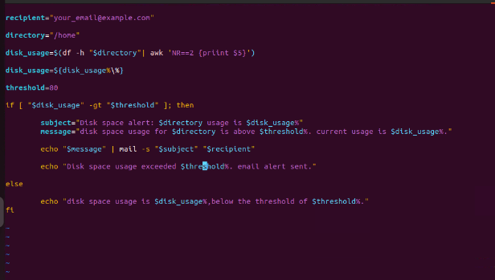

**13.** **Service Monitor:**

**Write a shell script to check if the nginx service is running and restart it if it is not**

