**Operator Overloading**

**1.What are the benefits and drawbacks of operator overloading?**

**Answer:**

**Benefits of Operator Overloading:**

1. **Intuitive Interface**: Provides a familiar interface for operations on user-defined types, improving code readability and maintainability.
2. **Consistency**: Allows custom types to behave more like built-in types, providing consistency in how operators are used across different types.
3. **Reduced Verbosity**: Helps in reducing the verbosity of code by enabling concise and expressive syntax for common operations.
4. **Functionality Extension**: Enables extending the functionality of operators beyond their original use cases, allowing them to work with custom types in meaningful ways.

**Drawbacks of Operator Overloading:**

1. **Ambiguity**: Overloading operators may introduce ambiguity or unexpected behaviors, especially when overloaded in unconventional ways.
2. **Semantic Shift**: Overloaded operators might not adhere to the original semantics of the operators, leading to confusion for developers familiar with standard usage.
3. **Compiler Limitations**: Some operators have limitations on how they can be overloaded, especially for certain operators like &&, ||, and ?:, which cannot be overloaded.
4. **Performance Concerns**: Incorrectly implemented overloaded operators can lead to performance issues, especially when complex objects are involved or when frequent operator calls are made.

**2.Can you overload the assignment operator in c++?i if so how would you ensure proper behavior?**

**Answer:**

Yes,we can overload the assignment operator in c++.Overloading assignment operator allows you to define custom behaviour for when one object is assigned to another.

Here are steps for proper behaviour ;

1.Return type:The assignment operator should return a reference to ‘*this ‘.

2.Parameter:Accept a const reference to the same class.

3.self-assignment check:Before performing any assignment ,check if this pointer is not equal to other.

4.copy semantics: Perform a deep copy of data members from other to *this

Overloading the assignment operator in c++ allows you to define how objects of your class are assigned to each other.

**3.Explain the difference between member function and non-member (friend) function overloading for operators**.

**Answer:**

• **Access to Private Members**:

* **Member Function**: Has direct access to the private members of the class since it is implicitly invoked on an object.
* **Non-Member Function**: Needs to be declared as a friend inside the class to access private members, otherwise, it can only access public and protected members.

• **Implicit/Object-Oriented Nature**:

* **Member Function**: The left-hand side operand is the invoking object (this pointer), providing a natural object-oriented syntax (obj1 + obj2).
* **Non-Member Function**: Operates on two explicitly passed objects (operator+(obj1, obj2)), allowing greater flexibility but not as directly object-oriented.

**Global Scope vs Class Scope**:

* **Member Function**: Operates within the context of the class and its objects.
* **Non-Member Function**: Operates globally, potentially for multiple types or even primitive types, if appropriately defined.

**4.Design a class Vector2D and overload the arithmetic operators (+, -, *, /) for vector addition, subtraction, scalar multiplication, and division (by a scalar).**

**Answer:**

#include <iostream>

class Vector2D {

private:

double x, y;

public:

// Constructor

Vector2D(double x = 0, double y = 0) : x(x), y(y) {}

// Getter methods

double getX() const { return x; }

double getY() const { return y; }

// Overload + operator for vector addition

Vector2D operator+(const Vector2D& other) const {

return Vector2D(x + other.x, y + other.y);

}

// Overload - operator for vector subtraction

Vector2D operator-(const Vector2D& other) const {

return Vector2D(x - other.x, y - other.y);

}

// Overload * operator for scalar multiplication

Vector2D operator*(double scalar) const {

return Vector2D(x * scalar, y * scalar);

}

// Overload / operator for scalar division

Vector2D operator/(double scalar) const {

if (scalar == 0) {

throw std::invalid_argument("Cannot divide by zero");

}

return Vector2D(x / scalar, y / scalar);

}

// Overload << operator for outputting the vector

friend std::ostream& operator<<(std::ostream& os, const Vector2D& vec) {

os << "Vector2D(" << vec.x << ", " << vec.y << ")";

return os;

}

};

int main() {

Vector2D v1(2, 3);

Vector2D v2(4, 1);

// Vector addition

Vector2D v3 = v1 + v2;

std::cout << v1 << " + " << v2 << " = " << v3 << std::endl;

// Vector subtraction

Vector2D v4 = v1 - v2;

std::cout << v1 << " - " << v2 << " = " << v4 << std::endl;

// Scalar multiplication

Vector2D v5 = v1 * 3;

std::cout << v1 << " * 3 = " << v5 << std::endl;

// Scalar division

Vector2D v6 = v2 / 2;

std::cout << v2 << " / 2 = " << v6 << std::endl;

return 0;

}

**5.Is it possible to overload the comparison operators (==, !=, <, >, <=, >=) for custom classes? If so, what considerations should be taken into account?**

**Answer:**

Yes, it is possible to overload the comparison operators (==, !=, <, >, <=, >=) for custom classes in C++. Here are the key considerations and an example of how to do it:

**Considerations for Overloading Comparison Operators**

1. **Consistent Logic**: Ensure that the logic for comparisons is consistent. For example, if a < b is true, then b > a should also be true.
2. **Return Type**: The comparison operators should return a boolean value (true or false).
3. **Member vs. Non-Member Functions**: Comparison operators can be implemented as either member functions or non-member (friend) functions. If the left operand is not of the class type (e.g., comparing a Vector2D with an integer), a non-member function is needed.
4. **Performance Considerations**: For large objects, consider passing arguments by reference to avoid unnecessary copying.
5. **Symmetry**: Ensure symmetry where appropriate. For example, a == b should yield the same result as b == a.

**6.Can you overload the stream insertion (<<) and extraction (>>) operators for your Vector2D class to allow easy printing and reading from streams?**

**Answer:**

#include <iostream>

class Vector2D {

private:

double x, y;

public:

// Constructor

Vector2D(double x = 0, double y = 0) : x(x), y(y) {}

// Getter methods

double getX() const { return x; }

double getY() const { return y; }

// Overload + operator for vector addition

Vector2D operator+(const Vector2D& other) const {

return Vector2D(x + other.x, y + other.y);

}

// Overload - operator for vector subtraction

Vector2D operator-(const Vector2D& other) const {

return Vector2D(x - other.x, y - other.y);

}

// Overload * operator for scalar multiplication

Vector2D operator*(double scalar) const {

return Vector2D(x * scalar, y * scalar);

}

// Overload / operator for scalar division

Vector2D operator/(double scalar) const {

if (scalar == 0) {

throw std::invalid_argument("Cannot divide by zero");

}

return Vector2D(x / scalar, y / scalar);

}

// Overload == operator for equality comparison

bool operator==(const Vector2D& other) const {

return x == other.x && y == other.y;

}

// Overload != operator for inequality comparison

bool operator!=(const Vector2D& other) const {

return !(*this == other);

}

// Overload < operator for less-than comparison (based on vector magnitude)

bool operator<(const Vector2D& other) const {

return (x * x + y * y) < (other.x * other.x + other.y * other.y);

}

// Overload > operator for greater-than comparison (based on vector magnitude)

bool operator>(const Vector2D& other) const {

return other < *this;

}

// Overload <= operator for less-than or equal-to comparison

bool operator<=(const Vector2D& other) const {

return !(other < *this);

}

// Overload >= operator for greater-than or equal-to comparison

bool operator>=(const Vector2D& other) const {

return !(*this < other);

}

// Overload << operator for outputting the vector

friend std::ostream& operator<<(std::ostream& os, const Vector2D& vec) {

os << "Vector2D(" << vec.x << ", " << vec.y << ")";

return os;

}

// Overload >> operator for reading the vector

friend std::istream& operator>>(std::istream& is, Vector2D& vec) {

is >> vec.x >> vec.y;

return is;

}

};

int main() {

Vector2D v1(2, 3);

Vector2D v2(4, 1);

// Output vector to stream

std::cout << "v1: " << v1 << std::endl;

std::cout << "v2: " << v2 << std::endl;

// Read vector from stream

Vector2D v3;

std::cout << "Enter vector v3 (format: x y): ";

std::cin >> v3;

std::cout << "v3: " << v3 << std::endl;

return 0;

}

**7.Describe a scenario where overloading the logical operators (&&, ||, !) for a custom class might be useful.**

**Answer**:

Imagine you are developing a system that filters data based on complex conditions. Each condition can be combined using logical operators to form more complex rules. Overloading the logical operators for a Condition class would allow you to easily combine and evaluate these conditions.

#include <iostream>

#include <functional>

class Condition {

private:

std::function<bool()> evaluator;

public:

// Constructor

Condition(std::function<bool()> evaluator) : evaluator(evaluator) {}

// Overload the ! operator

bool operator!() const {

return !evaluator();

}

// Overload the && operator

Condition operator&&(const Condition& other) const {

return Condition([=]() { return evaluator() && other.evaluator(); });

}

// Overload the || operator

Condition operator||(const Condition& other) const {

return Condition([=]() { return evaluator() || other.evaluator(); });

}

// Method to evaluate the condition

bool evaluate() const {

return evaluator();

}

};

int main() {

Condition isEven([]() { int x = 4; return x % 2 == 0; });

Condition isPositive([]() { int x = 4; return x > 0; });

Condition complexCondition = isEven && isPositive;

std::cout << "Is the number even and positive? " << (complexCondition.evaluate() ? "Yes" : "No") << std::endl;

Condition isOdd = !isEven;

std::cout << "Is the number odd? " << (isOdd.evaluate() ? "Yes" : "No") << std::endl;

Condition isEvenOrPositive = isEven || isPositive;

std::cout << "Is the number even or positive? " << (isEvenOrPositive.evaluate() ? "Yes" : "No") << std::endl;

return 0;

}

**8. Discuss the potential ambiguity that could arise when overloading the subscript operator ([]) for a class. How can this ambiguity be resolved?**

**Answer**:

Overloading the subscript operator ([]) in a class can lead to potential ambiguity because this operator can be used for different purposes: accessing elements, slicing, or even assigning values. When overloading the subscript operator, it's essential to consider how these different uses will be distinguished and handled within your class.

**Potential Ambiguities**

1. **Access vs. Assignment**:
   * Accessing an element: value = obj[key]
   * Assigning a value: obj[key] = value

Without clear differentiation in the implementation, the class might not correctly interpret whether the operation is intended to retrieve or set a value.

1. **Single Element vs. Slice**:
   * Accessing a single element: element = obj[index]
   * Accessing a slice of elements: subsequence = obj[start:stop]

The class needs to distinguish whether the subscript is referring to a single index or a range of indices.

**Resolving Ambiguity**

To resolve these ambiguities, Python provides two special methods that can be overloaded: getitem and setitem.

1. **Using getitem and setitem**:
   * _getitem__(self, key): This method is used for retrieving an item or slice. Inside this method, you can check the type of key to determine whether it is a single index or a slice.
   * __setitem__(self, key, value): This method is used for setting an item or slice. Similarly, you can check the type of key to handle the assignment correctly.
2. **Type Checking**: Inside both __getitem__ and __setitem__, you can use isinstance to check if the key is an integer (for a single element) or a slice object (for a range of elements).

**10**. **Can operator overloading be used to implement the concept of immutability (unchanging state) for a class? Explain your answer.**

**Answer:**

Operator overloading can play a role in implementing the concept of immutability for a class, but it cannot achieve immutability on its own. Immutability means that once an object is created, its state cannot be changed. Operator overloading can help ensure that certain operations do not modify the object's state, but additional techniques are needed to fully enforce immutability.

**Techniques to Enforce Immutability:**

1. **Private Attributes**: Use private attributes (with a leading underscore) and only provide read-only properties to access them.
2. **No Setter Methods**: Do not provide setter methods for attributes.
3. **Frozen Dataclasses**: In Python, dataclasses with frozen=True provide a built-in way to create immutable objects.
4. **Custom __setattr__ Method**: Override __setattr__ to prevent setting attributes after object creation.

While operator overloading can help in implementing immutability by ensuring operations return new objects rather than modifying the existing one, it cannot fully enforce immutability on its own. A combination of operator overloading, private attributes, and careful class design is needed to create truly immutable classes.

**11.When overloading operators, what are some best practices to ensure code clarity and maintainability?**

**Answer:**

When overloading operators, it's important to follow best practices to ensure code clarity and maintainability. Here are some key guidelines:

**1. Keep It Intuitive**

* Overload operators in a way that is intuitive and consistent with their typical use. For example, + should be used for addition or concatenation, - for subtraction, and so on.
* Ensure the overloaded behavior matches user expectations and the general semantics of the operators.

**2. Maintain Symmetry and Consistency**

* Overload corresponding operators together. For instance, if you overload __add__, consider overloading __iadd__ and __radd__ as well.
* Ensure commutativity and associativity properties hold where appropriate. For example, if a + b works, b + a should also work if both operands are of the same type.

**3. Return New Objects for Immutability**

* When overloading operators that modify the state (e.g., __add__, __sub__), return new instances of the object rather than modifying the existing instance. This ensures immutability and avoids side effects.

**4. Handle Type Errors Gracefully**

* Check the types of operands and raise appropriate errors if the types do not match. This prevents unexpected behavior and aids in debugging.
* For binary operators, ensure compatibility with other types by implementing the __r*__ methods (e.g., __radd__ for +).

**5. Use Rich Comparisons**

* When overloading comparison operators, implement all six (__eq__, __ne__, __lt__, __le__, __gt__, __ge__) to ensure comprehensive comparison capabilities.
* Avoid relying on the default implementations of __ne__, __le__, __ge__, as they may not always produce the desired results.

**6. Document the Overloaded Operators**

* Clearly document the behavior of overloaded operators in your class's docstrings. This helps other developers understand the intended use and behavior of the operators.
* Provide examples of usage in the documentation to illustrate how the operators should be used.

**7. Maintain Operator Overload Symmetry**

* For symmetric operations like __add__ and __radd__, ensure that both operations behave consistently and logically.
* Consider the implications of mixing types and ensure that your overloaded operators can handle mixed-type operations appropriately.

**Function Overloading:**

**1.What is the core concept behind function overloading?**

**Answer:**

The core concept behind function overloading is to allow multiple functions to have the same name but differ in the type or number of their parameters. This enables a function to handle different types of inputs or different numbers of arguments, enhancing code flexibility and readability.

**Key Concepts of Function Overloading**

1. **Same Function Name**: Multiple functions share the same name but differ in their parameter lists.
2. **Different Parameter Types**: The overloaded functions can have parameters of different types.
3. **Different Number of Parameters**: The overloaded functions can have a different number of parameters.
4. **Compile-Time Polymorphism**: In languages that support function overloading natively (such as C++ and Java), the correct function to call is determined at compile time based on the function signature (name and parameter list).

**Benefits of Function Overloading**

1. **Improves Readability**: Functions with the same purpose but different parameter types can share the same name, making the code more intuitive.
2. **Code Reusability**: Similar operations for different types can be grouped together, reducing code duplication.
3. **Flexibility**: Allows a single function name to handle different types or numbers of parameters, making the code more flexible.

**2.How does the compiler differentiate between overloaded functions with the same name?**

**Answer:**

**Function Overloading Resolution**

When a function call is made, the compiler determines the appropriate overloaded function to call based on the arguments provided:

* **Exact Match**: If there is an exact match in terms of the number and types of arguments, that function is chosen.
* **Promotion**: If an exact match is not found, the compiler looks for a match where arguments can be promoted to the required types. For example, an int can be promoted to a double.
* **Implicit Conversions**: If no exact match or promotion is found, the compiler considers implicit conversions, such as converting int to double.
* **Default Arguments**: Default arguments can also affect which overloaded function is chosen if no arguments are explicitly provided.

**3.Can functions with different return types be overloaded? Explain your reasoning.**

**Answer:**

No, functions with different return types cannot be overloaded in languages that strictly adhere to function overloading rules, such as C++ and Java. Function overloading is primarily based on the function signature, which includes the function name and parameter list, but not the return type.

### Reasons Why Functions with Different Return Types Cannot be Overloaded:

1. **Function Signature**: Overloaded functions must differ in their function signature, which consists of the function name and the types and/or number of parameters. The return type is not considered part of the function signature for the purpose of overloading.
2. **Ambiguity**: Allowing functions with different return types to be overloaded could lead to ambiguity when calling the function.

**3. Resolution by Return Type**: In many languages, function resolution (choosing which function to call) is primarily based on the function name and parameter types. Return type alone does not play a role in this decision-making process.

**4.Design a function printValue that can handle different data types (e.g., int, double, std::string) by overloading it with appropriate parameter lists.**

**Answer:**

#include <iostream>

#include <string>

// Function to print an integer

void printValue(int value) {

std::cout << "Integer value: " << value << std::endl;

}

// Function to print a double

void printValue(double value) {

std::cout << "Double value: " << value << std::endl;

}

// Function to print a string

void printValue(const std::string& value) {

std::cout << "String value: " << value << std::endl;

}

int main() {

int intValue = 10;

double doubleValue = 3.14;

std::string stringValue = "Hello, world!";

// Call the appropriate overloaded function based on the type

printValue(intValue);

printValue(doubleValue);

printValue(stringValue);

return 0;

}

• **Function Overloading**:

* We define three versions of printValue:
  + void printValue(int value): Prints an integer.
  + void printValue(double value): Prints a double.
  + void printValue(const std::string& value): Prints a string.

• **Usage in main**:

* Inside main, we declare variables of different types (int, double, std::string).
* We then call printValue with each of these variables. The compiler resolves which version of printValue to call based on the type of argument passed.

**5.Discuss the advantages and disadvantages of using default arguments in overloaded functions.**

**Answer:**

**Advantages:**

1. **Reduced Code Complexity**:
   * Default arguments can simplify the function interface by reducing the number of overloaded functions needed. Instead of defining multiple overloaded functions with different parameter lists, you can consolidate similar functionality into a single function with default arguments.
2. **Improved Readability**:

Default arguments can make function calls more readable and self-explanatory. Users can omit default parameters when they are not needed, focusing on the core aspects of the function call.

**3.Backward Compatibility**:

Default arguments allow new versions of functions to be introduced without breaking existing code that relies on the older versions. Existing function calls continue to work as expected, even if the new version introduces additional parameters with default values.

**Disadvantages:**

1. **Ambiguity and Confusion**:
   * Overusing default arguments or having complex combinations of default parameters can lead to ambiguity and confusion about which version of the function is being called.

1. **Potential for Bugs**:

Default arguments might mask errors or unintended behavior if not carefully managed. Changes in default values could affect the behavior of existing code that relies on those defaults.

3. **Compiler and Maintenance Overhead**:

Handling default arguments may impose additional overhead on the compiler and increase the complexity of function resolution during compilation.

Maintenance of functions with default arguments requires careful consideration to ensure compatibility and consistency across different versions of the function.

**6.In the context of function overloading, explain the concept of argument promotion and implicit type conversion**.

**Answer:**

In the context of function overloading, argument promotion and implicit type conversion refer to the mechanisms by which the compiler matches function calls with the appropriate overloaded function based on the types of the arguments passed.

**Argument Promotion:**

Argument promotion involves converting arguments to a higher type category when searching for a matching overloaded function. In many programming languages, including C++ and Java, argument promotion rules generally follow these principles:

1. **Integer Promotion**:
   * Smaller integer types (like char or short) are promoted to larger integer types (int or unsigned int) if a matching overloaded function is not found for the smaller types.
2. **Floating Point Promotion**:
   * Smaller floating-point types (like float) are promoted to larger floating-point types (double) if necessary.
3. **Enum Promotion**:
   * Enums are promoted to int or a higher type category if needed.

**Implicit Type Conversion:**

Implicit type conversion involves automatically converting one type of data into another type during function argument matching. This allows the compiler to find a compatible overloaded function even if the argument types don't exactly match the parameter types. Implicit type conversions include:

1. **Numeric Conversions**:
   * Converting between different numeric types, such as int to double, float to int, etc.
2. **Pointer Conversions**:
   * Converting between different pointer types, such as from a derived class pointer to a base class pointer.
3. **User-Defined Conversions**:
   * Conversions defined by user-defined conversion functions or conversion constructors in classes.

**Importance in Function Overloading:**

Argument promotion and implicit type conversion allow function overloading to be more flexible and versatile:

* They help in resolving function calls to the correct overloaded function even when exact type matches are not available.
* They facilitate code reuse and improve readability by reducing the need for explicitly defining overloaded functions for every possible type combination.
* They are essential for handling polymorphic behavior in object-oriented programming and for providing convenient ways to work with different data types in a consistent manner.

By understanding these mechanisms, developers can leverage them effectively to design more robust and flexible software systems using function overloading in languages that support these features.

**7. When might it be a better idea to use separate functions with descriptive names instead of overloading a single function**?

**Answer:**

• **Clarity and Readability**:

* When each function performs a distinctly different operation or handles different cases, using separate names makes the code more readable and understandable.
* Here, each function clearly indicates its specific purpose without relying on overloaded semantics, enhancing clarity for developers reading and maintaining the code.

**Avoiding Ambiguity**:

* Overloading a function with similar but subtly different behaviors can lead to ambiguity or confusion, especially when the differences are not immediately obvious.
* Using distinct names like loadDataFromFile and loadDataFromDatabase prevents misunderstandings about which operation is being performed.

• **Explicitness in API Design**:

* When designing APIs, using descriptive function names helps communicate the intended usage and functionality to users of the API.
* API users can immediately grasp the purpose of each function without needing to understand the nuances of function overloading rules.

• **Testing and Debugging**:

* Separate functions with descriptive names can simplify testing and debugging efforts. Test cases and debugging scenarios can be clearly mapped to specific functions, making it easier to isolate issues and verify functionality.
* Debugging a refund-related issue becomes straightforward when using processRefund instead of navigating through potentially overloaded logic.

• **Future Extensibility**:

* When anticipating future changes or extensions to functionality, using separate functions can provide more flexibility. New requirements can be accommodated with additional functions without affecting existing overloaded function semantics.
* If a new requirement emerges to export data to JSON format, it can be easily added as a new function (exportDataToJSON) without modifying existing overloaded logic

**8. Can function overloading be used to achieve polymorphism (the ability to treat objects of different derived classes in a similar way)? Explain.**

**Answer:**

Function overloading, as typically understood in languages like C++ and Java, does not directly achieve polymorphism in the object-oriented programming sense. Polymorphism, specifically subtype polymorphism, is achieved through inheritance and virtual functions (or interfaces in languages like Java). However, function overloading and polymorphism do share some related concepts and can work together in certain contexts:

**Understanding Function Overloading:**

1. **Function Overloading Basics**:
   * Function overloading allows multiple functions within the same scope to have the same name but different parameter lists.
   * This feature is primarily used to provide multiple ways to call a function based on different argument types or numbers.

**Relationship Between Function Overloading and Polymorphism:**

* **Parameter Polymorphism**: Function overloading can be seen as a form of ad-hoc polymorphism (or function overloading polymorphism) where different functions with the same name but different parameters can be invoked based on the type and number of arguments provided.
* **Compile-Time Polymorphism**: Function overloading is resolved at compile time based on the function signature, whereas polymorphism (subtype polymorphism) in OOP languages like C++ involves runtime binding through virtual functions.
* **Usage in Overriding**: When a function is overridden in derived classes (as shown in the Shape, Circle, and Rectangle example), the overridden functions can be called polymorphically through base class pointers or references. This allows treating objects of different derived classes uniformly when accessed through the base class interface.

**Achieving Polymorphism in C++:**

* **Virtual Functions**: To achieve true polymorphism in C++, you typically use virtual functions and inheritance. Virtual functions allow the invocation of derived class methods through base class pointers or references, enabling runtime polymorphic behavior based on the actual object type.
* **Example Modification**:

cpp

Copy code

class Shape {

public:

virtual void draw() {

std::cout << "Drawing a generic shape" << std::endl;

}

};

class Circle : public Shape {

public:

void draw() override {

std::cout << "Drawing a circle" << std::endl;

}

};

class Rectangle : public Shape {

public:

void draw() override {

std::cout << "Drawing a rectangle" << std::endl;

}

};

void drawShape(Shape* shape) {

shape->draw(); // Polymorphic behavior based on actual object type

}

int main() {

Circle circle;

Rectangle rectangle;

drawShape(&circle); // Calls Circle's draw() method polymorphically

drawShape(&rectangle); // Calls Rectangle's draw() method polymorphically

return 0;

}

**9.** **Describe a scenario where overloading a function with a variable number of arguments (varargs) could be beneficial.**

**Answer:**

Overloading a function with a variable number of arguments (varargs) can be highly beneficial in scenarios where you want to provide flexibility in function calls without needing to define multiple functions with slightly different parameter lists. Here’s a scenario to illustrate its usefulness:

**Scenario: Mathematical Operations**

Imagine you're designing a math utility library that performs various operations on numbers. You want to implement functions for basic arithmetic operations (like addition, multiplication) that can handle different numbers of arguments:

1. **Adding Numbers:** You want to add up a variable number of integers or floating-point numbers.
2. **Multiplying Numbers:** Similarly, you want to multiply a variable number of integers or floats.
3. **Handling Different Data Types:** You might also want to extend these functions to handle different data types or combinations, like adding integers and floats together seamlessly without needing separate functions for each case.

By overloading these functions with varargs (*args), you achieve several benefits:

* **Flexibility:** Users can call these functions with any number of arguments, making the code more versatile and easier to use.
* **Simplicity:** Instead of defining multiple functions for different numbers of arguments (like add_two_numbers(a, b), add_three_numbers(a, b, c), etc.), you maintain a single function definition (add_numbers(*args)) that covers all cases.
* **Readability:** It simplifies the API and makes the code cleaner and more readable since the function name remains consistent across different argument counts.

Overall, overloading functions with varargs is beneficial in scenarios where you need to handle variable numbers of arguments gracefully, providing both flexibility and simplicity in function usage.

**10. Compare and contrast function overloading with virtual functions in C++ inheritance. Which approach is more suitable for specific use cases?**

**Answer:**

**Function Overloading**

**Definition:** Function overloading involves creating multiple functions with the same name but different parameter lists within the same scope.

**Key Points:**

* **Static Binding:** The compiler determines which function to call at compile-time based on the function signature (number and types of parameters).
* **Syntax:** Functions must differ in the number of parameters or the types of parameters.
* **No Polymorphism:** Function overloading does not support polymorphism. The selection of the appropriate function is based purely on the static types of the arguments at compile-time.
* **Usage Context:** Function overloading is used when you want to provide multiple functionalities for a function name, differentiated by parameter types or counts.

**Virtual Functions in C++ Inheritance**

**Definition:** Virtual functions are functions declared in a base class that can be overridden in derived classes to achieve polymorphic behavior.

**Key Points:**

* **Dynamic Binding:** The actual function to call is determined at runtime based on the object's type (dynamic dispatch).
* **Syntax:** Declared with the virtual keyword in the base class. Overriding functions in derived classes can use the override keyword.
* **Polymorphism:** Virtual functions enable polymorphism, allowing derived classes to provide specific implementations of a function defined in a base class.
* **Usage Context:** Virtual functions are used when you need a common interface in a base class with different implementations in derived classes.

**Comparison and Contrast**

| **Aspect** | **Function Overloading** | **Virtual Functions** |
| --- | --- | --- |
| **Binding** | Static (compile-time) | Dynamic (runtime) |
| **Syntax** | Different parameter lists | virtual keyword in base class, override keyword in derived class (optional but recommended) |
| **Polymorphism** | No | Yes |
| **Usage Scenario** | Multiple variations of the same operation | Common interface with different implementations |
| **Resolution** | Based on static types of arguments | Based on the actual runtime type of the object |

**Suitability for Specific Use Cases**

1. **Function Overloading:**
   * **Simple Variations:** When you need to provide different variations of the same operation based on parameter types or counts.
   * **Compile-Time Determination:** Suitable when the decision on which function to call can be made at compile-time based on the static types of the arguments.
   * **Example:** Mathematical operations with different data types:
2. **Virtual Functions:**
   * **Polymorphic Behavior:** When you need polymorphism, allowing different derived classes to provide their own specific implementations.
   * **Runtime Flexibility:** Suitable when the decision on which function to call depends on the runtime type of the object.
   * **Example:** A base class Animal with a virtual function speak() overridden in derived classes Dog and Cat:

* **Function Overloading:** Use for providing multiple variations of the same operation differentiated by compile-time parameters. It simplifies code when you have similar operations that differ only in argument types or counts.
* **Virtual Functions:** Use for achieving polymorphism, where different classes can provide their own specific behavior while sharing a common interface. This is crucial for designing flexible and maintainable object-oriented systems.

**Operator Overloading**

**1.Complex Numbers (C++) - Define a class Complex to represent complex numbers with member variables for real and imaginary parts. Overload the +, -, and * operators for complex number addition, subtraction, and multiplication.**

**Answer:**

#include <iostream>

class Complex {

private:

double real;

double imag;

public:

// Constructors

Complex(double r = 0.0, double i = 0.0) : real(r), imag(i) {}

// Overloading + operator for addition

Complex operator+(const Complex& other) const {

return Complex(real + other.real, imag + other.imag);

}

// Overloading - operator for subtraction

Complex operator-(const Complex& other) const {

return Complex(real - other.real, imag - other.imag);

}

// Overloading * operator for multiplication

Complex operator*(const Complex& other) const {

double r = real * other.real - imag * other.imag;

double i = real * other.imag + imag * other.real;

return Complex(r, i);

}

// Function to display the complex number

void display() const {

std::cout << "(" << real << " + " << imag << "i)" << std::endl;

}

};

int main() {

// Creating complex numbers

Complex c1(3.0, 4.0); // 3 + 4i

Complex c2(1.0, 2.0); // 1 + 2i

// Testing operator overloading

Complex sum = c1 + c2;

Complex diff = c1 - c2;

Complex prod = c1 * c2;

// Display results

std::cout << "c1: ";

c1.display();

std::cout << "c2: ";

c2.display();

std::cout << "Sum: ";

sum.display();

std::cout << "Difference: ";

diff.display();

std::cout << "Product: ";

prod.display();

return 0;

}

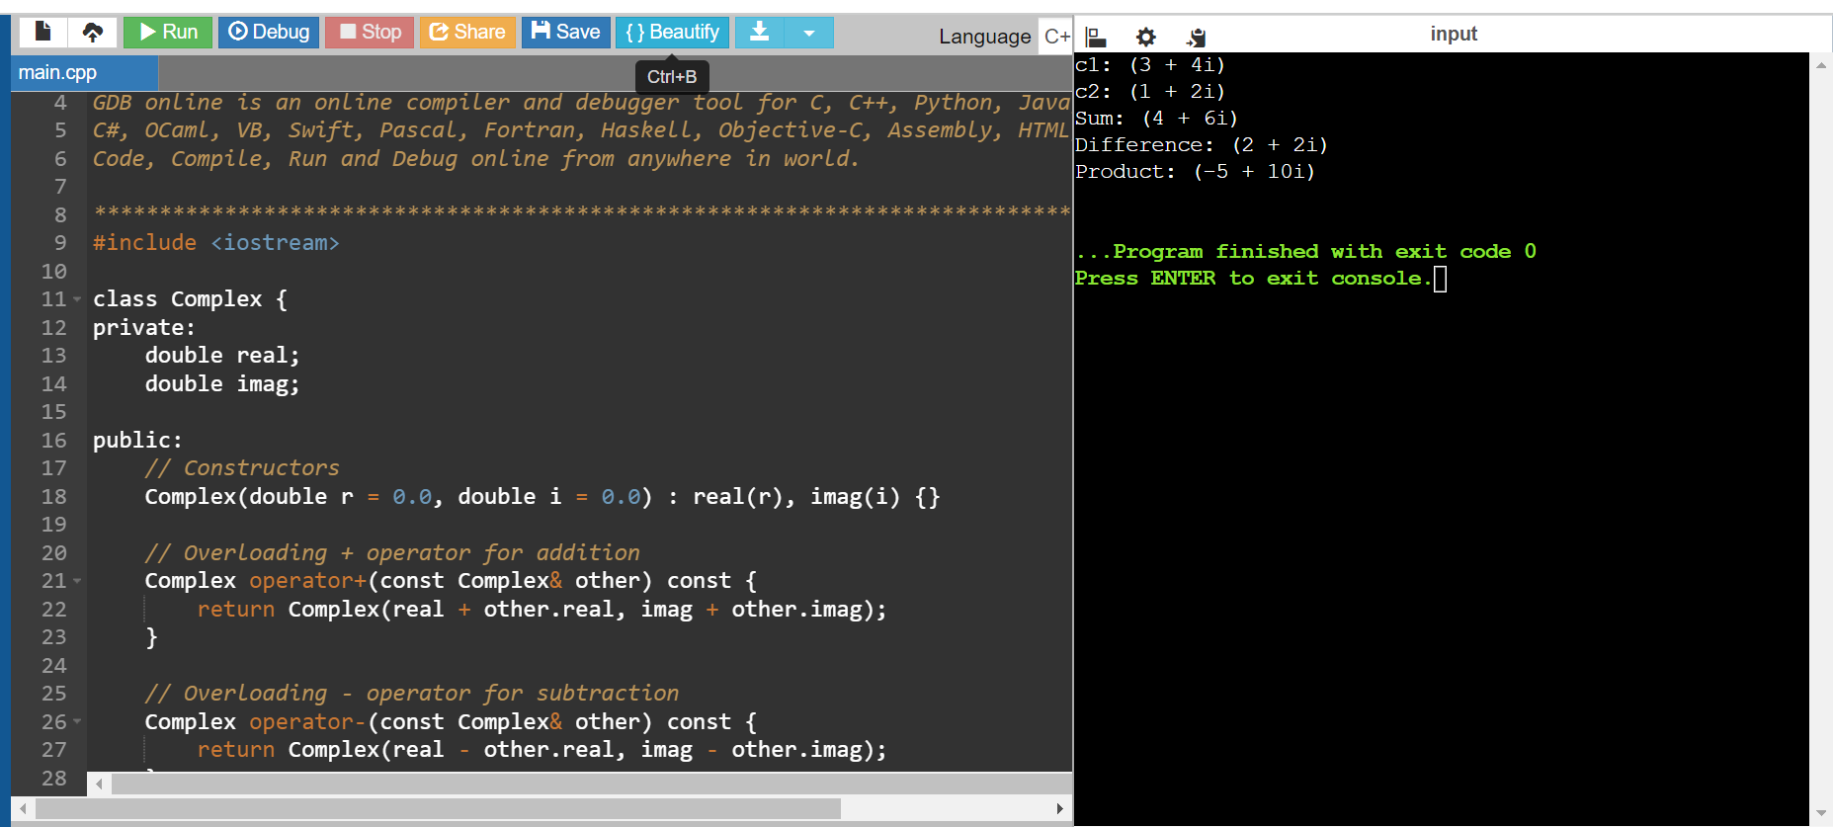

**2.Point2D (Java) - Create a class Point2D with x and y coordinates. Overload the + operator to return a new Point2D object representing the sum of two points.**

#include <iostream>

class Point2D {

private:

double x;

double y;

public:

// Constructors

Point2D(double xCoord = 0.0, double yCoord = 0.0) : x(xCoord), y(yCoord) {}

// Overloading + operator for point addition

Point2D operator+(const Point2D& other) const {

return Point2D(x + other.x, y + other.y);

}

// Function to display the point

void display() const {

std::cout << "(" << x << ", " << y << ")" << std::endl;

}

};

int main() {

// Creating two Point2D objects

Point2D p1(3.0, 4.0); // Point at (3, 4)

Point2D p2(1.0, 2.0); // Point at (1, 2)

// Adding two points using operator overloading

Point2D sum = p1 + p2;

// Displaying results

std::cout << "Point p1: ";

p1.display();

std::cout << "Point p2: ";

p2.display();

std::cout << "Sum of p1 and p2: ";

sum.display();

return 0;

}

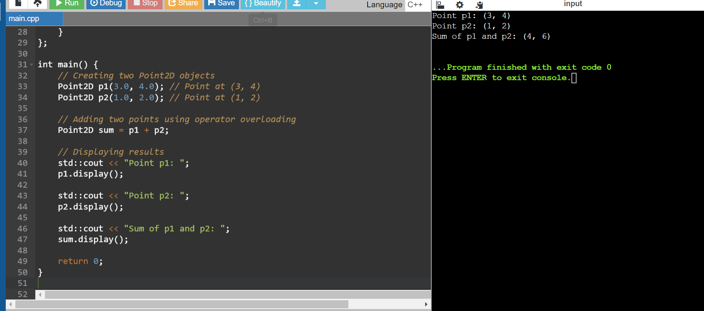

**3.Time (Python) - Design a class Time to store hours, minutes, and seconds. Overload the + operator to add two Time objects and return a new Time object with the combined duration.**

**Answer:**

#include <iostream>

class Time {

private:

int hours;

int minutes;

int seconds;

public:

// Constructors

Time(int h = 0, int m = 0, int s = 0) : hours(h), minutes(m), seconds(s) {}

// Overloading + operator for time addition

Time operator+(const Time& other) const {

int h = hours + other.hours;

int m = minutes + other.minutes;

int s = seconds + other.seconds;

// Adjust for overflow

if (s >= 60) {

m += s / 60;

s %= 60;

}

if (m >= 60) {

h += m / 60;

m %= 60;

}

return Time(h, m, s);

}

// Function to display the time

void display() const {

std::cout << hours << " hours, " << minutes << " minutes, " << seconds << " seconds" << std::endl;

}

};

int main() {

// Creating two Time objects

Time t1(2, 30, 45); // Time: 2 hours, 30 minutes, 45 seconds

Time t2(1, 45, 20); // Time: 1 hour, 45 minutes, 20 seconds

// Adding two times using operator overloading

Time sum = t1 + t2;

// Displaying results

std::cout << "Time t1: ";

t1.display();

std::cout << "Time t2: ";

t2.display();

std::cout << "Sum of t1 and t2: ";

sum.display();

return 0;

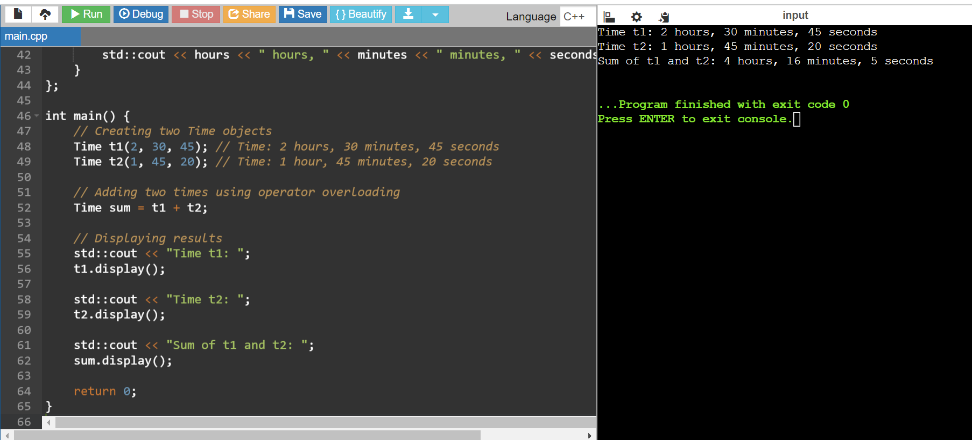

**4.Date (C#) - Implement a class Date with year, month, and day. Overload the comparison operators (== and !=) to compare two Date objects.**

**Answer:**

#include <iostream>

class Date {

private:

int year;

int month;

int day;

public:

// Constructor

Date(int y, int m, int d) : year(y), month(m), day(d) {}

// Overloaded equality operator (==)

bool operator==(const Date& other) const {

return (year == other.year && month == other.month && day == other.day);

}

// Overloaded inequality operator (!=)

bool operator!=(const Date& other) const {

return !(*this == other);

}

// Accessor methods (optional)

int getYear() const { return year; }

int getMonth() const { return month; }

int getDay() const { return day; }

};

int main() {

Date d1(2024, 6, 27);

Date d2(2024, 6, 27);

Date d3(2025, 1, 1);

// Testing equality

if (d1 == d2) {

std::cout << "d1 and d2 are the same date." << std::endl;

} else {

std::cout << "d1 and d2 are different dates." << std::endl;

}

// Testing inequality

if (d1 != d3) {

std::cout << "d1 and d3 are different dates." << std::endl;

} else {

std::cout << "d1 and d3 are the same date." << std::endl;

}

return 0;

}

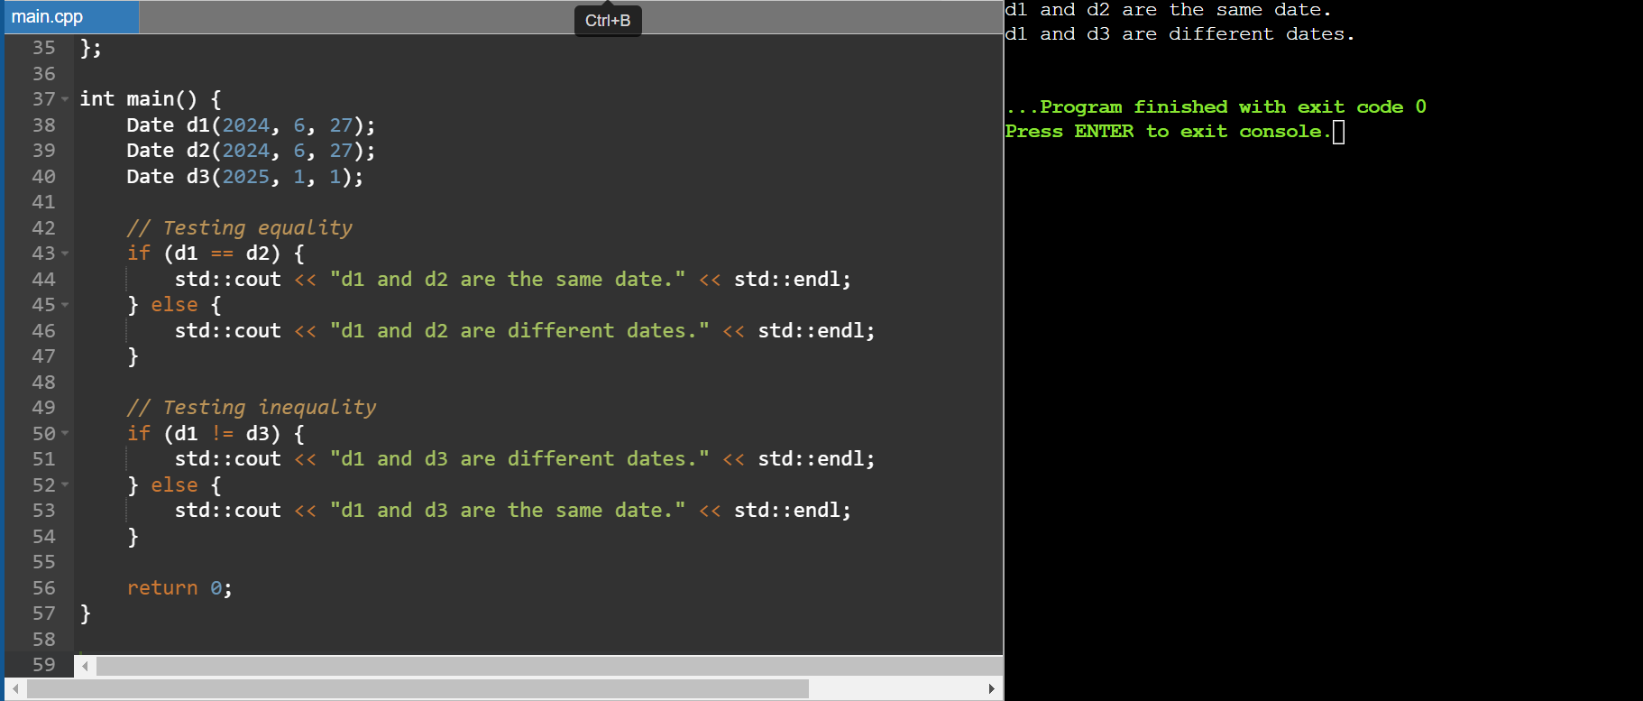

**5.String Equality (C++) - Overload the equality operator (==) for a custom String class to compare string contents (not just memory addresses).**

**Answer:**

#include <iostream>

#include <cstring> // For strlen and strcmp

class String {

private:

char* str; // Pointer to a dynamically allocated C-string

public:

// Constructors and Destructor

String(const char* s = "") {

str = new char[strlen(s) + 1];

strcpy(str, s);

}

String(const String& other) {

str = new char[strlen(other.str) + 1];

strcpy(str, other.str);

}

~String() {

delete[] str;

}

// Overloaded equality operator (==)

bool operator==(const String& other) const {

return strcmp(str, other.str) == 0;

}

// Getter function (optional)

const char* c_str() const {

return str;

}

};

int main() {

String s1("Hello");

String s2("Hello");

String s3("World");

// Testing equality

if (s1 == s2) {

std::cout << "s1 and s2 are equal." << std::endl;

} else {

std::cout << "s1 and s2 are not equal." << std::endl;

}

if (s1 == s3) {

std::cout << "s1 and s3 are equal." << std::endl;

} else {

std::cout << "s1 and s3 are not equal." << std::endl;

}

return 0;

}

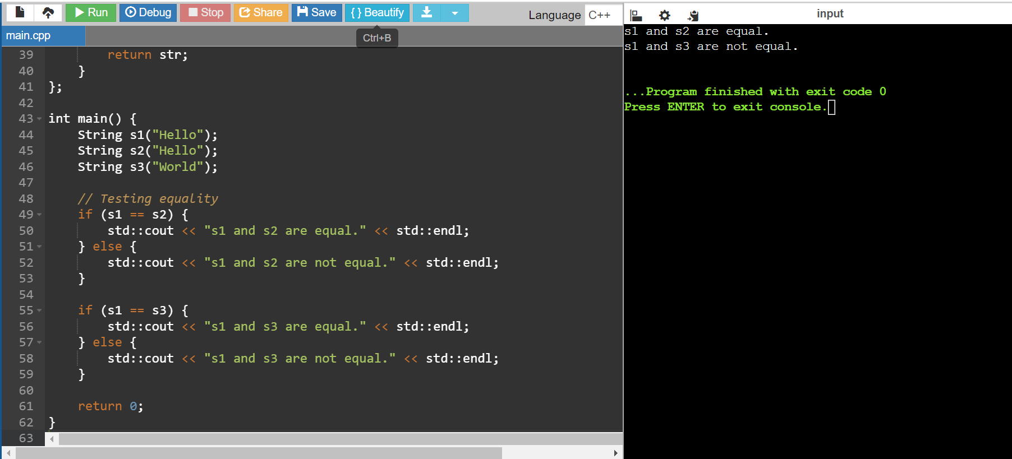

**Function Overloading**

**6.Area Calculation (Java) - Create a function calculateArea that can handle different shapes (e.g., rectangle, circle) by overloading it with parameters like width, height, or radius.**

**Answer:**

#include <iostream>

#include <cmath> // for M_PI if using circle

// Function to calculate area of a rectangle

double calculateArea(double width, double height) {

return width * height;

}

// Function to calculate area of a circle

double calculateArea(double radius) {

return M_PI * radius * radius; // M_PI is a constant defined in <cmath> for pi

}

int main() {

double width, height, radius;

// Example usage for rectangle

width = 5.0;

height = 3.0;

std::cout << "Area of rectangle with width " << width << " and height " << height << " is: " << calculateArea(width, height) << std::endl;

// Example usage for circle

radius = 4.0;

std::cout << "Area of circle with radius " << radius << " is: " << calculateArea(radius) << std::endl;

return 0;

}

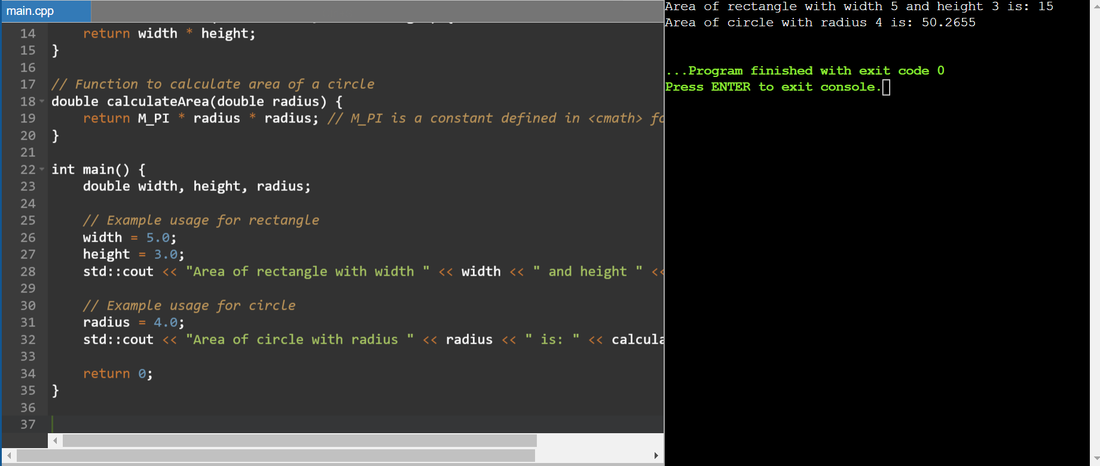

**7. Unit Conversion (Python) - Design a function convert that takes a value and a unit (e.g., meters, feet, Celsius, Fahrenheit) and converts it to another unit using appropriate conversion factors**

**Answer:**

#include <iostream>

#include <string>

// Function to convert between units

double convert(double value, const std::string& from_unit, const std::string& to_unit) {

double result = value;

// Convert from 'from_unit' to 'to_unit'

if (from_unit == "meters" && to_unit == "feet") {

result *= 3.28084; // 1 meter = 3.28084 feet

} else if (from_unit == "feet" && to_unit == "meters") {

result /= 3.28084; // 1 foot = 0.3048 meters

} else if (from_unit == "celsius" && to_unit == "fahrenheit") {

result = (value * 9.0/5.0) + 32.0; // Celsius to Fahrenheit conversion

} else if (from_unit == "fahrenheit" && to_unit == "celsius") {

result = (value - 32.0) * 5.0/9.0; // Fahrenheit to Celsius conversion

} else {

std::cerr << "Unsupported conversion: " << from_unit << " to " << to_unit << std::endl;

result = -1; // Return -1 to indicate unsupported conversion

}

return result;

}

int main() {

double value;

std::string from_unit, to_unit;

// Example conversions

value = 10.0;

from_unit = "meters";

to_unit = "feet";

std::cout << value << " " << from_unit << " = " << convert(value, from_unit, to_unit) << " " << to_unit << std::endl;

value = 32.0;

from_unit = "celsius";

to_unit = "fahrenheit";

std::cout << value << " " << from_unit << " = " << convert(value, from_unit, to_unit) << " " << to_unit << std::endl;

return 0;

}

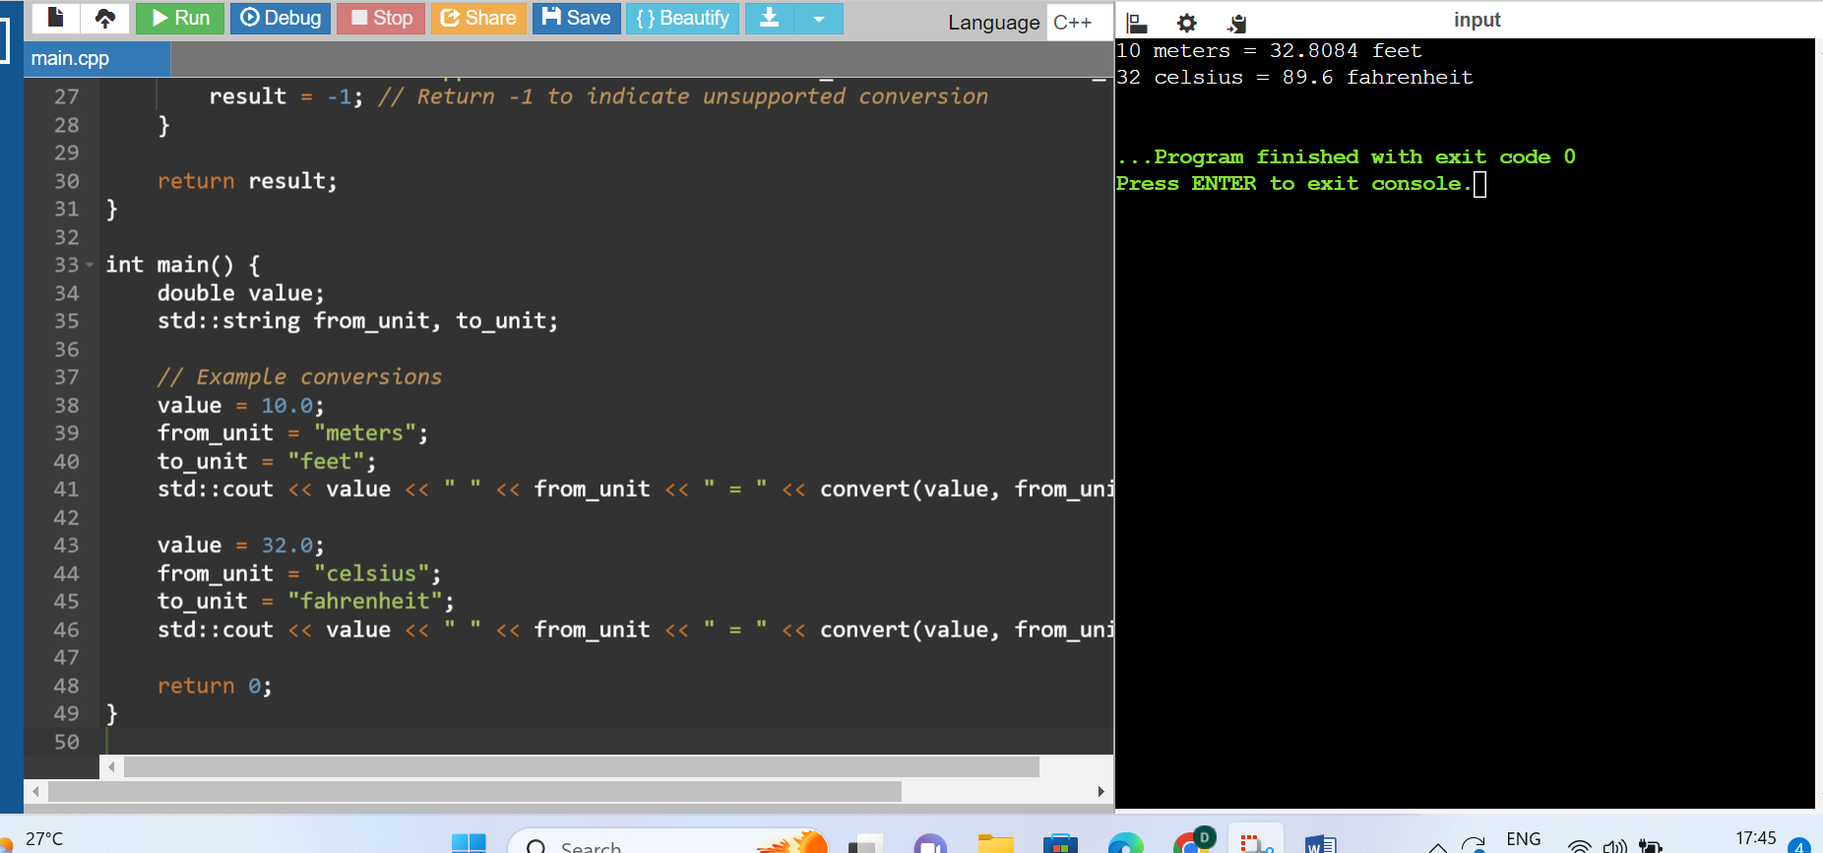

**8. Statistics (C++) - Implement functions average, minimum, and maximum that can take an array of integers or doubles as input, depending on the function call.**

**Answer:**

#include <iostream>

#include <algorithm> // for std::min_element and std::max_element

// Template function to calculate the average of an array

template <typename T>

T average(const T* array, size_t size) {

T sum = 0;

for (size_t i = 0; i < size; ++i) {

sum += array[i];

}

return sum / size;

}

// Template function to find the minimum value in an array

template <typename T>

T minimum(const T* array, size_t size) {

return *std::min_element(array, array + size);

}

// Template function to find the maximum value in an array

template <typename T>

T maximum(const T* array, size_t size) {

return *std::max_element(array, array + size);

}

int main() {

// Example with integers

int intArray[] = {1, 2, 3, 4, 5};

size_t intSize = sizeof(intArray) / sizeof(intArray[0]);

std::cout << "Integer array average: " << average(intArray, intSize) << std::endl;

std::cout << "Integer array minimum: " << minimum(intArray, intSize) << std::endl;

std::cout << "Integer array maximum: " << maximum(intArray, intSize) << std::endl;

// Example with doubles

double doubleArray[] = {1.1, 2.2, 3.3, 4.4, 5.5};

size_t doubleSize = sizeof(doubleArray) / sizeof(doubleArray[0]);

std::cout << "Double array average: " << average(doubleArray, doubleSize) << std::endl;

std::cout << "Double array minimum: " << minimum(doubleArray, doubleSize) << std::endl;

std::cout << "Double array maximum: " << maximum(doubleArray, doubleSize) << std::endl;

return 0;

}

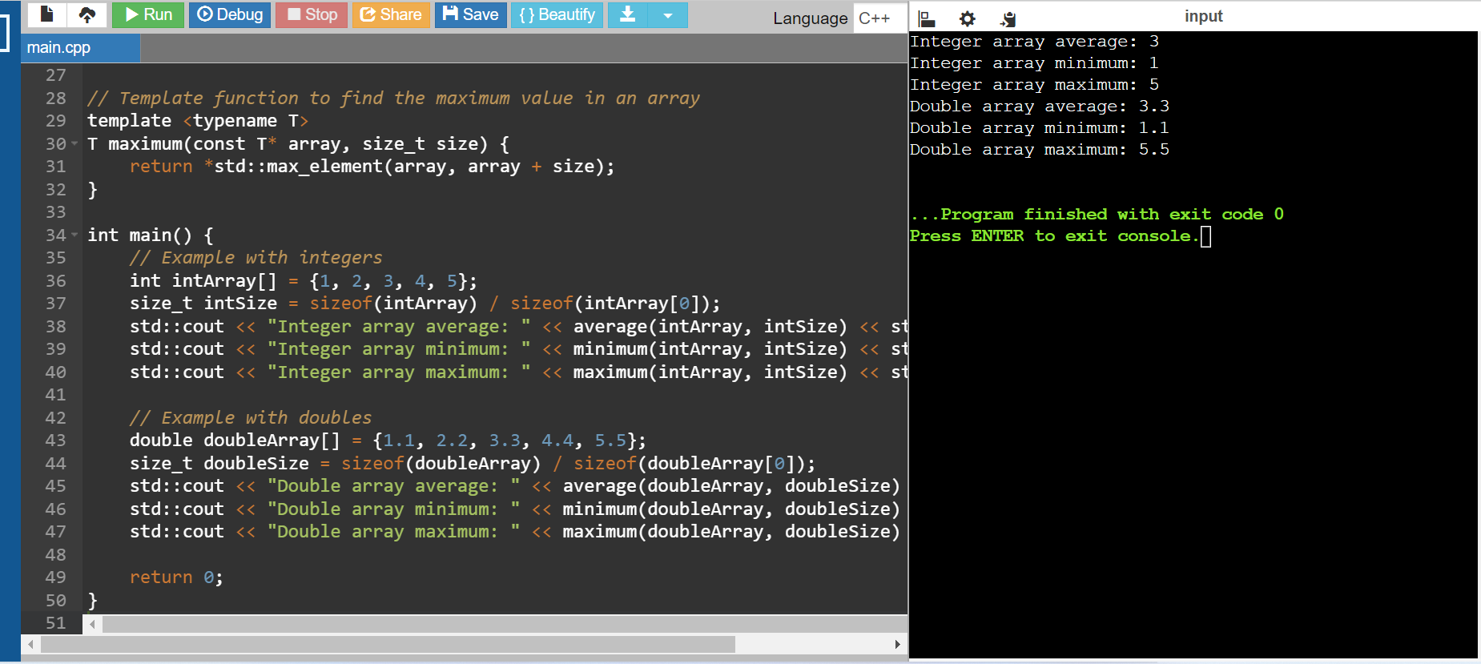

**9.Polynomial Addition (C++) - Define a class Polynomial to represent polynomials with terms (coefficient and exponent).**

**Answer:**

#include <iostream>

#include <vector>

// Structure to represent a term in the polynomial

struct Term {

double coefficient;

int exponent;

Term(double coeff = 0.0, int exp = 0) : coefficient(coeff), exponent(exp) {}

};

// Polynomial class

class Polynomial {

private:

std::vector<Term> terms; // Vector to store polynomial terms

public:

// Constructor to initialize polynomial from a list of terms

Polynomial(const std::vector<Term>& termsList) : terms(termsList) {}

// Function to add another polynomial to this polynomial

void add(const Polynomial& other) {

for (const auto& term : other.terms) {

addTerm(term.coefficient, term.exponent);

}

}

// Function to add a single term to the polynomial

void addTerm(double coefficient, int exponent) {

// Search for existing term with same exponent

for (auto& term : terms) {

if (term.exponent == exponent) {

term.coefficient += coefficient;

return;

}

}

// If not found, add as a new term

terms.push_back(Term(coefficient, exponent));

}

// Function to print the polynomial

void print() const {

bool firstTerm = true;

for (const auto& term : terms) {

if (!firstTerm && term.coefficient >= 0) {

std::cout << " + ";

}

std::cout << term.coefficient;

if (term.exponent > 0) {

std::cout << "x^" << term.exponent;

}

firstTerm = false;

}

std::cout << std::endl;

}

};

int main() {

// Example usage

std::vector<Term> poly1Terms = { {2.0, 3}, {1.0, 1}, {5.0, 0} };

Polynomial poly1(poly1Terms);

std::vector<Term> poly2Terms = { {3.0, 2}, {1.0, 1}, {-2.0, 0} };

Polynomial poly2(poly2Terms);

std::cout << "Polynomial 1: ";

poly1.print();

std::cout << "Polynomial 2: ";

poly2.print();

// Add polynomial 2 to polynomial 1

poly1.add(poly2);

std::cout << "After addition: ";

poly1.print();

return 0;

}

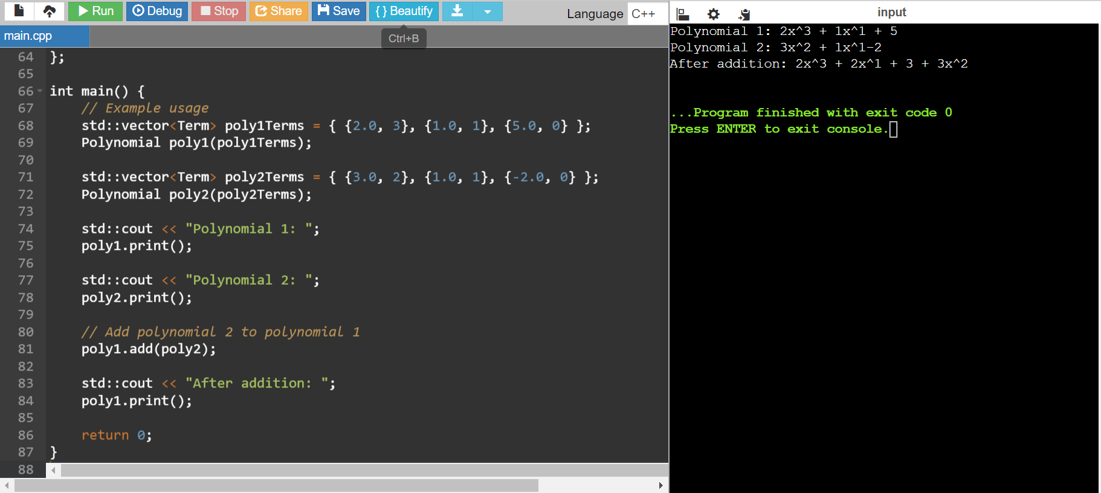

**10. Overload the + operator to add two Polynomial objects and return a new Polynomial with the combined terms**.

Answer:

#include <iostream>

#include <vector>

// Structure to represent a term in the polynomial

struct Term {

double coefficient;

int exponent;

Term(double coeff = 0.0, int exp = 0) : coefficient(coeff), exponent(exp) {}

};

// Polynomial class

class Polynomial {

private:

std::vector<Term> terms; // Vector to store polynomial terms

public:

// Constructor to initialize polynomial from a list of terms

Polynomial(const std::vector<Term>& termsList) : terms(termsList) {}

// Function to add another polynomial to this polynomial

void add(const Polynomial& other) {

for (const auto& term : other.terms) {

addTerm(term.coefficient, term.exponent);

}

}

// Function to add a single term to the polynomial

void addTerm(double coefficient, int exponent) {

// Search for existing term with same exponent

for (auto& term : terms) {

if (term.exponent == exponent) {

term.coefficient += coefficient;

return;

}

}

// If not found, add as a new term

terms.push_back(Term(coefficient, exponent));

}

// Overloading + operator to add two polynomials

Polynomial operator+(const Polynomial& other) const {

Polynomial result = *this; // Create a copy of current object

// Add terms from 'other' polynomial to 'result' polynomial

for (const auto& term : other.terms) {

result.addTerm(term.coefficient, term.exponent);

}

return result;

}

// Function to print the polynomial

void print() const {

bool firstTerm = true;

for (const auto& term : terms) {

if (!firstTerm && term.coefficient >= 0) {

std::cout << " + ";

}

std::cout << term.coefficient;

if (term.exponent > 0) {

std::cout << "x^" << term.exponent;

}

firstTerm = false;

}

std::cout << std::endl;

}

};

int main() {

// Example usage

std::vector<Term> poly1Terms = { {2.0, 3}, {1.0, 1}, {5.0, 0} };

Polynomial poly1(poly1Terms);

std::vector<Term> poly2Terms = { {3.0, 2}, {1.0, 1}, {-2.0, 0} };

Polynomial poly2(poly2Terms);

std::cout << "Polynomial 1: ";

poly1.print();

std::cout << "Polynomial 2: ";

poly2.print();

// Add polynomial 2 to polynomial 1 using operator+

Polynomial result = poly1 + poly2;

std::cout << "After addition: ";

result.print();

return 0;

}

