**Date:19-07-2024**

**Day_4_Linux_Assignments:**

**1.File Management: Create, rename, or delete multiple files based on a pattern or criteria. Organize files into a specific directory structure**.

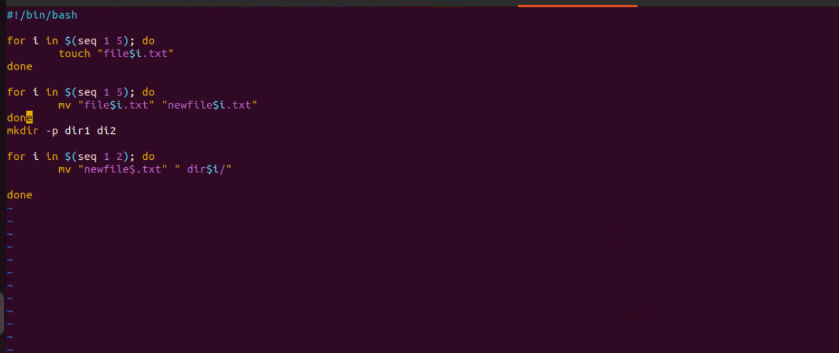

**2. Text Processing:Search and replace text within a group of files.Extract specific information from log files or data sets.Format text files in a particular way**

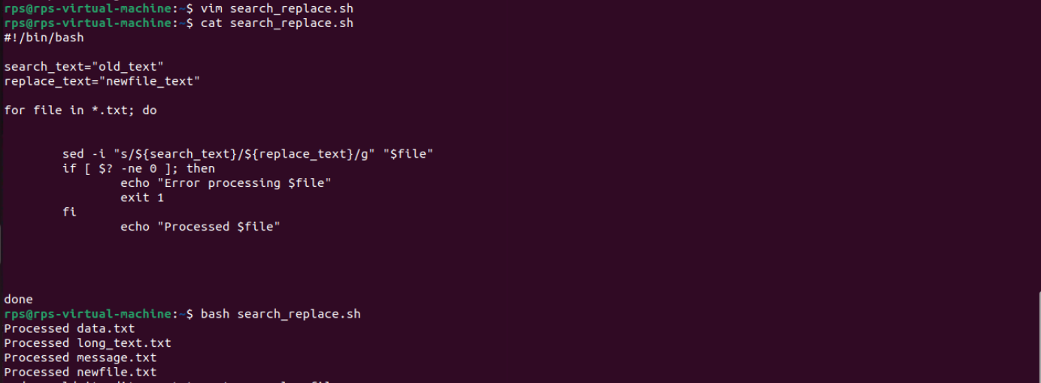

**3. write a shell script called file_checker.sh that checks if a file exits or not.the script take in file name as an argument and try to run cat on that file. Sh the script should then check the exit code of the cat command to determine if the file exists or not.if the file exists ,the script should print file exists!. if the file does not exist; the script should print file does not exist!. Bonus: change the actual output of cat and only include your script output (e.g file exits ! or file does not exist file).**

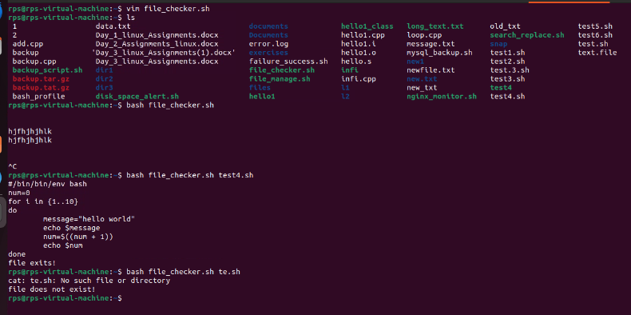

**4. Write a shell script called timely_greeting.sh that greets you based on the current time. The script should call the date command, extract the current hour (look into using %H) and then print the following greeting based on the time. If it is between 5AM (05:00) and 12PM (12:00): Good morning!If it is between 12PM (12:00) and 6PM (18:00): Good afternoon!If it is between 6PM (18:00) and 5AM (5:00): Good night!**

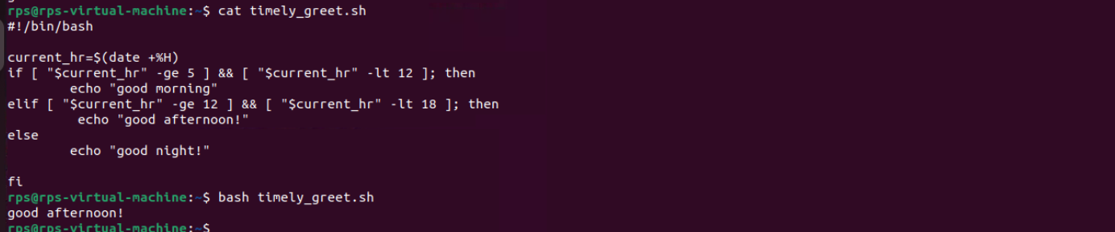

**5.calculator**

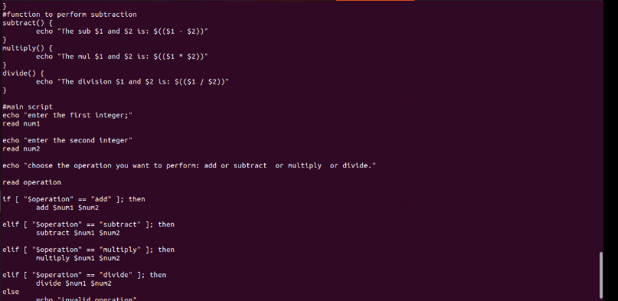

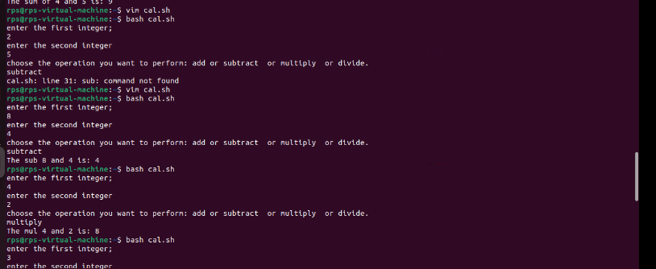

**6.Title: Create, Write, and Read Files Using Shell Script Objective: Develop a shell script that can create a file, write user-provided content into the file, and then read and display the content of the file.**

