14/06/2025

**Wipro_Training_Day_01**

|  |  |  |
| --- | --- | --- |
|  | **Dual-core** | **Quad-core** |
| 1. | It consists of 2 cores, each designated to perform a specific task. | It consists of 4 cores which give the ability to perform multiple jobs concurrently. |
| 2. | Resource-efficient as it uses less power as compared to Quad-core systems. | Resource utilization is more as compared to dual-core because the number of cores is more. |
| 3. | The clock speed and computation capability are slower than Quad-core. | It is much faster than dual-core systems and computational efficiency is high. |
| 4. | Parallel processing capability is not available in these processors. | It has 4 cores which give it the capability of parallel computing. |
| 5. | The graphic support of the dual-core system is weak and it cannot run heavy graphics. | The graphic support of the quad-core system is high and it is used to run heavy graphics. |
| 6. | The hardware of these processors does not get heated as they produce little heat. | Heat ejection is high and due to this, these processors make the hardware gets heated. |
| 7. | The performance of dual-core processing systems is good. | The performance of dual-core processing systems is better. |
| 8. | Not good for tasks like video editing or animations. | Easily handles the task of video editing and animations. |

**Comparision Between i5 and i7 Processor:**

I5 Processor:

* **Cost:** The i5 costs less than the i7. If you use your computer for general tasks with some gaming and light apps, the i5 is all you need.
* **Widespread use:** The i5 is a very popular processor found in many prebuilt mainstream computers. Plus, it features Turbo Boost technology for [overclocking your CPU](https://www.avg.com/en/signal/how-to-overclock-cpu), which can boost processing power without a hardware upgrade.
* **Speed:** For intensive tasks or high-end gaming, the i5 processor may slow down your workflow or struggle to maintain consistent performance. The i5 is also sensitive to higher voltages.
* **Updates:** Compared to the i7, the i5 is less likely to adapt to changing processing requirements

I7 Processor:

* **Processing power:** The i7 has powerful processing capabilities and more cores. It’s suited for demanding tasks like content creation and editing with the Adobe suite and multitasking — processing these tasks with speed and ease.
* **Cooling system:** The i7 also has a reliable cooling system. Heavy tasks can overheat your processor, so it’s important to [check your CPU’s temperature](https://www.avg.com/en/signal/check-cpu-temperature). And while you’re at it, [fix that loud computer fan](https://www.avg.com/en/signal/fix-loud-computer-fan) whirring in the background.
* **Gaming:** Comparing the i5 vs i7 for gaming, the i7 is better for intensive, high-end gaming performance. Plus, the i7 features Turbo Boost Max Technology 3.0 — the latest line in Intel’s overclocking feature.
* **Cost:** Computers with i7 processors are more expensive than those with i5 cores — though not by much.
* **Energy use:** Compared to other processors, the Intel Core i7’s power consumption is high.

Date-17/06/2024

**Wipro_Training_DAY_02:**

|  |  |  |  |  |
| --- | --- | --- | --- | --- |
|  | N | H | H | H |
| 18 | 255 | 0 | 0 | 0 |
| 19 | 255 | 128 | 0 | 0 |
| /10 | 255 | 192 | 0 | 0 |
| /11 | 255 | 224 | 0 | 0 |
| /12 | 255 | 240 | 0 | 0 |
| /13 | 255 | 248 | 0 | 0 |
| /14 | 255 | 252 | 0 | 0 |
| /15 | 255 | 254 | 0 | 0 |
| /16 | 255 | 255 | 128 | 0 |
| /17 | 255 | 255 | 192 | 0 |
| /18 | 255 | 255 | 224 | 0 |
| /19 | 255 | 255 | 240 | 0 |
| /20 | 255 | 255 | 248 | 0 |
| /21 | 255 | 255 | 252 | 0 |
| /22 | 255 | 255 | 254 | 0 |
| /23 | 255 | 255 | 255 | 0 |
| /24 | 255 | 255 | 255 | 0 |
| /25 | 255 | 255 | 255 | 128 |
| /26 | 255 | 255 | 255 | 192 |
| /27 | 255 | 255 | 255 | 224 |
| /28 | 255 | 255 | 255 | 240 |
| /29 | 255 | 255 | 255 | 248 |
| /30 | 255 | 255 | 255 | 252 |
| /31 | 255 | 255 | 255 | 254 |
| /32 | 255 | 255 | 255 | 255 |

Subnet mask=255.255.255.0

Network Address=70.49.72.0

Answers:

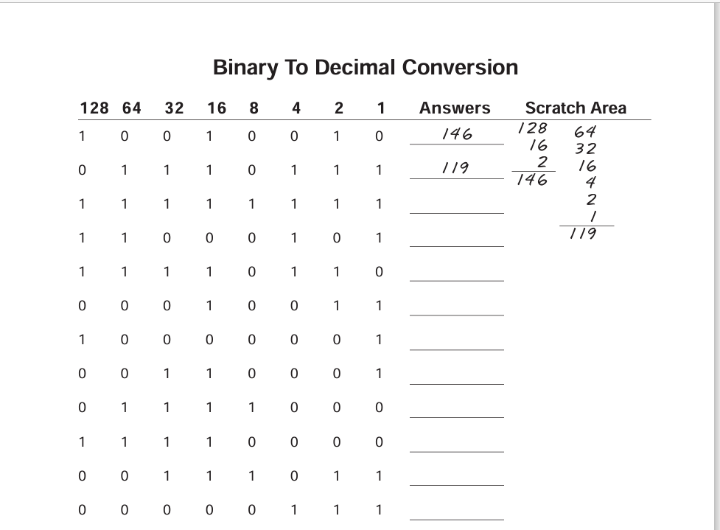146

119

255

197

246

19

129

49

120

240

59

7

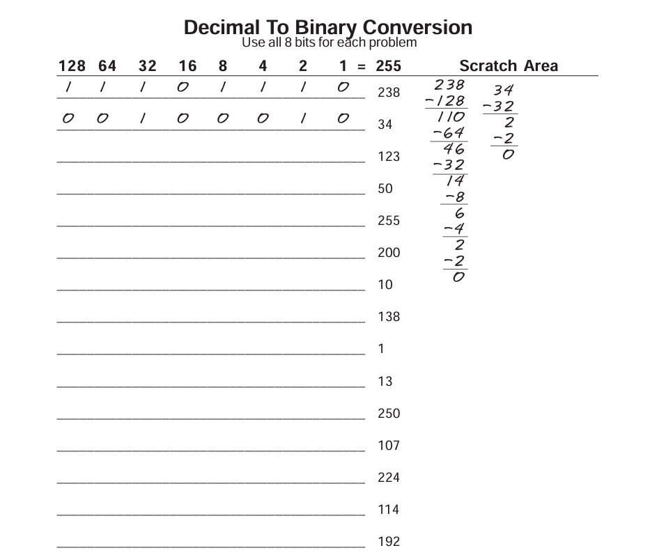

Answers:

238=11101110

34=00100010

123=1111011

50=11010

2551111111

200=11001000

10=1010

138=10001010

1=1

13=1101

250=11111010

107=1101011

224=11100000

114=1110010

192=11000000

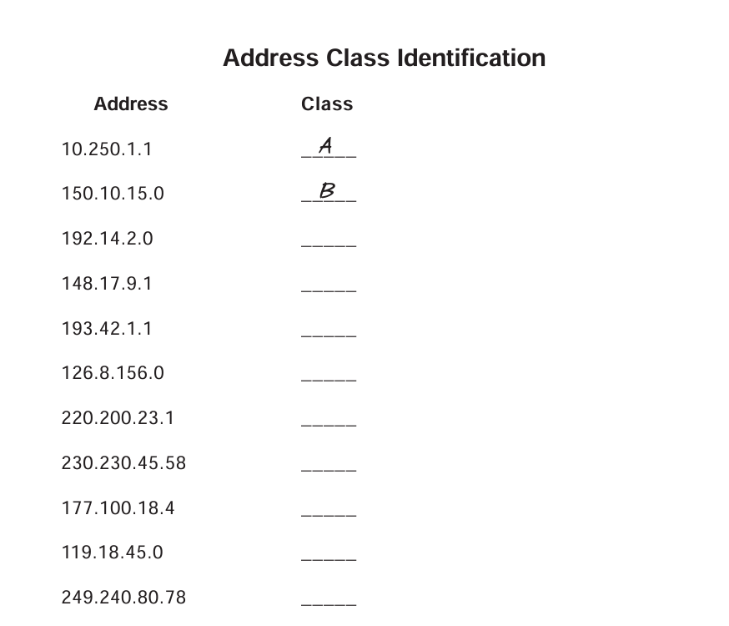

Answers:

Class

A

B

C

B

C

A

C

D

B

A

E

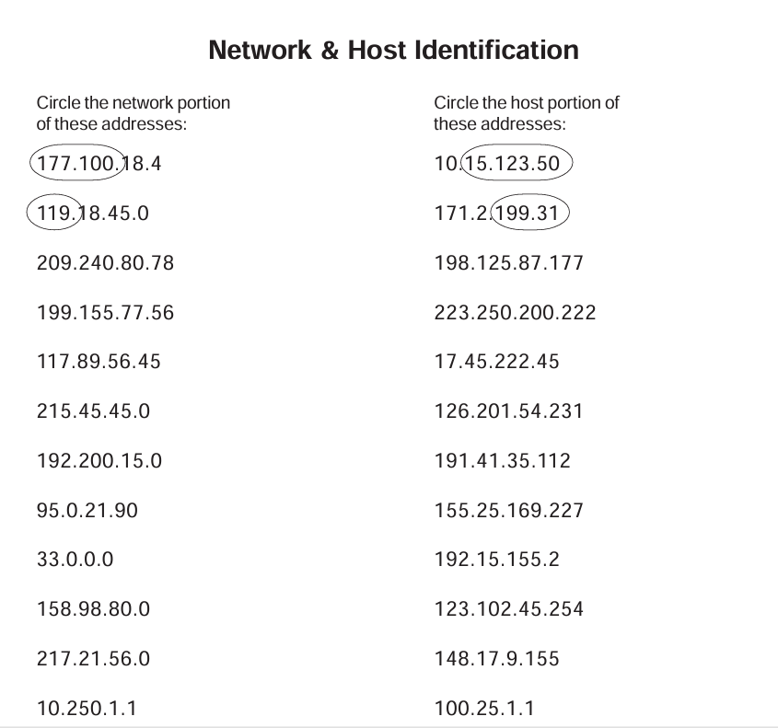

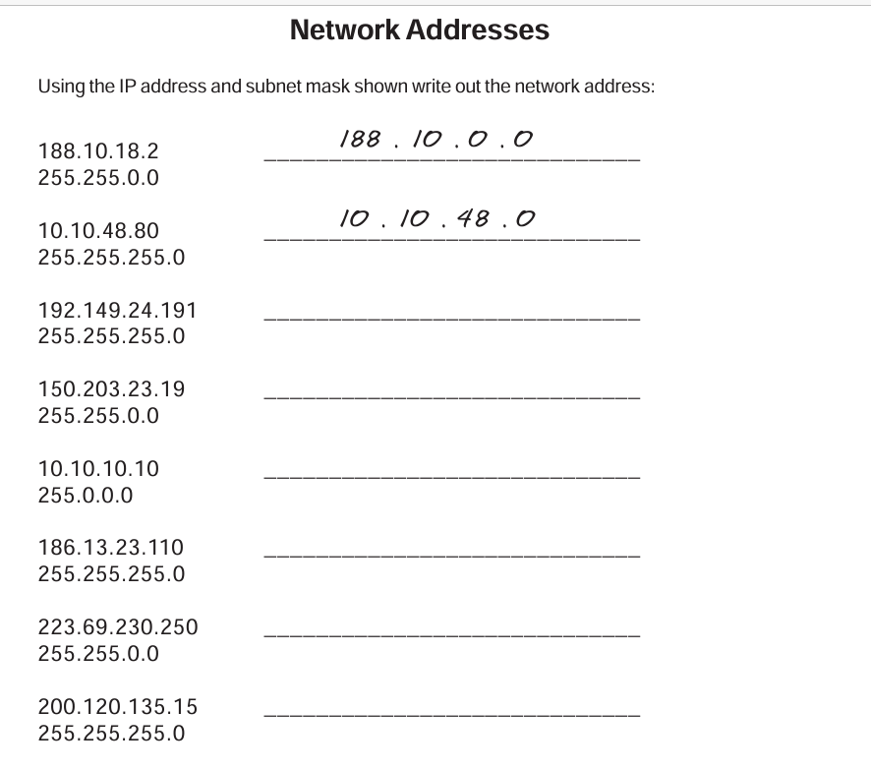

Answers:

188.10.0.0

10.10.48.0

192.149.24.0

150.203.0.0

10.0.0.0

186.13.23.110

223.69.0.0

200.120.135.0

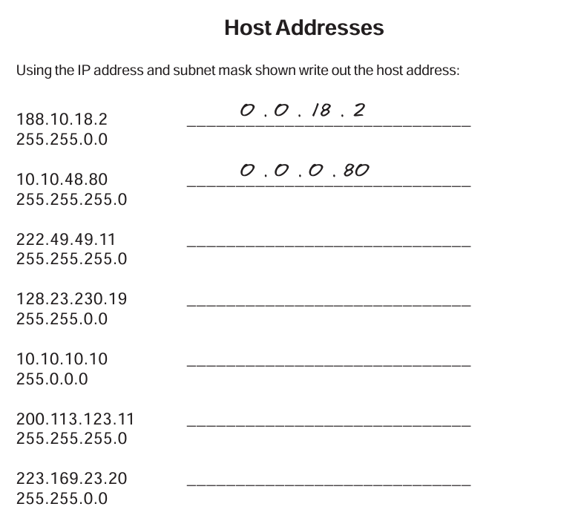

Answer:

0.0.18.2

0.0.0.80

0.0.0.11

0.0.230.19

0.10.10.10

0.0.0.11

0.0.23.20

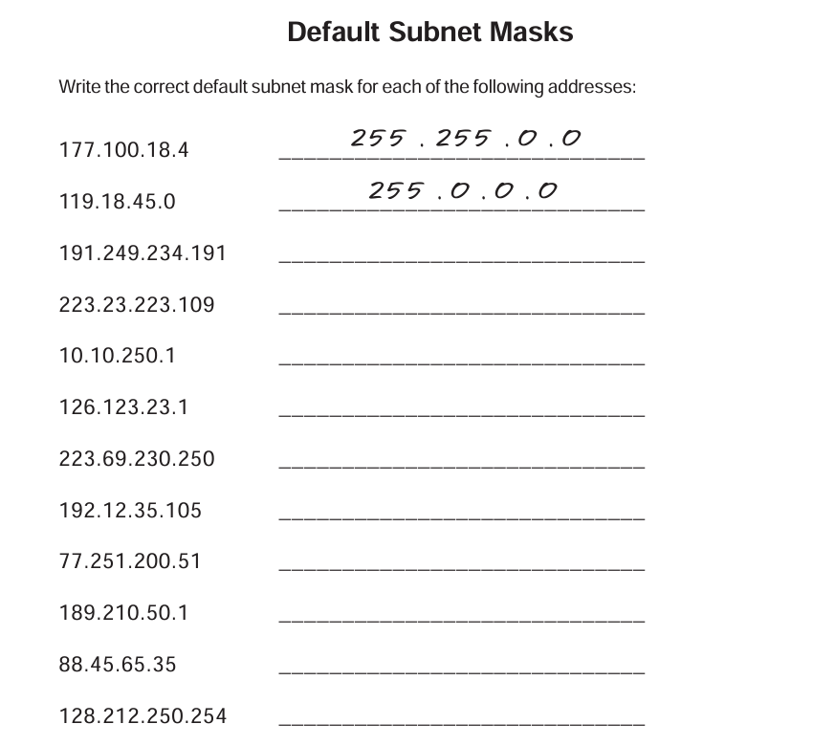

Answers:

255.255.0.0

255.0.0.0

255.255.0.0

255.255.255.0

255.0.0.0

255.0.0.0

255.255.255.0

255.0.0.0

255.255.0.0

255.0.0.0

Date-18/06/2024

**Wipro_training_Day_03:**

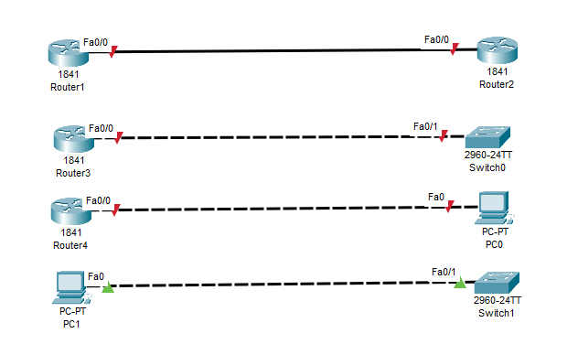

Lab =1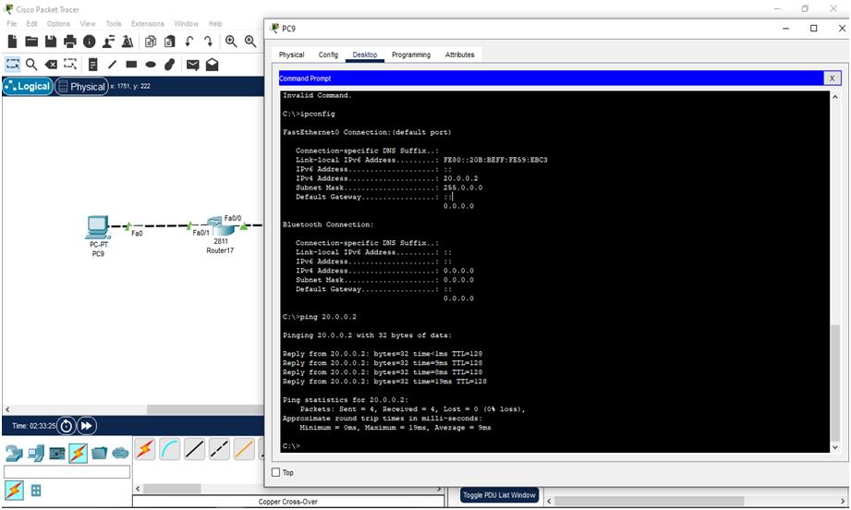

Lab 2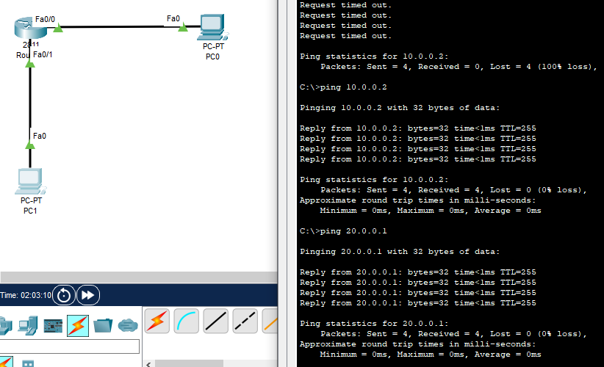Lab 3: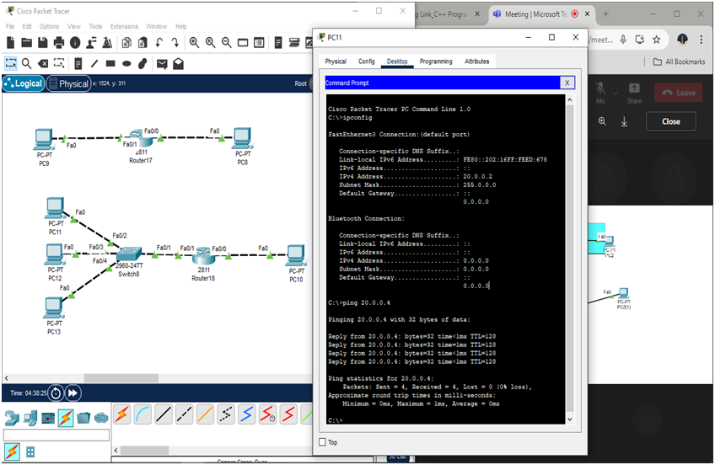

Lab 4:

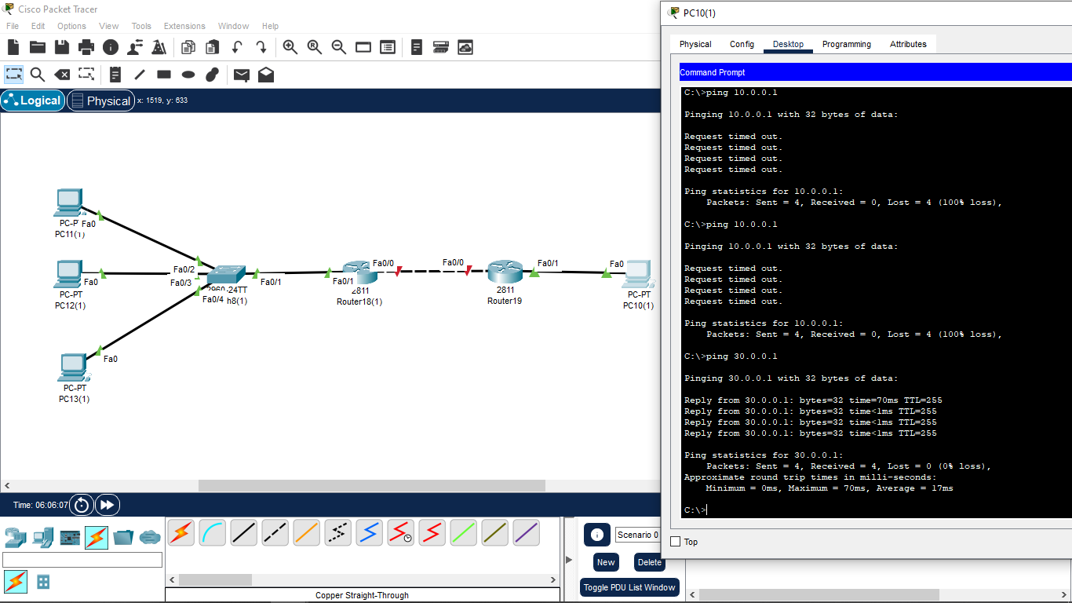

Date:19/06/2024

**Wipro_Training_DAY_04:**

LAB 1:

Static Routing

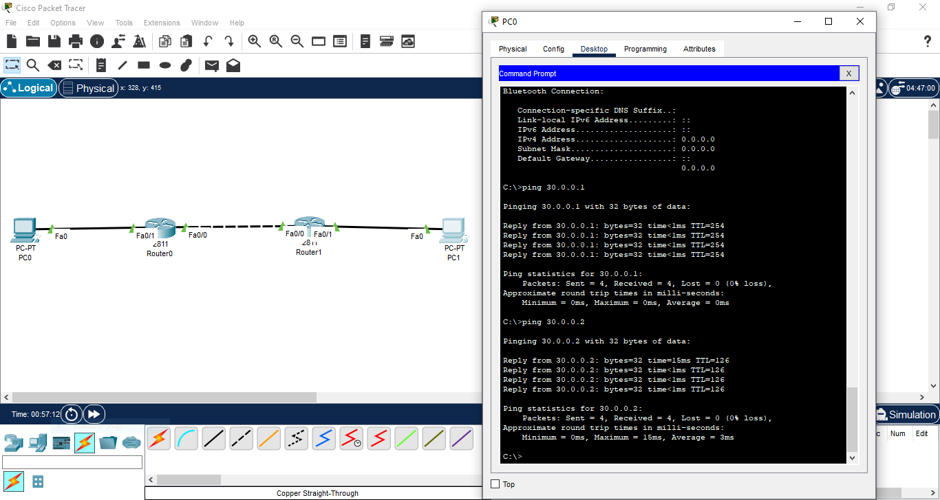

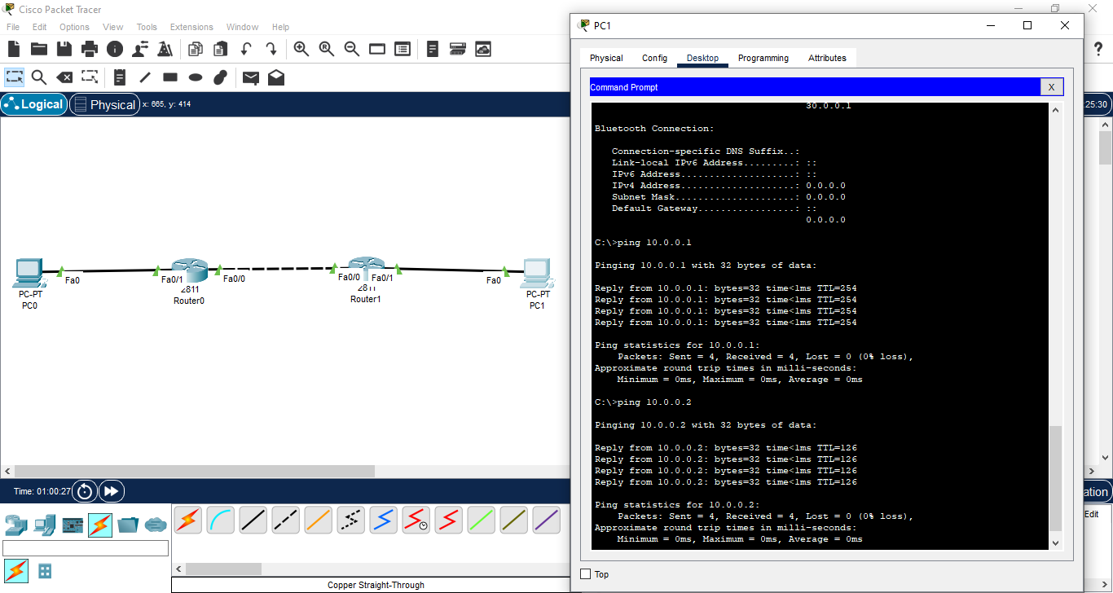

Date:20/06/2024

**DAY 05:**

OSI Model:

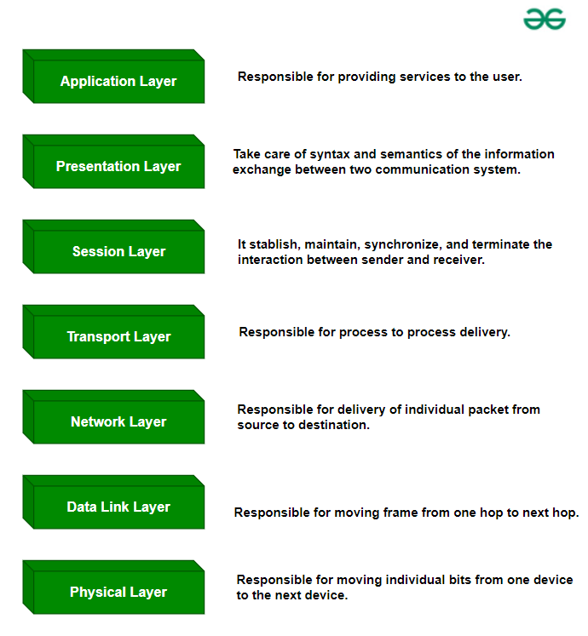

|  |  |
| --- | --- |
| **OSI Model** | **TCP/IP Model** |
| It stands for Open System Interconnection. | It stands for Transmission Control Protocol. |
| OSI model has been developed by ISO (International Standard Organization). | It was developed by ARPANET (Advanced Research Project Agency Network). |
| It is an independent standard and generic protocol used as a communication gateway between the network and the end user. | It consists of standard protocols that lead to the development of an internet. It is a communication protocol that provides the connection among the hosts. |
| In the OSI model, the transport layer provides a guarantee for the delivery of the packets. | The transport layer does not provide the surety for the delivery of packets. But still, we can say that it is a reliable model. |
| This model is based on a vertical approach. | This model is based on a horizontal approach. |
| In this model, the session and presentation layers are separated, i.e., both the layers are different. | In this model, the session and presentation layer are not different layers. Both layers are included in the application layer. |
| It is also known as a reference model through which various networks are built. For example, the TCP/IP model is built from the OSI model. It is also referred to as a guidance tool. | It is an implemented model of an OSI model. |
| In this model, the network layer provides both connection-oriented and connectionless service. | The network layer provides only connectionless service. |
| Protocols in the OSI model are hidden and can be easily replaced when the technology changes. | In this model, the protocol cannot be easily replaced. |
| It consists of 7 layers. | It consists of 4 layers. |
| OSI model defines the services, protocols, and interfaces as well as provides a proper distinction between them. It is protocol independent. | In the TCP/IP model, services, protocols, and interfaces are not properly separated. It is protocol dependent. |
| The usage of this model is very low. | This model is highly used. |

LAB 1: NAT Enable Concept

