GET
FILE='C:\Users\ADMIN\Desktop\Dhanashri\Bsc ASA SOS\SEM 5\Multivariate Analysis\Insurance.sav'.
DATASET NAME DataSet1 WINDOW=FRONT.
GGRAPH
/GRAPHDATASET NAME="graphdataset"
VARIABLES=smoker[LEVEL=nominal]
MISSING=LISTWISE REPORTMISSING=NO
/GRAPHSPEC SOURCE=VIZTEMPLATE(NAME="Bar of Counts"[LOCATION=LOCAL]
MAPPING( "categories"="smoker"[DATASET="graphdataset"] "Summary"="count"))
VIZSTYLESHEET="Traditional"[LOCATION=LOCAL]
LABEL='BAR OF COUNTS: smoker'
DEFAULTTEMPLATE=NO.

SMOKERS Bar Chart

Notes
Output Created |  | 10-AUG-2021 00:31:36
Comments
Input | Data | C:\Users\ADMIN\Desktop\Dhanashri\Bsc ASA SOS\SEM 5\Multivariate Analysis\Insurance.sav
Input | Active Dataset | DataSet1
Input | Filter | <none>
Input | Weight | <none>
Input | Split File | <none>
Input | N of Rows in Working Data File | 1338
Syntax |  | GGRAPH  /GRAPHDATASET NAME="graphdataset"  VARIABLES=smoker[LEVEL=nominal]  MISSING=LISTWISE REPORTMISSING=NO  /GRAPHSPEC SOURCE=VIZTEMPLATE(NAME="Bar of Counts"[LOCATION=LOCAL]  MAPPING( "categories"="smoker"[DATASET="graphdataset"] "Summary"="count"))  VIZSTYLESHEET="Traditional"[LOCATION=LOCAL]  LABEL='BAR OF COUNTS: smoker'  DEFAULTTEMPLATE=NO.
Resources | Processor Time | 00:00:09.06
Resources | Elapsed Time | 00:00:04.13

[DataSet1] C:\Users\ADMIN\Desktop\Dhanashri\Bsc ASA SOS\SEM 5\Multivariate Analysis\Insurance.sav

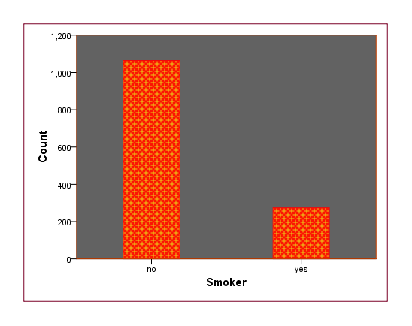

The above bar chart depicts the number of smokers. There are less number of smokers in the sample.

GRAPH
/PIE=COUNT BY region.

REGION Pie Chart

Notes
Output Created |  | 10-AUG-2021 01:01:23
Comments
Input | Data | C:\Users\ADMIN\Desktop\Dhanashri\Bsc ASA SOS\SEM 5\Multivariate Analysis\Insurance.sav
Input | Active Dataset | DataSet1
Input | Filter | <none>
Input | Weight | <none>
Input | Split File | <none>
Input | N of Rows in Working Data File | 1338
Syntax |  | GRAPH  /PIE=COUNT BY region.
Resources | Processor Time | 00:00:01.17
Resources | Elapsed Time | 00:00:00.62

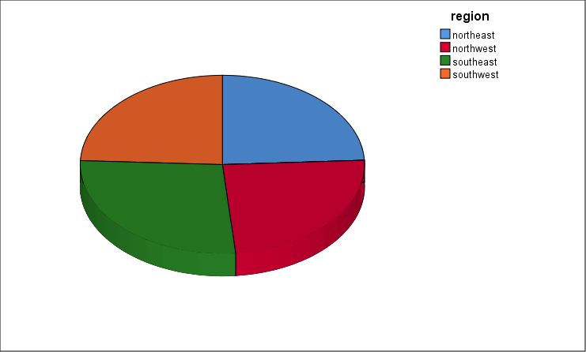

* Chart Builder.
GGRAPH
/GRAPHDATASET NAME="graphdataset" VARIABLES=age bmi charges MISSING=LISTWISE REPORTMISSING=NO
/GRAPHSPEC SOURCE=INLINE
/FITLINE TOTAL=NO.
BEGIN GPL
SOURCE: s=userSource(id("graphdataset"))
DATA: age=col(source(s), name("age"))
DATA: bmi=col(source(s), name("bmi"))
DATA: charges=col(source(s), name("charges"))
GUIDE: axis(dim(1.1), ticks(null()))
GUIDE: axis(dim(2.1), ticks(null()))
GUIDE: axis(dim(1), gap(0px))
GUIDE: axis(dim(2), gap(0px))
GUIDE: text.title(label("Scatterplot Matrix age,bmi,charges"))
TRANS: age_label = eval("age")
TRANS: bmi_label = eval("bmi")
TRANS: charges_label = eval("charges")
ELEMENT: point(position((age/age_label+bmi/bmi_label+charges/charges_label)*(age/age_label+
bmi/bmi_label+charges/charges_label)))
END GPL.

SCATTERPLOT MATRIX OF Age, BMI, Charges

Notes
Output Created |  | 10-AUG-2021 01:35:04
Comments
Input | Data | C:\Users\ADMIN\Desktop\Dhanashri\Bsc ASA SOS\SEM 5\Multivariate Analysis\Insurance.sav
Input | Active Dataset | DataSet1
Input | Filter | <none>
Input | Weight | <none>
Input | Split File | <none>
Input | N of Rows in Working Data File | 1338
Syntax |  | GGRAPH  /GRAPHDATASET NAME="graphdataset" VARIABLES=age bmi charges MISSING=LISTWISE REPORTMISSING=NO  /GRAPHSPEC SOURCE=INLINE  /FITLINE TOTAL=NO.  BEGIN GPL  SOURCE: s=userSource(id("graphdataset"))  DATA: age=col(source(s), name("age"))  DATA: bmi=col(source(s), name("bmi"))  DATA: charges=col(source(s), name("charges"))  GUIDE: axis(dim(1.1), ticks(null()))  GUIDE: axis(dim(2.1), ticks(null()))  GUIDE: axis(dim(1), gap(0px))  GUIDE: axis(dim(2), gap(0px))  GUIDE: text.title(label("Scatterplot Matrix age,bmi,charges"))  TRANS: age_label = eval("age")  TRANS: bmi_label = eval("bmi")  TRANS: charges_label = eval("charges")  ELEMENT: point(position((age/age_label+bmi/bmi_label+charges/charges_label)*(age/age_label+  bmi/bmi_label+charges/charges_label)))  END GPL.
Resources | Processor Time | 00:00:04.17
Resources | Elapsed Time | 00:00:01.65

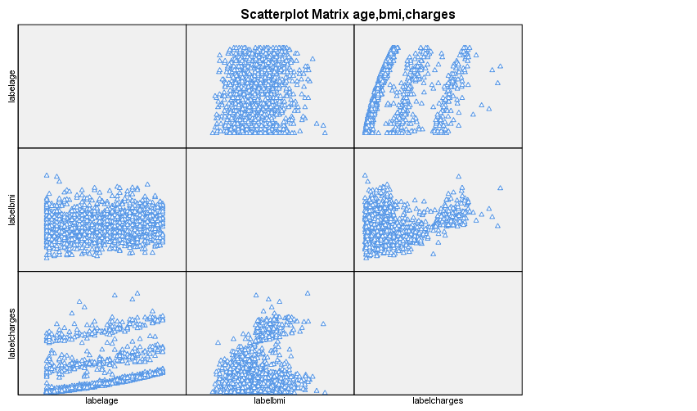

GGRAPH
/GRAPHDATASET NAME="graphdataset"
VARIABLES=charges[LEVEL=scale]
MISSING=LISTWISE REPORTMISSING=NO
/GRAPHSPEC SOURCE=VIZTEMPLATE(NAME="Histogram"[LOCATION=LOCAL]
MAPPING( "x"="charges"[DATASET="graphdataset"] "Summary"="count"))
VIZSTYLESHEET="Traditional"[LOCATION=LOCAL]
LABEL='HISTOGRAM: charges'
DEFAULTTEMPLATE=NO.

HISTOGRAM of Charges

Notes
Output Created |  | 10-AUG-2021 01:41:35
Comments
Input | Data | C:\Users\ADMIN\Desktop\Dhanashri\Bsc ASA SOS\SEM 5\Multivariate Analysis\Insurance.sav
Input | Active Dataset | DataSet1
Input | Filter | <none>
Input | Weight | <none>
Input | Split File | <none>
Input | N of Rows in Working Data File | 1338
Syntax |  | GGRAPH  /GRAPHDATASET NAME="graphdataset"  VARIABLES=charges[LEVEL=scale]  MISSING=LISTWISE REPORTMISSING=NO  /GRAPHSPEC SOURCE=VIZTEMPLATE(NAME="Histogram"[LOCATION=LOCAL]  MAPPING( "x"="charges"[DATASET="graphdataset"] "Summary"="count"))  VIZSTYLESHEET="Traditional"[LOCATION=LOCAL]  LABEL='HISTOGRAM: charges'  DEFAULTTEMPLATE=NO.
Resources | Processor Time | 00:00:00.69
Resources | Elapsed Time | 00:00:00.84

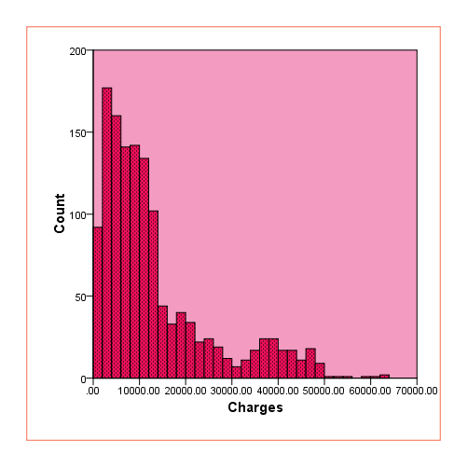

HISTOGRAM of BMI

BMI follows a normal distribution

Notes
Output Created |  | 10-AUG-2021 01:47:36
Comments
Input | Data | C:\Users\ADMIN\Desktop\Dhanashri\Bsc ASA SOS\SEM 5\Multivariate Analysis\Insurance.sav
Input | Active Dataset | DataSet1
Input | Filter | <none>
Input | Weight | <none>
Input | Split File | <none>
Input | N of Rows in Working Data File | 1338
Syntax |  | GGRAPH  /GRAPHDATASET NAME="graphdataset"  VARIABLES=bmi[LEVEL=scale]  MISSING=LISTWISE REPORTMISSING=NO  /GRAPHSPEC SOURCE=VIZTEMPLATE(NAME="Histogram"[LOCATION=LOCAL]  MAPPING( "x"="bmi"[DATASET="graphdataset"] "Summary"="count"))  VIZSTYLESHEET="Traditional"[LOCATION=LOCAL]  LABEL='HISTOGRAM: bmi'  DEFAULTTEMPLATE=NO.
Resources | Processor Time | 00:00:00.98
Resources | Elapsed Time | 00:00:00.99

GGRAPH
/GRAPHDATASET NAME="graphdataset"
VARIABLES=bmi[LEVEL=scale]
MISSING=LISTWISE REPORTMISSING=NO
/GRAPHSPEC SOURCE=VIZTEMPLATE(NAME="Histogram with Normal Distribution"[LOCATION=LOCAL]
MAPPING( "x"="bmi"[DATASET="graphdataset"]))
VIZSTYLESHEET="Traditional"[LOCATION=LOCAL]
LABEL='HISTOGRAM WITH NORMAL DISTRIBUTION: bmi'
DEFAULTTEMPLATE=NO.

Notes
Output Created |  | 10-AUG-2021 02:07:48
Comments
Input | Data | C:\Users\ADMIN\Desktop\Dhanashri\Bsc ASA SOS\SEM 5\Multivariate Analysis\Insurance.sav
Input | Active Dataset | DataSet1
Input | Filter | <none>
Input | Weight | <none>
Input | Split File | <none>
Input | N of Rows in Working Data File | 1338
Syntax |  | GGRAPH  /GRAPHDATASET NAME="graphdataset"  VARIABLES=bmi[LEVEL=scale]  MISSING=LISTWISE REPORTMISSING=NO  /GRAPHSPEC SOURCE=VIZTEMPLATE(NAME="Histogram with Normal Distribution"[LOCATION=LOCAL]  MAPPING( "x"="bmi"[DATASET="graphdataset"]))  VIZSTYLESHEET="Traditional"[LOCATION=LOCAL]  LABEL='HISTOGRAM WITH NORMAL DISTRIBUTION: bmi'  DEFAULTTEMPLATE=NO.
Resources | Processor Time | 00:00:00.75
Resources | Elapsed Time | 00:00:00.71

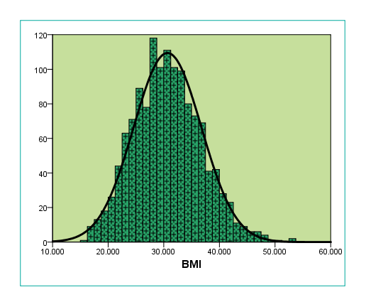

* Chart Builder.
GGRAPH
/GRAPHDATASET NAME="graphdataset" VARIABLES=age MISSING=LISTWISE REPORTMISSING=NO
/GRAPHSPEC SOURCE=INLINE.
BEGIN GPL
SOURCE: s=userSource(id("graphdataset"))
DATA: age=col(source(s), name("age"))
GUIDE: axis(dim(1), label("age"))
GUIDE: axis(dim(2), label("Frequency"))
GUIDE: text.title(label("Simple Line of age"))
ELEMENT: line(position(summary.count(bin.rect(age))), missing.wings())
END GPL.

LINE CHART Age

Notes
Output Created |  | 10-AUG-2021 07:37:50
Comments
Input | Data | C:\Users\ADMIN\Desktop\Dhanashri\Bsc ASA SOS\SEM 5\Multivariate Analysis\Insurance.sav
Input | Active Dataset | DataSet1
Input | Filter | <none>
Input | Weight | <none>
Input | Split File | <none>
Input | N of Rows in Working Data File | 1338
Syntax |  | GGRAPH  /GRAPHDATASET NAME="graphdataset" VARIABLES=age MISSING=LISTWISE REPORTMISSING=NO  /GRAPHSPEC SOURCE=INLINE.  BEGIN GPL  SOURCE: s=userSource(id("graphdataset"))  DATA: age=col(source(s), name("age"))  GUIDE: axis(dim(1), label("age"))  GUIDE: axis(dim(2), label("Frequency"))  GUIDE: text.title(label("Simple Line of age"))  ELEMENT: line(position(summary.count(bin.rect(age))), missing.wings())  END GPL.
Resources | Processor Time | 00:00:00.55
Resources | Elapsed Time | 00:00:00.50

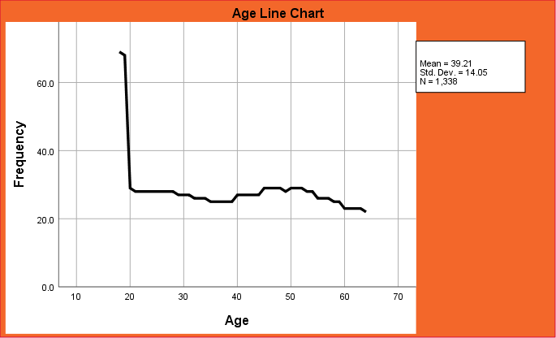

FREQUENCIES VARIABLES=children region
/ORDER=ANALYSIS.

Frequency table of Region and Children

Notes
Output Created |  | 10-AUG-2021 07:45:48
Comments
Input | Data | C:\Users\ADMIN\Desktop\Dhanashri\Bsc ASA SOS\SEM 5\Multivariate Analysis\Insurance.sav
Input | Active Dataset | DataSet1
Input | Filter | <none>
Input | Weight | <none>
Input | Split File | <none>
Input | N of Rows in Working Data File | 1338
Missing Value Handling | Definition of Missing | User-defined missing values are treated as missing.
Missing Value Handling | Cases Used | Statistics are based on all cases with valid data.
Syntax |  | FREQUENCIES VARIABLES=children region  /ORDER=ANALYSIS.
Resources | Processor Time | 00:00:00.03
Resources | Elapsed Time | 00:00:00.04

Statistics
 |  | children | region
N | Valid | 1338 | 1338
N | Missing | 0 | 0

Frequency Table

children
 |  | Frequency | Percent | Valid Percent | Cumulative Percent
Valid | 0 | 574 | 42.9 | 42.9 | 42.9
Valid | 1 | 324 | 24.2 | 24.2 | 67.1
Valid | 2 | 240 | 17.9 | 17.9 | 85.1
Valid | 3 | 157 | 11.7 | 11.7 | 96.8
Valid | 4 | 25 | 1.9 | 1.9 | 98.7
Valid | 5 | 18 | 1.3 | 1.3 | 100.0
Valid | Total | 1338 | 100.0 | 100.0

region
 |  | Frequency | Percent | Valid Percent | Cumulative Percent
Valid | northeast | 324 | 24.2 | 24.2 | 24.2
Valid | northwest | 325 | 24.3 | 24.3 | 48.5
Valid | southeast | 364 | 27.2 | 27.2 | 75.7
Valid | southwest | 325 | 24.3 | 24.3 | 100.0
Valid | Total | 1338 | 100.0 | 100.0

DESCRIPTIVES VARIABLES=age bmi charges
/STATISTICS=MEAN VARIANCE MIN MAX
/SORT=NAME (A).

Descriptives statistics for Age, BMI and Charges

Notes
Output Created |  | 10-AUG-2021 07:48:35
Comments
Input | Data | C:\Users\ADMIN\Desktop\Dhanashri\Bsc ASA SOS\SEM 5\Multivariate Analysis\Insurance.sav
Input | Active Dataset | DataSet1
Input | Filter | <none>
Input | Weight | <none>
Input | Split File | <none>
Input | N of Rows in Working Data File | 1338
Missing Value Handling | Definition of Missing | User defined missing values are treated as missing.
Missing Value Handling | Cases Used | All non-missing data are used.
Syntax |  | DESCRIPTIVES VARIABLES=age bmi charges  /STATISTICS=MEAN VARIANCE MIN MAX  /SORT=NAME (A).
Resources | Processor Time | 00:00:00.03
Resources | Elapsed Time | 00:00:00.02

Descriptive Statistics
 | N | Minimum | Maximum | Mean | Variance
age | 1338 | 18 | 64 | 39.21 | 197.401
bmi | 1338 | 15.960 | 53.130 | 30.66340 | 37.188
charges | 1338 | 1121.87 | 63770.43 | 13270.4223 | 146652372.153
Valid N (listwise) | 1338

EXAMINE VARIABLES=charges BY smoker
/PLOT BOXPLOT STEMLEAF
/COMPARE GROUPS
/STATISTICS DESCRIPTIVES
/CINTERVAL 95
/MISSING LISTWISE
/NOTOTAL.

Explore Charges with factor Smoker

Notes
Output Created |  | 10-AUG-2021 07:50:12
Comments
Input | Data | C:\Users\ADMIN\Desktop\Dhanashri\Bsc ASA SOS\SEM 5\Multivariate Analysis\Insurance.sav
Input | Active Dataset | DataSet1
Input | Filter | <none>
Input | Weight | <none>
Input | Split File | <none>
Input | N of Rows in Working Data File | 1338
Missing Value Handling | Definition of Missing | User-defined missing values for dependent variables are treated as missing.
Missing Value Handling | Cases Used | Statistics are based on cases with no missing values for any dependent variable or factor used.
Syntax |  | EXAMINE VARIABLES=charges BY smoker  /PLOT BOXPLOT STEMLEAF  /COMPARE GROUPS  /STATISTICS DESCRIPTIVES  /CINTERVAL 95  /MISSING LISTWISE  /NOTOTAL.
Resources | Processor Time | 00:00:00.78
Resources | Elapsed Time | 00:00:00.72

smoker

Case Processing Summary
 | smoker | Cases
 | smoker | Valid |  | Missing |  | Total
 | smoker | N | Percent | N | Percent | N | Percent
charges | no | 1064 | 100.0% | 0 | 0.0% | 1064 | 100.0%
charges | yes | 274 | 100.0% | 0 | 0.0% | 274 | 100.0%

Descriptives
 | smoker |  |  | Statistic | Std. Error
charges | no | Mean |  | 8434.2683 | 183.75117
charges | no | 95% Confidence Interval for Mean | Lower Bound | 8073.7121
charges | no | 95% Confidence Interval for Mean | Upper Bound | 8794.8245
charges | no | 5% Trimmed Mean |  | 7811.0211
charges | no | Median |  | 7345.4053
charges | no | Variance |  | 35925420.496
charges | no | Std. Deviation |  | 5993.78182
charges | no | Minimum |  | 1121.87
charges | no | Maximum |  | 36910.61
charges | no | Range |  | 35788.73
charges | no | Interquartile Range |  | 7379.69
charges | no | Skewness |  | 1.538 | .075
charges | no | Kurtosis |  | 3.149 | .150
charges | yes | Mean |  | 32050.2318 | 697.25036
charges | yes | 95% Confidence Interval for Mean | Lower Bound | 30677.5609
charges | yes | 95% Confidence Interval for Mean | Upper Bound | 33422.9028
charges | yes | 5% Trimmed Mean |  | 31820.4234
charges | yes | Median |  | 34456.3485
charges | yes | Variance |  | 133207311.206
charges | yes | Std. Deviation |  | 11541.54718
charges | yes | Minimum |  | 12829.46
charges | yes | Maximum |  | 63770.43
charges | yes | Range |  | 50940.97
charges | yes | Interquartile Range |  | 20283.24
charges | yes | Skewness |  | .128 | .147
charges | yes | Kurtosis |  | -1.037 | .293

charges

Stem-and-Leaf Plots

charges Stem-and-Leaf Plot for
smoker= no

Frequency Stem & Leaf

92.00 1 . 11111222255666666666666777777777788888999999&
99.00 2 . 0001111111122222223333444444555666777777888899
78.00 3 . 00011122222333344455555677788899999
90.00 4 . 00011122233334444445555566667777778888999
70.00 5 . 000111222223333344444566677899999
73.00 6 . 0011111222333334444555666677778899
68.00 7 . 00111111222233334444556666777799&
78.00 8 . 0000112222233344455555556666778889999
64.00 9 . 011122223334445556667778888899
60.00 10 . 001112233444555667777889999
74.00 11 . 00001122233333444555566777888888999
56.00 12 . 0011222233444556666789999
43.00 13 . 001122344446788899&
28.00 14 . 001223334449&
7.00 15 . 1&&
5.00 16 . 0&
4.00 17 . &&
8.00 18 . 89&
6.00 19 . 4&&
8.00 20 . 47&&
5.00 21 . &&
2.00 22 . &
46.00 Extremes (>=22494)

Stem width: 1000.00
Each leaf: 2 case(s)

& denotes fractional leaves.

charges Stem-and-Leaf Plot for
smoker= yes

Frequency Stem & Leaf

7.00 1 . 2334444
55.00 1 . 5555566666666667777777777777788888888888999999999999999
44.00 2 . 00000000111111111111122222233333333444444444
16.00 2 . 5556667777888999
22.00 3 . 0022233333344444444444
51.00 3 . 555556666666666667777777777888888888889999999999999
41.00 4 . 00000000001111111222222222233333334444444
31.00 4 . 5555666666666777777777888888889
2.00 5 . 12
2.00 5 . 58
3.00 6 . 023

Stem width: 10000.00
Each leaf: 1 case(s)

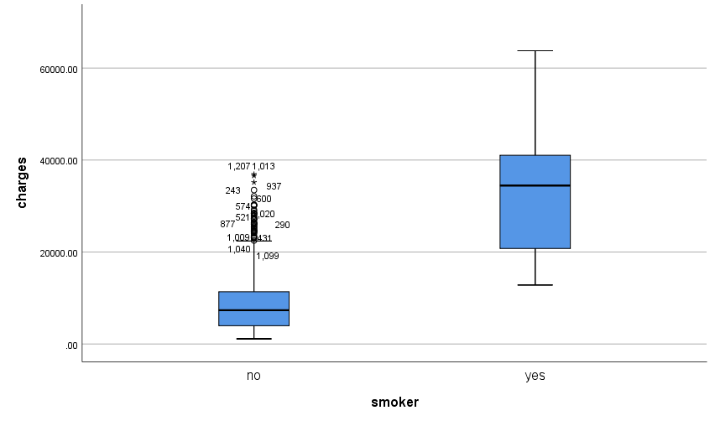

EXAMINE VARIABLES=charges BY sex
/PLOT BOXPLOT STEMLEAF
/COMPARE GROUPS
/STATISTICS DESCRIPTIVES
/CINTERVAL 95
/MISSING LISTWISE
/NOTOTAL.

Explore Charges with factor Sex

Notes
Output Created |  | 10-AUG-2021 07:51:47
Comments
Input | Data | C:\Users\ADMIN\Desktop\Dhanashri\Bsc ASA SOS\SEM 5\Multivariate Analysis\Insurance.sav
Input | Active Dataset | DataSet1
Input | Filter | <none>
Input | Weight | <none>
Input | Split File | <none>
Input | N of Rows in Working Data File | 1338
Missing Value Handling | Definition of Missing | User-defined missing values for dependent variables are treated as missing.
Missing Value Handling | Cases Used | Statistics are based on cases with no missing values for any dependent variable or factor used.
Syntax |  | EXAMINE VARIABLES=charges BY sex  /PLOT BOXPLOT STEMLEAF  /COMPARE GROUPS  /STATISTICS DESCRIPTIVES  /CINTERVAL 95  /MISSING LISTWISE  /NOTOTAL.
Resources | Processor Time | 00:00:00.94
Resources | Elapsed Time | 00:00:00.75

sex

Case Processing Summary
 | sex | Cases
 | sex | Valid |  | Missing |  | Total
 | sex | N | Percent | N | Percent | N | Percent
charges | female | 662 | 100.0% | 0 | 0.0% | 662 | 100.0%
charges | male | 676 | 100.0% | 0 | 0.0% | 676 | 100.0%

Descriptives
 | sex |  |  | Statistic | Std. Error
charges | female | Mean |  | 12569.5788 | 432.52936
charges | female | 95% Confidence Interval for Mean | Lower Bound | 11720.2818
charges | female | 95% Confidence Interval for Mean | Upper Bound | 13418.8759
charges | female | 5% Trimmed Mean |  | 11324.5294
charges | female | Median |  | 9412.9625
charges | female | Variance |  | 123848048.289
charges | female | Std. Deviation |  | 11128.70380
charges | female | Minimum |  | 1607.51
charges | female | Maximum |  | 63770.43
charges | female | Range |  | 62162.92
charges | female | Interquartile Range |  | 9589.84
charges | female | Skewness |  | 1.729 | .095
charges | female | Kurtosis |  | 2.754 | .190
charges | male | Mean |  | 13956.7512 | 498.88561
charges | male | 95% Confidence Interval for Mean | Lower Bound | 12977.1969
charges | male | 95% Confidence Interval for Mean | Upper Bound | 14936.3054
charges | male | 5% Trimmed Mean |  | 12811.7448
charges | male | Median |  | 9369.6158
charges | male | Variance |  | 168247513.288
charges | male | Std. Deviation |  | 12971.02592
charges | male | Minimum |  | 1121.87
charges | male | Maximum |  | 62592.87
charges | male | Range |  | 61471.00
charges | male | Interquartile Range |  | 14459.90
charges | male | Skewness |  | 1.336 | .094
charges | male | Kurtosis |  | .818 | .188

charges

Stem-and-Leaf Plots

charges Stem-and-Leaf Plot for
sex= female

Frequency Stem & Leaf

22.00 0 . 11111111111
107.00 0 . 22222222222222222222222222222333333333333333333333333
84.00 0 . 444444444444444444444455555555555555555555
71.00 0 . 66666666666666777777777777777777777
71.00 0 . 88888888888888888889999999999999999
66.00 1 . 000000000000011111111111111111111
59.00 1 . 22222222222222233333333333333
29.00 1 . 44444444444555
18.00 1 . 666667777
20.00 1 . 8888899999
13.00 2 . 000111
10.00 2 . 22333
14.00 2 . 444445
10.00 2 . 6677
3.00 2 . 8
65.00 Extremes (>=28923)

Stem width: 10000.00
Each leaf: 2 case(s)

charges Stem-and-Leaf Plot for
sex= male

Frequency Stem & Leaf

186.00 0 . 11111111111111111111111111111111111222222222222222222223333333333333344444444444444444444444
171.00 0 . 5555555555555556666666666666666666666777777777777788888888888888888889999999999999999
120.00 1 . 00000000000000000111111111111111112222222222222333333334444
41.00 1 . 5556677777888899999
38.00 2 . 00000111112233344
17.00 2 . 5567778
19.00 3 . 00234444
37.00 3 . 556666777888899999
3.00 4 . 0
44.00 Extremes (>=40721)

Stem width: 10000.00
Each leaf: 2 case(s)

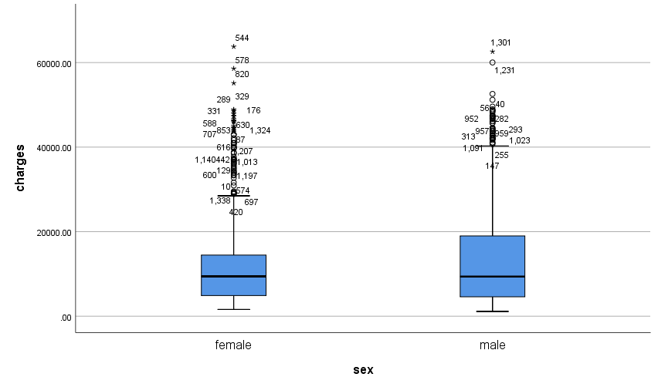

EXAMINE VARIABLES=charges BY region
/PLOT BOXPLOT STEMLEAF
/COMPARE GROUPS
/STATISTICS DESCRIPTIVES
/CINTERVAL 95
/MISSING LISTWISE
/NOTOTAL.

Explore Charges with factor Region

Notes
Output Created |  | 10-AUG-2021 07:53:02
Comments
Input | Data | C:\Users\ADMIN\Desktop\Dhanashri\Bsc ASA SOS\SEM 5\Multivariate Analysis\Insurance.sav
Input | Active Dataset | DataSet1
Input | Filter | <none>
Input | Weight | <none>
Input | Split File | <none>
Input | N of Rows in Working Data File | 1338
Missing Value Handling | Definition of Missing | User-defined missing values for dependent variables are treated as missing.
Missing Value Handling | Cases Used | Statistics are based on cases with no missing values for any dependent variable or factor used.
Syntax |  | EXAMINE VARIABLES=charges BY region  /PLOT BOXPLOT STEMLEAF  /COMPARE GROUPS  /STATISTICS DESCRIPTIVES  /CINTERVAL 95  /MISSING LISTWISE  /NOTOTAL.
Resources | Processor Time | 00:00:00.92
Resources | Elapsed Time | 00:00:00.81

Warnings
Text: region Command: EXAMINE
This procedure cannot use string variables longer than 8 bytes. The values will be truncated.

region

Case Processing Summary
 | region | Cases
 | region | Valid |  | Missing |  | Total
 | region | N | Percent | N | Percent | N | Percent
charges | northeas | 324 | 100.0% | 0 | 0.0% | 324 | 100.0%
charges | northwes | 325 | 100.0% | 0 | 0.0% | 325 | 100.0%
charges | southeas | 364 | 100.0% | 0 | 0.0% | 364 | 100.0%
charges | southwes | 325 | 100.0% | 0 | 0.0% | 325 | 100.0%

Descriptives
 | region |  |  | Statistic | Std. Error
charges | northeas | Mean |  | 13406.3845 | 625.32239
charges | northeas | 95% Confidence Interval for Mean | Lower Bound | 12176.1655
charges | northeas | 95% Confidence Interval for Mean | Upper Bound | 14636.6035
charges | northeas | 5% Trimmed Mean |  | 12305.9569
charges | northeas | Median |  | 10057.6520
charges | northeas | Variance |  | 126693102.651
charges | northeas | Std. Deviation |  | 11255.80307
charges | northeas | Minimum |  | 1694.80
charges | northeas | Maximum |  | 58571.07
charges | northeas | Range |  | 56876.28
charges | northeas | Interquartile Range |  | 11582.85
charges | northeas | Skewness |  | 1.493 | .135
charges | northeas | Kurtosis |  | 1.756 | .270
charges | northwes | Mean |  | 12417.5754 | 614.17942
charges | northwes | 95% Confidence Interval for Mean | Lower Bound | 11209.2924
charges | northwes | 95% Confidence Interval for Mean | Upper Bound | 13625.8584
charges | northwes | 5% Trimmed Mean |  | 11186.5903
charges | northwes | Median |  | 8965.7958
charges | northwes | Variance |  | 122595316.361
charges | northwes | Std. Deviation |  | 11072.27693
charges | northwes | Minimum |  | 1621.34
charges | northwes | Maximum |  | 60021.40
charges | northwes | Range |  | 58400.06
charges | northwes | Interquartile Range |  | 10196.84
charges | northwes | Skewness |  | 1.682 | .135
charges | northwes | Kurtosis |  | 2.625 | .270
charges | southeas | Mean |  | 14735.4114 | 732.28454
charges | southeas | 95% Confidence Interval for Mean | Lower Bound | 13295.3588
charges | southeas | 95% Confidence Interval for Mean | Upper Bound | 16175.4641
charges | southeas | 5% Trimmed Mean |  | 13589.9569
charges | southeas | Median |  | 9294.1319
charges | southeas | Variance |  | 195191595.783
charges | southeas | Std. Deviation |  | 13971.09859
charges | southeas | Minimum |  | 1121.87
charges | southeas | Maximum |  | 63770.43
charges | southeas | Range |  | 62648.55
charges | southeas | Interquartile Range |  | 15111.19
charges | southeas | Skewness |  | 1.251 | .128
charges | southeas | Kurtosis |  | .520 | .255
charges | southwes | Mean |  | 12346.9374 | 641.07695
charges | southwes | 95% Confidence Interval for Mean | Lower Bound | 11085.7385
charges | southwes | 95% Confidence Interval for Mean | Upper Bound | 13608.1363
charges | southwes | 5% Trimmed Mean |  | 11123.3345
charges | southwes | Median |  | 8798.5930
charges | southwes | Variance |  | 133568388.767
charges | southwes | Std. Deviation |  | 11557.17910
charges | southwes | Minimum |  | 1241.57
charges | southwes | Maximum |  | 52590.83
charges | southwes | Range |  | 51349.26
charges | southwes | Interquartile Range |  | 8717.98
charges | southwes | Skewness |  | 1.682 | .135
charges | southwes | Kurtosis |  | 2.109 | .270

charges

Stem-and-Leaf Plots

charges Stem-and-Leaf Plot for
region= northeas

Frequency Stem & Leaf

10.00 0 . 1111111111
46.00 0 . 2222222222222222222222222233333333333333333333
33.00 0 . 444444444444444444444445555555555
35.00 0 . 66666666666666666667777777777777777
37.00 0 . 8888888888888889999999999999999999999
33.00 1 . 000000000000001111111111111111111
30.00 1 . 222222222222333333333333333333
15.00 1 . 444444444445555
10.00 1 . 6666667777
7.00 1 . 8899999
11.00 2 . 00000001111
8.00 2 . 22223333
8.00 2 . 44444555
3.00 2 . 677
3.00 2 . 899
3.00 3 . 001
3.00 3 . 233
29.00 Extremes (>=34254)

Stem width: 10000.00
Each leaf: 1 case(s)

charges Stem-and-Leaf Plot for
region= northwes

Frequency Stem & Leaf

14.00 0 . 11111111111111
49.00 0 . 2222222222222222222222222222222223333333333333333
43.00 0 . 4444444444444444444444445555555555555555555
40.00 0 . 6666666666666666666666677777777777777777
30.00 0 . 888888888888888888999999999999
34.00 1 . 0000000000000000111111111111111111
25.00 1 . 2222222222222222233333333
13.00 1 . 4444444445555
8.00 1 . 66677777
8.00 1 . 88888899
11.00 2 . 00011111111
4.00 2 . 2333
6.00 2 . 444445
3.00 2 . 666
8.00 2 . 88888899
29.00 Extremes (>=30064)

Stem width: 10000.00
Each leaf: 1 case(s)

charges Stem-and-Leaf Plot for
region= southeas

Frequency Stem & Leaf

105.00 0 . 1111111111111111111222222222223333333333444444444444
88.00 0 . 5555555555666666677777778888888888889999999
55.00 1 . 00000011111112222222333444
28.00 1 . 6777888899999&
14.00 2 . 012344
13.00 2 . 567777&
6.00 3 . 44&
19.00 3 . 66677889&
10.00 4 . 0012
26.00 Extremes (>=42211)

Stem width: 10000.00
Each leaf: 2 case(s)

& denotes fractional leaves.

charges Stem-and-Leaf Plot for
region= southwes

Frequency Stem & Leaf

30.00 0 . 111111111111111111111111111111
39.00 0 . 222222222222222222333333333333333333333
39.00 0 . 444444444444444444455555555555555555555
38.00 0 . 66666666666666666777777777777777777777
36.00 0 . 888888888888888888888999999999999999
40.00 1 . 0000000000000000001111111111111111111111
26.00 1 . 22222222222222333333333333
8.00 1 . 44444555
6.00 1 . 666777
7.00 1 . 8889999
7.00 2 . 0000111
5.00 2 . 22333
4.00 2 . 4455
2.00 2 . 66
38.00 Extremes (>=27941)

Stem width: 10000.00
Each leaf: 1 case(s)

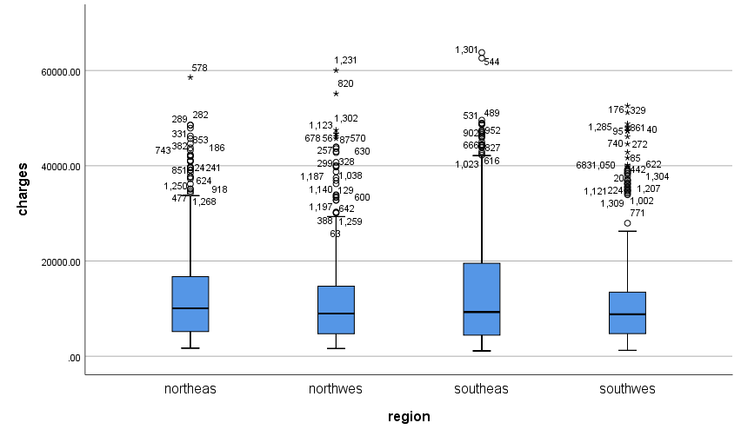

EXAMINE VARIABLES=age BY sex
/PLOT BOXPLOT STEMLEAF
/COMPARE GROUPS
/STATISTICS DESCRIPTIVES
/CINTERVAL 95
/MISSING LISTWISE
/NOTOTAL.

Explore Age with factor Sex

Notes
Output Created |  | 10-AUG-2021 07:54:32
Comments
Input | Data | C:\Users\ADMIN\Desktop\Dhanashri\Bsc ASA SOS\SEM 5\Multivariate Analysis\Insurance.sav
Input | Active Dataset | DataSet1
Input | Filter | <none>
Input | Weight | <none>
Input | Split File | <none>
Input | N of Rows in Working Data File | 1338
Missing Value Handling | Definition of Missing | User-defined missing values for dependent variables are treated as missing.
Missing Value Handling | Cases Used | Statistics are based on cases with no missing values for any dependent variable or factor used.
Syntax |  | EXAMINE VARIABLES=age BY sex  /PLOT BOXPLOT STEMLEAF  /COMPARE GROUPS  /STATISTICS DESCRIPTIVES  /CINTERVAL 95  /MISSING LISTWISE  /NOTOTAL.
Resources | Processor Time | 00:00:00.78
Resources | Elapsed Time | 00:00:00.72

sex

Case Processing Summary
 | sex | Cases
 | sex | Valid |  | Missing |  | Total
 | sex | N | Percent | N | Percent | N | Percent
age | female | 662 | 100.0% | 0 | 0.0% | 662 | 100.0%
age | male | 676 | 100.0% | 0 | 0.0% | 676 | 100.0%

Descriptives
 | sex |  |  | Statistic | Std. Error
age | female | Mean |  | 39.50 | .546
age | female | 95% Confidence Interval for Mean | Lower Bound | 38.43
age | female | 95% Confidence Interval for Mean | Upper Bound | 40.58
age | female | 5% Trimmed Mean |  | 39.39
age | female | Median |  | 40.00
age | female | Variance |  | 197.521
age | female | Std. Deviation |  | 14.054
age | female | Minimum |  | 18
age | female | Maximum |  | 64
age | female | Range |  | 46
age | female | Interquartile Range |  | 25
age | female | Skewness |  | .029 | .095
age | female | Kurtosis |  | -1.245 | .190
age | male | Mean |  | 38.92 | .540
age | male | 95% Confidence Interval for Mean | Lower Bound | 37.86
age | male | 95% Confidence Interval for Mean | Upper Bound | 39.98
age | male | 5% Trimmed Mean |  | 38.74
age | male | Median |  | 39.00
age | male | Variance |  | 197.406
age | male | Std. Deviation |  | 14.050
age | male | Minimum |  | 18
age | male | Maximum |  | 64
age | male | Range |  | 46
age | male | Interquartile Range |  | 25
age | male | Skewness |  | .082 | .094
age | male | Kurtosis |  | -1.244 | .188

age

Stem-and-Leaf Plots

age Stem-and-Leaf Plot for
sex= female

Frequency Stem & Leaf

66.00 1 . 888888888888888888888888888888888999999999999999999999999999999999
68.00 2 . 00000000000000111111111111122222222222223333333333333344444444444444
67.00 2 . 5555555555555666666666666677777777777777888888888888889999999999999
65.00 3 . 00000000000001111111111111222222222222233333333333334444444444444
62.00 3 . 55555555555566666666666677777777777788888888888889999999999999
67.00 4 . 0000000000000111111111111122222222222223333333333333344444444444444
72.00 4 . 555555555555556666666666666677777777777777788888888888888899999999999999
72.00 5 . 000000000000001111111111111112222222222222223333333333333344444444444444
65.00 5 . 55555555555556666666666666777777777777788888888888889999999999999
58.00 6 . 0000000000011111111111122222222222233333333333344444444444

Stem width: 10
Each leaf: 1 case(s)

age Stem-and-Leaf Plot for
sex= male

Frequency Stem & Leaf

71.00 1 . 88888888888888888888888888888888888899999999999999999999999999999999999
73.00 2 . 0000000000000001111111111111112222222222222223333333333333344444444444444
72.00 2 . 555555555555555666666666666666777777777777778888888888888899999999999999
67.00 3 . 0000000000000011111111111111222222222222233333333333334444444444444
63.00 3 . 555555555555566666666666667777777777777888888888888999999999999
68.00 4 . 00000000000000111111111111112222222222222233333333333334444444444444
72.00 4 . 555555555555555666666666666666777777777777778888888888888899999999999999
71.00 5 . 00000000000000011111111111111222222222222223333333333333344444444444444
63.00 5 . 555555555555566666666666667777777777777888888888888999999999999
56.00 6 . 00000000000011111111111222222222223333333333344444444444

Stem width: 10
Each leaf: 1 case(s)

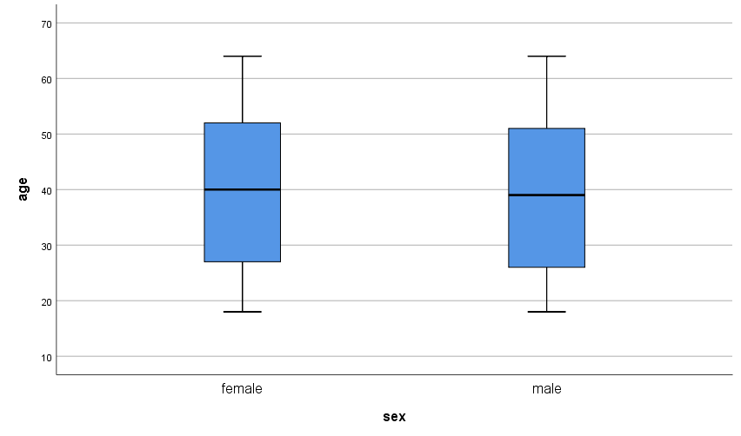

* Custom Tables.
CTABLES
/VLABELS VARIABLES=region smoker sex DISPLAY=LABEL
/TABLE region [COUNT F40.0] BY smoker > sex
/CATEGORIES VARIABLES=region smoker sex ORDER=A KEY=VALUE EMPTY=EXCLUDE
/CRITERIA CILEVEL=95.

Crosstab for Region, Smoker and Sex

Notes
Output Created |  | 10-AUG-2021 07:57:48
Comments
Input | Data | C:\Users\ADMIN\Desktop\Dhanashri\Bsc ASA SOS\SEM 5\Multivariate Analysis\Insurance.sav
Input | Active Dataset | DataSet1
Input | Filter | <none>
Input | Weight | <none>
Input | Split File | <none>
Input | N of Rows in Working Data File | 1338
Syntax |  | CTABLES  /VLABELS VARIABLES=region smoker sex DISPLAY=LABEL  /TABLE region [COUNT F40.0] BY smoker > sex  /CATEGORIES VARIABLES=region smoker sex ORDER=A KEY=VALUE EMPTY=EXCLUDE  /CRITERIA CILEVEL=95.
Resources | Processor Time | 00:00:00.06
Resources | Elapsed Time | 00:00:00.08

 |  | smoker
 |  | no |  | yes
 |  | sex |  | sex
 |  | female | male | female | male
 |  | Count | Count | Count | Count
region | northeast | 132 | 125 | 29 | 38
region | northwest | 135 | 132 | 29 | 29
region | southeast | 139 | 134 | 36 | 55
region | southwest | 141 | 126 | 21 | 37

CROSSTABS
/TABLES=sex BY smoker
/FORMAT=AVALUE TABLES
/CELLS=COUNT
/COUNT ROUND CELL.

Crosstab of Sex vs Smoker

Notes
Output Created |  | 10-AUG-2021 07:59:12
Comments
Input | Data | C:\Users\ADMIN\Desktop\Dhanashri\Bsc ASA SOS\SEM 5\Multivariate Analysis\Insurance.sav
Input | Active Dataset | DataSet1
Input | Filter | <none>
Input | Weight | <none>
Input | Split File | <none>
Input | N of Rows in Working Data File | 1338
Missing Value Handling | Definition of Missing | User-defined missing values are treated as missing.
Missing Value Handling | Cases Used | Statistics for each table are based on all the cases with valid data in the specified range(s) for all variables in each table.
Syntax |  | CROSSTABS  /TABLES=sex BY smoker  /FORMAT=AVALUE TABLES  /CELLS=COUNT  /COUNT ROUND CELL.
Resources | Processor Time | 00:00:00.06
Resources | Elapsed Time | 00:00:00.07
Resources | Dimensions Requested | 2
Resources | Cells Available | 524245

Case Processing Summary
 | Cases
 | Valid |  | Missing |  | Total
 | N | Percent | N | Percent | N | Percent
sex * smoker | 1338 | 100.0% | 0 | 0.0% | 1338 | 100.0%

sex * smoker Crosstabulation
Count
 |  | smoker |  | Total
 |  | no | yes | Total
sex | female | 547 | 115 | 662
sex | male | 517 | 159 | 676
Total |  | 1064 | 274 | 1338

CROSSTABS
/TABLES=smoker BY region
/FORMAT=AVALUE TABLES
/CELLS=COUNT
/COUNT ROUND CELL
/BARCHART.

Crosstab for Smoker vs Region along with a clustered bar chart

Notes
Output Created |  | 10-AUG-2021 08:02:43
Comments
Input | Data | C:\Users\ADMIN\Desktop\Dhanashri\Bsc ASA SOS\SEM 5\Multivariate Analysis\Insurance.sav
Input | Active Dataset | DataSet1
Input | Filter | <none>
Input | Weight | <none>
Input | Split File | <none>
Input | N of Rows in Working Data File | 1338
Missing Value Handling | Definition of Missing | User-defined missing values are treated as missing.
Missing Value Handling | Cases Used | Statistics for each table are based on all the cases with valid data in the specified range(s) for all variables in each table.
Syntax |  | CROSSTABS  /TABLES=smoker BY region  /FORMAT=AVALUE TABLES  /CELLS=COUNT  /COUNT ROUND CELL  /BARCHART.
Resources | Processor Time | 00:00:00.67
Resources | Elapsed Time | 00:00:00.55
Resources | Dimensions Requested | 2
Resources | Cells Available | 524245

Case Processing Summary
 | Cases
 | Valid |  | Missing |  | Total
 | N | Percent | N | Percent | N | Percent
smoker * region | 1338 | 100.0% | 0 | 0.0% | 1338 | 100.0%

smoker * region Crosstabulation
Count
 |  | region |  |  |  | Total
 |  | northeast | northwest | southeast | southwest | Total
smoker | no | 257 | 267 | 273 | 267 | 1064
smoker | yes | 67 | 58 | 91 | 58 | 274
Total |  | 324 | 325 | 364 | 325 | 1338

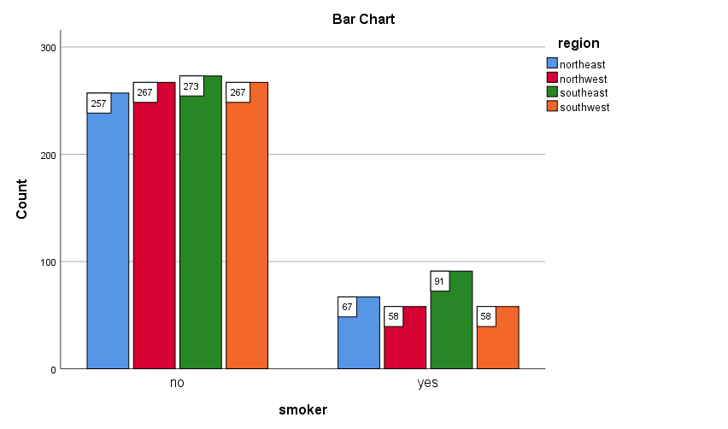

GRAPH
/BAR(GROUPED)=MEAN(charges) BY region BY sex.

Mean Charges Genderwise and Regionwise

Notes
Output Created |  | 10-AUG-2021 14:35:10
Comments
Input | Data | C:\Users\ADMIN\Desktop\Dhanashri\Bsc ASA SOS\SEM 5\Multivariate Analysis\Insurance.sav
Input | Active Dataset | DataSet1
Input | Filter | <none>
Input | Weight | <none>
Input | Split File | <none>
Input | N of Rows in Working Data File | 1338
Syntax |  | GRAPH  /BAR(GROUPED)=MEAN(charges) BY region BY sex.
Resources | Processor Time | 00:00:00.88
Resources | Elapsed Time | 00:00:00.35

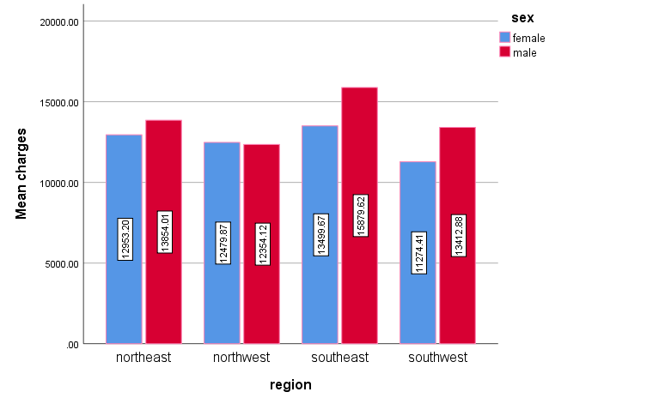

GRAPH
/BAR(SIMPLE)=MEAN(bmi) BY age.

Mean BMI for different Age

Notes
Output Created |  | 10-AUG-2021 14:43:43
Comments
Input | Data | C:\Users\ADMIN\Desktop\Dhanashri\Bsc ASA SOS\SEM 5\Multivariate Analysis\Insurance.sav
Input | Active Dataset | DataSet1
Input | Filter | <none>
Input | Weight | <none>
Input | Split File | <none>
Input | N of Rows in Working Data File | 1338
Syntax |  | GRAPH  /BAR(SIMPLE)=MEAN(bmi) BY age.
Resources | Processor Time | 00:00:00.69
Resources | Elapsed Time | 00:00:00.26

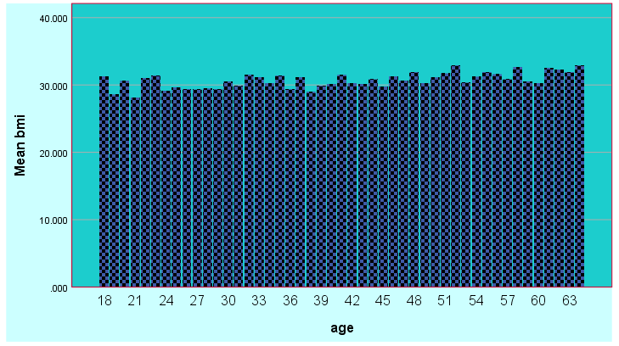

* Chart Builder.
GGRAPH
/GRAPHDATASET NAME="graphdataset" VARIABLES=inccat COUNT()[name="COUNT"] MISSING=LISTWISE
REPORTMISSING=NO
/GRAPHSPEC SOURCE=INLINE.
BEGIN GPL
SOURCE: s=userSource(id("graphdataset"))
DATA: inccat=col(source(s), name("inccat"),
notIn("1.00"), unit.category())
DATA: COUNT=col(source(s), name("COUNT"))
GUIDE: axis(dim(1), label("Income category in thousands"))
GUIDE: axis(dim(2), label("Count"))
GUIDE: text.title(label("Simple Bar Count of Income category in thousands"))
SCALE: cat(dim(1), include("2.00", "3.00", "4.00"))
SCALE: linear(dim(2), include(0))
ELEMENT: interval(position(inccat*COUNT), shape.interior(shape.square))
END GPL.

BAR CHART of Income Category

Notes
Output Created |  | 10-AUG-2021 14:55:20
Comments
Input | Data | C:\PROGRA~1\IBM\SPSS\STATIS~1\25\Samples\English\demo.sav
Input | Active Dataset | DataSet1
Input | Filter | <none>
Input | Weight | <none>
Input | Split File | <none>
Input | N of Rows in Working Data File | 6400
Syntax |  | GGRAPH  /GRAPHDATASET NAME="graphdataset" VARIABLES=inccat COUNT()[name="COUNT"] MISSING=LISTWISE  REPORTMISSING=NO  /GRAPHSPEC SOURCE=INLINE.  BEGIN GPL  SOURCE: s=userSource(id("graphdataset"))  DATA: inccat=col(source(s), name("inccat"),  notIn("1.00"), unit.category())  DATA: COUNT=col(source(s), name("COUNT"))  GUIDE: axis(dim(1), label("Income category in thousands"))  GUIDE: axis(dim(2), label("Count"))  GUIDE: text.title(label("Simple Bar Count of Income category in thousands"))  SCALE: cat(dim(1), include("2.00", "3.00", "4.00"))  SCALE: linear(dim(2), include(0))  ELEMENT: interval(position(inccat*COUNT), shape.interior(shape.square))  END GPL.
Resources | Processor Time | 00:00:04.53
Resources | Elapsed Time | 00:00:01.85

[DataSet1] C:\PROGRA~1\IBM\SPSS\STATIS~1\25\Samples\English\demo.sav

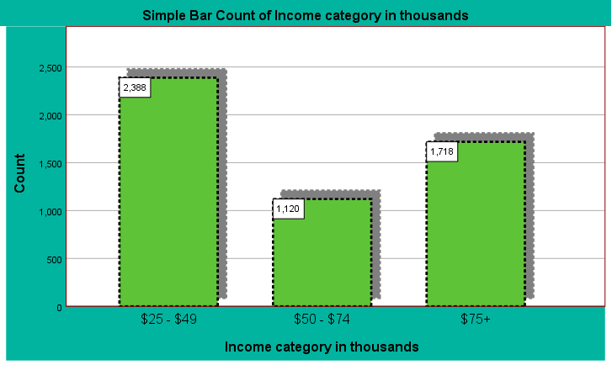

* Chart Builder.
GGRAPH
/GRAPHDATASET NAME="graphdataset" VARIABLES=age MISSING=LISTWISE REPORTMISSING=NO
/GRAPHSPEC SOURCE=INLINE.
BEGIN GPL
SOURCE: s=userSource(id("graphdataset"))
DATA: age=col(source(s), name("age"))
GUIDE: axis(dim(1), label("Age in years"))
GUIDE: axis(dim(2), label("Frequency"))
GUIDE: text.title(label("Simple Histogram of Age in years"))
ELEMENT: interval(position(summary.count(bin.rect(age))), shape.interior(shape.square))
END GPL.

HISTOGRAM of Age

Notes
Output Created |  | 10-AUG-2021 15:04:30
Comments
Input | Data | C:\PROGRA~1\IBM\SPSS\STATIS~1\25\Samples\English\demo.sav
Input | Active Dataset | DataSet1
Input | Filter | <none>
Input | Weight | <none>
Input | Split File | <none>
Input | N of Rows in Working Data File | 6400
Syntax |  | GGRAPH  /GRAPHDATASET NAME="graphdataset" VARIABLES=age MISSING=LISTWISE REPORTMISSING=NO  /GRAPHSPEC SOURCE=INLINE.  BEGIN GPL  SOURCE: s=userSource(id("graphdataset"))  DATA: age=col(source(s), name("age"))  GUIDE: axis(dim(1), label("Age in years"))  GUIDE: axis(dim(2), label("Frequency"))  GUIDE: text.title(label("Simple Histogram of Age in years"))  ELEMENT: interval(position(summary.count(bin.rect(age))), shape.interior(shape.square))  END GPL.
Resources | Processor Time | 00:00:00.83
Resources | Elapsed Time | 00:00:00.42

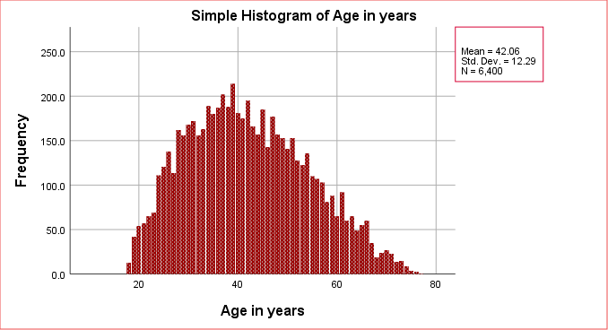

* Chart Builder.
GGRAPH
/GRAPHDATASET NAME="graphdataset" VARIABLES=employ income MISSING=LISTWISE REPORTMISSING=NO
/GRAPHSPEC SOURCE=INLINE
/FITLINE TOTAL=NO.
BEGIN GPL
SOURCE: s=userSource(id("graphdataset"))
DATA: employ=col(source(s), name("employ"))
DATA: income=col(source(s), name("income"))
GUIDE: axis(dim(1), label("Years with current employer"))
GUIDE: axis(dim(2), label("Household income in thousands"))
GUIDE: text.title(label("Simple Scatter of Household income in thousands by Years with current ",
"employer"))
ELEMENT: point(position(employ*income))
END GPL.

SCATTERPLOT of Household Income VS Years with Current Employer

Notes
Output Created |  | 10-AUG-2021 15:12:04
Comments
Input | Data | C:\PROGRA~1\IBM\SPSS\STATIS~1\25\Samples\English\demo.sav
Input | Active Dataset | DataSet1
Input | Filter | <none>
Input | Weight | <none>
Input | Split File | <none>
Input | N of Rows in Working Data File | 6400
Syntax |  | GGRAPH  /GRAPHDATASET NAME="graphdataset" VARIABLES=employ income MISSING=LISTWISE REPORTMISSING=NO  /GRAPHSPEC SOURCE=INLINE  /FITLINE TOTAL=NO.  BEGIN GPL  SOURCE: s=userSource(id("graphdataset"))  DATA: employ=col(source(s), name("employ"))  DATA: income=col(source(s), name("income"))  GUIDE: axis(dim(1), label("Years with current employer"))  GUIDE: axis(dim(2), label("Household income in thousands"))  GUIDE: text.title(label("Simple Scatter of Household income in thousands by Years with current ",  "employer"))  ELEMENT: point(position(employ*income))  END GPL.
Resources | Processor Time | 00:00:00.56
Resources | Elapsed Time | 00:00:00.32

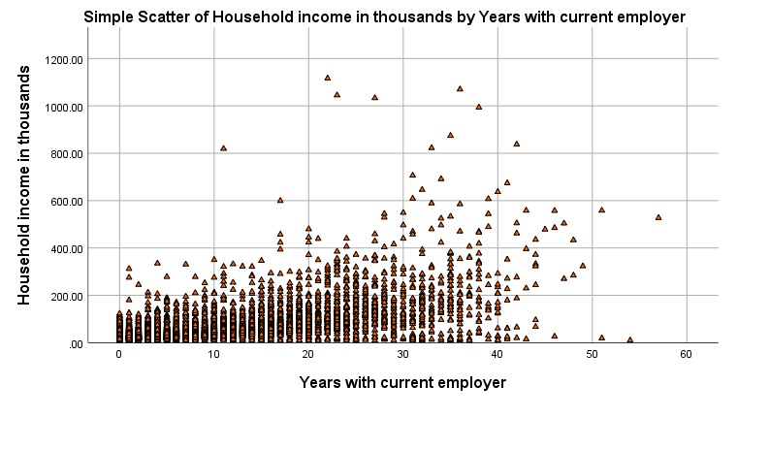

GGRAPH
/GRAPHDATASET NAME="graphdataset"
VARIABLES=inccat[LEVEL=ordinal] age[LEVEL=scale]
MISSING=LISTWISE REPORTMISSING=NO
/GRAPHSPEC SOURCE=VIZTEMPLATE(NAME="3-D Pie"[LOCATION=LOCAL]
MAPPING( "values"="age"[DATASET="graphdataset"]
"categories"="inccat"[DATASET="graphdataset"] "Summary"="sum"))
VIZSTYLESHEET="Traditional"[LOCATION=LOCAL]
LABEL='3-D PIE: inccat-age'
DEFAULTTEMPLATE=NO.

PIE CHART for Income Category and Age

Notes
Output Created |  | 10-AUG-2021 15:20:58
Comments
Input | Data | C:\PROGRA~1\IBM\SPSS\STATIS~1\25\Samples\English\demo.sav
Input | Active Dataset | DataSet1
Input | Filter | <none>
Input | Weight | <none>
Input | Split File | <none>
Input | N of Rows in Working Data File | 6400
Syntax |  | GGRAPH  /GRAPHDATASET NAME="graphdataset"  VARIABLES=inccat[LEVEL=ordinal] age[LEVEL=scale]  MISSING=LISTWISE REPORTMISSING=NO  /GRAPHSPEC SOURCE=VIZTEMPLATE(NAME="3-D Pie"[LOCATION=LOCAL]  MAPPING( "values"="age"[DATASET="graphdataset"]  "categories"="inccat"[DATASET="graphdataset"] "Summary"="sum"))  VIZSTYLESHEET="Traditional"[LOCATION=LOCAL]  LABEL='3-D PIE: inccat-age'  DEFAULTTEMPLATE=NO.
Resources | Processor Time | 00:00:01.42
Resources | Elapsed Time | 00:00:00.67

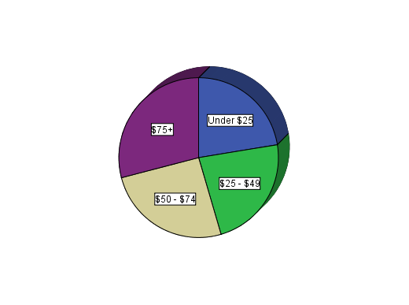

The bar chart depicts the mean age for different Income categories. The income category of $75+ has comparatively higher mean.

EXAMINE VARIABLES=age BY marital retire gender
/PLOT BOXPLOT STEMLEAF
/COMPARE GROUPS
/STATISTICS DESCRIPTIVES
/CINTERVAL 95
/MISSING LISTWISE
/NOTOTAL.

Explore Age with Gender, Martial Status and Retirement Status

Notes
Output Created |  | 10-AUG-2021 15:26:43
Comments
Input | Data | C:\PROGRA~1\IBM\SPSS\STATIS~1\25\Samples\English\demo.sav
Input | Active Dataset | DataSet1
Input | Filter | <none>
Input | Weight | <none>
Input | Split File | <none>
Input | N of Rows in Working Data File | 6400
Missing Value Handling | Definition of Missing | User-defined missing values for dependent variables are treated as missing.
Missing Value Handling | Cases Used | Statistics are based on cases with no missing values for any dependent variable or factor used.
Syntax |  | EXAMINE VARIABLES=age BY marital retire gender  /PLOT BOXPLOT STEMLEAF  /COMPARE GROUPS  /STATISTICS DESCRIPTIVES  /CINTERVAL 95  /MISSING LISTWISE  /NOTOTAL.
Resources | Processor Time | 00:00:01.41
Resources | Elapsed Time | 00:00:01.15

Marital status

Case Processing Summary
 | Marital status | Cases
 | Marital status | Valid |  | Missing |  | Total
 | Marital status | N | Percent | N | Percent | N | Percent
Age in years | Unmarried | 3224 | 100.0% | 0 | 0.0% | 3224 | 100.0%
Age in years | Married | 3176 | 100.0% | 0 | 0.0% | 3176 | 100.0%

Descriptives
 | Marital status |  |  | Statistic | Std. Error
Age in years | Unmarried | Mean |  | 42.02 | .217
Age in years | Unmarried | 95% Confidence Interval for Mean | Lower Bound | 41.60
Age in years | Unmarried | 95% Confidence Interval for Mean | Upper Bound | 42.45
Age in years | Unmarried | 5% Trimmed Mean |  | 41.74
Age in years | Unmarried | Median |  | 41.00
Age in years | Unmarried | Variance |  | 151.934
Age in years | Unmarried | Std. Deviation |  | 12.326
Age in years | Unmarried | Minimum |  | 18
Age in years | Unmarried | Maximum |  | 75
Age in years | Unmarried | Range |  | 57
Age in years | Unmarried | Interquartile Range |  | 19
Age in years | Unmarried | Skewness |  | .305 | .043
Age in years | Unmarried | Kurtosis |  | -.607 | .086
Age in years | Married | Mean |  | 42.10 | .217
Age in years | Married | 95% Confidence Interval for Mean | Lower Bound | 41.67
Age in years | Married | 95% Confidence Interval for Mean | Upper Bound | 42.52
Age in years | Married | 5% Trimmed Mean |  | 41.83
Age in years | Married | Median |  | 41.00
Age in years | Married | Variance |  | 150.162
Age in years | Married | Std. Deviation |  | 12.254
Age in years | Married | Minimum |  | 18
Age in years | Married | Maximum |  | 77
Age in years | Married | Range |  | 59
Age in years | Married | Interquartile Range |  | 18
Age in years | Married | Skewness |  | .293 | .043
Age in years | Married | Kurtosis |  | -.596 | .087

Age in years

Stem-and-Leaf Plots

Age in years Stem-and-Leaf Plot for
marital= Unmarried

Frequency Stem & Leaf

28.00 1 . 889999
184.00 2 . 000001111112222222333333444444444444
356.00 2 . 555555555556666666666666677777777777788888888888888888899999999999999999
417.00 3 . 00000000000000001111111111111111111222222222222222333333333333333334444444444444444
480.00 3 . 555555555555555555666666666666666666777777777777777777778888888888888888888899999999999999999999
465.00 4 . 0000000000000000000000111111111111111122222222222222222222233333333333333333344444444444444444
393.00 4 . 5555555555555555556666666666666777777777777777777888888888888888999999999999999
344.00 5 . 000000000000001111111111111112222222222223333333333334444444444444444
240.00 5 . 555555555555666666666677777777788888889999999999
166.00 6 . 000000011111111111222223333344444
103.00 6 . 5555556666667777888999
45.00 7 . 0001112334
3.00 7 . 5

Stem width: 10
Each leaf: 5 case(s)

Age in years Stem-and-Leaf Plot for
marital= Married

Frequency Stem & Leaf

27.00 1 . 89999
172.00 2 . 0000011112222233333344444444
335.00 2 . 5555555555566666666666777777777888888888888999999999999
431.00 3 . 000000000000000111111111111122222222222223333333333333444444444444444444
491.00 3 . 5555555555555556666666666666666777777777777777778888888888888889999999999999999999
409.00 4 . 00000000000011111111111111112222222222222223333333333333444444444444
422.00 4 . 5555555555555555666666666666677777777777777788888888888889999999999999
337.00 5 . 000000000000111111111111122222222222233333333334444444444
249.00 5 . 555555556666666666777777777788888888999999
165.00 6 . 000001111112222233333334444
90.00 6 . 55556666677789
43.00 7 . 001234
5.00 7 . &

Stem width: 10
Each leaf: 6 case(s)

& denotes fractional leaves.

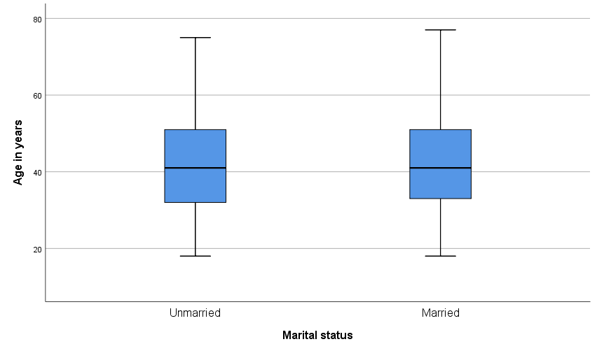

Retired

Case Processing Summary
 | Retired | Cases
 | Retired | Valid |  | Missing |  | Total
 | Retired | N | Percent | N | Percent | N | Percent
Age in years | No | 6092 | 100.0% | 0 | 0.0% | 6092 | 100.0%
Age in years | Yes | 308 | 100.0% | 0 | 0.0% | 308 | 100.0%

Descriptives
 | Retired |  |  | Statistic | Std. Error
Age in years | No | Mean |  | 40.90 | .146
Age in years | No | 95% Confidence Interval for Mean | Lower Bound | 40.61
Age in years | No | 95% Confidence Interval for Mean | Upper Bound | 41.18
Age in years | No | 5% Trimmed Mean |  | 40.69
Age in years | No | Median |  | 40.00
Age in years | No | Variance |  | 129.507
Age in years | No | Std. Deviation |  | 11.380
Age in years | No | Minimum |  | 18
Age in years | No | Maximum |  | 74
Age in years | No | Range |  | 56
Age in years | No | Interquartile Range |  | 17
Age in years | No | Skewness |  | .232 | .031
Age in years | No | Kurtosis |  | -.612 | .063
Age in years | Yes | Mean |  | 65.00 | .278
Age in years | Yes | 95% Confidence Interval for Mean | Lower Bound | 64.46
Age in years | Yes | 95% Confidence Interval for Mean | Upper Bound | 65.55
Age in years | Yes | 5% Trimmed Mean |  | 64.95
Age in years | Yes | Median |  | 65.00
Age in years | Yes | Variance |  | 23.723
Age in years | Yes | Std. Deviation |  | 4.871
Age in years | Yes | Minimum |  | 55
Age in years | Yes | Maximum |  | 77
Age in years | Yes | Range |  | 22
Age in years | Yes | Interquartile Range |  | 8
Age in years | Yes | Skewness |  | .162 | .139
Age in years | Yes | Kurtosis |  | -.633 | .277

Age in years

Stem-and-Leaf Plots

Age in years Stem-and-Leaf Plot for
retire= No

Frequency Stem & Leaf

55.00 1 . 89999
356.00 2 . 00000111111222222333333344444444444
691.00 2 . 555555555555666666666666667777777777788888888888888889999999999999999
848.00 3 . 0000000000000000011111111111111111222222222222222233333333333333334444444444444444444
971.00 3 . 5555555555555555556666666666666666666777777777777777777778888888888888888888999999999999999999999
874.00 4 . 000000000000000000111111111111111112222222222222222222333333333333333334444444444444444
815.00 4 . 555555555555555555666666666666667777777777777777778888888888888888999999999999999
681.00 5 . 00000000000000111111111111111222222222222233333333333344444444444444
446.00 5 . 555555555556666666666777777777888888899999999
226.00 6 . 000000111111122223333444
101.00 6 . 5556667789
28.00 7 . 013&

Stem width: 10
Each leaf: 10 case(s)

& denotes fractional leaves.

Age in years Stem-and-Leaf Plot for
retire= Yes

Frequency Stem & Leaf

2.00 5 . 55
17.00 5 . 66666666777777777
24.00 5 . 888888888888899999999999
35.00 6 . 00000000011111111111111111111111111
47.00 6 . 22222222222222222222222233333333333333333333333
47.00 6 . 44444444444444444444444555555555555555555555555
45.00 6 . 666666666666666666666666666667777777777777777
23.00 6 . 88888888899999999999999
35.00 7 . 00000000000000000000011111111111111
20.00 7 . 22222222222333333333
9.00 7 . 444445555
4.00 7 . 6667

Stem width: 10
Each leaf: 1 case(s)

Boxplots

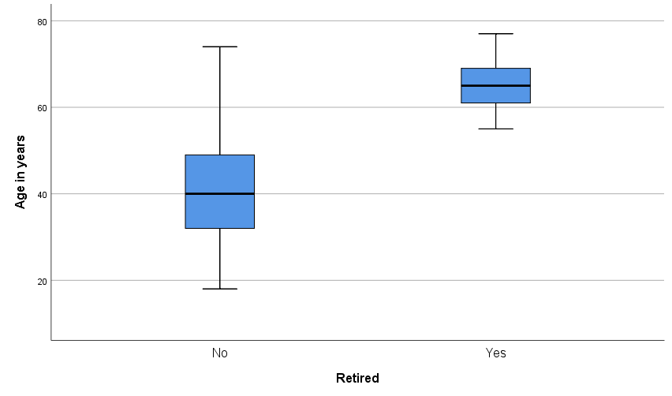

Gender

Case Processing Summary
 | Gender | Cases
 | Gender | Valid |  | Missing |  | Total
 | Gender | N | Percent | N | Percent | N | Percent
Age in years | Female | 3179 | 100.0% | 0 | 0.0% | 3179 | 100.0%
Age in years | Male | 3221 | 100.0% | 0 | 0.0% | 3221 | 100.0%

Descriptives
 | Gender |  |  | Statistic | Std. Error
Age in years | Female | Mean |  | 41.74 | .212
Age in years | Female | 95% Confidence Interval for Mean | Lower Bound | 41.32
Age in years | Female | 95% Confidence Interval for Mean | Upper Bound | 42.15
Age in years | Female | 5% Trimmed Mean |  | 41.45
Age in years | Female | Median |  | 41.00
Age in years | Female | Variance |  | 142.988
Age in years | Female | Std. Deviation |  | 11.958
Age in years | Female | Minimum |  | 18
Age in years | Female | Maximum |  | 76
Age in years | Female | Range |  | 58
Age in years | Female | Interquartile Range |  | 17
Age in years | Female | Skewness |  | .327 | .043
Age in years | Female | Kurtosis |  | -.534 | .087
Age in years | Male | Mean |  | 42.37 | .222
Age in years | Male | 95% Confidence Interval for Mean | Lower Bound | 41.94
Age in years | Male | 95% Confidence Interval for Mean | Upper Bound | 42.81
Age in years | Male | 5% Trimmed Mean |  | 42.11
Age in years | Male | Median |  | 41.00
Age in years | Male | Variance |  | 158.818
Age in years | Male | Std. Deviation |  | 12.602
Age in years | Male | Minimum |  | 18
Age in years | Male | Maximum |  | 77
Age in years | Male | Range |  | 59
Age in years | Male | Interquartile Range |  | 19
Age in years | Male | Skewness |  | .268 | .043
Age in years | Male | Kurtosis |  | -.667 | .086

Age in years

Stem-and-Leaf Plots

Age in years Stem-and-Leaf Plot for
gender= Female

Frequency Stem & Leaf

24.00 1 . 8999
165.00 2 . 000001111222223333344444444
341.00 2 . 55555555556666666666677777777788888888888899999999999999
448.00 3 . 000000000000000111111111111112222222222222233333333333333344444444444444444
507.00 3 . 55555555555555566666666666666666777777777777777777888888888888888999999999999999999
441.00 4 . 00000000000000011111111111111122222222222222223333333333333334444444444444
415.00 4 . 55555555555555555666666666666777777777777778888888888888999999999999
328.00 5 . 000000000000111111111111222222222233333333334444444444
231.00 5 . 55555555556666666677777778888889999999
148.00 6 . 000001111111122233333444
94.00 6 . 5555666667778899
34.00 7 . 0011234
2.00 7 . &
1.00 Extremes (>=76)

Stem width: 10
Each leaf: 6 case(s)

& denotes fractional leaves.

Age in years Stem-and-Leaf Plot for
gender= Male

Frequency Stem & Leaf

31.00 1 . 899999
191.00 2 . 000001111111222222233333333444444444444
350.00 2 . 5555555555556666666666666677777777777788888888888888888999999999999999
400.00 3 . 00000000000000001111111111111111122222222222222233333333333333344444444444444444
464.00 3 . 555555555555555555666666666666666667777777777777777778888888888888888888999999999999999999999
433.00 4 . 000000000000000000111111111111111112222222222222222222233333333333333334444444444444444
400.00 4 . 5555555555555555666666666666667777777777777777778888888888888889999999999999999
353.00 5 . 00000000000000111111111111111122222222222222333333333333444444444444444
258.00 5 . 5555555555666666666666777777777777888888888999999999
183.00 6 . 000000011111111222222223333333444444
99.00 6 . 5555556666667778999
54.00 7 . 0001122334
5.00 7 . &

Stem width: 10
Each leaf: 5 case(s)

& denotes fractional leaves.

Boxplots

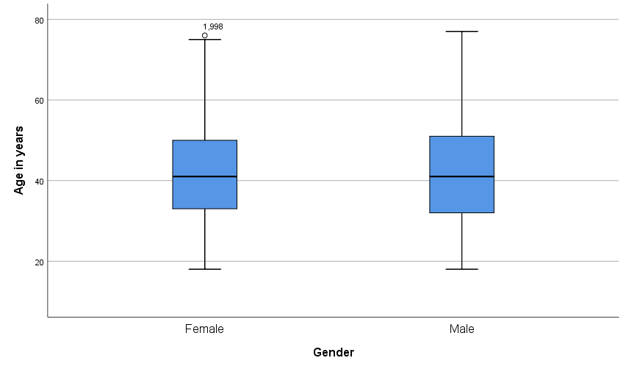

GET
FILE='C:\Users\ADMIN\Desktop\Dhanashri\Bsc ASA SOS\SEM 5\Multivariate Analysis\Newdata.sav'.
DATASET NAME DataSet1 WINDOW=FRONT.
NEW FILE.
DATASET NAME DataSet2 WINDOW=FRONT.

SAVE OUTFILE='C:\Users\ADMIN\Desktop\Dhanashri\Bsc ASA SOS\SEM 5\Multivariate Analysis\Ver_data.sav'
/COMPRESSED.
DATASET ACTIVATE DataSet1.
DATASET CLOSE DataSet2.
ADD FILES /FILE=*
/FILE='C:\Users\ADMIN\Desktop\Dhanashri\Bsc ASA SOS\SEM 5\Multivariate Analysis\Ver_data.sav'.
EXECUTE.
DATASET ACTIVATE DataSet1.

SAVE OUTFILE='C:\Users\ADMIN\Desktop\Dhanashri\Bsc ASA SOS\SEM 5\Multivariate Analysis\Newdata.sav'
/COMPRESSED.
NEW FILE.
DATASET NAME DataSet3 WINDOW=FRONT.

SAVE OUTFILE='C:\Users\ADMIN\Desktop\Dhanashri\Bsc ASA SOS\SEM 5\Multivariate Analysis\Hor_data.sav'
/COMPRESSED.
DATASET ACTIVATE DataSet1.
DATASET CLOSE DataSet3.
MATCH FILES /FILE=*
/FILE='C:\Users\ADMIN\Desktop\Dhanashri\Bsc ASA SOS\SEM 5\Multivariate Analysis\Hor_data.sav'.
EXECUTE.
DATASET ACTIVATE DataSet1.

SAVE OUTFILE='C:\Users\ADMIN\Desktop\Dhanashri\Bsc ASA SOS\SEM 5\Multivariate Analysis\Newdata.sav'
/COMPRESSED.

